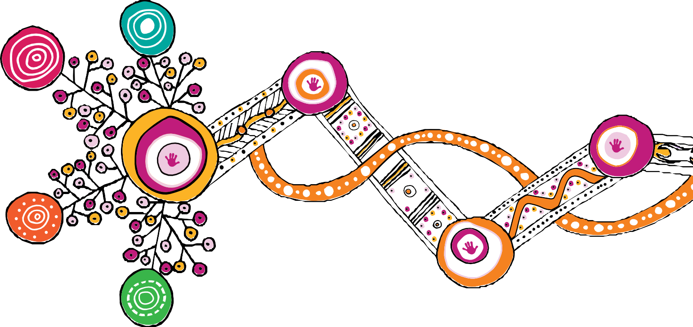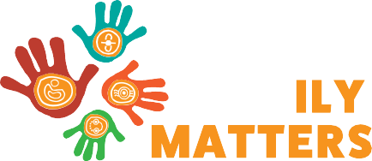

# Queensland First Children and Families Board

**Changing Tracks**

# Progress report

**2020–2021**

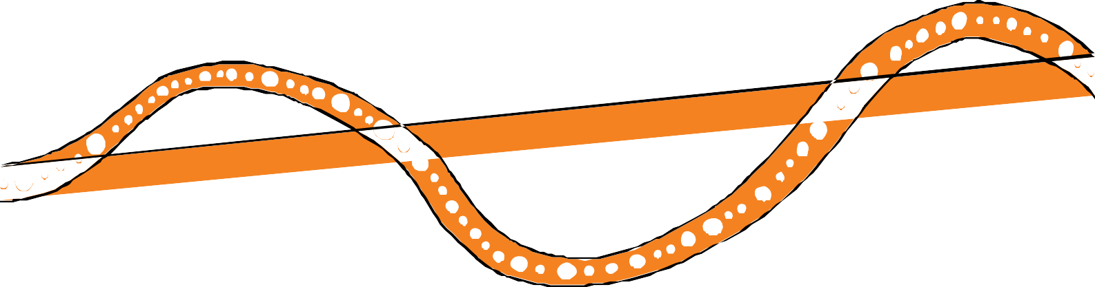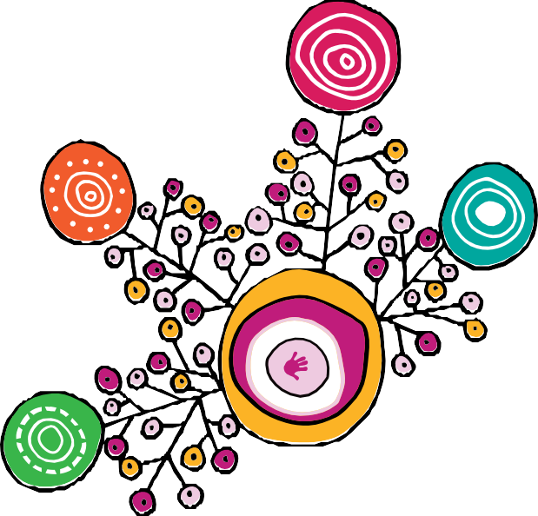

### We respectfully acknowledge the First Nations people in the State of Queensland; we acknowledge the cultural and spiritual connection that Aboriginal and Torres Strait Islander peoples have with the land and sea.

**We respectfully acknowledge Aboriginal people and Torres Strait Islander people as two unique and diverse peoples with their own rich and distinct cultures.**

**We pay our respects to Elders past and present as well as the existing and emerging leaders who walk together in partnership on this journey.**

**We acknowledge the contributions of Rachael Sarra for the original design of artworks and the creative leadership of Gilimbaa in this report.**

Prepared by: Deloitte Access Economics, in partnership with Murawin and the Social Research Centre

# Contents



Glossary 2

Message from the Queensland First Children and Families Board 3

1. The Strategy and context 5
   1. Introduction 5
      1. Our Way 5
      2. What the evidence tells us 7
      3. Our Way, commitment 7
   2. Background to this year’s annual report 7
      1. Impact of COVID-19 7
      2. Meeting needs with appropriate services 8

2 Progress in 2020-2021 12

* 1. Achievements for Changing Tracks in 2020-2021 12
     1. Building block 1: All families enjoy access to quality, culturally safe universal and targeted services necessary for Aboriginal and Torres Strait Islander

children to thrive 12

* + 1. Building block 2: Aboriginal and Torres Strait Islander peoples and organisations participate in and have control over decisions that affect their children 13
    2. Building block 3: Law, policy and practice in child and family welfare are

culturally safe and responsive 14

* + 1. Building block 4: Government and community services are accountable to

Aboriginal and Torres Strait Islander peoples 15

3 Next steps 16

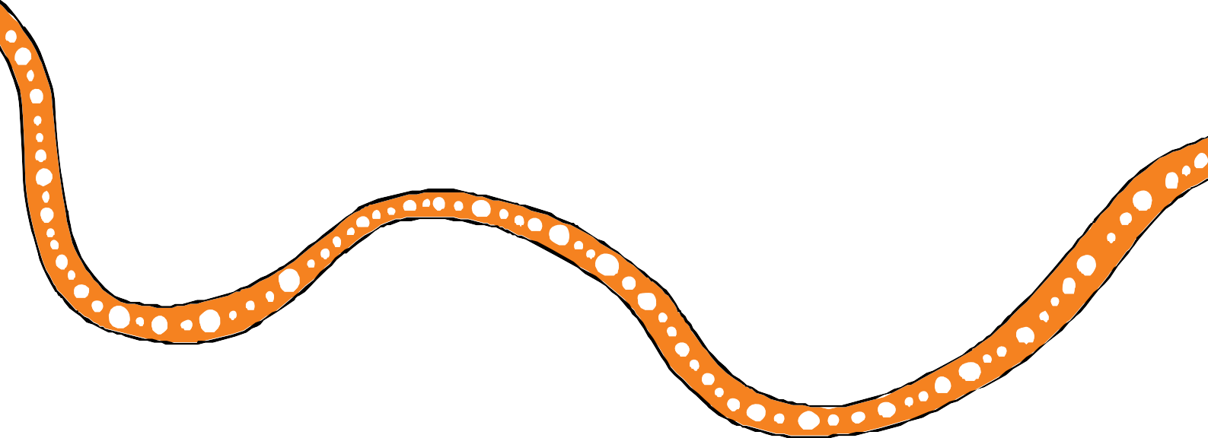

* 1. Looking forward 16
     1. Next steps for Changing Tracks 16
     2. Next steps for Our Way 16

**Appendix A Key achievements from Changing Tracks action plan 2020–22 17**

**References 31**

1

# Glossary



|  |  |
| --- | --- |
| **ACRONYM** | **FULL NAME** |
| ACCO | Aboriginal and Torres Strait Islander Community Controlled Organisation |
| CGEA | Certificates in General Education for Adults |
| DCYJMA | Department of Children, Youth Justice and Multicultural Affairs |
| DoE | Department of Education |
| DESBT | Department of Employment, Small Business and Training |
| DCHDE | Department of Communities, Housing and Digital Economy |
| DJAG | Department of Justice and Attorney-General |
| DSDSATSIP | The Department of Seniors, Disability Services and Aboriginal and Torres Strait Islander Partnerships |
| ERICT | Emotional Regulation and Impulsive Control Training |
| FWS | Family Wellbeing Service |
| IUIH | Institute for Urban Indigenous Health |
| LHPs | Local Housing Plans |
| LTC | Local Thriving Communities |
| QATSICPP | Queensland Aboriginal and Torres Strait Islander Child Protection Peak |
| QFCFB | Queensland First Children and Families Board |
| QH | Queensland Health |
| VTQ | Vocational Training Queensland |

2

# Message from the Queensland First Children and Families Board



With the launch of *Our Way: A generational strategy for Aboriginal and Torres Strait Islander children and families 2017–2037* in 2017, the Queensland Government, in partnership with Family Matters Queensland committed to set the foundations for change across the child protection system in Queensland by supporting Aboriginal and Torres Strait Islander children to grow up safe, loved and cared for in family, community and culture, to eliminate the disproportionate representation of Aboriginal and Torres Strait Islander children in the child protection system, and close the gap in life outcomes for Aboriginal and Torres Strait Islander children. Launched in early 2020, the *Changing Tracks 2020-2022 action plan* (Changing Tracks) continues to build on the above commitment.

This is the Queensland First Children and Families Board’s fourth annual progress report and highlights the achievements made under the *Changing Tracks Action Plan 2020-22*. This period has once again presented significant challenges for us, our partners, our families and

our communities. Despite these challenges, it is important to note however, that the majority of Aboriginal and Torres Strait Islander children and families in Queensland are safe, loved, connected to family, community and culture, and the Board is confident that progress has been made through:

* The proportion of children in care who are Aboriginal and Torres Strait Islander remains relatively stable, a reversal of the pre-reform (2012-13) trend of growing disproportionate representation of Aboriginal and Torres Strait Islander children in the child protection system.
* Increased proportional funding to Aboriginal and Torres Strait Islander community controlled organisations.
* The successful implementation of delegated authority in the earlier adopter sites of Rockhampton and the Sunshine Coast and the preparation for expansion of this initiative state-wide.
* A new kinship care program for Aboriginal and Torres Strait Islander families, Family Caring for Family being developed in partnership with Queensland Aboriginal and Torres Strait Islander Child Protection Peak (QATSICPP), and member organisations, and
* The legal recognition of Torres Strait child rearing practices in Queensland law with the passage of the *Meriba Omasker Kaziw Kazipa (Torres Strait Islander Traditional Child Rearing Practice) Act 2020*, including the establishment of the Office of the Commissioner (Meriba Omasker Kaziw Kazipa).

The Board congratulates Commissioner C’Zarke Maza on his appointment and we look forward to working with him.

3

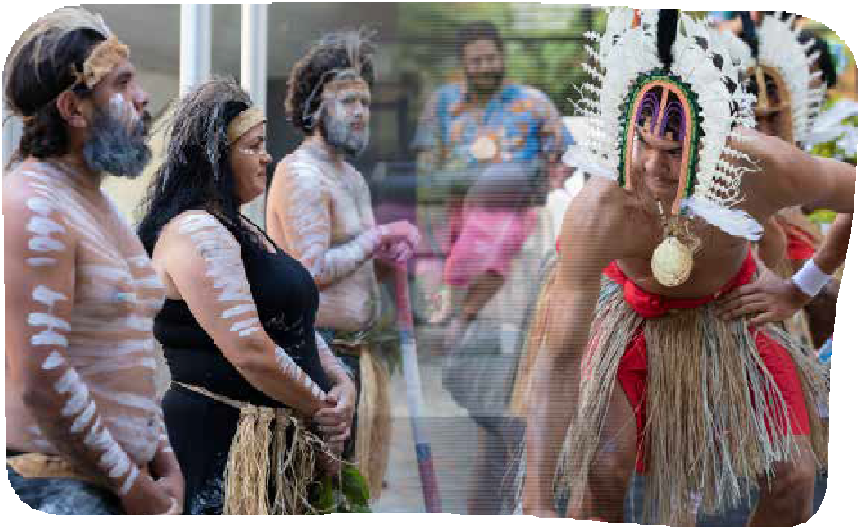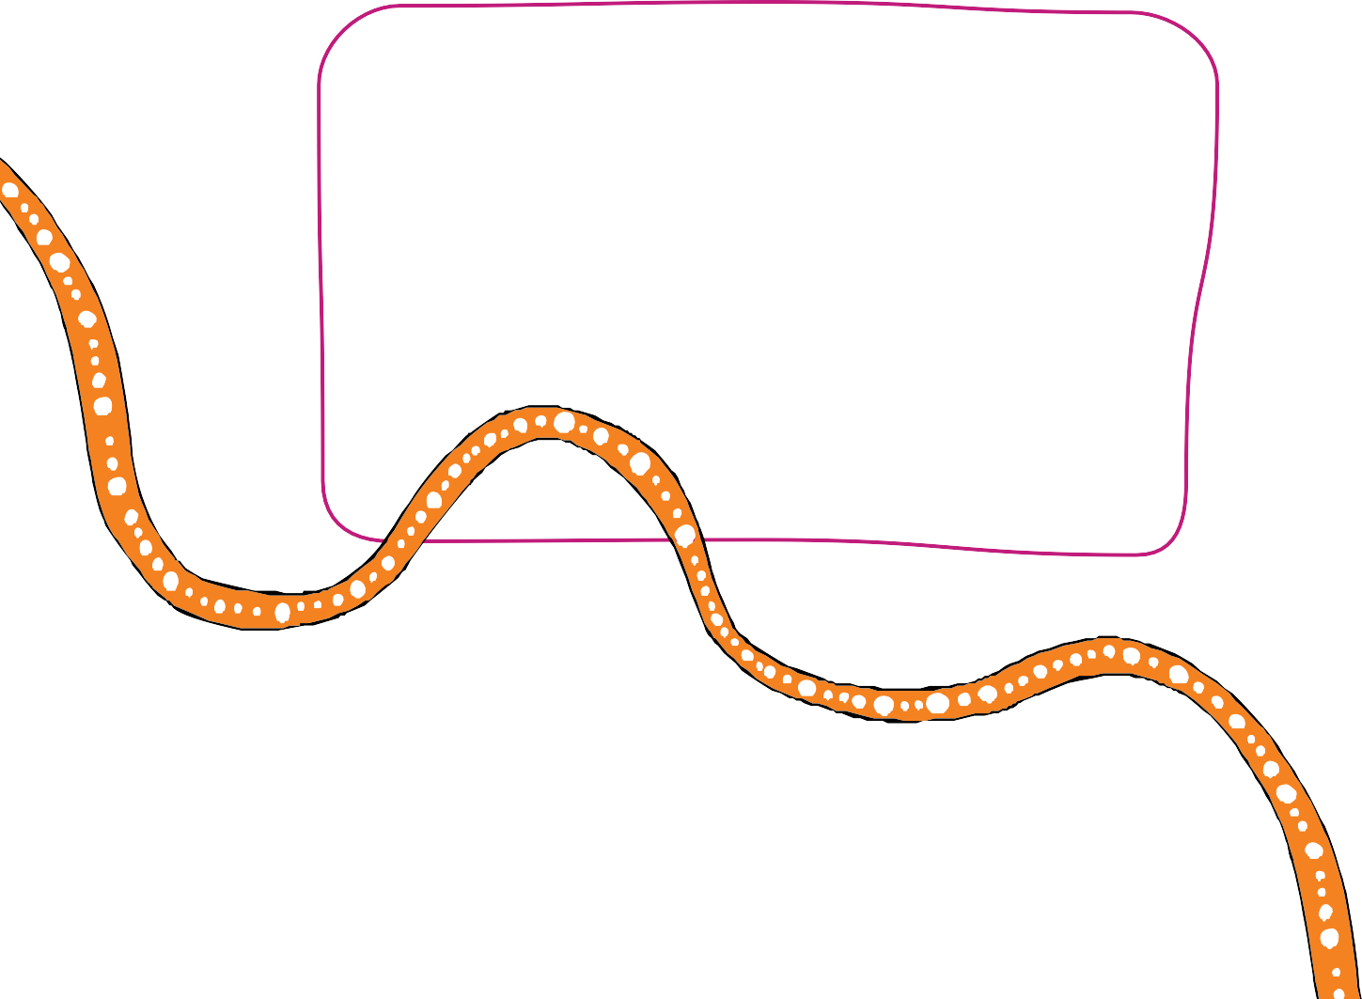

4

                         

The Board also welcomes the ongoing support and commitment of the Queensland Government and the Honourable Leanne Linard MP, Minister for Children and Youth Justice and Minister

for Multicultural Affairs to eliminating the disproportionate representation of Aboriginal and Torres Strait Islander children in care and supporting the Board in its oversight role in the implementation of the Our Way strategy.

As we move into the final phase of Changing Tracks and begin development of the next phase, *Breaking Cycles 2023-2031* and the first *Breaking Cycles action plan 2023-2025*, it is vital that we remain steadfast in our shared commitment to actively work together to address the needs of Aboriginal and Torres Strait Islander children, young people and families.

#### Professor Boni Robertson Mr Mick Gooda

Co-chair Co-chair

## Introduction



**1**

**The Strategy and context**

### Our Way

The Queensland Government and Family Matters Queensland1 are committed to working in partnerships with Aboriginal and Torres Strait Islander communities to ensure children stay safe and connected to family, culture and their communities as they grow up. This is reflected in the *Our Way: A generational strategy for Aboriginal and Torres Strait Islander children and families 2017–2037* (Our Way). The Our Way strategy is a whole-of-government and whole-of-community approach to:

* + - * Eliminating the disproportionate representation of Aboriginal and Torres Strait Islander children in the child protection system by 2037, and
      * Close the gap in life outcomes for Aboriginal and Torres Strait Islander children and families.

The Our Way strategy comprises of a series of action plans that span over three discrete phases, or cycles of change, outlined in Figure 1.

### Figure 1: Implementation plan

Each plan is designed to improve outcomes for all Aboriginal and Torres Strait Islander children and their families in Queensland and embed the core Family Matters building blocks across the child protection system (see Table 1).

**Changing Tracks** First and second action plan

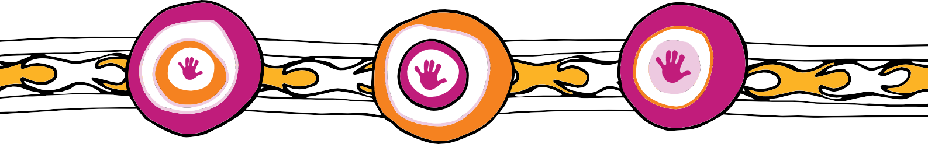

(2017-2022)

**Breaking Cycles** Third, fourth and fifth action plans

(2023-2031)

**Hitting Targets** Sixth and seventh action plans (2023-2031)

### OUR WAY STRATEGY (2017-2037)

**Ongoing monitoring and evaluation**

5



6

                      

### Table 1: Building blocks

|  |  |
| --- | --- |
| **Building block** | **Description** |
| **1: Universal and targeted services** | All families enjoy access to quality, culturally safe universal and targeted services necessary for Aboriginal and Torres Strait Islander children to thrive |
| **2: Participation, control and self-determination** | Aboriginal and Torres Strait Islander peoples and organisations participate in and have control over decisions that affect their children |
| **3: Culturally safe and responsive systems** | Law, policy and practice in child and family welfare are culturally safe and responsive |
| **4: Accountability** | Government and community services are accountable to Aboriginal and Torres Strait Islander peoples |

The look and feel of each action plan is informed by the insights, outputs and outcomes of the preceding action plan.

The first Changing Tracks 2017-2019 action plan is complete. These actions focused on five priority areas in service and system change:

1. Meeting the needs of Aboriginal and Torres Strait Islander young women under 25 years, and their partners, before and during pregnancy and parenting, especially during the first 1000 days
2. Increasing access to, and involvement in, early years, health and disability programs for Aboriginal and Torres Strait Islander children aged two to five years
3. Providing Aboriginal and Torres Strait Islander families who have complex needs and children at risk with the right services
4. Enabling Aboriginal and Torres Strait Islander children and young people in out-of-home care to thrive, and re-engaging those disconnected from family and kin
5. Enabling Aboriginal and Torres Strait Islander children and young people aged 15 to 21 years in or leaving out-of-home care to learn and earn and stay safe and well.

Implementation is now underway for the second Changing Tracks action plan (2020–2022). The action plan comprises of **24 targeted actions** aligned to the four Family Matters Building Blocks, that continues to set the foundations for change across the child protection system to achieve the Our Way targets, and consolidates and builds on actions and achievements in the first action plan.

A total of **5 actions** have been completed and **19 are in progress** and on track to be delivered by the end of 2022. See **Appendix A** for full details of the progression of actions delivered under the second Changing Tracks action plan (2020–2022) between July 2020 and June 2021.



7

                      

### What the evidence tells us

Whilst the majority of Aboriginal and Torres Strait Islander children in Queensland live safely at home with family, community and culture in Queensland:

* + - * The proportion of children in care who are Aboriginal and Torres Strait Islander has remained relatively stable, a reversal of the pre-reform (2012-13) trend of growing disproportionate representation of Aboriginal and Torres Strait Islander children in the child protection system
      * The rate of disproportionate representation is low compared to other jurisdictions2.
      * Aboriginal and Torres Strait Islander children are:

– 7.1 times more likely than non-Indigenous children to receive child protection services (this is below the national average of 8.2)3.

* + - * There has been an increased proportional funding to ACCOs4.
      * Queensland leads the way with the highest proportion of expenditure on ACCOs for the delivery of family support and intensive family support services (21.82%), and
      * Queensland’s legislation remains the most comprehensive, in supporting the participation of Aboriginal and Torres Strait Islander children, families and communities in the context of child protection decision-making across the child protection system.5

### Our Way, commitment

The Queensland Government continues its long-term commitment, in partnership with Family Matters Queensland and the Queensland First Children and Families Board, to eliminate the disproportionate representation of Aboriginal and Torres Strait Islander children and families in the child protection system through:

* + - * enhancing opportunities for Aboriginal and Torres Strait Islander peoples and organisations to participate in and have control over decisions that affect their children;
      * building the Aboriginal and Torres Strait Islander community controlled sector;
      * embedding and applying the Aboriginal and Torres Strait Islander Child Placement Principle; and
      * moving towards a state-wide delegated authority model.

## Background to this year’s annual report

### Impact of COVID-19

The COVID-19 pandemic has posed unprecedented challenges on both the community and service provision; providers have had to adapt to service and travel restrictions impacting on to whom, where and how services can be delivered. This has required service providers to design and implement new and different ways of working to communities where there were already services access issues before the pandemic.

In parallel, individual Aboriginal and Torres Strait Islander children and families have been deeply impacted by the pandemic. Pre-existing vulnerabilities have exacerbated the health, social and economic impacts of the virus.6,7



8

                      

***Community networks were heavily disrupted while social distancing measures were in place, limiting opportunities for children to maintain connection to their families and cultures. There is strong evidence that interrupted family and cultural connections can have dire impacts on the mental health and wellbeing of children if left unaddressed.8***

In addition, families have experienced increased stress associated with economic hardship, demands of home schooling, barriers impacting on family caring for family and lack of respite for parents and carers of children with disabilities, behavioural issues and developmental delays.9

In October and November 2020, the SNAICC – National Voice for our Children (SNAICC) conducted an online survey of child and family sector organisations to gain further insight into the short- and long-term effects of COVID-19.10 Aboriginal and Torres Strait Islander children and families and ACCO workers reported COVID-19 has severely impacted child wellbeing.11 The majority of survey respondents reported high to extreme impact on mental health and emotional wellbeing, culture and connection, and learning and skills (74%, 65%, and 60%, respectively).12

The short-term impacts on children and families have increased the demand for child and family support services. The long-term impacts are likely to include ongoing increased demand for these services.

### Meeting needs with appropriate services

Changing Tracks acknowledges that there is much more work to be done across secondary and universal service systems to ensure Aboriginal and Torres Strait Islander children and young people grow up safe, loved and cared for in family, community and culture. It also highlights that the necessary changes cannot be achieved by one service or government agency, alone. System change requires a long-term commitment to evidence-based change across government and community.

Key Queensland Government policies and reforms focused on closing the gap in life outcomes for Aboriginal and Torres Strait Islander children and families that intersect with the Our Way strategy and action plans are outlined in Table 2:

### Table 2: Strategies that intersect Our Way

|  |  |
| --- | --- |
| **Strategy** | **Description** |
| **Making Tracks Together13** | Queensland’s Aboriginal and Torres Strait Islander Health Equity Framework. The Framework prioritises the ideas and aspirations of Aboriginal and Torres Strait Islander community members in  determining healthcare service design and delivery, and commits to improving health and wellbeing outcomes by:   * Actively eliminating racial discrimination and institutional racism within services * Increasing access to healthcare services * Influencing the social, cultural and economic determinants of health * Delivering sustainable, culturally safe and responsive healthcare services * Working with Aboriginal and Torres Strait Islander communities and organisations to design, deliver, monitor and review health services. |



9

                      

|  |  |
| --- | --- |
| **Strategy** | **Description** |
| **Working Together Changing the Story: Youth Justice Strategy 2019-202314** | A suite of reforms has redesigned community and detention services to improve outcomes for children and young people in the youth justice system. *Working Together Changing the Story* is an evidence- based framework that underpins collaboration between government, services and communities, focused on keeping communities safe.  The strategy is built on four pillars:   * **Intervene early:** children and young people in vulnerable families have their health, education, safety and wellbeing needs met * **Keep children out of court:** children and young people with early or low-level offending are engaged in education and training, and are supported to address their behaviours * **Keep children of out custody:** children and young people who have offended have a safe place to live and are supervised and supported to repair harms, address behaviours, and reconnect with families and communities as an alternative to incarceration * **Reduce re-offending:** children and young people who are repeat offenders get responses, punishments and support that work to stop re-offending and enable successful reintegration with their families, culture and communities. |
| **Skilling Queenslanders for Work15** | A commitment from the Queensland Government to support up to 15,000 disadvantaged Queenslanders, annually, to enter the workforce. This includes upskilling through training and qualifications. Funding is particularly focused on young people  (including those in and transitioned from out-of-home care) and Aboriginal and Torres Strait Islander peoples, as well as other cohorts experiencing relative underemployment. |
| **Queensland’s Closing the Gap Implementation Plan16** | Queensland’s approach to addressing and monitoring progress against the priority reforms and socioeconomic targets in the [National Agreement on Closing the Gap](https://www.closingthegap.gov.au/national-agreement/national-agreement-closing-the-gap). The Plan:   * Reflects the Queensland context * Reflects what Aboriginal and Torres Strait Islander community members have to say about their ambitions for their lives and communities * Outlines ongoing and planned structural reforms that will transform decision-making processes with Aboriginal and Torres Strait Islander communities.   These structural reforms include:   * Progressing the Path to Treaty and Local Thriving Communities * Establishing the Queensland First Children and Families Board * Developing Queensland’s Framework for Action – Reshaping our approach to Aboriginal and Torres Strait Islander Domestic and Family Violence * Developing the First Nations health equity reform agenda. |



10

                      

|  |  |
| --- | --- |
| **Strategy** | **Description** |
| **Local Thriving Communities17, and Path to Treaty18** | * Queensland Government is committed to a reframed relationship with Aboriginal and Torres Strait Islander peoples through Local Thriving Communities and Path to Treaty initiatives. * Local Thriving Communities seeks to increase community based decision making and leadership, foster self determination for Aboriginal and Torres Strait Islander peoples and communities, improve outcomes and increase the accountability of government and service providers. * Path to Treaty will seek to formally acknowledge and address the intergenerational impact of Queensland’s colonial history and past protectionist policies on the life outcomes of First Nations peoples, and to move together in a shared, equitable and respectful future for both Aboriginal and Torres Strait Islander peoples and non-Indigenous peoples. |
| **Queensland’s Framework for Action – Reshaping our approach to Aboriginal and**  **Torres Strait Islander Domestic and Family Violence19** | In leading the significant reform to achieve a Queensland free from domestic and family violence, the Queensland Government committed to three foundational elements in the Domestic and Family Violence Prevention Strategy 2016-2026 (DFVP Strategy):   1. shifting community attitudes and behaviours 2. enhancing service responses 3. strengthening justice system responses.   The DFVP Strategy acknowledges the need for targeted responses to Aboriginal and Torres Strait Islander domestic and family violence, with relevant initiatives included in the first and second action plans. |
| **Queensland Housing Strategy 2017-2027** | The Queensland Housing Strategy 2017-2027 sets out the Queensland Government’s commitment to work with communities, industry and the housing sector to deliver a better housing future for all Queenslanders.  The Housing Strategy is being delivered through mechanisms including the *Housing and Homelessness Action Plan 2021-2025* and the *Aboriginal and Torres Strait Islander Housing Action Plan 2019-2023*.  These mechanisms set out the Queensland Government’s commitment to work with communities, industry and the housing and homelessness sector to deliver more social and affordable homes and greater service integration to better support vulnerable peoples and groups. |

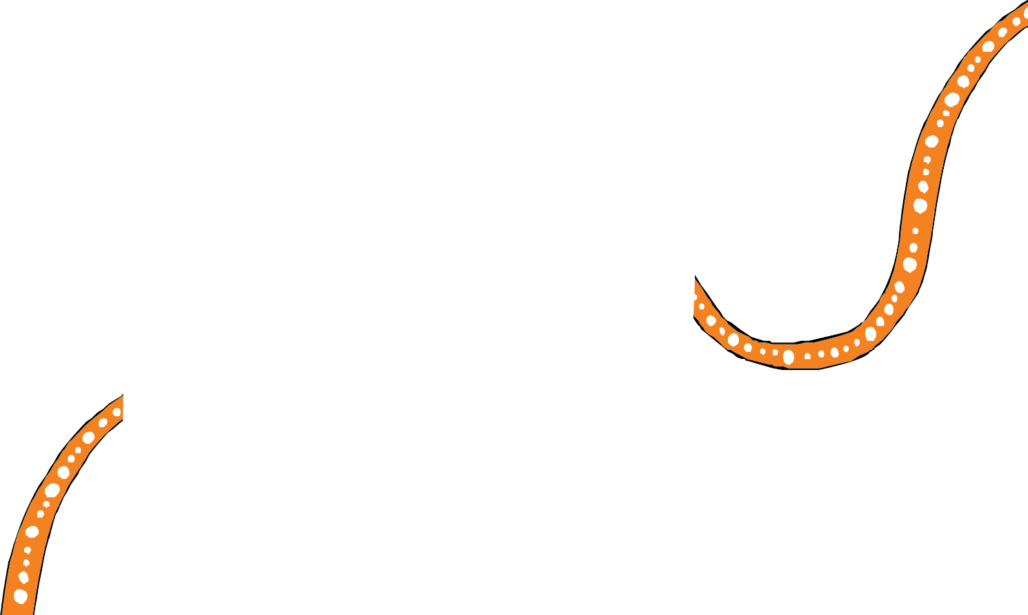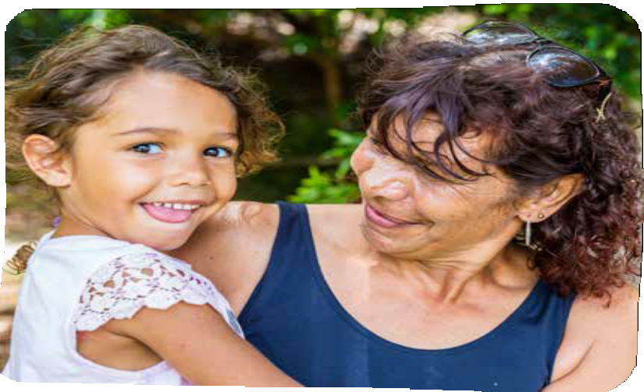

                      

Our Way is also aligned to the goals of initiatives at a national level, including:

* Family Matters Campaign at both national and state level
* National Agreement on Closing the Gap between the Australian governments and the Coalition of Aboriginal and Torres Strait Islander Peak Organisations
* Council of Australian Governments Closing the Gap in Indigenous Disadvantage
* *Third Three Year Action Plan, 2015-18: Driving Change: Intervening Early National Framework for Protecting Australia’s Children 2009-2020*
* *National Plan to Reduce Violence Against Women and their Children 2010–2022*
* *National Aboriginal and Torres Strait Islander Education Strategy 2015*
* *Belonging, Being and Becoming: The Early Years Learning Framework for Australia*
* *Australia’s Disability Strategy 2021-2031*
* National Disability Insurance Scheme20
  + *Aboriginal and Torres Strait Islander Engagement Strategy*
  + *Rural and Remote Strategy 2016-2019*
* *Shifting the Focus – Supporting a comprehensive whole of governments approach to suicide prevention*
* *The National Children’s Mental Health and Wellbeing Strategy*
* *National Strategy to Prevent and Respond to Child Sexual Abuse 2021-2030*.

11

## Achievements for Changing Tracks in 2020-2021



**2 Progress in 2020-2021**

### Building block 1: All families enjoy access to quality, culturally safe universal and targeted services necessary for Aboriginal and Torres Strait Islander children to thrive

**Highlights**



Building block 1 relates to access to **quality and culturally safe, universal and targeted services** necessary for Aboriginal and Torres Strait Islander children to thrive. Aboriginal and Torres Strait Islander families experience significantly higher levels of poverty and disadvantage than non-Indigenous families. **Early investment in strengthening families** provides long-term social and economic benefits by interrupting trajectories that lead to health problems, criminalisation, and child protection intervention.21

* + - * DCYJMA funded 31 Indigenous youth and family workers attached to community controlled Aboriginal and Torres Strait Islander Family Wellbeing Services (FWS) in 17 high need locations to address both youth and family risk factors associated with offending.
      * An evaluation of the FWS program has found almost all (93%) of children and families who participated in FWS and had a case closed with all or majority of their needs met, required no further investigation by child protection within six months.
      * The Department of Education continues to roll out the Be Well Learn Well initiative in partnership with Gidgee Healing, and the Apunapima Cape York Health Council, across eight remote communities, to identify and address behavioural and learning issues of Aboriginal and Torres Strait Islander children and to improve educational outcomes for this cohort.
      * The Department of Employment, Small Business and Training (DESBT) through the Skilling Queenslanders for Work initiative has supported 11,418 Aboriginal and Torres Strait Islander peoples to actively upskill as they seek work.22 Almost one fifth (19%) of state-wide participants are Aboriginal and Torres Strait Islander community members.
      * 17,498 students from Aboriginal and Torres Strait Islander communities accessed subsidised upskilling and training opportunities through vocational education and training (VET) programs.
      * The DSDSATSIP continues to implement targeted programs to support Aboriginal and Torres Strait Islander health and wellbeing, build youth resilience and prevent youth suicide.

12



13

                      

* The DCHDE continues to develop a culturally responsive pathway planning initiative to address the housing and wellbeing needs of Aboriginal and Torres Strait Islander communities. The initiative is underpinned by co-design and person-centred design

principles and will ensure community can access the products and integrated services they need when they need them.

* The Queensland Housing and Homelessness Action Plan 2021-25 was launched in June 2021. This is the second stage in implementing the Queensland Housing Strategy 2017- 2027 and will build on the work already delivered under the Aboriginal and Torres Strait Islander Action Plan 2019-2023.
* The Aboriginal and Torres Strait Islander Housing Action Plan 2019-2023 was launched in 2019. The plan sets out actions to develop and deliver improved housing responses for First Nations Queenslanders through place-based and person-centred solutions supported by a strengthened housing sector.

### Building block 2: Aboriginal and Torres Strait Islander peoples and organisations participate in and have control over decisions that affect their children

Building block 2 focuses on **self-determination** of Aboriginal and Torres Strait Islander peoples and organisations. Self-determination is

an essential pre-requisite for improving safety and well-being outcomes for Aboriginal and Torres Strait Islander children and young people, their families and communities. It is fundamental at all points of contact with the child and family welfare system.23

## Highlights

* The DCYJMA has implemented delegated authority in two locations, Rockhampton and the Sunshine Coast, to enable the transfer of powers and functions of the Chief Executives, for an Aboriginal and or Torres Strait Islander child, to an Indigenous Chief Executive of an Aboriginal and/or Torres Strait Islander entity.
* DCYJMA continues to implement and embed Aboriginal and Torres Strait Islander family led decision making to enhance Aboriginal and Torres Strait Islander self-determination and ensure that Aboriginal and Torres Strait Islander children and families are involved in all decisions across the child protection system that affect them, as well as trialled youth justice family led decision making with four community services across Queensland.
* The DSDSATSIP is working with an inter-departmental committee and community to develop the first action plan of the *Local Thriving Community (LTC)* Implementation Plan to ensure government and community are prepared for engaging in local decision making.



14

                      

* DCHDE is leading the development of a youth homelessness policy and integrated framework of housing, with support from Aboriginal and Torres Strait Islander community members and organisations, including Brisbane Youth Service, Queensland Youth Housing Coalition and Aboriginal and Torres Strait Islander Community Health Services Brisbane. This will be informed by the *Local Thriving Community* framework.
* The DoE is piloting across 13 schools, the *Local Community Engagement Through Co-design* model which aims to improve educational outcomes for Aboriginal students and Torres Strait Islander students.

### Building block 3: Law, policy and practice in child and family welfare are culturally safe and responsive



Building block 3 relates to **law, policy and practice**. State, territory and federal governments have responsibilities to transform services for Aboriginal and Torres Strait Islander families to **create a culturally safe and competent service system**.24

## Highlights

* + - * The DCYJMA has funded 33 Aboriginal and Torres Strait Islander people to undertake the Associate Diploma of Human Services qualification through Griffith University, under the Queensland Aboriginal and Torres Strait Islander Child Protection Peak (QATSICPP),

Professional Scholarships Program. Of these, five recipients completed their qualifications, and 28 other recipients have continued with their studies.

* + - * DCYJMA engaged QATSICPP to co-design the development of a new Aboriginal and Torres Strait Islander kinship care model, *Family Caring for Family*, to maximise placement of Aboriginal and Torres Strait Islander children in out of home care with family and kin, connected to community and culture.
      * The Healing Foundation delivered the Queensland Aboriginal and Torres Strait Islander Healing Strategy, Leading Healing Our Way (2020-2040), to address the intergenerational impacts of trauma, violence and abuse experienced by Aboriginal and Torres Strait Islander children and families.
      * DSDSATSIP continues to lead government’s commitment to reframe the relationship with Aboriginal and Torres Strait Islander peoples and communities through the LTC and Path to Treaty initiatives.
      * On 1 July 2021, the Queensland Government enacted the Meriba Omasker Kaziw Kazipa Act 2020 (Torres Strait Islander Traditional Child Rearing Practice). The Act recognises traditional child rearing practices legally and establishes an Office of the Commissioner Meriba Omasker Kaziw Kazipa.
      * The Queensland Registry of Births, Deaths and Marriages has led extensive community engagement enabling the development of community-based responses and practical methods of implementing local strategies to increase the uptake of Aboriginal and Torres Strait Islander birth registrations for children aged 0-10 as part of the ‘Closing the Registration Gap – Our Kids Count’ program.

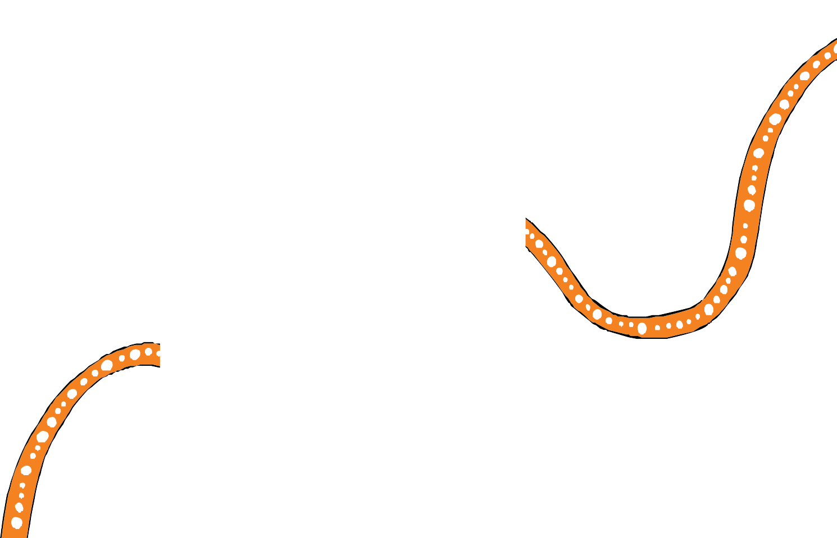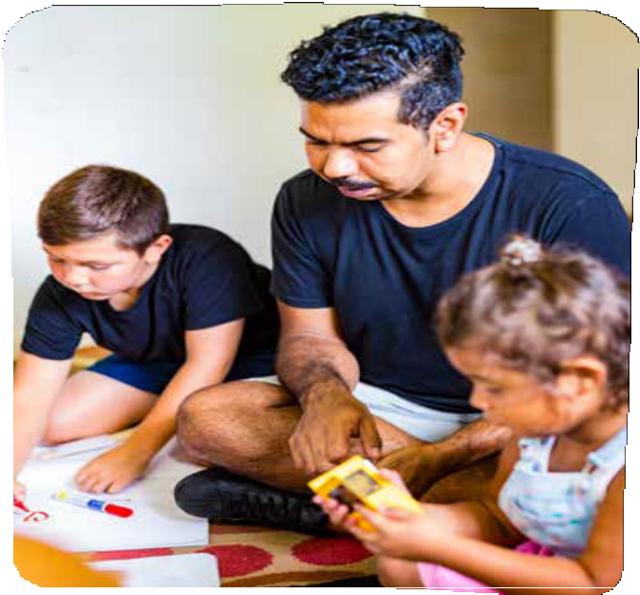

                      

### Building block 4: Government and community services are accountable to Aboriginal and Torres Strait Islander peoples

Building block 4 relates to accountability. The persistent, escalating rate of removal of Aboriginal and Torres Strait Islander children into out-of-home care is a concern across the state and the nation that requires a clear and concerted national response 25

## Highlights

* The Queensland First Children and Families Board (QFCFB) continues to oversee the implementation of the Our Way strategy and supporting action plans.
* QATSICPP established the Centre of Excellence, with support from DCYJMA. The Centre is partnering with universities and experts to build a robust and rigorous evaluation and research methodology including peer review processes.
* The DCYJMA engaged Deloitte Access Economics Pty Ltd, Murawin Pty Ltd and the Social Research Centre to undertake an evaluation to measure the impact and outcomes achieved under the Our Way strategy and Changing Tracks action plans.
* Queensland Government supported the establishment of an independent national Aboriginal and Torres Strait Islander Children’s Commissioner.

15

## Looking forward



**3 Next steps**

### Next steps for Changing Tracks

The Changing Tracks implementation phase of the Our Way strategy will wind-up in 2022. During 2021-2022 we will continue the Our Way journey towards a Queensland where all Aboriginal

and Torres Strait Islander children and young people grow up safe, loved and cared for in family, community and culture.

Our Way partners will continue the implementation of the remaining Changing Tracks 2020-2022 actions to set the foundations for transformational change. Appendix A provides full details of each of the actions and current status.

### Next steps for Our Way

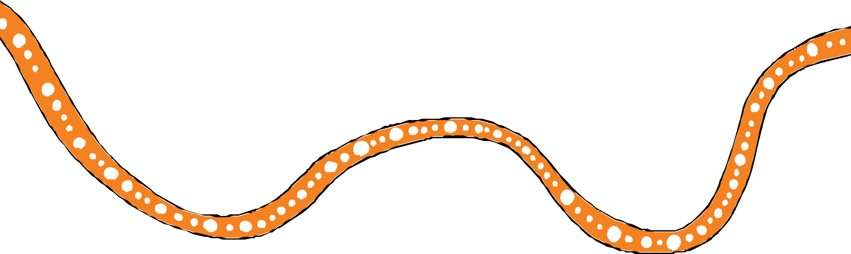Throughout 2022, the Queensland Government will partner with Family Matters Queensland, the Aboriginal and Torres Strait Islander community, government and non-government partners to co-design *Breaking Cycles 2023-2025 action plan* and supporting actions.

16

This appendix summarises key outcomes of actions delivered under the second Changing Tracks action plan (2020–2022) between July 2020 and June 2021.

**Appendices**

**Appendix A**

**Key achievements from Changing Tracks action plan 2020–22**

Five actions are complete under Changing Tracks 2020-2022 and the remaining 19 actions are being implemented or progressing as expected, and system changes are emerging as a result.

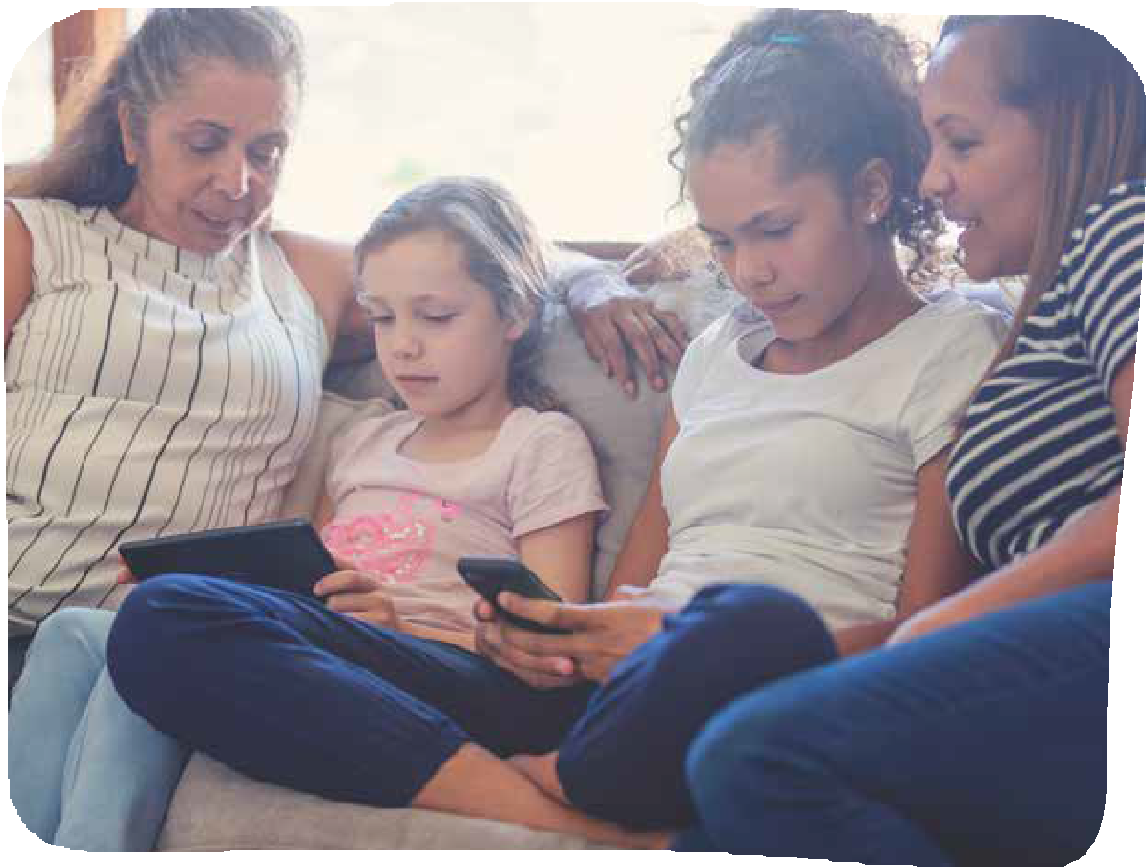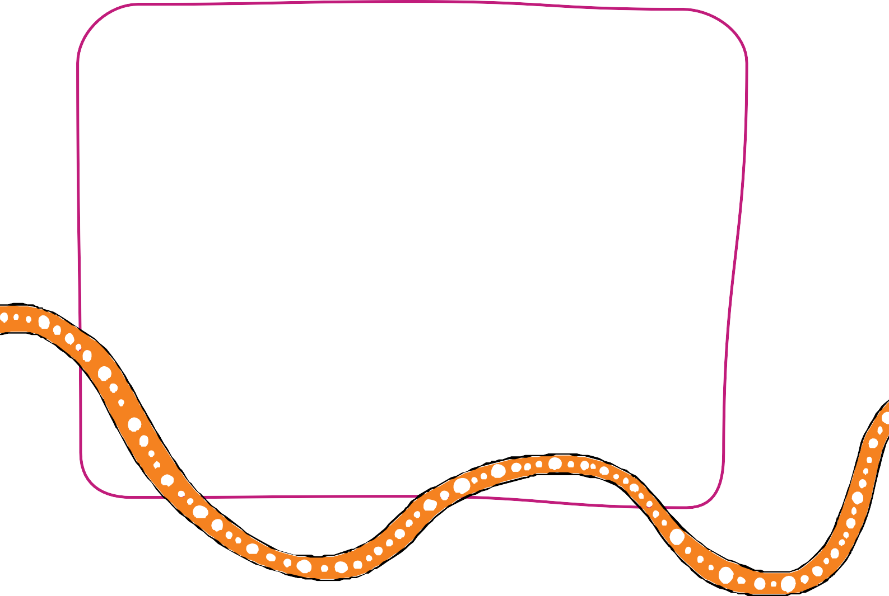

17

**Appendix A Key achievements from Changing Tracks action plan 2020–22**

### Building block 1:



18

**All families enjoy access to quality, culturally safe universal and targeted services necessary for Aboriginal and Torres Strait Islander children to thrive**

|  |  |  |  |
| --- | --- | --- | --- |
| **Action** | **Lead** | **Status** | **Evidence** |
| **1.1 Enhance community controlled Aboriginal and Torres Strait Islander Family Wellbeing Services, with a focus on youth justice and domestic and family violence.** | DCYJMA | On track | * DCYJMA funded 31 Indigenous youth and family workers attached to community controlled Aboriginal and Torres Strait Islander Family Wellbeing Services (FWS) in 17 high need locations to address both youth and family risk factors associated with offending. * Referrals to community controlled Aboriginal and Torres Strait Islander Family Wellbeing Services (FWS) increased by 3% in a 12-month period, with 4,597 referrals for the year. * Since it was established in 2016 (all services onboard by April 2018), FWS have delivered 823,364 service hours. Almost one third (29%) of these hours were delivered this year. * Government provided an additional $2.7m in funding to FWS to meet increased demand associated with hardships resulting from COVID-19. * An evaluation of the FWS program, *Final Report Aboriginal and Torres Strait Islander Family Wellbeing Services Evaluation,* has found almost all (93%) of children and families who participated in FWS and had a case closed with all or majority of their needs met, required no further investigation by child protection within six months. |
| **1.2 To enhance the Be Well Learn Well program being delivered in eight remote communities that have a high level of developmental vulnerability among Aboriginal and Torres Strait Islander children to ensure current and future generations of Aboriginal and Torres Strait**  **Islander children in Queensland will be able**  **to listen, learn and reach their full potential** | DoE | On track | * Allied health professionals continued to deliver the *Be Well Learn Well* program in the eight remote communities the program supports. Government is negotiating a contract extension and the addition of an audiologist to ensure the program continues to support community needs beyond   January 2022. |

**Appendix A Key achievements from Changing Tracks action plan 2020–22**

19

#### Building block 1

|  |  |  |  |
| --- | --- | --- | --- |
| **Action** | **Lead** | **Status** | **Evidence** |
| **1.3 Increase the participation of unemployed Aboriginal and Torres Strait Islander parents and young people exiting long term care in skills development and vocational education and training under the Skills for Queensland – Great training for quality jobs strategy.** | DESBT | On track | * Skilling Queenslanders for Work has supported 11,418 Aboriginal and Torres Strait Islander people to actively upskill as they seek work.26 Almost one fifth (19%) of state-wide participants are Aboriginal and Torres Strait Islander community members. * 17,498 students from Aboriginal and Torres Strait Islander communities accessed subsidised upskilling and training opportunities through vocational education and training (VET) programs. * Work is underway to secure $5m in funding for a First Nations Training Strategy under the Queensland Government’s Future Skills Fund. |
| **1.4 In planning for mental health, alcohol and other drug treatment services consider culturally safe responses to meet the needs of Aboriginal and Torres Strait Islander people, families and communities** | QH | On track | * The Hospital and Health Boards Regulation 2012 and recently published *Making Tracks Together: Health equity framework.*This work has been informed by the *Hospital and Health Boards Act 2011*. * Queensland Health is developing a new five-year plan specifically for mental health alcohol and other drug state-funded services to respond to the needs of individuals and their families who require treatment and care. |
| **1.5 Develop an Aboriginal and Torres Strait Islander mental health and wellbeing program and deliver youth resilience and suicide prevention projects.** | DSDSATSIP | On track | * The Institute for Urban Indigenous Health (IUIH) Early Childhood Wellbeing project has integrated early learning and health improving activities in Caboolture. * ‘Deadly Brains’ has been approved for Woorabinda State School; a service agreement has been executed and the first instalment payment has been made. The brain health and fitness program was developed with community and will be available to all school students. * Emotional Regulation and Impulsive Control Training (ERICT) was provided to mental health professionals from Mornington Island, Doomadgee and Yarrabah. |

**Appendix A Key achievements from Changing Tracks action plan 2020–22**

**Building block 1**

20

|  |  |  |  |
| --- | --- | --- | --- |
| **Action** | **Lead** | **Status** | **Evidence** |
| **1.6 Implement culturally responsive pathway planning and case coordination to connect people to the support they need to improve their housing and wellbeing outcomes.** | DCHDE | On track | * A culturally responsive pathway planning initiative is being developed to understand and define housing and wellbeing needs of Aboriginal and Torres Strait Islander customers. The initiative is underpinned by co-design and person-centred design principles and will ensure customers can make choices and access the products and integrated services they need when they need them. * This is the second stage in implementing the Queensland Housing Strategy 2017-2027. * Some actions comprising the Queensland Housing and Homelessness Action Plan 2021-25 have commenced. This includes the launch of the Queensland Housing Investment Growth Initiative. * The Queensland Housing and Homelessness Action Plan 2021-25 contains actions committing to:   + better integration service delivery across government and community services, including through joint assessment, pathway planning, referral protocols and information sharing;   + develop a formalised service delivery framework between state government agencies to prevent people exiting government services into homelessness; and   + deliver integrated health and housing responses. |

**Appendix A Key achievements from Changing Tracks action plan 2020–22**

21

**Building block 1**

|  |  |  |  |
| --- | --- | --- | --- |
| **Action** | **Lead** | **Status** | **Evidence** |
| **1.7 Deliver an Aboriginal and Torres Strait Islander specific place-based trial to address youth sexual violence and abuse as part of the Government’s priority actions to address this issue** | DCYJMA | Minor Delays | * The projects are being implemented using a staged approach. Work on two projects (Toowoomba and Bundaberg) commenced in October 2020, and work on the third project (Yarrabah) commenced in 2021. COVID-19 significantly impacted on aspects of this work in 2020. * Community co-design workshops were conducted in Bundaberg and Toowoomba with young people, parents/caregivers and sector between March to July 2021. Awakening Cultural Ways facilitated culturally specific co-design sessions with Aboriginal and Torres Strait Islander young people, Elders, community members and stakeholders in both locations. * There has been strong community engagement. In Bundaberg, 258 people contributed ideas about local prevention strategies, including 77 young people. In Toowoomba, 302 people participated in co-design, including 102 young people. Both locations identified the need to implement comprehensive whole-of-community prevention strategies. There is also strong support for a youth-led approach in both locations. * For the Toowoomba and Bundaberg projects, Community Action Plans are currently being prepared for community endorsement (due end February 2021). Community workshops were held in both locations in December 2021 to showcase community ideas and provide input into the draft Action Plans. * The Yarrabah Positive and Respectful Relationships Project involves a partnership between the Department of Justice and Attorney-General and the Department of Seniors, Disability Services and Aboriginal and Torres Strait Islander Partnerships (DSDSATSIP). The project provides an   excellent opportunity to pilot news ways of working under the Local Thriving Communities (LTC) reforms.   * A DSDSATSIP Principal Project Officer was recruited in June 2021. Local community stakeholders were involved with the selection and interview process. The Officer is well placed to support local community engagement, implementation and capacity building. * A community planning workshop was hosted in October 2021 to work with community stakeholders on the project plan, governance arrangements and the preferred co-design approach. The project team are currently preparing the project plan and co-design model for community endorsement. |

**Appendix A Key achievements from Changing Tracks action plan 2020–22**

**Building block 1**

22

|  |  |  |  |
| --- | --- | --- | --- |
| **Action** | **Lead** | **Status** | **Evidence** |
| **1.8 Implement culturally responsive and developmentally appropriate literacy and numeracy training options for young people through Vocational Training Queensland** | DoE | On track | * Vocational Training Queensland (VTQ) is delivering literacy and numeracy qualifications and support programs in partnership with 66 programs statewide, including in rural, remote and discrete Aboriginal and Torres Strait Islander communities. * Developed under a successful two-year project pilot funded by the Department of Education, VTQ is now transitioning to business as usual, and four levels of Certificates in General Education for Adults (CGEA) and prevocational literacy and numeracy programs will be available to communities across Queensland. |

**Appendix A Key achievements from Changing Tracks action plan 2020–22**

23

**Building block 2:**

**Aboriginal and Torres Strait Islander peoples and organisations participate in and have control over decisions that affect their children**

|  |  |  |  |
| --- | --- | --- | --- |
| **Action** | **Lead** | **Status** | **Evidence** |
| **2.1 Implement delegated authority to permit one or more of the chief executive’s functions or powers under the *Child Protection Act 1999* in relation to an Aboriginal or Torres Strait Islander child to be delegated to the chief executive officer of an Aboriginal or Torres Strait Islander entity to authorise the CEO to make decisions for the child in relation to**  **those matters.** | DCYJMA/ QATSICPP | On track | * The Director-General approved 22 instruments of delegated authority. With the delegated decision making sitting with an Aboriginal and / or Torres Strait Islander Chief Executive Officer 8 children were supported to reunify with family. The remaining 14 children are in the process of being reunified or connected with family, culture, country and community. * The Department of Children, Youth Justice and Multicultural Affairs (CYJMA) has partnered with Queensland Aboriginal and Torres Strait Islander   Child Protection Peak (QATSICPP) to develop a blueprint for the state- wide implementation of delegated authority. The blueprint will leverage  implementation lessons from Central Queensland & Sunshine Coast region, action research led by QATSICPP, sector readiness work, and the experiences of other jurisdictions in implementing delegated authority. |
| **2.2 Embed the Aboriginal and Torres Strait Islander family-led decision-making model across the child protection continuum to ensure culturally safe responses to child protection matters.** | DCYJMA | Completed | * The Aboriginal and Torres Strait Islander family led decision making model has been implemented and Child Safety is continuing to embed and consolidate practice in relation to Aboriginal and Torres Strait Islander family-led decision- making. * The Family Participation Program received over 3,300 referrals, with 390 of them being self-referrals from Aboriginal and Torres Strait Islander families. |
| **2.3 Pilot youth justice Aboriginal and Torres Strait Islander Family-Led Decision-Making processes in four locations to increase cultural authority in identifying and responding to the needs of Aboriginal and Torres Strait Islander young people in the youth justice system.** | DCYJMA | On track | * Youth Justice family led decision making continues to be implemented in four communities. Services are being delivered by Goolburri Aboriginal Health Advancement, Kurbingui Youth and Family Development, Aboriginal and Torres Strait Islander Community Health Service in Brisbane, and Wuchopperan Health Service. |

**Appendix A Key achievements from Changing Tracks action plan 2020–22**

**Building block 2**

24

|  |  |  |  |
| --- | --- | --- | --- |
| **Action** | **Lead** | **Status** | **Evidence** |
| **2.4 Implement the Local Thriving Communities framework to create the enabling and authorising environment that supports communities, including young people, to make decisions about their own future.** | All agencies | Minor delays | * DCHDE is developing a youth homelessness policy and integrated framework of housing with support with Aboriginal and Torres Strait Islander community members and organisations, including Brisbane Youth Service, Queensland Youth Housing Coalition and Aboriginal and Torres Strait Islander Community Health Services Brisbane. This will be informed by the *Local Thriving Community* framework. * DSDSATSIP has been working with local community organisations to lead community engagement that will identify local housing priorities and issues. * All communities have been funded to progress discussions on local decision- making and are progressing along the Pathway to Local Decision Making. * Local housing plans (LHPs) are being delivered in remote and discrete communities as part of the *Local Thriving Community* reform. * Aboriginal and Torres Strait Islander local government authorities are establishing relationships with Council to document LHPs. This includes determining appropriate activities to engage relevant community organisations and members. * DSDSATSIP is facilitating whole-of-government engagement with community leadership groups on emerging initiatives to enhance mental health and wellbeing outcomes for communities. * *LTC* leadership models are emerging, with models implemented (or being implemented) in Yarrabah, Woorabinda, Kowanyama, Coen, Mapoon, and Napranum. Advisory Committees to Council have been formed through a community Expression of Interest process and comprise representatives from council and community. They will guide decision-making on *LTC* reform. * In Aurukun, the ‘Wik Thonam’ (Wik One Voice) leadership group has been established to represent and progress community priorities through *LTC* implementation. |

**Appendix A Key achievements from Changing Tracks action plan 2020–22**

25

**Building block 3:**



**Law, policy and practice in child and family welfare are culturally safe and responsive**

|  |  |  |  |
| --- | --- | --- | --- |
| **Action** | **Lead** | **Status** | **Evidence** |
| **3.1 Apply the Wellbeing Outcomes Framework to inform government investment and the development and evaluation of policies, programs and services for Aboriginal**  **and Torres Strait Islander children and**  **young people** | DCYJMA | Minor delays | * While the Wellbeing Outcomes Framework has been used broadly to inform the Evaluation of Our Way Changing Tracks and is occasionally referenced/ linked to other key work across the department, more work is required to ensure that it informs key work such as the DCYJMA commissioning   reform work. |
| **3.2 Implement the Queensland Aboriginal and Torres Strait Islander Child Protection Peak Professional Scholarships Program to improve the quality of family services**  **provided by community-controlled services** | DCYJMA/ QATSICPP | Completed | * Five recipients of scholarships through the Queensland Aboriginal and Torres Strait Islander Child Protection Peak Professional Scholarships Program completed their qualifications, and 28 other recipients have continued with their studies. * QATSICPP has continued to work closely with Griffith University to ensure their educational offerings are relevant and accessible for workers in the family support sector. |
| **3.3 Embed active efforts to implement and give full effect to all five elements of the Aboriginal and Torres Strait Islander Child Placement Principle across the five system elements of the family support system (legislation, policy, programs, processes and practice.)** | All agencies | On track | * DCYJMA continues to embed active efforts in the application of the Aboriginal and Torres Strait Islander child placement principle through:   + updates to policies procedures and practice guidance in the Child Safety Practice Manual to strengthen implementation of active efforts when working with Aboriginal and Torres Strait Islander children, families and partners;   + development of a case reflection tool to strengthen the safe care and connection and permanency for Aboriginal and Torres Strait Islander children integrating the Aboriginal and Torres Strait Islander Placement Principle and active efforts with the three dimensions of permanency: relational, physical and legal.   + DCYJMA and QATSICPP online statewide presentation on to Child Safety staff on the Aboriginal and Torres Strait Islander Child Placement Principle and active efforts. The presentation is now available to all departmental   staff as a podcast; and |

**Appendix A Key achievements from Changing Tracks action plan 2020–22**

**Building block 3**

26

|  |  |  |  |
| --- | --- | --- | --- |
| **Action** | **Lead** | **Status** | **Evidence** |
|  |  |  | – DCYJMA significant procurement processes for Social Services include consideration of this principle.   * DCYJMA continues to ensure culture remains central to the design, development and implementation of its new case management system, Unify. Unify supports a practice change that enables active effort in the application of the Aboriginal and Torres Strait Islander child placement principle across the unify system. |
| * 1. **Partner with QATSICPP to develop and implement an Aboriginal and Torres Strait Islander Kinship program, inclusive of relevant services, that:**      + **connect children in care with kin and culture.**      + **enable and support kin to care for children to prevent ongoing statutory intervention.**      + **enable children who require ongoing statutory intervention to be cared for by kin wherever possible and safe to do so.** | DCYJMA | On track | * DCYJMA engaged QATSICPP over two years to co-design the development of the Family Caring for Family Aboriginal and Torres Strait Islander kinship care program. * DCYJMA commenced a project to redesign the family-based care investment specifications to separate kinship care and foster carer service types and the related service activities. * The *Finding Kin Outcome-Based Payment* initiative has been implemented. The initiative is currently being reviewed to explore more efficient procurement options and potentially increase future referral priority cohorts beyond the non-family-based sector. * As of 30 June 2021, approximately 17 Aboriginal and Torres Strait islander young people have transferred from residential care to being placed with family. |

**Appendix A Key achievements from Changing Tracks action plan 2020–22**

27

**Building block 3**

|  |  |  |  |
| --- | --- | --- | --- |
| **Action** | **Lead** | **Status** | **Evidence** |
| **3.5 Co-design and implement a Queensland Aboriginal and Torres Strait Islander healing strategy to address the impact of intergenerational trauma, grief and loss, violence and abuse.** | DCYJMA | On track | * The Healing Foundation delivered the Queensland Aboriginal and Torres Strait Islander Healing Strategy, Leading Healing Our Way (2020-2040), the accompanying Leading Healing Our Way A3 schematic, and ‘Keeping Spirit Strong’, the Research and Co-design Report, Keeping Spirit Strong. * As part of the development of Path to Treaty, the (then) Department of Aboriginal and Torres Strait Islander Partnerships convened an Eminent Panel of high profile Aboriginal and Torres Strait Islander and Non-Indigenous Queenslanders to provide advice to the government on what a Treaty might mean for Queensland including timing, process and next steps. In their final report, released in August 2020, the Eminent Panel recommended a key priority focus on Truth Telling and Healing. * The Queensland Government has accepted, in principle, the recommendation from the Eminent Panel and specifically identified the Healing Strategy as informing the development of a whole of government implementation plan to respond to the Truth Telling and Healing priority area. * The implementation of the Path to Treaty is overseen by a Treaty Advancement Committee who provides expert advice and guidance on options for implementation recommendations. * The Treaty Advancement Committee provided the Queensland Government with advice on implementing the Path to Treaty. This will inform the implementation of the Healing Strategy so that it supports Healing and Truth Telling in Queensland. |

**Appendix A Key achievements from Changing Tracks action plan 2020–22**

**Building block 3**

28

|  |  |  |  |
| --- | --- | --- | --- |
| **Action** | **Lead** | **Status** | **Evidence** |
| **3.6 Enact legislation providing legal recognition to Torres Strait Islander families’ traditional child rearing practice.** | DSDSATSIP | Completed | * The *Meriba Omasker Kaziw Kazipa (Torres Strait Islander Traditional Child Rearing Practice) Act 2020* came into force on 1 July 2021. The Act establishes an Office of the Commissioner Meriba Omasker Kaziw Kazipa who is a qualified Torres Strait Islander person with statutory powers to consider applications and make Cultural Recognition Orders. * Commissioner C’Zarke Maza was announced as the Inaugural Commissioner. |
| **3.7 Work with Aboriginal and Torres Strait Islander communities to increase the birth registration rate of children aged 0–10 years Birth.** | DJAG | On Track | * The Queensland Registry of Births, Deaths and Marriages (RBDM) is leading the Closing the Registration Gap – Our Kids Count program (the Program) that aims to increase the birth registration rate of Aboriginal and Torres Strait Islander children. * The program is responding to the Queensland Ombudsman report, ‘The Indigenous Birth Registration Report: An investigation into the under- registration of Indigenous births in Queensland’ (the Report), that was tabled in 2018.The Closing the Registration Gap Strategy and Action Plan was launched on 8 April 2021. Nine government agencies are contributing to implementation of the three-year cross agency strategy and action plan. * Extensive community engagement enabled the development of community- based responses and practical methods of implementing local strategies. This engagement took place in Cherbourg, Woorabinda, Mossman, Yarrabah and Thursday Island. Due to the successes, further community engagement activities are planned in the future, with a continual emphasis on stakeholder feedback and input. |

**Appendix A Key achievements from Changing Tracks action plan 2020–22**

29

**Building block 4:**

**Government and community services are accountable to Aboriginal and Torres Strait Islander peoples**

|  |  |  |  |
| --- | --- | --- | --- |
| **Action** | **Lead** | **Status** | **Evidence** |
| **4.1 Continue to support the Queensland First Children and Families Board (QFCFB).** | DCYJMA | On track | * DCYJMA continues to support the QFCFB, particularly in terms of supporting Board members and co-Chairs to complete their roles and ensure effective operation. |
| **4.2 Continue to explore options for the establishment of a centre of excellence to build the evidence base for what works for Aboriginal and Torres Strait Islander child and family reforms.** | DCYJMA/ QATSICPP | On track | * The Centre of Excellence was established by QATSICPP, with support from DCYJMA. Website content, structure and design are progressing and will be ready for public launch at the QATSICPP conference in early 2022. * The Centre of Excellence is partnering with Universities and Critical Friends to build a robust and rigorous evaluation and research methodology including peer review processes. |
| **4.3 Evaluate the Changing Tracks action plan 2017-2019 to measure the change (impact) in the lives of children and families as a result of the initiatives in Changing Tracks 2017-2019.** | DCYJMA/ QFCFB | On track | * The *Evaluation of Our Way: Changing Tracks* continues and will examine the impacts and outcomes achieved under the Our Way strategy, the findings of which will inform development of future action plans, and includes:   + establishing a baseline and examining early indicators of progress of the Our Way strategy to ascertain if the policy settings are beginning to shift to realise the long-term goals and vision of Our Way, due November 2021.   + a final outcomes evaluation of the Changing Tracks phase of Our Way, along with a revised evaluation framework and plan to inform future monitoring, reporting and evaluation priorities for Our Way, due June 2022. * During July 2020 and June 2021 extensive consultation has occurred with community, the Aboriginal and Torres Strait Islander community controlled sector and government. * Information collected aims to highlight the experiences and community perspectives of Aboriginal and Torres Strait Islander children, families and communities and how they are faring in key wellbeing domains. * Early feedback indicates that partners believe there has been an improved ‘focus on the child’, but further work is required to ‘strengthen shared power and responsibility’ amongst Our Way partners and improve accountability. |

**Appendix A Key achievements from Changing Tracks action plan 2020–22**

**Building block 4**

30

|  |  |  |  |
| --- | --- | --- | --- |
| **Action** | **Lead** | **Status** | **Evidence** |
|  |  |  | * Early findings identify some areas for improvement including:   + governance and shared responsibility for Our Way outcomes amongst partners;   + investment approaches to better understand demands on the sector and balance improving cultural safety of non-Indigenous service providers; and   + monitoring, reporting and evaluation of actions across the three implementation phases, that will enable the delivery of the Our Way vision. |
| **4.4 Develop annual progress reports to ensure that strategy and action plans are**  **responsive to the needs of the Queensland Government and community and reflect the**  **Family Matters partnership.** | DCYJMA/ QFCFB | Completed | * The Queensland First Children and Families Board provided their annual update via the Minister for Children to Queensland Government and the Premier. The report facilitates a feedback loop to community and partners supporting *Our Way* and its progress. |
| **4.5 Support Our Way partners in the call for a national Aboriginal and Torres Strait**  **Islander children’s strategy, overseen by an independent national Aboriginal and Torres Strait Islander Children’s Commissioner.** | DCYJMA | Completed | * The Minister for Children, Youth Justice and Multicultural Affairs confirmed the Queensland Government’s support for Family Matters’ call for a National Aboriginal and Torres Strait Islander children’s strategy overseen by an independent and autonomous National Aboriginal and Torres Strait Islander Children’s Commissioner. * The position would build upon the increasing recognition by state and territory governments of the importance and value of a commissioner dedicated specifically to ending intergenerational disadvantage and promoting better outcomes for Aboriginal and Torres Strait Islander children and young people now and in the future. * SNAICC continues to drive the campaign for establishment of a national commissioner, including the development of an options and position paper outlining how the role would provide oversight and accountability of governments’ child protection systems and services. |

**References**



1. Family Matters Queensland is led by SNAICC – National Voice for our Children and is supported by a Strategic Alliance of over 150 Aboriginal and Torres Strait Islander and non-Indigenous organisations, leading academics and prominent educational institutions.
2. [2020 Family Matters Report.](https://www.familymatters.org.au/publications/)
3. [2020 Family Matters Report.](https://www.familymatters.org.au/publications/)
4. [2020 Family Matters Report.](https://www.familymatters.org.au/publications/)
5. [2020 Family Matters Report.](https://www.familymatters.org.au/publications/)
6. Family Matters. (2020). [2020 Family Matters Report](https://www.familymatters.org.au/publications/).
7. SNAICC. (2021). SNAICC COVID-19 Ongoing Impacts Survey Report: January 2021.
8. SNAICC. (2021). SNAICC COVID-19 Ongoing Impacts Survey Report: January 2021.
9. SNAICC. (2021). SNAICC COVID-19 Ongoing Impacts Survey Report: January 2021.
10. SNAICC. (2021). SNAICC COVID-19 Ongoing Impacts Survey Report: January 2021.
11. SNAICC. (2021). SNAICC COVID-19 Ongoing Impacts Survey Report: January 2021.
12. SNAICC. (2021). SNAICC COVID-19 Ongoing Impacts Survey Report: January 2021.
13. Queensland Health. (2021). [Making Tracks Together: Health equity framework.](https://www.health.qld.gov.au/public-health/groups/atsihealth/making-tracks-together-queenslands-atsi-health-equity-framework)
14. Department of Children, Youth Justice and Multicultural Affairs. (2021). [Youth justice strategy](https://www.cyjma.qld.gov.au/youth-justice/reform/youth-justice-strategy).
15. Department of Education, Small Business and Training. (2021). [Skilling Queenslanders for Work.](https://desbt.qld.gov.au/training/training-careers/incentives/sqw)
16. Department of Seniors, Disability Services and Aboriginal and Torres Strait Islander Partnerships. (2021). [Closing the Gap](https://www.dsdsatsip.qld.gov.au/our-work/aboriginal-torres-strait-islander-partnerships/reconciliation-tracks-treaty/closing-gap#%3A~%3Atext%3DQueensland%27s%202021%20Closing%20the%20Gap%20Implementation%20Plan%26text%3DThese%20structural%20reforms%20include%3A%2CTreaty%20and%20Local%20Thriving%20Communities%26text%3Ddeveloping%20Queensland%27s%20Framework%20for%20Action%2CIslander%20Domestic%20and%20Family%20Violence).
17. Department of Seniors, Disability Services and Aboriginal and Torres Strait Islander Partenrships. (2021)
18. Department of Seniors, Disability Services and Aboriginal and Torres Strait Islander Partnerships. (2021). [About Path to Treaty](https://www.dsdsatsip.qld.gov.au/our-work/aboriginal-torres-strait-islander-partnerships/reconciliation-tracks-treaty/tracks-treaty/path-treaty/about-path-treaty).
19. Department of Justice and Attorney General. (2021). [Queensland’s Framework for Action – Reshaping our approach to Aboriginal and Torres Strait Islander Domestic and Family Violence.](https://www.justice.qld.gov.au/initiatives/end-domestic-family-violence/our-progress/enhancing-service-responses/reshaping-our-approach-aboriginal-torres-strait-islander-domestic-family-violence)
20. [Our Way: A generational strategy for Aboriginal and Torres Strait Islander children and families 2017–2037*.*](https://www.cyjma.qld.gov.au/resources/campaign/supporting-families/our-way.pdf)
21. Secretariat of National Aboriginal and Islander Child Care (SNAICC) – National Voice for our Children. (2017). The Family Matters Roadmap.
22. Data is a cumulative total spanning July 2015 to July 2021.
23. Secretariat of National Aboriginal and Islander Child Care (SNAICC) – National Voice for our Children. (2017). The Family Matters Roadmap.
24. Secretariat of National Aboriginal and Islander Child Care (SNAICC) – National Voice for our Children. (2017). The Family Matters Roadmap.
25. Secretariat of National Aboriginal and Islander Child Care (SNAICC) – National Voice for our Children. (2017). The Family Matters Roadmap.
26. Data is a cumulative total spanning July 2015 to July 2021.

31

32

**Story of the motif**

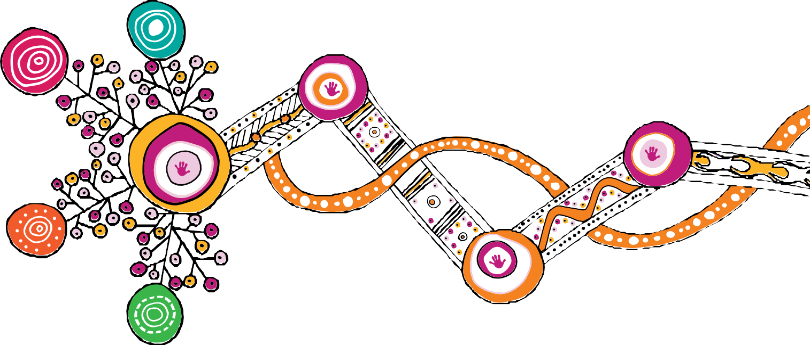

**The motif artwork was created by Rachael Sarra, an Indigenous artist and designer from creative agency Gilimbaa. Rachael originates from the Bunda People in Goreng Goreng country.**

**The motif design is a reflection of equal partners joining together in conversation and positive action. It represents a clear and focused pathway that began as the dispersed energy of many that has now fused to channel clarity, momentum, and strength. It shows the power of unity and simplicity that evolves from complexity. The artwork shows the journey of the child, depicted as the hands, connected to and supported by structures that nurture and guide.**

**Through the woven orange line it acknowledges culture, kin and the strength of learning from the past to act in the present and grow for the future.**

The text in this publication is licensed under a Creative Commons Attribution-NonCommercial-ShareAlike

4.0 International

The artwork in this publication is the property of the Queensland Government (Department of Child Safety, Youth and Women) and is licensed under a Creative Commons Attribution-NonCommercial-NoDerivatives

4.0 International

Visit <http://creativecommons.org.au/>for more information about Creative Commons licences.

© The State of Queensland (Department of Children, Youth Justice and Multicultural Affairs) 2022

Copyright protects this publication. Excerpts may be reproduced with acknowledgement of the State of Queensland (Department of Children, Youth Justice and Multicultural Affairs).

Department of Children, Youth Justice and Multicultural Affairs Locked Bag 3405, Brisbane QLD 4001

[www.cyjma.qld.gov.au](http://www.cyjma.qld.gov.au/)

0951_MAR2022

