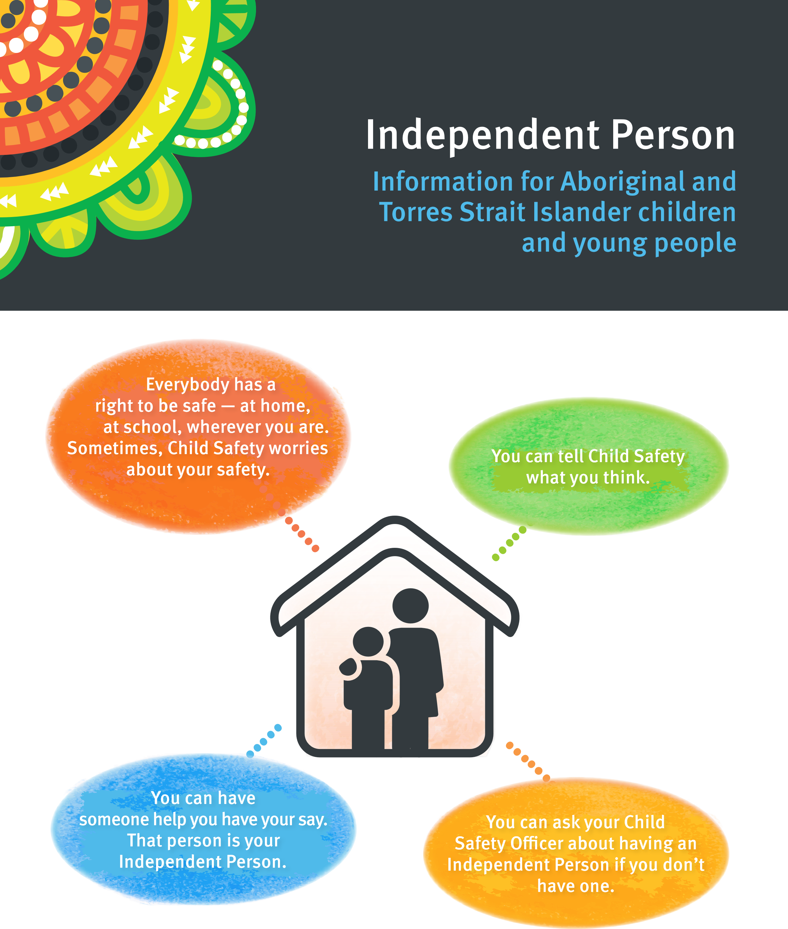
2018
OCT
0654
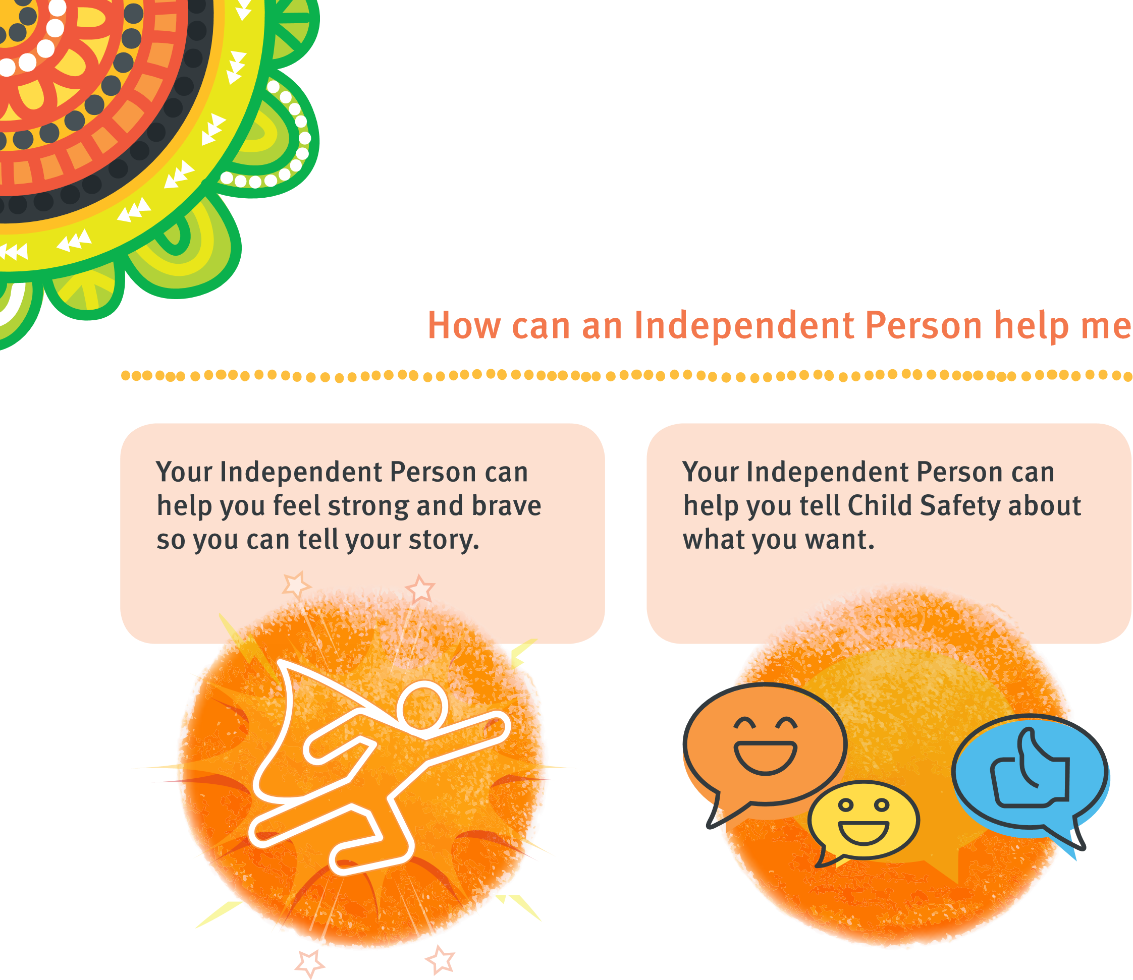
Who can be my Independent Person
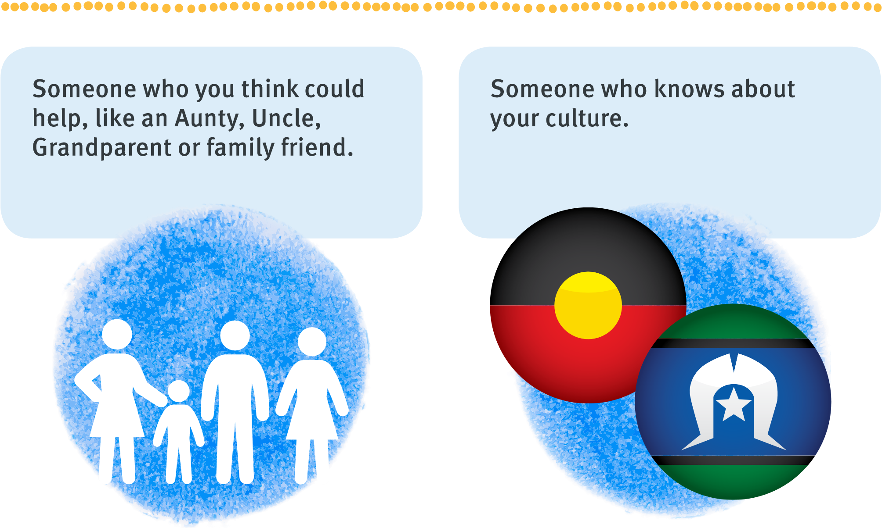
When can my Independent Person help me
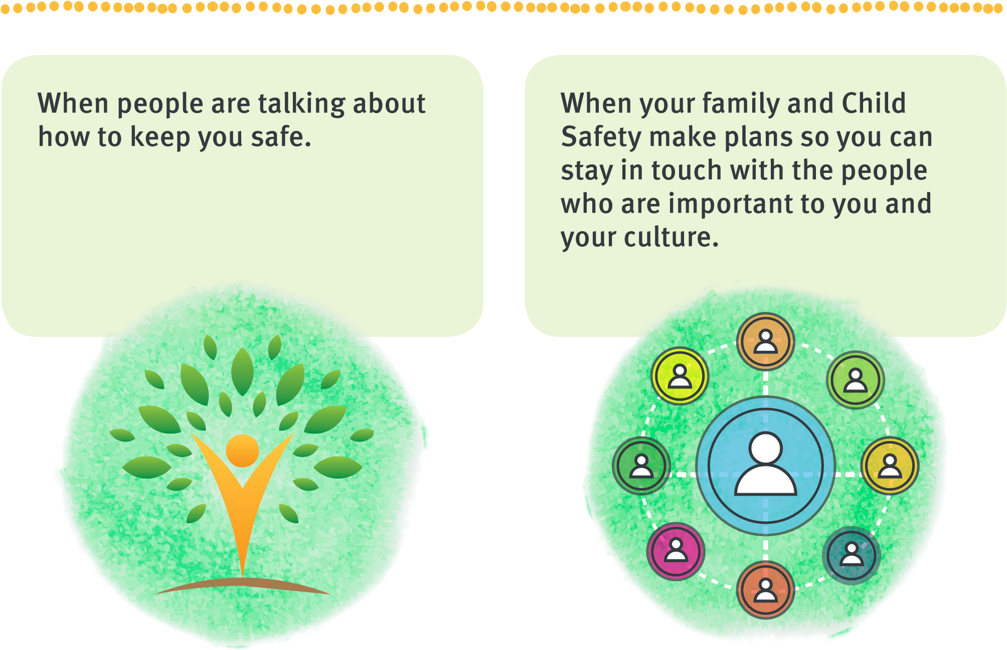
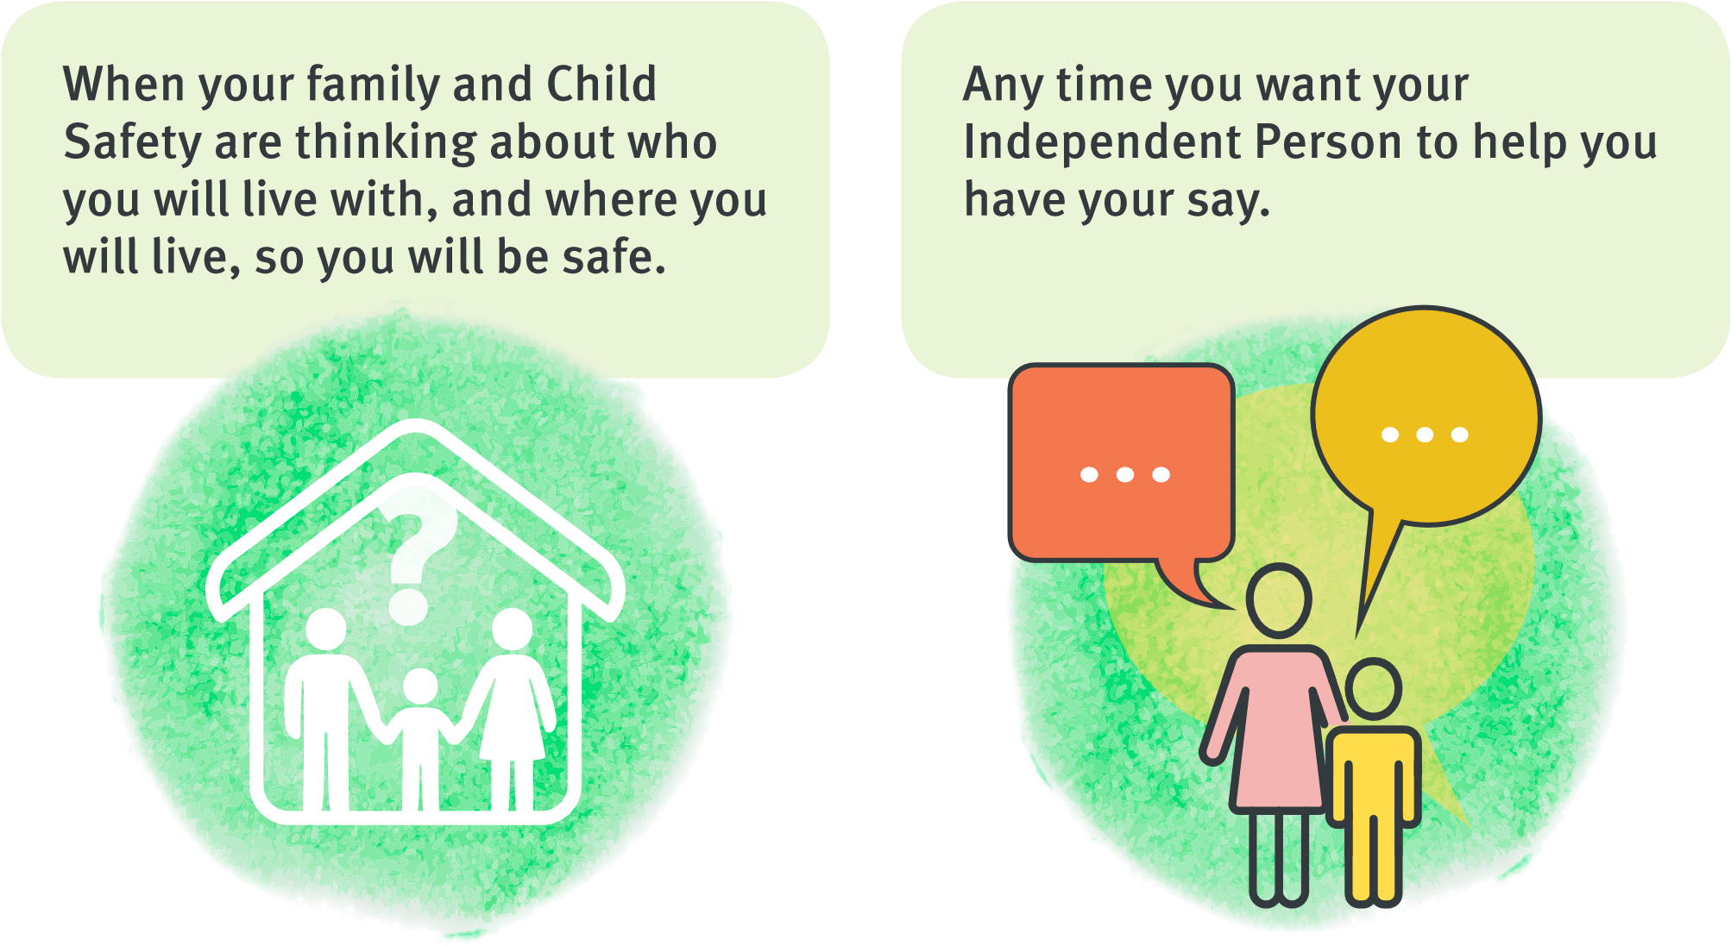
An Independent Person is:

- An Aboriginal or Torres Strait Islander person
- A person who knows you and your culture
- Someone you trust
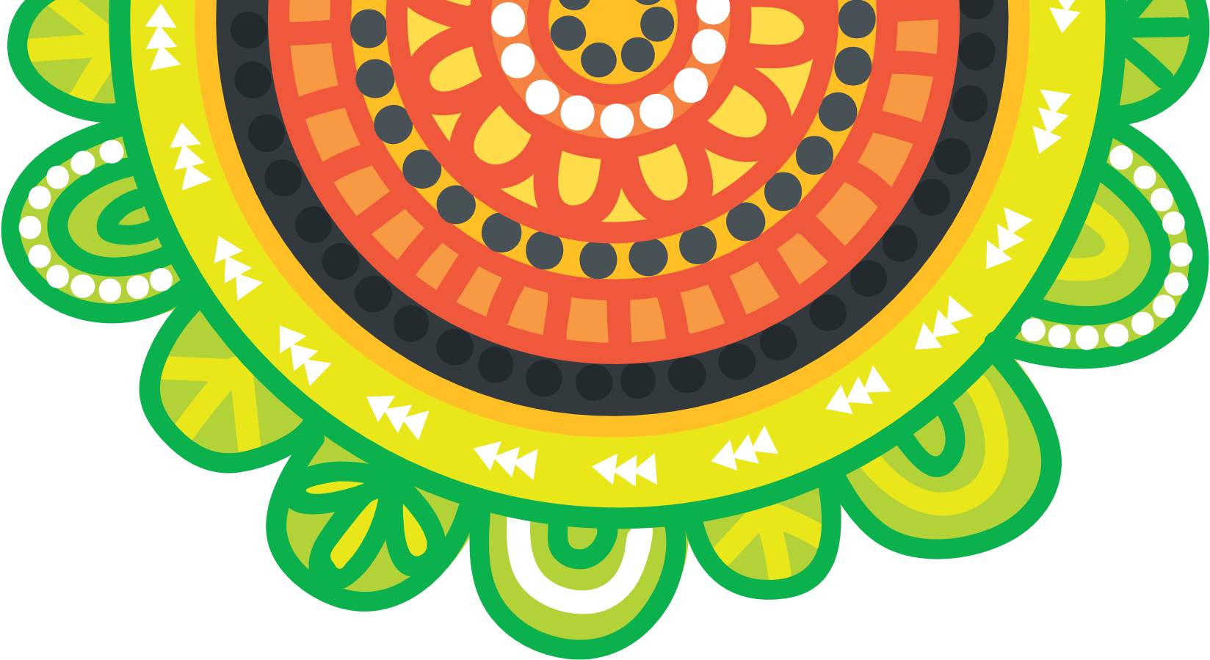
- A person who can help you say what you want
For more information:
- Talk to your Child Safety Officer
- Go to the website: www.qld.gov.au/independentperson
- Look at the information section of Kicbox

