

**Need help in your language?**

If you have difficulty understanding this publication or other funding documents and need language assistance, please call **1800 512 451** and ask for an interpreter.

**Funding Guidelines for Multicultural Events**



**Celebrating Multicultural Queensland Program**

Building an inclusive, harmonious and united Queensland

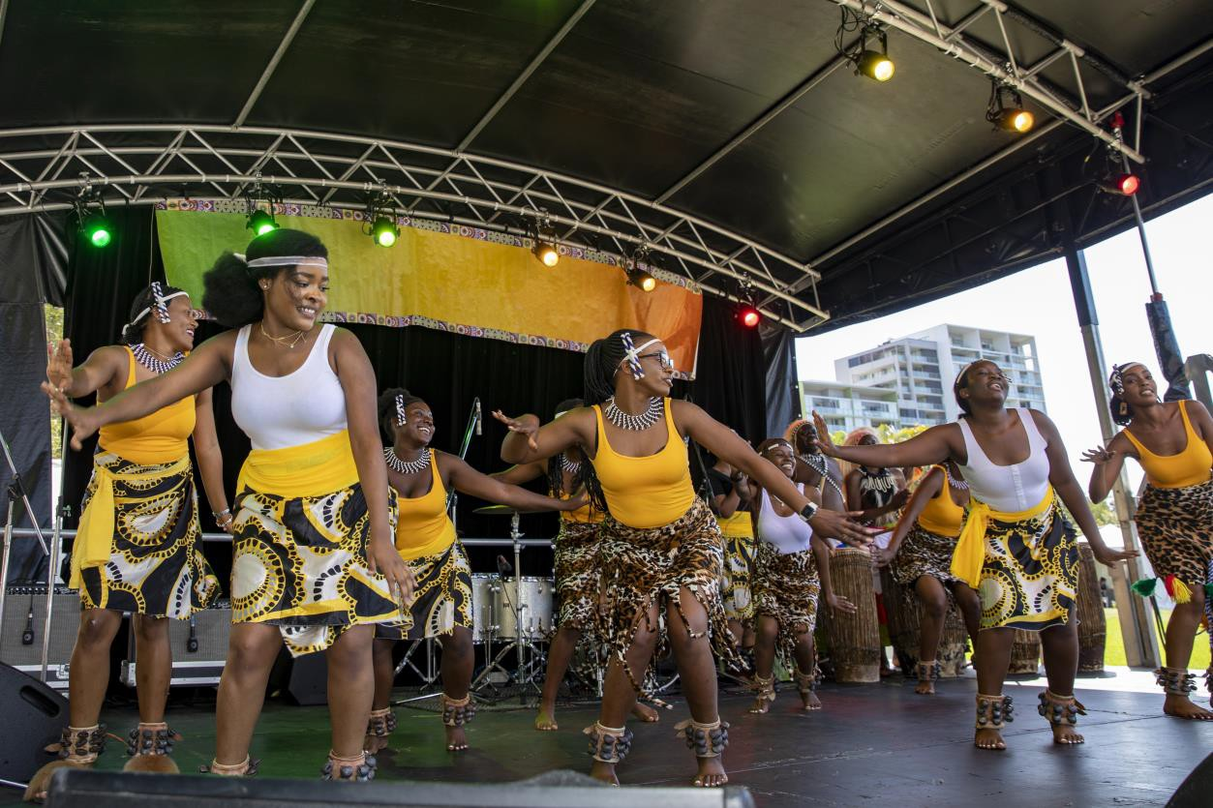

# Contents

1. Contents 2

2. Multicultural Queensland Charter 3

3. About the Celebrating Multicultural Queensland program 4

Program objectives 4

4. Who is eligible to apply? 4

5. Who is not eligible to apply? 5

6. Multicultural Events 5

What is considered an event? 5

Funding rounds 5

Funding purpose 6

Funding outcomes 6

Grant levels 6

7. Funding Criteria 6

Category One events – up to $10,000 (excluding GST) 6

Category Two events – up to $20,000 (excluding GST) 7

8. What applications will not be funded? 7

9. What can CMQ funding be used for? 8

10. What can’t CMQ funding be used for? 8

11. How to apply 9

Completing the application budget 9

Goods and services tax (GST) 10

Example Budget 10

12. Assistance 10

13. How will applications be assessed? 11

14. Funding decisions 11

15. Successful applications 12

16. Receiving the funding 13

17. Unsuccessful applications 14

18. Help with running successful events 14

19. Glossary of Terms 15

Attachment 1 – Glossary of Expenditure Types 16

Attachment 2 – Sample EFT Application form 17

Attachment 3 – Sample invoice 18

# Multicultural Queensland Charter

The [*Multicultural Recognition Act 2016*](https://www.cyjma.qld.gov.au/multicultural-affairs/policy-governance/multicultural-recognition-act-2016) recognises the valuable contribution of culturally diverse groups to the Queensland community, promotes Queensland as an inclusive, harmonious and united community, and ensures services provided by government are responsive to the cultural diversity of our communities including:

* + honouring the Aboriginal peoples and Torres Strait Islander peoples, the First Australians, whose lands, winds and waters we all now share, and their ancient and enduring cultures;
  + acknowledging the achievements of our forebears, coming from many backgrounds, and that bringing together the cultures of people from many backgrounds forms an integral part of Queensland’s identity; and
  + recognising that diversity deepens and enriches our community and provides an invaluable asset for Queensland’s future.

The ***Multicultural Recognition Act 2016*** establishes the Multicultural Queensland Charter, which has the following principles:

1. A shared commitment to Queensland and Australia, and a free and democratic society governed by the rule of law, fosters a strong and unified community.
2. The people of Queensland come from many diverse backgrounds and have worked, and continue to work together to build a prosperous, fair and harmonious Queensland.
3. The people of Queensland should be able to express and celebrate, in a lawful way, their cultural, linguistic and religious diversity.
4. Equal rights and responsibilities under the law and equitable access to the services provided or funded by the government for all people of Queensland helps build a fair community.
5. A shared commitment, among members of the Queensland community, to mutual respect, fair treatment and valuing the diversity of peoples in the community fosters a caring, safe and inclusive community.
6. The creation of opportunities that encourage the full participation of people from diverse backgrounds in the cultural, economic, political and social life of Queensland helps build a prosperous state.
7. Sustained, respectful and inclusive engagement between all individuals, groups and the government are a basis for mutual understanding.
8. A unified and harmonious community promotes a sense of belonging among its people and builds community confidence and resilience.

# About the Celebrating Multicultural Queensland program

The Celebrating Multicultural Queensland (CMQ) program provides funding towards multicultural events and projects that engage culturally diverse communities, groups and individuals, and the broader community, to partner and contribute to building an inclusive, harmonious and united Queensland.

The Department of Children, Youth Justice and Multicultural Affairs acknowledges the cultural diversity of First Nations peoples. However, for the purposes of these guidelines, the term ‘culturally diverse’ refers to people from migrant and refugee backgrounds, people seeking asylum and Australian South Sea Islander peoples.

## Program objectives

The objectives of the CMQ program, in alignment with the [Multicultural Queensland Charter](https://www.cyjma.qld.gov.au/multicultural-affairs/policy-governance/multicultural-queensland-charter), is to provide funding towards events and projects that promote:

* Queensland’s multicultural identity;
* intercultural connections and community participation;
* increased understanding between culturally diverse groups;
* increased opportunities to support the economic and social aspirations of people from culturally diverse backgrounds;
* increased community capacity to address emerging issues and foster access to services; and/or
* increased engagement of general community groups in connecting and welcoming people from culturally diverse backgrounds into a wide range of community activities.

# Who is eligible to apply?

* Not-for-profit/charitable organisations legally registered in Australia;
* Local Government bodies;
* State School P&C Associations;
* Charitable institutions established through specific legislation; and
* Queensland Universities.

**Eligible organisations must have**:

* **a registered and active Australian Business Number (ABN)**;
* **operations or delivers ongoing services in Queensland**; and
* **no overdue reports**, or service delivery or performance issues for funding provided by the Department of Children, Youth Justice and Multicultural Affairs.
  + Applications submitted by funded organisations with overdue progress or acquittal reports at the time a funding round closes will be ineligible. If an organisation has a report but it is not yet due, they are still eligible to apply.
  + If you are unsure if you have any overdue reports or would like to organise alternate arrangements, please email [MAfunding@cyjma.qld.gov.au](mailto:MAfunding@cyjma.qld.gov.au) before the funding round closes.

|  |
| --- |
| **If you are not incorporated or do not have an active ABN**, you can ask an eligible organisation to auspice your event. If successful in receiving funding, the auspicing organisation will enter into a funding agreement, receive the funds and carries the financial risk and legal responsibility for activities of the auspiced organisation. |

Go to the Glossary of Terms for more information.

# Who is not eligible to apply?

* Individuals or commercial entities;
* Queensland State Schools;
* Queensland Government departments, agencies and statutory authorities;
* Australian Government departments, agencies and statutory authorities; and
* Organisations based outside of Queensland who do not provide services in Queensland

# Multicultural Events

### What is considered an event?

* A festival that showcases the cultures and traditions of multiple cultural groups to enhance appreciation and recognition of the diverse cultures in Queensland and promote community awareness about the benefits of multiculturalism.
* A cultural event that celebrates the traditions of people from a particular cultural group or community, together with the wider community; usually held on a date of cultural significance or as a celebration of cultural heritage.

## Funding rounds

Funding rounds for Multicultural Events will **open on 1 June and close on 13 July each year** for events to be delivered in the following calendar year, for example:

* **Funding round opening on 1 June 2023 is for events to be delivered in 2024**
* **Funding round opening on 1 June 2024 is for events to be delivered in 2025.**

|  |
| --- |
| Funding rounds for **multicultural projects** open on 1 October each year. If you are looking for funding for a project, you can go to [www.cyjma.qld.gov.au/cmq-program](http://www.cyjma.qld.gov.au/cmq-program) for more information. |

Partnerships between organisations in the delivery of events is encouraged, especially for events with plans to involve multiple community groups or events that are similar to others being held in the same location. Partnerships are important for fostering innovation, cross-cultural collaboration and whole-of- community engagement in building an inclusive, harmonious and united Queensland.

To explore partnering opportunities with community associations, cultural groups, and community organisations across Queensland, you can go to:

* the My Community Directory website at [www.mycommunitydirectory.com.au/Queensland](http://www.mycommunitydirectory.com.au/Queensland); or
* the Multicultural Resource Directory at <https://www.cyjma.qld.gov.au/multicultural-affairs/multicultural-communities/multicultural-affairs-mailing-list-resource-directory/search-directory>.

## Funding purpose

The purpose of the funding is to support events that promote intercultural connections and inclusion by bringing together the people of Queensland to build an inclusive, harmonious and united community.

## Funding outcomes

Events funded under the CMQ program will:

* welcome people from culturally diverse backgrounds into communities to increase a sense of belonging for all;
* increase understanding of the diversity of small and emerging communities and new arrivals; and/or
* celebrate, promote, and increase opportunities for intercultural connections.

Applications **must demonstrate** that the event will engage people who identify as being from diverse cultural, religious and linguistic backgrounds, specifically people from migrant and refugee backgrounds, people seeking asylum, and Australian South Sea Islander peoples, as the target audience/participants for the event, including contributing towards the planning and delivery process.

|  |
| --- |
| Grant levels The maximum grant levels are:   * **Up to $10,000** (excluding GST) for **Category One events**. * **Up to $20,000** (excluding GST) for **Category Two events**.   **Funding rounds under the CMQ program are extremely competitive due to the high volume of applications. Applicants are encouraged to seek funding for their events from multiple sources.** |

# Funding Criteria

## Category One events – up to $10,000 (excluding GST)

|  |  |
| --- | --- |
| **Mandatory Criteria** | * Demonstrates how the event will align with the Multicultural Queensland Charter, promoting:   + improved intercultural understanding;   + engagement among people from diverse cultural groups; and   + an inclusive and welcoming Queensland. * Presents a justified and realistic budget. * Must be open to the general public, in a public venue. |
| **Desirable Criteria** (Not essential, but will strengthen the application) | * Demonstrates practical strategies to strengthen the event’s funding base to increase sustainability, such as alternative or other sources of funding. * Demonstrates a financial contribution (either cash or in-kind) from the applicant organisation and other sources. |

## Category Two events – up to $20,000 (excluding GST)

|  |  |
| --- | --- |
| **Mandatory Criteria** | * A large scale/established event that has been undertaken:   + annually in the past five years; or   + biennially in the past six years. * Has an average attendance of:   + **8,000 or more** (for events in Brisbane, Logan and Gold Coast regions); or   + **5,000 or more** (for events outside of Brisbane, Logan and Gold Coast). * Demonstrates strong community support, and how the event will align with the Multicultural Queensland Charter, promoting:   + improved intercultural understanding;   + increased engagement among diverse cultural groups; and   + an inclusive and welcoming Queensland. * Demonstrates the event engages people from multiple cultural groups in the planning and delivery process and are actively involved in the event. * Presents a justified and realistic budget with a financial cash contribution from the applicant organisation. * Must be open to the general public, in a public venue. |
| **Desirable Criteria** (Not essential, but will strengthen the application) | * Demonstrates practical strategies to strengthen the event’s funding base to increase sustainability and to support future expansion, such as alternative or other sources of funding. * Demonstrates practical strategies to mentor new and emerging associations to build their event and volunteer management capabilities. * Presents financial contributions from other sources. |

# What applications will not be funded?

* Applications that **fail to address the program objectives, purpose and mandatory criteria.**
* **An application seeking funding for multiple events**. For example, an application seeking funding for a New Year event, a Spring Festival and a football tournament. A separate application must be submitted for each individual event.
* An application for an event that is **already receiving funding under the CMQ program**.
* Events that have a focus on **competitions, commercial or fundraising activities**.
* Events that have the **sole focus of celebrating an anniversary or milestone of the applicant** or a **celebration of the applicant’s clients**.
* Events held **outside of Queensland**.
* Events that have been **fully funded by another funding agency**.
* **Conferences, research and academic studies**.

# What can CMQ funding be used for?

Expenses must directly relate to the delivery of the event and be essential for its delivery. Further detail on expenses can be found in Attachment 1 – Glossary of Expenditure Types

* **Non-recurrent Salaries, Wages & On-costs** for short-term or casual workers for the purpose of the event delivery – capped at 50% of the funding from the CMQ program*.*
* **Equipment Hire** – capped at $5,000 of the funding from the CMQ program
* **Venue Hire** – capped at $5,000 of the funding from the CMQ program
* **Advertising & Promotion** – capped at $3,000 of the funding from the CMQ program
* **Food and Catering** – capped at $1,000 of the funding from the CMQ program
* **Transport Assistance** – capped at $500 of the funding from the CMQ program  
  Transport assistance to reduce barriers for people to attend the event
* **Performers & Entertainment**
* **Auspicing Fees**
* **Cleaning (including rubbish removal)**
* **Decorations and consumables**
* **Security Expenses**
* **Volunteer Costs** – including the costs of managing volunteers, allowances, reimbursements and incidental expenses paid to volunteers.

# What can’t CMQ funding be used for?

* **Capital expenditure** for equipment or assets of any kind, for example:
  + the purchase, repair, extension or renovation of buildings; and
  + the purchase of:
    - motor vehicles;
    - stage/venue equipment;
    - musical instruments;
    - costumes or uniforms;
    - office equipment such as computers and photocopiers; and
    - devices of any kind.
* **Accommodation costs**
* **Travel costs**, including airfares, fuel, and event planning travel costs
* **Recurrent costs**, for example:
  + ongoing staff costs;
  + established positions within the organisation; and
  + core functions of the organisation
* **Website development or enhancement**
* **Prizes, trophies, awards, donations, gifts or souvenirs**
* **Costs that are not essential or not related to the proposed event**
* **Retrospective funding** for event activities already underway or delivered

# How to apply

* **Ensure you carefully read these guidelines** to determine whether your application meets the program requirements for events funding.
* **Complete your application online** through SmartyGrants at [https://maq.smartygrants.com.au](https://maq.smartygrants.com.au/).
  + Go to the CMQ program website at [www.cyjma.qld.gov.au/cmq-program](http://www.cyjma.qld.gov.au/cmq-program) for more information, including access to the application form, a help guide to assist you complete and submit your form, and contact details for any technical issues.
  + Ensure you start completing your application early, including gathering supporting information and documentation. This will ensure you have adequate time to submit a completed application by the closing date.
  + Letters of support and additional supporting documents are not required as part of the application. Responses to the application questions are required in the form fields and cannot be submitted as attachments or links.
* **Attach an Electronic Funds Transfer (EFT) form as part of the application**.
  + To ensure funding is provided to successful applicants as quickly as possible after the funding announcement, EFT forms are required to be uploaded as part of your application.
  + The EFT form provides the department with the organisation’s bank account details required for the direct deposit of the funds.
  + **Submitting the EFT form does not guarantee your organisation will receive funding.**
* **Submit the application by the due date.** An acknowledgement email from SmartyGrants will be sent to you once you have successfully submitted your application.

**If you do not receive an acknowledgement email, your application has not been submitted**.  
Check your application for errors and resubmit. If your application does not submit, contact SmartyGrants Technical Support on (03) 9320 6888.

|  |
| --- |
| **SmartyGrants will automatically close at 11.59pm on the closing date and will not allow applications past this time. Please ensure you allow adequate time to submit your application.**  **Applications and supporting documentation will not be accepted after this time to ensure fairness to all applicants.** |

### Completing the application budget

* Use whole dollar amounts (no cents)
* Do not use commas – For example: enter 1000 not 1,000. This will ensure your figures for each table add up correctly.
* Insert ‘0’ against items not relevant to your event.
* Provide an itemised list of the expense items, the total amount of that expense, and the amount of CMQ funding that will contribute to that expense.
* Itemise each expense with a clear explanation of what the expense is for. For example:
  + write *'Bus hire for people to attend the event'* and not just *'Transport'*.
  + write *‘Equipment hire’* and not just *‘Equipment’*
* List expenses of different categories on separate lines. For example:
  + writing *'Performers, Security and Rubbish Removal'* as one total expense item will not be accepted as they are all different categories of expenses.
* If the event has obtained or is seeking additional income from other sources, these funds must be outlined in the budget. Applicants may be asked to submit more details or provide clarification during the assessment process.

### Goods and services tax (GST)

If your organisation **IS** registered for GST, you are required to provide the **GST exclusive** amount for the expenditure on your proposed event.

If your organisation is **NOT** registered for GST, you are required to provide the **GST inclusive** amount for the expenditure on your proposed event.

For advice on GST, the applicant is advised to seek independent professional advice on taxation obligations or seek assistance from the ATO on 13 28 69 or via its website at [www.ato.gov.au](http://www.ato.gov.au/). Multicultural Affairs is unable to provide advice on the applicant’s particular taxation circumstances.

### Example Budget

| **Expense Item Type** | **CMQ Funding Amount** | **Total Expense Amount** |
| --- | --- | --- |
|  | *The amount of CMQ funding that will contribute to the total cost of the expense.* | *The total cost of the expense.* |
| Non-recurrent Salaries, Wages & On-costs | 1000 | 2000 |
| Equipment Hire | 750 | 3000 |
| Venue Hire | 500 | 1500 |
| Advertising & Promotion | 1000 | 2000 |
| Food and Catering | 0 | 2000 |
| Transport Assistance to reduce barriers for people to attend the event | 500 | 1000 |
| Performers & Entertainment | 1250 | 1500 |
| **Totals** | **5000** | **10000** |

# Assistance

If you still have questions after reading these guidelines, you can contact the Department of Children, Youth Justice and Multicultural Affairs by email at [MAfunding@cyjma.qld.gov.au](mailto:MAfunding@cyjma.qld.gov.au).

If you need support with grant design and application writing, you can contact the Community Development and Training Coordinator at Ethnic Communities Council of Queensland (ECCQ) by emailing [advocacy@eccq.com.au](mailto:advocacy@eccq.com.au). **This assistance is available up to one week prior to the closing date.** You can also access online and easily accessible resources, and information on education workshops on ECCQ’s website at <https://eccq.com.au/what-we-do/strengthening-communities/community-sector-development/>.

If you need assistance with your SmartyGrants account, contact SmartyGrants Technical Support on (03) 9320 6888 or [service@smartygrants.com.au](mailto:service@smartygrants.com.au). Support Desk Hours are from 9:00am to 5:00pm AEST, Monday to Friday.

# How will applications be assessed?

An initial check will be conducted by the department to ensure eligibility of the applicant and to confirm the application aligns with the funding guidelines. The assessment of applications is performed through SmartyGrants so only information that is included within the application form will be reviewed and assessed.

Applicants will be notified of an ineligible application within six (6) weeks of the funding round closing.

Eligible applications will be progressed to an **independent Assessment Panel** who will assess each application through a merit-based process against the following criteria:

* **Addressing the funding purpose, outcomes and mandatory criteria**
  + The extent to which the proposed event aligns with the funding purpose, one or more of the funding outcomes and addresses the mandatory criteria.
* **Benefits and delivery of the event**
  + The application is inclusive, promotes intercultural connections, is clear about what the event is celebrating and its cultural significance, and demonstrates how the event is to be delivered.
* **Value for money/cost effectiveness**
  + The extent to which the event has been costed realistically (justification of budget items) and provides value for money, demonstrated in the event budget.

|  |
| --- |
| The Assessment panel will recommend funding allocations through a merit-based process, taking into consideration:   * how strongly the application addresses the above criteria; * the applicant’s capacity to plan and deliver the proposed event, and any previous performance issues; * the geographic and demographic spread of available funds; * the in-kind and cash contributions committed by the applicant and/or level of funding obtained from other sources; and * the justification of budget items. |

# Funding decisions

Funding outcomes for multicultural events are expected by **31 October** each year.

All applicants will be notified by email of the outcome of their application. Go to the website at [www.cyjma.qld.gov.au/cmq-program](http://www.cyjma.qld.gov.au/cmq-program) for relevant information and public notices.

**Due to the high demand, successful applicants may be offered a lower amount of funding than requested. In instances where the funding offer is less than the amount requested, negotiation of the event scope may be required to ensure the event is still viable with the funding offer.**

|  |
| --- |
| The CMQ program is highly competitive, and funding is provided through an independent, merit-based process. There is no guarantee that previous successful applicants will receive funding, or receive the same amount of funding as previously provided.Funding decisions are final. Unsuccessful applications, and funding amounts offered to successful applicants, will not be reconsidered. |

# Successful applications

**All applicants successful** in receiving funding will be required to:

|  |  |
| --- | --- |
| **Enter into a funding agreement** | * Comprises of the approval letter, funding guidelines, the submitted application, and the Terms and Conditions, as amended from time to time. * “Particulars” in the Terms and Conditions means the submitted application * Ensure you comply with any relevant laws and regulations, such as requirements for working with children, in the delivery of the event. |
| **Hold public liability insurance to the value of not less than $10 million.** | * The successful applicant organisation, or auspice organisation, must hold public liability insurance to the value of not less than $10 million that covers the event. |
| **Acknowledge the Queensland Government funding** | * Use the Queensland Government crest on all promotional material associated with the funded event. The files for the crest and the instructions for their use will be provided to you by the department. |
| **Invite the Minister for Multicultural Affairs to the funded event** | * The Minister would welcome an opportunity to participate, if available. The department will provide contact details for sending an invitation. |
| **Submit an online *Event Details Confirmation* form** | * The *Event Details Confirmation* form will be attached to the funding application in SmartyGrants two months prior to the event month. * The form must be submitted by the due date. |
| **Submit an online *Event Acquittal Report* within six weeks after delivery of the event** | * Funding recipients will receive email notification when the report template has been attached to the funding application in SmartyGrants. The report must be submitted by the due date.   + The acquittal report collects information about event outcomes, including cultural, social and economic returns on investment.   + It is recommended that you familiarise yourself with the sample acquittal report available at [www.cyjma.qld.gov.au/cmq-program](http://www.cyjma.qld.gov.au/cmq-program) before you submit your application, so you understand the reporting obligations and the information required to complete the report.   + The department may request the return of grant funds if they are unspent at the time of acquittal, or due to breaches of the funding agreement. |
| **Submit an online *Variation Request Form* to request approval for proposed changes to the funded event** | * Send an email to [MAfunding@cyjma.qld.gov.au](mailto:MAfunding@cyjma.qld.gov.au) to request a *Variation Request Form*. The department will attach the form to your application. * Approval must be sought as soon as you become aware of the need for any changes to the activity title, dates, locations, proposed attendance, funded activities or scope. * The organisation must also advise the department immediately of the cancellation of the event. * It is extremely important the organisation notify and receive approval before any changes are implemented – not to do so will be a breach of the Terms and Conditions of the funding agreement and may require the organisation to return all funding. |
| **Ensure a COVID-Safe event** | * Ensure you comply with COVID safe practices and social distancing requirements set out by the Queensland Government when delivering your event. * Go to <https://www.covid19.qld.gov.au/government-actions>for more information. |

Successful applications will be advertised on Queensland Government websites. An applicant must inform the department if the organisation does not want their contact information made public.

# Receiving the funding

**If the applicant/auspice organisation is registered for GST:**

* One-off funding will be paid in a single instalment to the bank account nominated in the application’s EFT Form.
* The department will issue recipient created tax invoices on the organisation’s behalf for the funding amount with the following conditions:
  + the organisation must be registered for GST when the Tax Invoice is issued;
  + the organisation will not issue a Tax Invoice for this funding;
  + the organisation acknowledges that it is registered for GST and agrees to notify the Department if the organisation ceases to be registered or ceases to satisfy any of the requirements relating to Recipient Created Tax Invoices.
* The department will add GST to the approved funding when raising the recipient created tax invoice. The organisation must remit the GST amount to the Australian Taxation Office.

**If the applicant/auspice organisation is not registered for GST**:

* An *‘Invoice Submission Form’* will be attached to the funding application in SmartyGrants to allow you to submit an invoice to the department for the approved funding amount. Invoices **cannot** be accepted if provided outside of SmartyGrants.
* One-off funding will be paid in a single instalment to the bank account nominated in the application’s EFT Form, and subject to the submission of the invoice through SmartyGrants.
* Any funding paid to you will not include a GST component.
* **If the invoice is not submitted by the due date, the offer of funding will be withdrawn, and notice will be given to you in writing**.

**If the applicant/auspice organisation is a local government**:

* Following changes to the Goods and Services Tax (GST), grant payments to local governments are not subject to GST. Councils are to submit an invoice that does **not** include GST.
* An *‘Invoice Submission Form’* will be attached to the funding application in SmartyGrants to allow you to submit an invoice to the department for the approved funding amount. Invoices **cannot** be accepted if provided outside of SmartyGrants.
* One-off funding will be paid in a single instalment to the bank account nominated in the application’s EFT Form, and subject to the submission of the invoice through SmartyGrants.
* Any funding paid to you will not include a GST component.
* **If the invoice is not submitted by the due date, the offer of funding will be withdrawn, and notice will be given to you in writing.**

Please contact the department via [MAfunding@cyjma.qld.gov.au](mailto:MAfunding@cyjma.qld.gov.au) if you have any queries about the requirements under the funding agreement.

# Unsuccessful applications

All applicants unsuccessful in receiving funding:

* will receive a notification letter by email;
* can go to the following links for a range of other funding programs or grant opportunities that are managed by the different levels of government and private sectors:
  + **Australian Government** – Funding programs available within the Australian Government.  
    <https://www.communitygrants.gov.au/>  
    <https://www.business.gov.au/Grants-and-Programs>
  + **Queensland Government** – Funding programs available within the Queensland Government.  
    [http://www.grants.services.qld.gov.au](http://www.grants.services.qld.gov.au/)
  + **Local Government** – Contact details for local councils to discuss funding programs available.  
    <https://www.statedevelopment.qld.gov.au/local-government/local-government-directory/search-the-local-government-directory>
  + **Other funding options** – Government and Philanthropic funding opportunities available:  
    <https://www.qcoss.org.au/grants/>
* can go to the Ethnic Communities Council of Queensland (ECCQ) website at [https://eccq.com.au/what-we- do/strengthening-communities/community-sector-development/](https://eccq.com.au/what-we-do/strengthening-communities/community-sector-development/) to access online and easily accessible resources and information on education workshops. You can also contact the Community Development and Training Coordinator at [advocacy@eccq.com.au](mailto:advocacy@eccq.com.au) for assistance on grant design, writing assistance and one-on-one support
* can go to Community Door, a resource and information hub managed by the Queensland Council of Social Service (QCOSS) for Queensland’s community services sector, which includes resources on fundraising, philanthropy, grants and funding sources links to grants and funding. For further information, go to <https://communitydoor.org.au/resources/fundraising-and-philanthropy#0-text-nav-item-3>.

# Help with running successful events

**COVID Safe Events**

* Due to COVID-19, certain measures may be required for staging of public events. Events must operate in accordance with the current public health and social measures. For the latest information on COVID safe event planning, go to <https://www.covid19.qld.gov.au/government-actions>.

**Events in Queensland, Best Practice Guidelines for event delivery in Queensland**

* To assist event organisers, the Department of the Premier and Cabinet (DPC) has produced the *Events in Queensland, Best Practice Guidelines for event delivery in Queensland* which is available for download at <https://www.qld.gov.au/about/events-awards-honours/events/running-events/>. The document outlines guiding principles for event organisers interacting with the Queensland Government and local government authorities to enable them to successfully plan and manage an event. While the guidelines are targeted toward medium sized events, they could be used for most event types.
* DPC has also produced a range of templates to help event and festival organisers which are available on their website at <https://www.qld.gov.au/about/events-awards-honours/events/running-events/>. Templates cover aspects such as event budget, event management, marketing and communications, risk management and event site plans and are provided as support and guidance materials only.

# Glossary of Terms

|  |  |
| --- | --- |
| **Acquittal** | A report that ensures grant recipients have administered grant funds responsibly and in accordance with the terms and conditions of the funding agreement. An acquittal report usually consists of a written report that summarises how the funded activity fared against the initial objectives of the grant. It also provides a financial statement detailing how the funds were spent. |
| **Auspice** | An agreement where one organisation (the ‘auspicing organisation’) agrees to administer funding on behalf of a group that is not incorporated (the ‘auspiced organisation’). If the funding application is successful, the auspicing organisation then receives and administers the funding to the auspiced group so that the auspiced group can complete the funded activity. |
| **Australian South Sea Islander peoples** | Australian South Sea Islander peoples are the Australian-born direct descendants of people who were brought (in the main) to Australia between 1863 and 1904 to work as indentured labourers in the primary industries. |
| **Biennial event** | An event occurring every two years. |
| **Charitable institutions** | Institutions established through specific legislation, for example institutions granted letters patent under the *Religious Educational and Charitable Institutions Act 1861 (Qld)*. |
| **Criteria** | An element or standard by which the application will be judged or decided. |
| **Culturally diverse** | People from migrant and refugee backgrounds, people seeking asylum, and Australian South Sea Islander peoples. |
| **Grant** | A grant is a sum of money given to groups or organisations for a specified purpose directed at achieving objectives and outcomes consistent with specific policies. |
| **Incorporated** | Being incorporated infers that an organisation has a legal identity of its own, recognised by State and Federal Governments, and is separate and distinct from the individuals who form or make up the group. |
| **Ineligible** | Applicants or items that are not permitted under the rules of the program. |
| **In-kind contribution** | Includes an estimated value for non-cash contributions such as services, equipment, time and materials. |
| **Intercultural** | Intercultural is the interaction between people from two or more different cultural backgrounds. |
| **Local Government** | Bodies constituted under the *Local Government Act 2009* (Qld) and *City of Brisbane Act 2010* (Qld). |
| **Non-recurrent Salaries, Wages & On-costs** | Payments and wages for short-term or casual workers for the purpose of delivering the event. On-costs are the additional costs associated with employing someone, including Payroll Tax, Workers Compensation, Superannuation, and Long Service Leave. |
| **Not-for-profit / charitable organisations** | Not-for-profit organisations legally registered in Australia and are one of the following entity types:   * Incorporated Association * Company * Cooperative * Indigenous Corporation |
| **Objectives** | Objectives are the big picture aims or goals which a policy, plan, program or project seeks to achieve. For example, targeted communication and outreach in the community. |
| **Outcomes** | Outcomes are the changes that have occurred for the beneficiaries of your initiative. Generally, outcomes can be framed as an increase or decrease in one or more of the following:   * skills, knowledge, confidence, aspiration, motivation * actions, behaviour, change in policy * social, financial, environmental, physical conditions. |
| **Queensland Universities** | Universities established under a university Act. |
| **Small and Emerging Communities** | Small and emerging communities are usually defined as having a Queensland wide population of less than 10,000 people, of which a significant proportion have arrived in the last five years. |

# Attachment 1 – Glossary of Expenditure Types

| ***Expenditure Type*** | ***Description of Expense*** |
| --- | --- |
| Advertising & Promotion | This expenditure type covers all advertising, marketing and promotion fees paid by non-profits while marketing, advertising and promotion of events and services, etc. It *includes* all printing relating to promotional material and website maintenance, design, content (not capitalised) and *excludes* any marketing staff and management salaries. |
| Auspicing Fees | This expenditure type represents fees paid by a non-profit organisation to another organisation for providing auspicing support. The auspicing organisation signs agreements, carries financial risk and legal responsibility for activities of the auspiced organisation. |
| Cleaning & Pest Control | This expenditure type represents all costs attached to general cleaning and cleaning materials, including waste disposal. |
| Equipment Hire | This expenditure type represents all hiring or operating leasing costs of equipment by the non-profit organisation. |
| Fees and Permits | This expenditure type represents any fees and permits that are specifically required for the event |
| Food and Catering | This expenditure type represents any food and catering costs incurred by the non-profit organisation. |
| Health & Safety | This includesfirst aid costs |
| Management Fees |  |
| Performers and Entertainment | Costs relating to entertainment and performers should be included in this expenditure type. |
| Postage, Freight and Courier | This expenditure type represents all freight, postage, stamps, franking costs and courier costs incurred by the non-profit organisation. |
| Printing & Stationery | This expenditure type includes all administrative costs associated with printing and stationery incurred by the non-profit organisation such as photocopying and purchase of paper. * It excludes the costs incurred in printing promotional materials (these are to be allocated to Advertising and Promotion). |
| Non-recurrent Salaries, Wages & On-costs | This expenditure type represents all salaries and wages paid to staff employed by the non-profit organisation on a short-term or casual basis for the delivery of the event. On-costs are the additional costs associated with employing someone including: Payroll Tax, Workers Compensation, Superannuation, and Long Service Leave. |
| Security Expenses | This expenditure type represents the costs of security paid for the event. |
| Telephone & Fax Charges & Internet | This expenditure type represents all telephone, mobile telephone, and fax costs incurred by the non-profit organisation. Internet costs are included here as these are usually included on the telephone bill. |
| Transport Assistance | This expenditure type represents costs to provide transport assistance to reduce barriers for people to attend the event. |
| Utilities | This expenditure type includesthe cost of utilities during the event (e.g. electricity, gas and excess water rates). |
| Venue Hire | It includes venue and exhibition costs such as theatre, performance, rehearsal or exhibition space, front of house costs. |
| Volunteer Costs | This expenditure type represents all costs relating to volunteers (including training of volunteers). * It includes the costs of managing volunteers, and allowances, reimbursements and incidental expenses paid to volunteers (excluding Board members), and all costs related to volunteer training |

# Attachment 2 – Sample EFT Application form

A sample of a completed EFT Application form is provided below for your information.  
Please ensure **all fields** are completed and it is signed by two members of your executive or committee.

*Incorrect or incomplete forms will delay the processing of payments.*

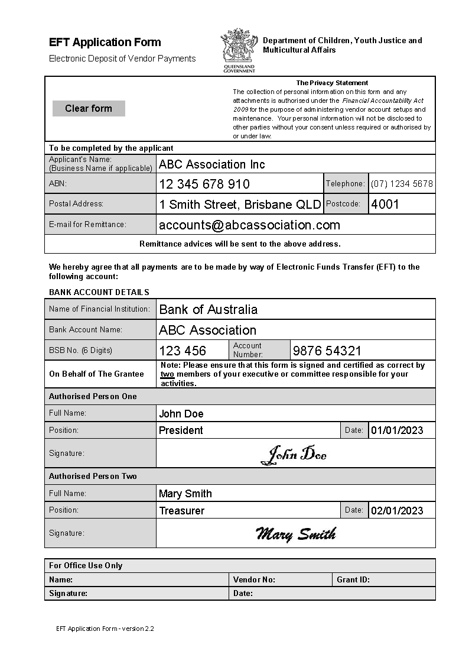

Ensure only one email address and one phone number is provided.

All remittances from the Queensland Government will be sent to this email address

Ensure two people complete verify the form details and sign with a signature. Typing a name or initials (e.g. JD) is not permitted

Ensure you provide the names and position titles of both authorised persons

Ensure you include the name of your bank and the name of your account

Ensure the BSB has 6 digits and the account number is correct

# Attachment 3 – Sample invoice

An example of a completed invoice showing all relevant information that is required to be included.



Approved funding

Include the grant application number and the activity title in the description of supply

Invoice number

Invoice date

Organisation address, telephone, number and email address for remittances.

Organisation name and ABN number

Indicate number of days that payment is to be made within

Insert Account name, BSB number and the Account Number of the account that funds will be deposited into.