Who are older Queenslanders?

To progress towards an age-friendly Queensland, we need to understand the characteristics of Queensland’s older population and some of the underlying demographic changes that are contributing to the ageing of Queensland’s population.

This fact sheet looks at the current population of older Queenslanders, where they live across the State, their cultural diversity, and the projected population growth over time.

**Who do we mean by older Queenslanders?**

For this fact sheet, older Queenslanders (or seniors) refers to persons aged 65 years and over, unless specified otherwise in the text and charts.

# Queensland’s older population is increasing

The number of older Queenslanders has more than tripled over the last 40 years, to more than 900,000 people in 2023 (Figure 1). In 2023, older people accounted for around 1 in 6 Queenslanders (or 17.0%), up from around 1 in 10 in 1983 (or 9.8%). Over this period, people aged 85 years and over increased their share of Queensland’s population from 0.7% to 1.9%.

**Figure 1: Estimated population of older Queenslanders, selected years**



Over the past two decades, population ageing, driven by sustained low fertility and increasing life expectancy, and the ageing baby boomer cohort has contributed to proportionally larger increases in older Queenslanders compared with younger age groups (Figure 2). Overseas migration, and to a lesser extent interstate migration, have also contributed to the population growth in older Queenslanders.

**Figure 2: Estimated population change by age group, 2003–2023**



This ageing of the population has seen the share of Queensland’s population aged 65 years and over steadily increasing, reaching 17.0% in 2023 (Figure 3). As the last of the baby boomer cohort (those born between the years 1946 and 1964) turn 65 years over the next five years, the size of Queensland’s aged 65 years and over population is projected to increase. By 2038, 1 in 5 Queenslanders (or 20.2%) are projected to be aged 65 years or over.

The share of Queensland’s population aged 85 years and over has also been steadily increasing and is projected to reach 4.4% by 2053.

**The share of Queenslanders aged 85 years and over is projected to more than double between 2023 and 2053**

**Figure 3: Estimated and projected population of older Queenslanders, selected years**



Over the next 30 years the number of older Queenslanders aged 65 years and over is projected to more than double, reaching more than 1.7 million persons by 2053. The number of Queenslanders aged 85 years and over is projected to reach more than 340,000 persons by 2053.

# Older Queenslanders are living longer

Life expectancy for both men and women continues to increase. Although women on average tend to live longer than men, male life expectancy is increasing at a greater rate than female life expectancy.

**What do we mean by life expectancy?**

Life expectancy refers to the *average* number of additional years a person of a given age and sex might expect to live if current mortality rates persist. It does not equate to the number of years of life any one person or group of persons will *actually* live.

A 65-year old woman in 2020–2022 could expect to live, on average, to 87.7 years of age, compared with 84.7 years for a woman aged 65 years in 1993–1995 (Figure 4).

Similarly, in 2020–2022, a 65-year old man could expect to live, on average, to 85.0 years of age, compared with 80.9 years for a man aged 65 years in 1993–1995.

**Figure 4: Life expectancy at age 65 years by sex, 1993–1995 to 2020–2022**

**Although women still live longer, on average, than men, the gender gap in life expectancy for persons aged 65 years narrowed between 1995 and 2022**



2020–2022

In 2020, Australia recorded a lower than expected death rate as public health measures were put in place to restrict the spread of COVID-19. These measures resulted in a reduction of deaths across a number of other causes1. In 2022, the pattern of mortality differed when COVID-19 became the third leading cause of death, while Ischemic heart disease remained as the leading cause of death, continuing the long-term trend2.

Higher female life expectancy significantly impacts the male to female ratio of older Queenslanders, with the number of males for every 100 females reducing from age 70 onwards (Figure 5). For example, two-thirds (66.4%) of women aged 65 years in 2022 are expected to reach their 85th birthday compared with over half of their male counterparts (54.0%).

However, greater gains in male life expectancy have contributed to the male to female ratio increasing since 1995, a trend expected to continue over the short-term as improvements in male life expectancy continue to outpace those for females.

**Figure 5: Number of males per 100 females by age group, 1995 and 2023**



**In 2023 there were 76 males for every 100 females aged 85–89 years**

Looking ahead, improvements in life expectancy are expected to continue, driven by further advancements in medical technology and improvements in lifestyle behaviours.

# Older Queenslanders are culturally diverse

## Older Aboriginal and Torres Strait Islander Queenslanders

Older Aboriginal and Torres Strait Islander persons contribute greatly to the cultural diversity of Queensland’s senior population and play an important role in maintaining cultural and language systems for Aboriginal and Torres Strait Islander peoples.

**Who do we mean by older Aboriginal and Torres Strait Islander Queenslanders?**

For this fact sheet, older Aboriginal and Torres Strait Islander Queenslanders refers to persons identifying as being Aboriginal and/or Torres Strait Islander that were aged 50 years and over, unless specified otherwise in the text and charts. This age bracket is chosen to reflect the fact that, generally, ageing-related conditions affect Aboriginal and Torres Strait Islander Queenslanders at a younger age than non-Indigenous Queenslanders.

In 2021, there were an estimated 46,800 older Aboriginal and Torres Strait Islander Queenslanders, with more than 7 in 10 (69.5%) aged between 50–64 years (Figure 6).

**Figure 6: Estimated population of older First Nations Queenslanders, 2021**



**Only 1.5% of older First Nations Queenslanders were aged 85 years and over in 2021**

The proportion of people aged 50 years and over was significantly lower within Queensland’s Aboriginal and Torres Strait Islander population compared with the   
non-Indigenous population (Figure 7). Only 0.3% of Queensland’s Aboriginal and Torres Strait Islander total population were aged 85 years and over.

**Figure 7: Proportion of population aged 50 years and over by Indigenous status, 2021**



Non-Indigenous

Aboriginal and Torres Strait Islander

**Over 1 in 6 First Nations Queenslanders were aged 50 years or older compared with over 1 in 3 non-Indigenous Queenslanders**

The lower proportion of older persons reflects the higher fertility and mortality rates and lower life expectancy of Aboriginal and Torres Strait Islander Queenslanders.

In 2022, a 50–54 year old Aboriginal and Torres Strait Islander woman could expect to live, on average, to 79.3 years of age, over two years longer than her male counterpart (Figure 8). Life expectancy for Aboriginal and Torres Strait Islander Queenslanders has been increasing, however there are still inequalities that exist between Aboriginal and Torres Strait Islander and non-Indigenous Queenslanders. The three leading drivers of the life expectancy gap between Aboriginal and Torres Strait Islander and other Queenslanders, which together explain over half of the gap are cardiovascular disease, cancers and diabetes3.

**Figure 8: Life expectancy at age 50–54 years for First Nations Queenslanders by sex, 2020–2022**



**In 2020–2022, there was a 2.2 year gap in life expectancy for First Nations males and females aged 50–54 years.**

Language is an important part of cultural identity for older Aboriginal and Torres Strait Islander people. The 2021 Census revealed 15.2% of older Aboriginal and Torres Strait Islander Queenslanders spoke an Australian Indigenous language in addition to English at home, with the majority of this group reporting they speak English well or very well.

## Culturally and linguistically diverse older Queenslanders

Queensland’s older population is made up of people from many different cultural and linguistic backgrounds. The 2021 Census found that almost 1 in 3 (29.1%) older Queenslanders were born overseas, from across 191 countries, compared with 23.1% of Queenslanders aged under 65 years.

**Figure 9: Snapshot of overseas-born Queensland seniors, Census 2021**



Of those older Queenslanders born overseas, more than half (56.4%) were born in countries from which Australia receives, or has received, significant numbers of overseas settlers who are likely to speak English4.

England was the top source country for overseas-born older Queenslanders, accounting for 8.4% of the total senior population (Figure 9).

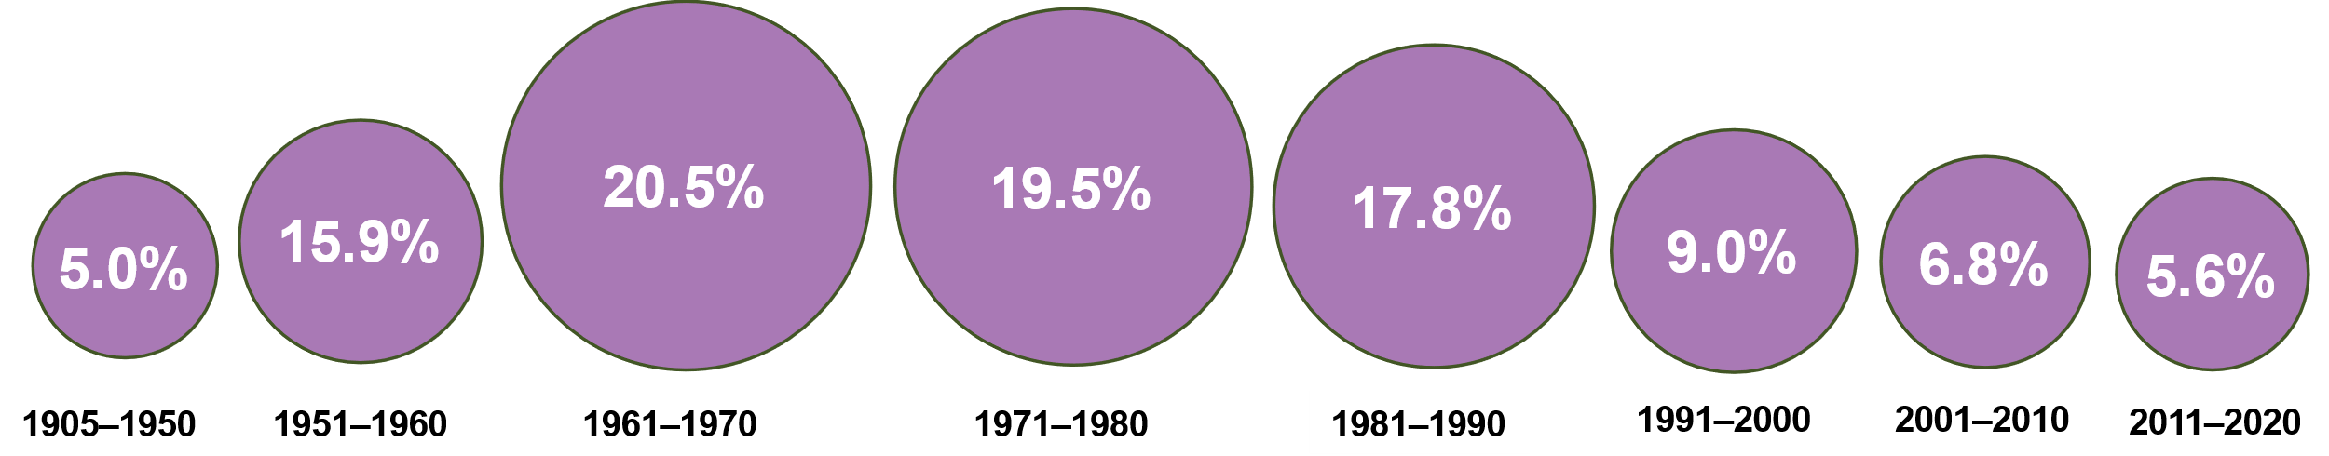

**Year of arrival for overseas-born older Queenslanders**

**4 out of 10 overseas-born Queensland seniors arrived in Australia during 1961 to 1980**

The 2021 Census found 8.2% of older Queenslanders spoke a language other than English at home, with around 7 in 10 (71.9%) of this group reporting they speak English well or very well. The top five languages other than English spoken at home by Queensland seniors were Italian, Mandarin, Cantonese, German, and Greek.

# Most older Queenslanders live in the south east

Consistent with the geographic distribution of Queensland’s total population, the largest numbers of older persons live in South East Queensland, with the local government areas (LGAs) of Brisbane, Gold Coast, Moreton Bay, Sunshine Coast, and Logan recording the largest seniors populations in 2021 (Appendix A).

In contrast, when looking at the LGAs with the highest proportions of older people in 2021, all LGAs with at least 20% older residents were located outside of South East Queensland, except for Noosa (Figure 10). Fraser Coast had the highest proportion of older persons, accounting for nearly 1 in 3 (30.2%) of the LGA’s population.

In 2022 Fraser Coast still had the highest share of older people in Queensland, however, the LGA with the highest median age, 51.9 years, was Hinchinbrook. Fraser Coast followed with 51.5 years, and Noosa with 50.8 years.

While Hinchinbrook recorded very little overall population growth in the year to June 2023, both Noosa (1.8%) and Fraser Coast (2.5%) recorded considerable growth.

Among Statistical Areas Level 2, the areas with the oldest median ages were on Queensland’s east coast, including:

* Bribie Island (63.1 years) to the north of Brisbane
* Cooloola (62.2 years) in the Wide Bay region
* Southern Moreton Bay Islands (61.0 years) to the east of Brisbane.

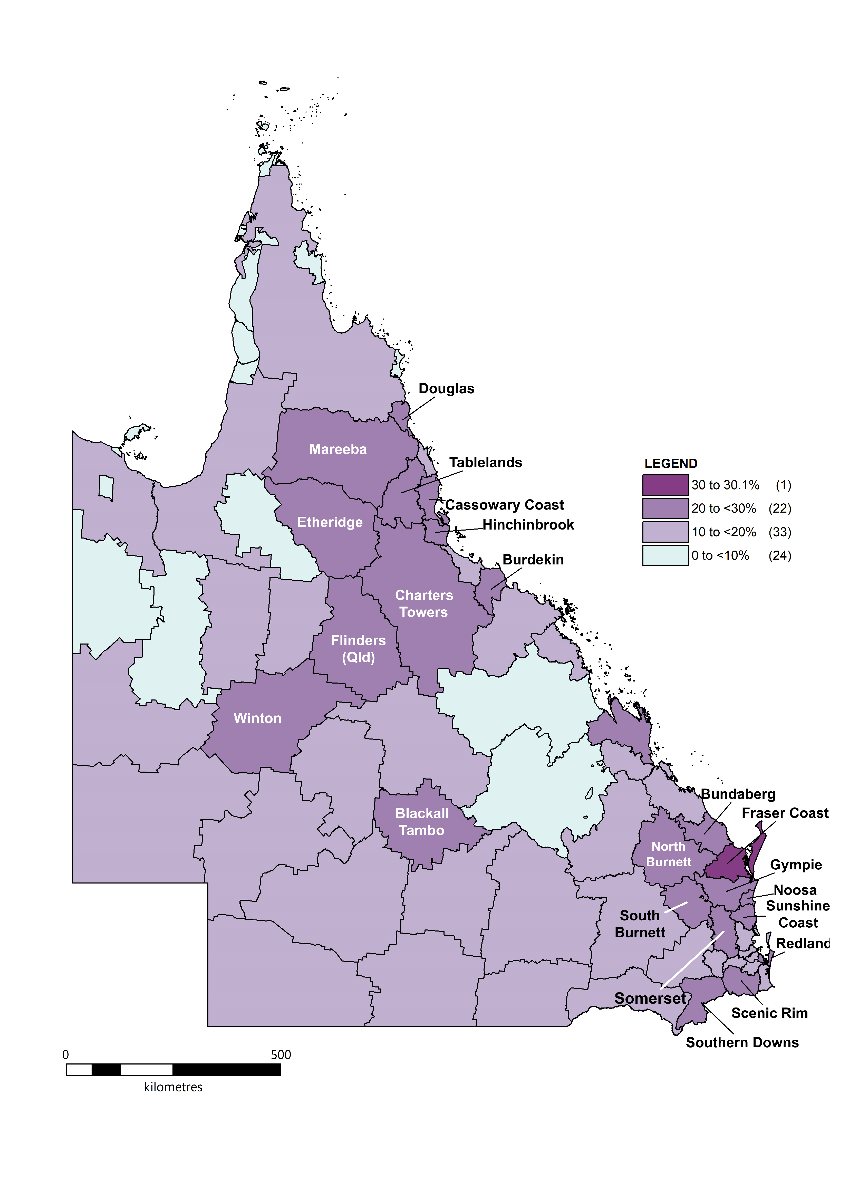**Figure 10: Estimated share of population aged 65 years and over, by LGA, 2022**

**Top 10 LGAs by % 65 years and over**

|  |  |  |
| --- | --- | --- |
| **Rank** | **LGA** | **%** |
| **1** | Fraser Coast | 30.1 |
| **2** | Hinchinbrook | 29.1 |
| **3** | Noosa | 27.7 |
| **4** | North Burnett | 27.0 |
| **5** | Blackall Tambo | 26.5 |
| **6** | Tablelands | 26.5 |
| **7** | Southern Downs | 26.4 |
| **8** | South Burnett | 26.3 |
| **9** | Bundaberg | 26.0 |
| **10** | Gympie | 25.2 |

By 2046 it is projected that fourteen LGAs will have more than 30% of their residents aged 65 years and over, with Fraser Coast projected to be the LGA with the highest proportion, followed by Southern Downs (Figure 11). Hinchinbrook is projected to remain the LGA with the highest proportion of persons aged 85 years and over (Appendix A).

**Figure 11: Projected share of population aged 65 years and over, by LGA, 2046**

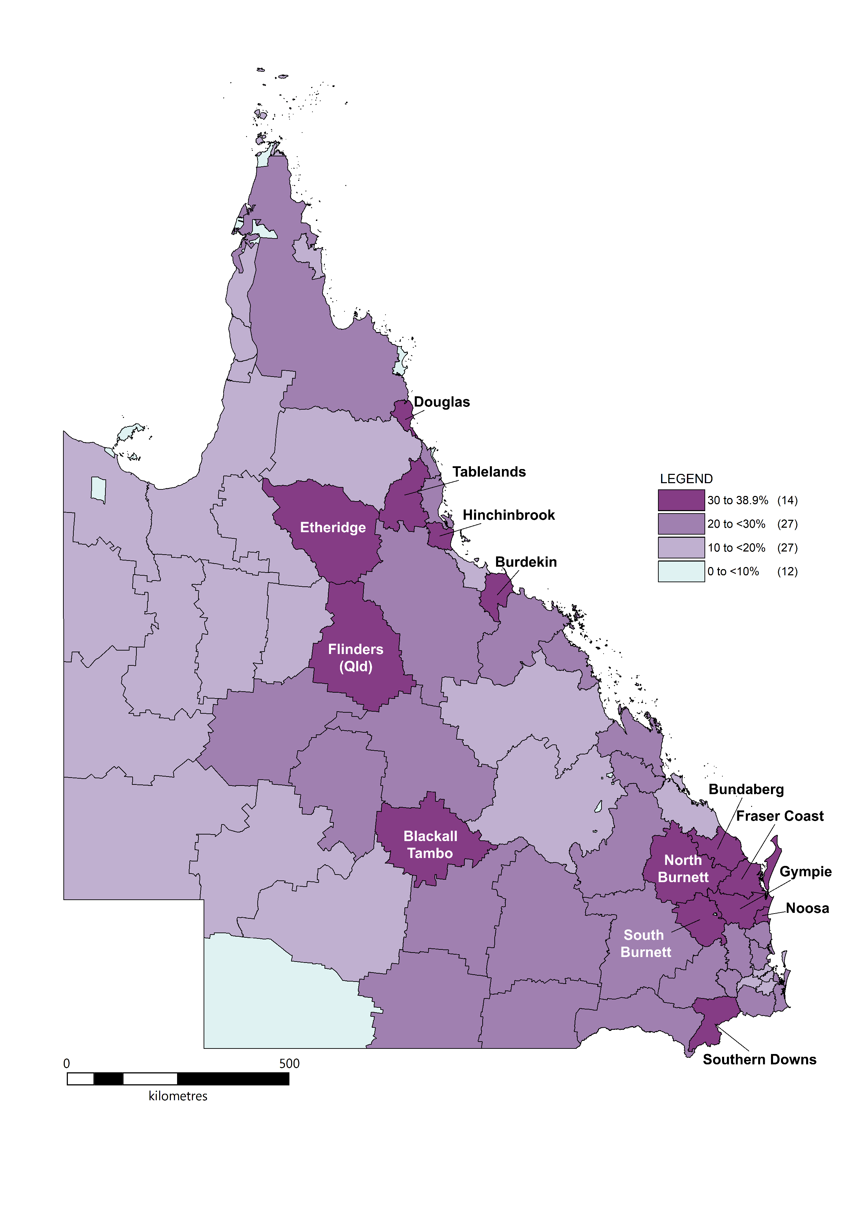

**Top 10 LGAs by % 65 years and over**

|  |  |  |
| --- | --- | --- |
| **Rank** | **LGA** | **%** |
| **1** | Fraser Coast (R) | 38.8 |
| **2** | Southern Downs (R) | 36.6 |
| **3** | Hinchinbrook (S) | 36.5 |
| **4** | Blackall Tambo (R) | 36.1 |
| **5** | Noosa (S) | 34.5 |
| **6** | Gympie (R) | 34.3 |
| **7** | Tablelands (R) | 34.1 |
| **8** | South Burnett (R) | 33.4 |
| **9** | North Burnett (R) | 32.5 |
| **10** | Flinders (S) | 32.4 |
| *(R) = Regional Council (S) = Shire* | | |

Appendix A: Older persons by LGA, 2021 and 2046

Queensland Government Population Projections, 2023 edition, medium series.   
2021 data shown here are preliminary estimated resident populations.

| **LGA name** | **Population aged 65 years and over** | | | **Population aged 85 years and over** | | |
| --- | --- | --- | --- | --- | --- | --- |
| *In alphabetical order* | 2021 | 2021 | 2046 | 2021 | 2021 | 2046 |
|  | Number | Proportion | Proportion | Number | Proportion | Proportion |
| Aurukun (S) | 41 | 3.6 | 10.2 | 0 | 0.0 | 0.8 |
| Balonne (S) | 709 | 16.2 | 29.8 | 69 | 1.6 | 5.9 |
| Banana (S) | 2,298 | 15.7 | 21.4 | 249 | 1.7 | 4.6 |
| Barcaldine (R) | 524 | 18.3 | 26 | 38 | 1.3 | 4.3 |
| Barcoo (S) | 46 | 14.7 | 16.2 | 0 | 0.0 | 1.6 |
| Blackall-Tambo (R) | 527 | 27.4 | 36.1 | 83 | 4.3 | 8.3 |
| Boulia (S) | 49 | 10.4 | 12.6 | 4 | 0.9 | 2.9 |
| Brisbane (C) | 166,463 | 13.2 | 17.2 | 22,336 | 1.8 | 3.6 |
| Bulloo (S) | 21 | 6.1 | 8.3 | 0 | 0.0 | 0.4 |
| Bundaberg (R) | 25,517 | 25.5 | 32.3 | 2,693 | 2.7 | 6.6 |
| Burdekin (S) | 3,909 | 23.2 | 30.6 | 493 | 2.9 | 6.4 |
| Burke (S) | 53 | 12.3 | 16.5 | 3 | 0.7 | 3.3 |
| Cairns (R) | 25,438 | 15.0 | 20.5 | 2,341 | 1.4 | 3.9 |
| Carpentaria (S) | 294 | 13.6 | 15.7 | 4 | 0.2 | 1.5 |
| Cassowary Coast (R) | 6,578 | 22.3 | 28.2 | 716 | 2.4 | 6 |
| Central Highlands (R) | 2,626 | 9.3 | 14.5 | 171 | 0.6 | 2.5 |
| Charters Towers (R) | 2,502 | 21.0 | 29.2 | 269 | 2.3 | 6.7 |
| Cherbourg (S) | 31 | 2.6 | 3.3 | 0 | 0.0 | 0.1 |
| Cloncurry (S) | 345 | 9.3 | 13.7 | 10 | 0.3 | 1.6 |
| Cook (S) | 802 | 17.3 | 25.5 | 15 | 0.3 | 3.2 |
| Croydon (S) | 22 | 8.2 | 10.3 | 2 | 0.7 | 2.1 |
| Diamantina (S) | 41 | 15.2 | 16 | 2 | 0.7 | 2.3 |
| Doomadgee (S) | 25 | 1.7 | 2.8 | 0 | 0.0 | 0.5 |
| Douglas (S) | 2,530 | 20.3 | 30.3 | 172 | 1.4 | 5.9 |
| Etheridge (S) | 175 | 24.2 | 30.2 | 5 | 0.7 | 3.2 |
| Flinders (S) | 339 | 22.3 | 32.4 | 29 | 1.9 | 5.4 |
| Fraser Coast (R) | 33,123 | 29.6 | 38.8 | 3,179 | 2.8 | 7.9 |
| Gladstone (R) | 8,615 | 13.4 | 16.6 | 616 | 1.0 | 2.7 |
| Gold Coast (C) | 109,879 | 17.3 | 22.1 | 12,784 | 2.0 | 4.7 |
| Goondiwindi (R) | 1,960 | 18.8 | 27.5 | 230 | 2.2 | 6.6 |
| Gympie (R) | 13,350 | 24.8 | 34.3 | 1,194 | 2.2 | 6.9 |
| Hinchinbrook (S) | 3,145 | 28.6 | 36.5 | 447 | 4.1 | 8.7 |
| Hope Vale (S) | 44 | 4.4 | 7.5 | 0 | 0.0 | 1.2 |
| Ipswich (C) | 25,934 | 11.1 | 14.8 | 2,517 | 1.1 | 2.8 |
| Isaac (R) | 1,431 | 6.4 | 10.7 | 69 | 0.3 | 2.1 |
| Kowanyama (S) | 61 | 5.5 | 14.6 | 2 | 0.2 | 1.3 |
| Livingstone (S) | 7,834 | 19.6 | 29.5 | 715 | 1.8 | 6.3 |
| Lockhart River (S) | 44 | 6.7 | 16.4 | 1 | 0.2 | 4.8 |
| Lockyer Valley (R) | 7,150 | 17.1 | 24.8 | 643 | 1.5 | 5.2 |
| Logan (C) | 45,340 | 12.9 | 17.9 | 3,965 | 1.1 | 3.4 |
| Longreach (R) | 623 | 16.9 | 27.9 | 81 | 2.2 | 5.3 |
| Mackay (R) | 18,327 | 14.9 | 21.8 | 1,929 | 1.6 | 4.5 |
| Mapoon (S) | 70 | 8.4 | 11.6 | 6 | 0.7 | 1.2 |
| Maranoa (R) | 39 | 8.8 | 21.3 | 2 | 0.5 | 5 |
| Mareeba (S) | 2,042 | 15.8 | 26 | 225 | 1.7 | 5.3 |
| McKinlay (S) | 4,646 | 20.0 | 12.6 | 466 | 2.0 | 2.1 |
| Moreton Bay (R) | 83,881 | 17.3 | 23.2 | 8,525 | 1.8 | 4.8 |
| Mornington (S) | 53 | 5.0 | 6 | 0 | 0.0 | 0.6 |
| Mount Isa (C) | 1,519 | 7.9 | 10.1 | 109 | 0.6 | 1.3 |
| Murweh (S) | 771 | 19.2 | 24.8 | 107 | 2.7 | 4.4 |
| Napranum (S) | 38 | 4.2 | 6.8 | 0 | 0.0 | 0.9 |
| Noosa (S) | 15,520 | 27.3 | 34.5 | 1,604 | 2.8 | 7.5 |
| North Burnett (R) | 2,695 | 26.6 | 32.5 | 288 | 2.8 | 7.4 |
| Northern Peninsula Area (R) | 109 | 3.8 | 9.5 | 0 | 0.0 | 1.4 |
| Palm Island (S) | 93 | 4.3 | 13 | 0 | 0.0 | 2 |
| Paroo (S) | 401 | 23.5 | 28.4 | 29 | 1.7 | 3.8 |
| Pormpuraaw (S) | 37 | 5.9 | 15.5 | 2 | 0.3 | 1.4 |
| Quilpie (S) | 58 | 8.3 | 10.9 | 11 | 1.6 | 2.8 |
| Redland (C) | 33,213 | 20.5 | 28.6 | 3,835 | 2.4 | 6 |
| Richmond (S) | 104 | 13.5 | 19.6 | 6 | 0.8 | 2 |
| Rockhampton (R) | 13,400 | 16.2 | 21.3 | 1,704 | 2.1 | 4.4 |
| Scenic Rim (R) | 9,711 | 22.3 | 29.7 | 1,006 | 2.3 | 6.2 |
| Somerset (R) | 5,313 | 20.9 | 27.8 | 338 | 1.3 | 5 |
| South Burnett (R) | 8,644 | 25.9 | 33.4 | 800 | 2.4 | 6.7 |
| Southern Downs (R) | 9,469 | 25.8 | 36.6 | 1,003 | 2.7 | 8.3 |
| Sunshine Coast (R) | 73,508 | 21.2 | 27.3 | 9,005 | 2.6 | 6.1 |
| Tablelands (R) | 6,844 | 25.8 | 34.1 | 696 | 2.6 | 7.1 |
| Toowoomba (R) | 33,430 | 19.1 | 24.4 | 4,332 | 2.5 | 5.4 |
| Torres (S) | 249 | 7.0 | 13 | 1 | 0.0 | 1.7 |
| Torres Strait Island (R) | 280 | 6.5 | 12.1 | 6 | 0.1 | 1.8 |
| Townsville (C) | 27,102 | 13.9 | 19.1 | 2,541 | 1.3 | 3.9 |
| Weipa (T) | 111 | 2.7 | 13.1 | 3 | 0.1 | 1 |
| Western Downs (R) | 5,723 | 16.7 | 20.9 | 605 | 1.8 | 4.4 |
| Whitsunday (R) | 6,184 | 16.4 | 24 | 497 | 1.3 | 4.5 |
| Winton (S) | 237 | 20.9 | 22.9 | 6 | 0.5 | 3.4 |
| Woorabinda (S) | 63 | 6.1 | 6.8 | 0 | 0.0 | 0.5 |
| Wujal (S) | 10 | 3.5 | 6.7 | 0 | 0.0 | 1 |
| Yarrabah (S) | 116 | 4.5 | 9.7 | 4 | 0.2 | 1.4 |
| *(C) = City     (R) = Regional Council     (S) = Shire    (T) = Town* | | | | | | |

References

1. Australian Bureau of Statistics (ABS) 3302.0.55.001, *Life expectancy, Australia*, 2020-2022, published 8 November 2023.
2. Australian Bureau of Statistics (ABS) 3303.0, *Causes of Death, Australia*, 2022, published 27 September 2023.
3. Queensland Health, *Closing the gap performance report 2018*, published March 2019.
4. Based on the concept of ‘main English-speaking countries’ as outlined in ABS 3415.0, *Migrant Data Matrices*, Australia, published 15 December 2021. See data note (h) for a list of countries included in this estimate. The list is not an attempt to classify countries based on whether English is the predominant or official language of each country and it is important to note that being from a country not included in this list does not imply a lack of proficiency in English.

Data notes

1. All data in this fact sheet were the most recent at the time of preparation and represent Queensland-specific data. Data in this fact sheet may differ from data in other publications due to revisions and different calculation methods.
2. All charts and maps have been produced by the Queensland Government Statistician’s Office.
3. Population data refers to the estimated resident population at 30 June (the official measure of the population).
4. Projected population data are based on medium series projections and reflect the outcomes of applying a set of assumptions about the future direction of fertility, mortality and migration to a base population. These population projections do not attempt to directly measure any future changes in economic, social and political implications that may influence future population growth and distribution and they should not be interpreted as precise point estimate forecasts or predictions.
5. Life expectancy data is based on three years of data ending in the year shown and assumes a continuation of the male or female age-specific death rates for that given period throughout a person’s lifetime.
6. All Census analysis is based on usual resident counts at 10 August 2021.
7. The Census estimate for overseas-born excludes the following codes; ‘Australia, (includes External Territories), nfd’, ‘Australia’, ‘Norfolk Island’, ‘Australian External Territories, nec’ and ‘Not stated’.
8. The Census estimate for born in a main English-speaking country includes the following codes; ‘New Zealand’, ‘United Kingdom, Channel Islands and Isle of Man, nfd’, ‘England’, ‘Isle of Man’, ‘Northern Ireland’, ‘Scotland’, ‘Wales’, ‘Guernsey’, ‘Jersey’, ‘Ireland’, ‘Canada’, ‘United States of America’ and ‘South Africa’.
9. Census estimates for overseas-born, language spoken at home and proficiency in English have been based on exclusion of ‘Not stated’ from the denominator (‘Inadequately described’ is also excluded from the denominator for language spoken at home). Readers should note that proficiency in English has a high ‘Not stated’ component.

Data sources

ABS 1269.0, *Standard Australian Classification of Countries*, 2016, published 27 June 2016.

ABS 1270.0.55.003, *Australian Statistical Geography Standard (ASGS) Edition 3 – Non ABS Structures*, July 2021 – June 2026, published 20 July 2021.

ABS 3101.0, *National, state and territory population*, June 2023, published 14 December 2023.

ABS 3235.0, *Regional Population by Age and Sex*, 2021, published 30 August 2022.

ABS 3238.0.55.001, *Estimates of Aboriginal and Torres Strait Islander Australians*, 30 June 2021, published 31 August 2023.

ABS 3302.0.55.001, *Life expectancy*, 2020-2022, published 08 November 2023.

ABS 3302.0.55.003, *Aboriginal and Torres Strait Islander life expectancy*, 2020-2022, published 29 November 2023.

ABS *Census of Population and Housing*, 2021, Tablebuilder Pro. Findings based on use of ABS Tablebuilder data.

*Queensland Government population projections*, 2023 edition, published 12 June 2023.

© The State of Queensland (Queensland Treasury) 2024

The Queensland Government supports and encourages the dissemination and exchange of information. However, copyright protects this publication. The State of Queensland has no objection to this material being reproduced, made available online or electronically but only if it is recognised as the owner of the copyright and this material remains unaltered.

**Licence**

**[](http://creativecommons.org/licenses/by/4.0)**This document is licensed under a Creative Commons Attribution (CC BY 4.0) International licence.

To view a copy of this licence, visit http://creativecommons.org/licenses/by/4.0

**Attribution**

This fact sheet has been prepared by the Queensland Government’s Statistician’s Office, Queensland Treasury on behalf of the Department of Child Safety, Seniors and Disability Services.

Content from this fact sheet should be attributed to: Queensland Government Statistician’s Office, Queensland Treasury, *Who are older Queenslanders? fact sheet*, March 2024.

**Disclaimer**

All data and information in this report are believed to be accurate and have come from sources believed to be reliable. However, Queensland Treasury does not guarantee or represent that the data and the information are accurate, up to date or complete, and disclaims liability for all claims, losses, damages or costs of whatever nature and howsoever occurring, arising as a result of relying on the data and information, regardless of the form of action, whether in contract, tort (including negligence), breach of statutory duty or otherwise.