Module six

Carer Advocacy and Support

Activities

Activity 1 – Practical application of Statement of Commitment (slide 12)

Statement of Commitment - Slides for this topic 6 -> 11

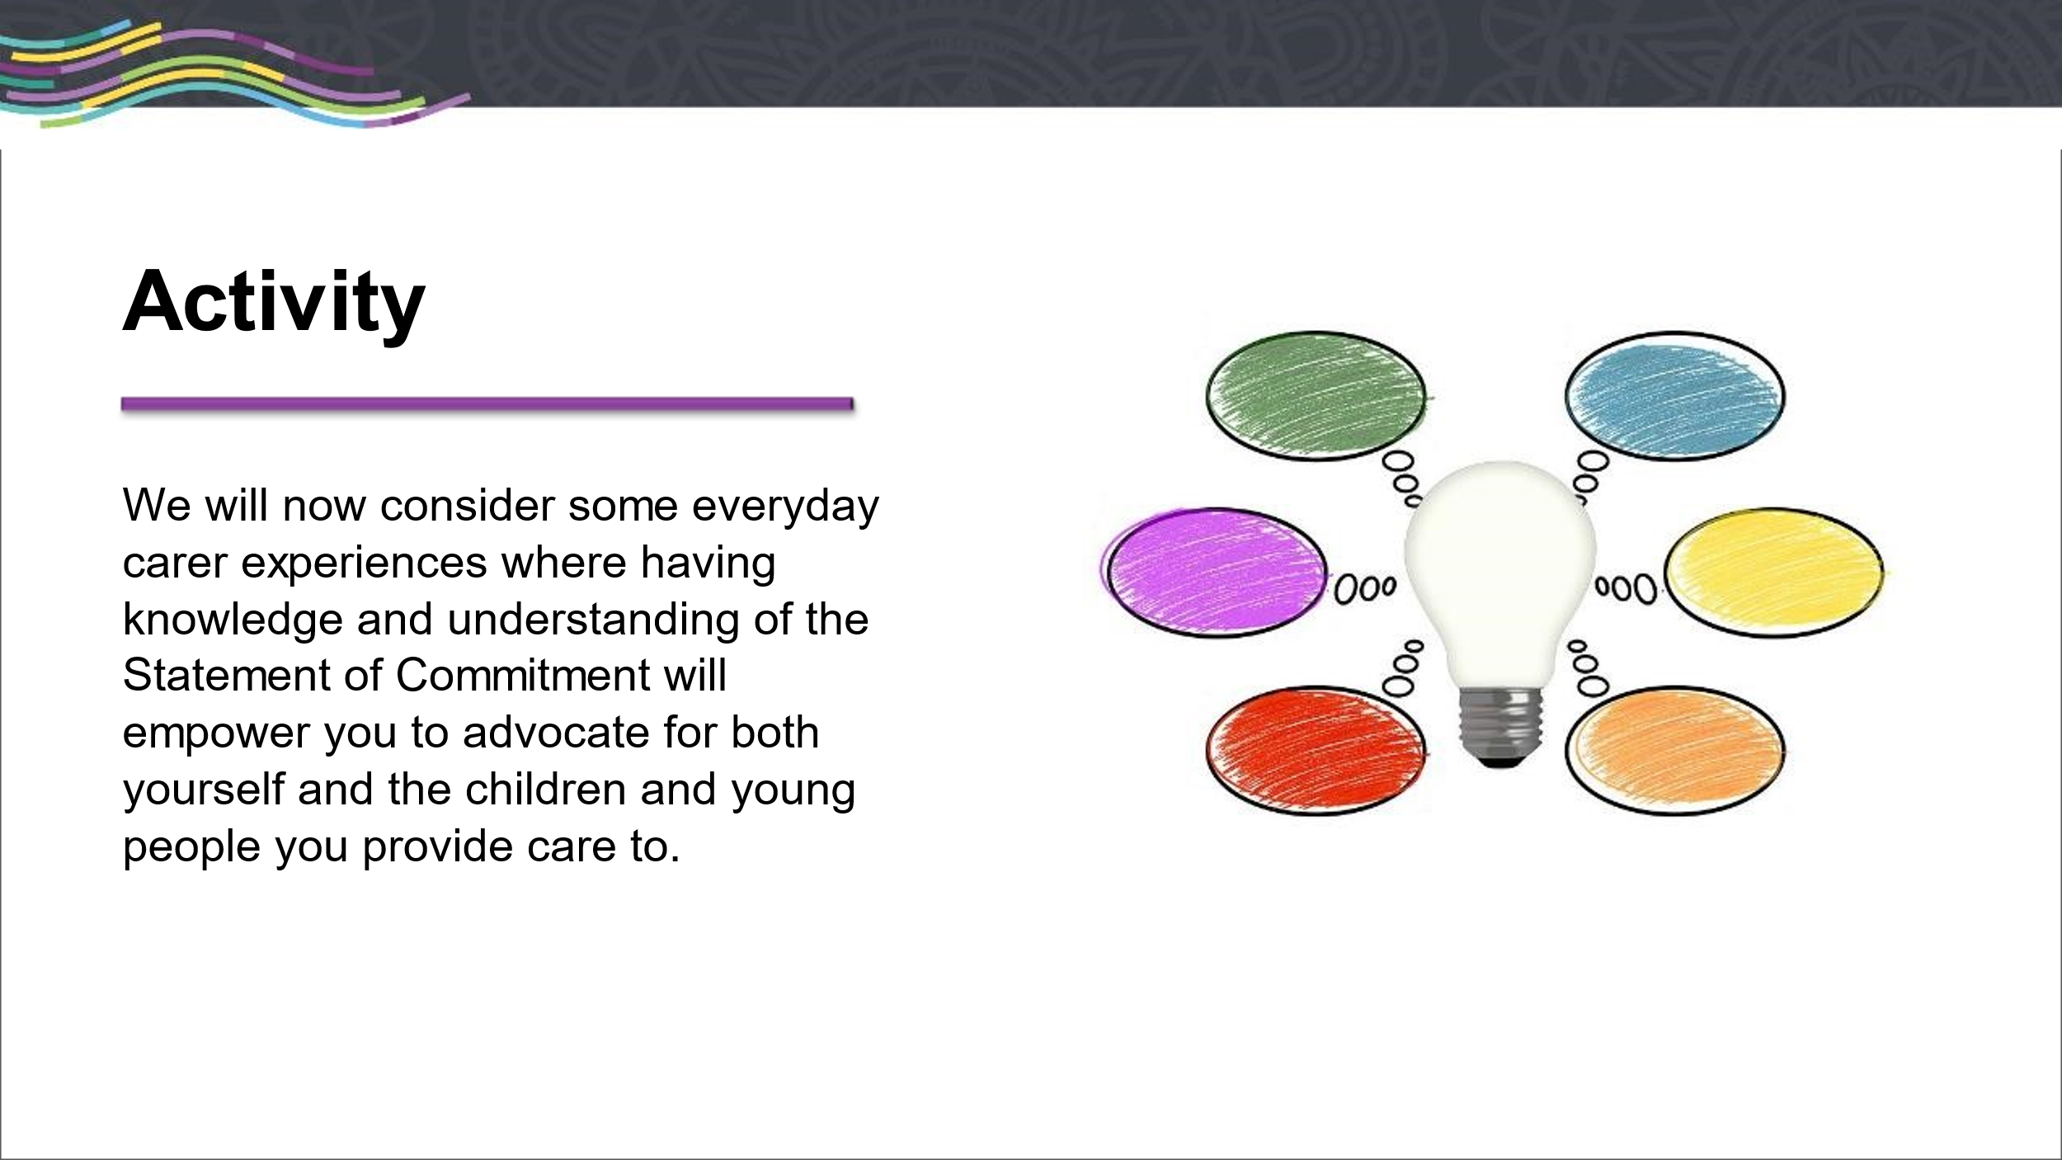

Time – 15 mins total (7 ½ mins to discuss in small groups/7 ½ mins to discuss as larger group)
Resources – Statement of Commitment, five Scenarios

Split into groups and hand out the scenario’s to each group and allocate each group a scenario
Each group will consider the scenario in three parts
- Role of Carer
- Responsibility of Carer
- Rights of Carer
When finished ask each group to provide one role, one right and one responsibility for their scenario.
The training team can provide additional examples of each as per the resource
Emphasise that the Statement of Commitment applies to every day caring and carers should always refer back to the Statement of Commitment when faced with a challenge to help clarify and support moving forward.

Activity 2 - Roles and Responsibilities of Others (slide 18)

Small Groups x 4

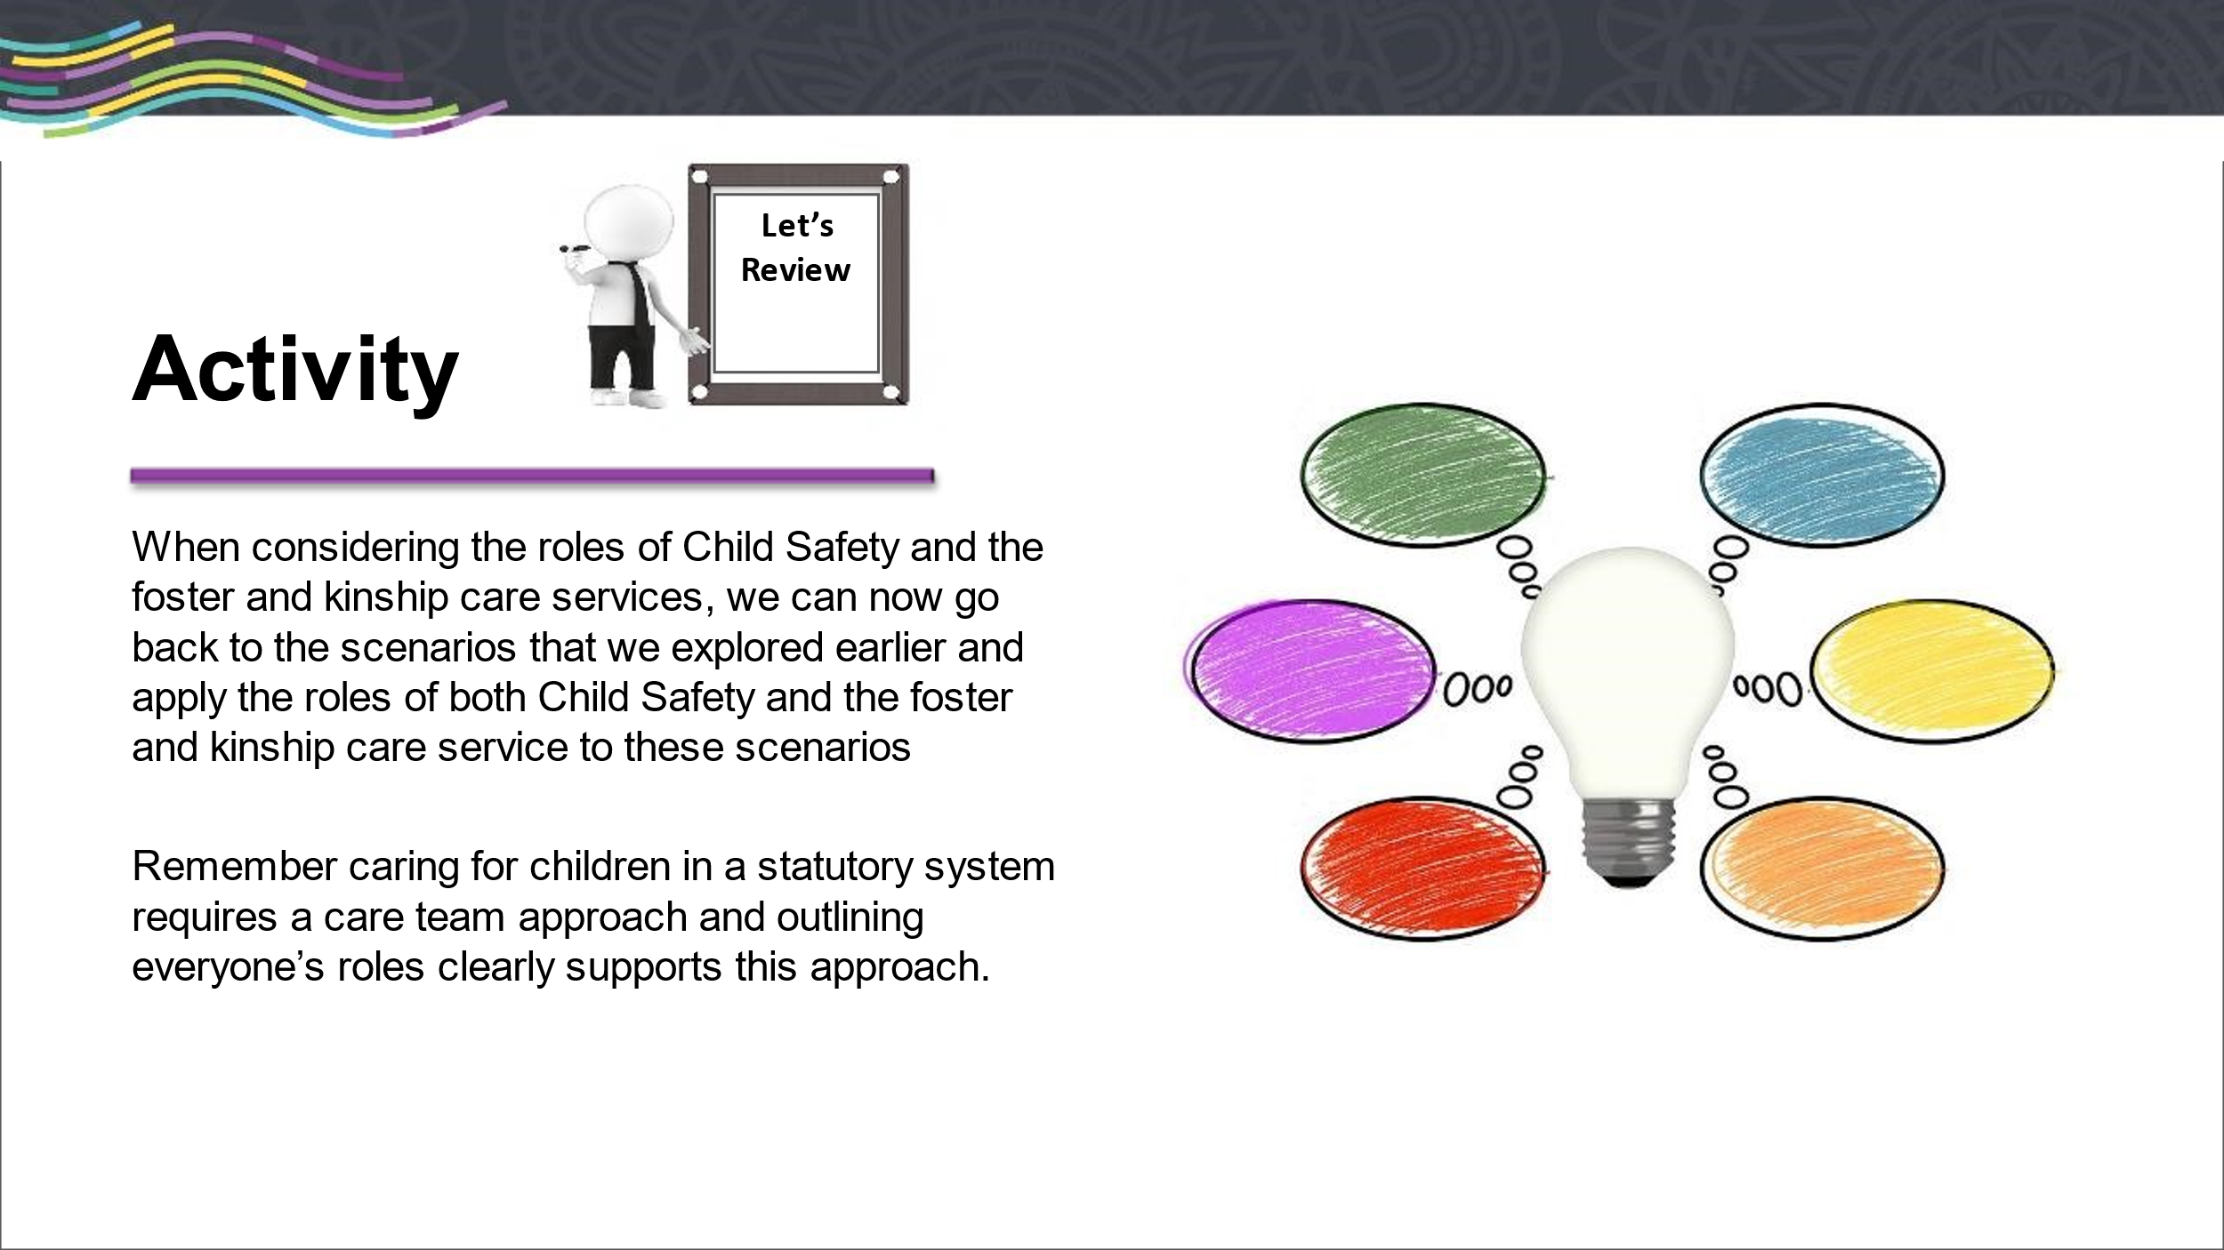

Time – 15 mins
Resources - Whiteboard / Pens, Statement of Commitment, Scenario 1 & 5

Ask each group to consider what they believe would be the Foster and Kinship Care Service and Child Safety’s role in Scenario 1 and then Scenario 5
- Group 1 – consider the scenario in relation to the Role of Child Safety
- Group 2 – consider the scenario in relation to the Role of the Agency
- Group 3 – consider the scenario in relation to Responsibilities of Child Safety
- Group 4 – consider the scenario in relation to the Responsibilities of the Agency

The training team can provide additional examples of each as per the resource

Activity 3 – Human Rights Act 2019 (slide 26)

Human Rights Act 2019 - Slides for this topic are Slide 20 – Slide 25

Small Group Activity

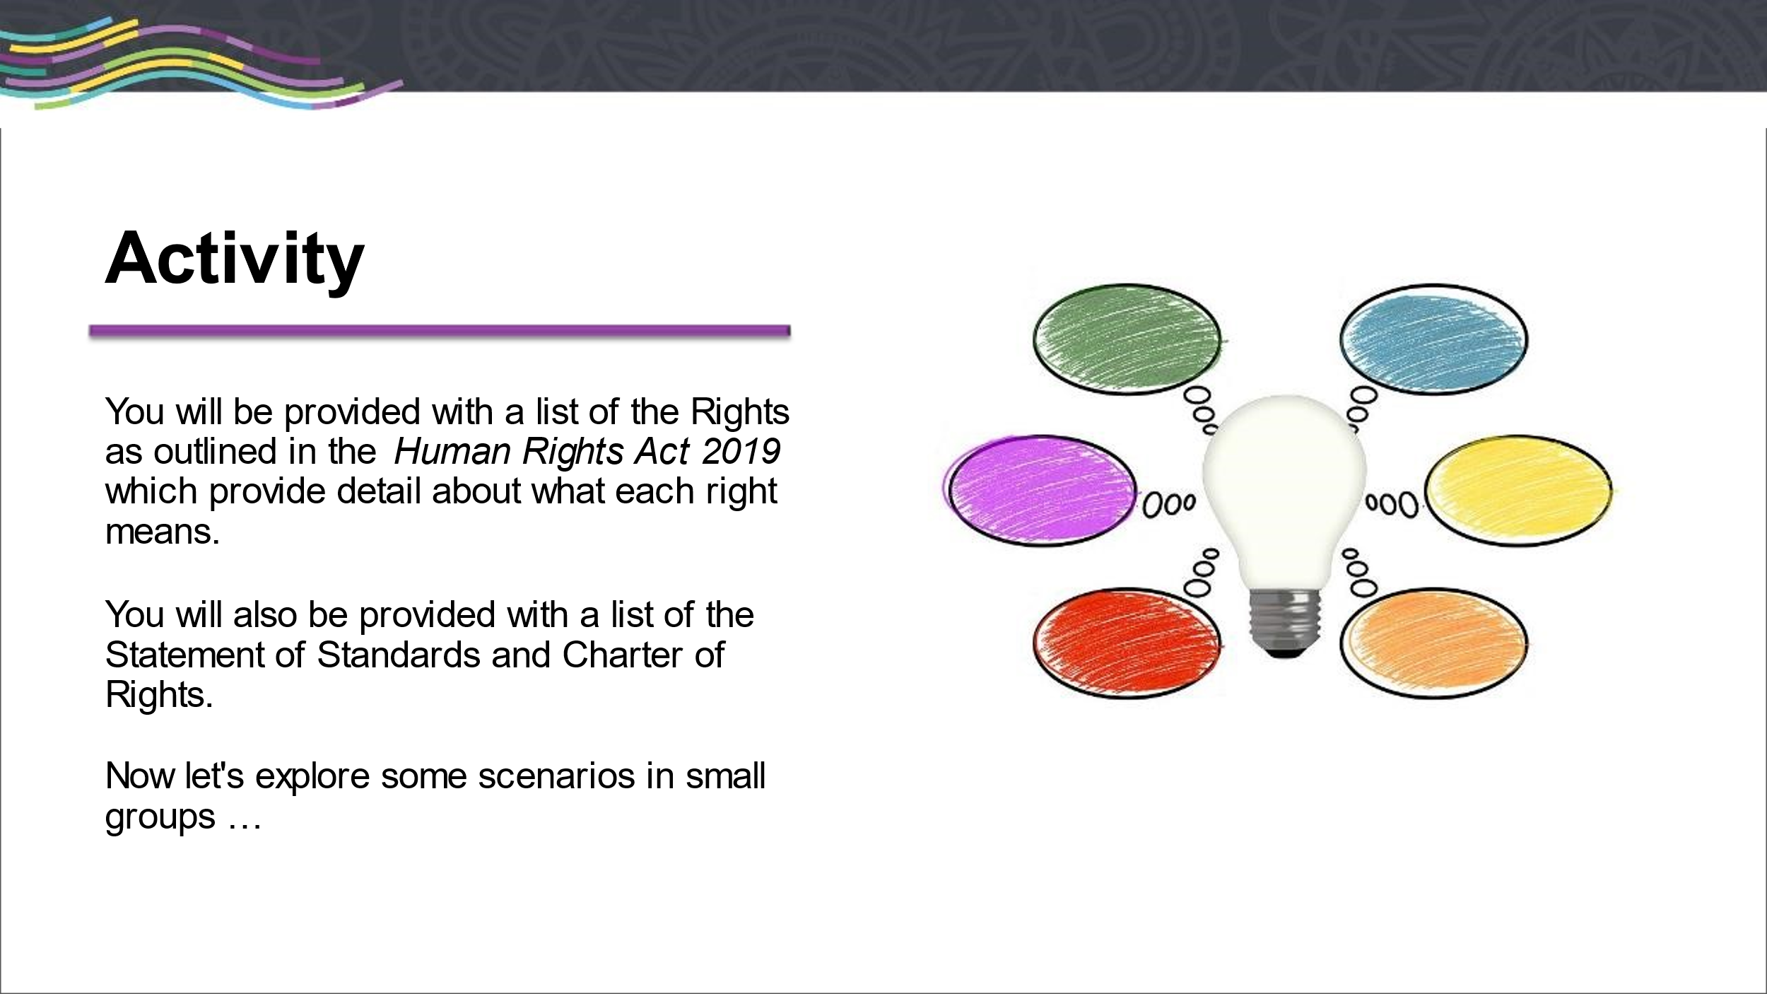

Time – 15 mins (7 ½ small group discussion & 7 ½ as a large group discussion)
Resources
Part 1
Human Rights Act 2019, Statement of Standards and Charter of Rights, Human Rights Case Scenarios
- Ask the group which of the Human Rights applies to each scenario

Part 2
- Now ask which of the Statement of Standards and Charter of Rights apply

Brainstorm -> Activity 5- Managing Grief & Loss (slide 74)

Grief and Loss

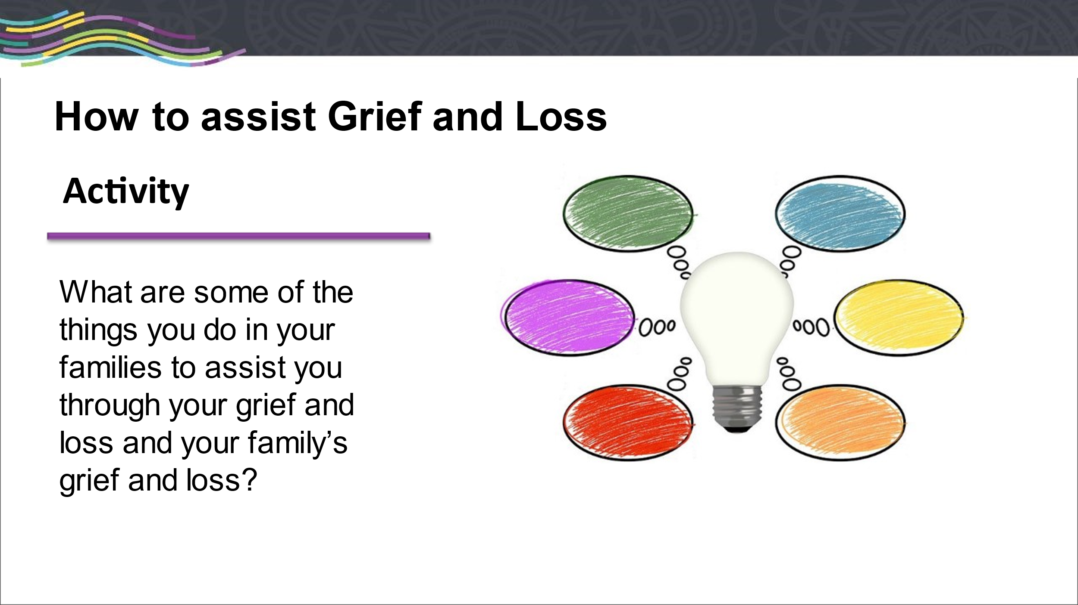

Brainstorm
Time – 5 mins
Resources – Whiteboard and markers

Facilitators to take photo of brainstorm activity and provide use any additional ideas for future training

Additional ideas not on slide
- Create a collage of artwork carers and children have done together
- Collage a quilt of old clothing or other sentimental treasures for the child to keep
- Colour calico bears together
- Have strategies that build a positive working relationship with biological families – ie. communication books, writing letters with child for family,
- Work to develop an understanding of how the child is feeling about moving on and when/where appropriate share your own feelings (appropriately)
- Collect books and movies that relate to grief, loss, emotions and letting go ie. Frozen, Inside Out
- Create your own story books about the child’s time with you (supports ID and the child knowing their story), families can help with this if appropriate, or photo books
- Give children space to ask questions
- Role play with toys

