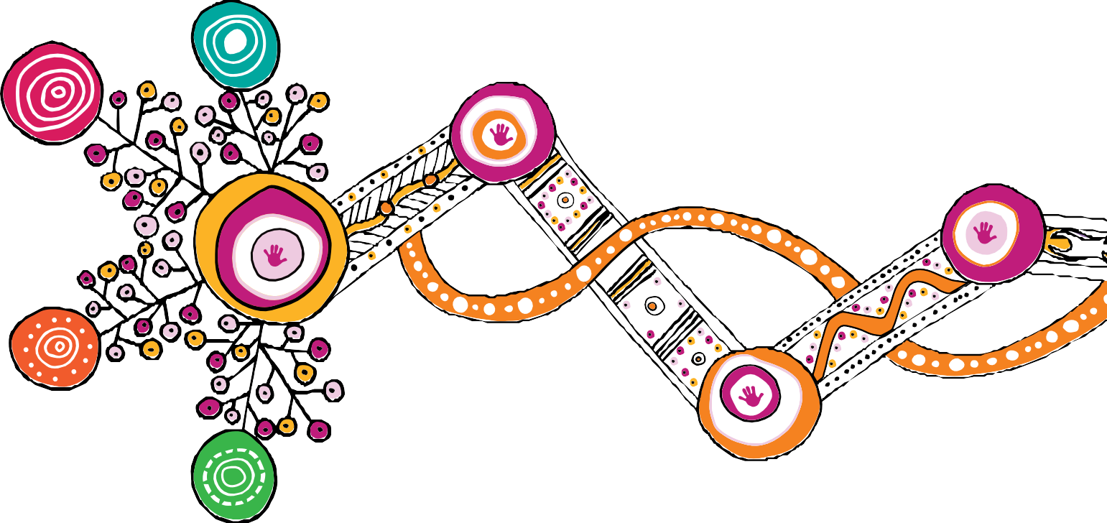

# Queensland First Children and Families Board

Changing Tracks

# Progress report

**July 2019–June 2020**

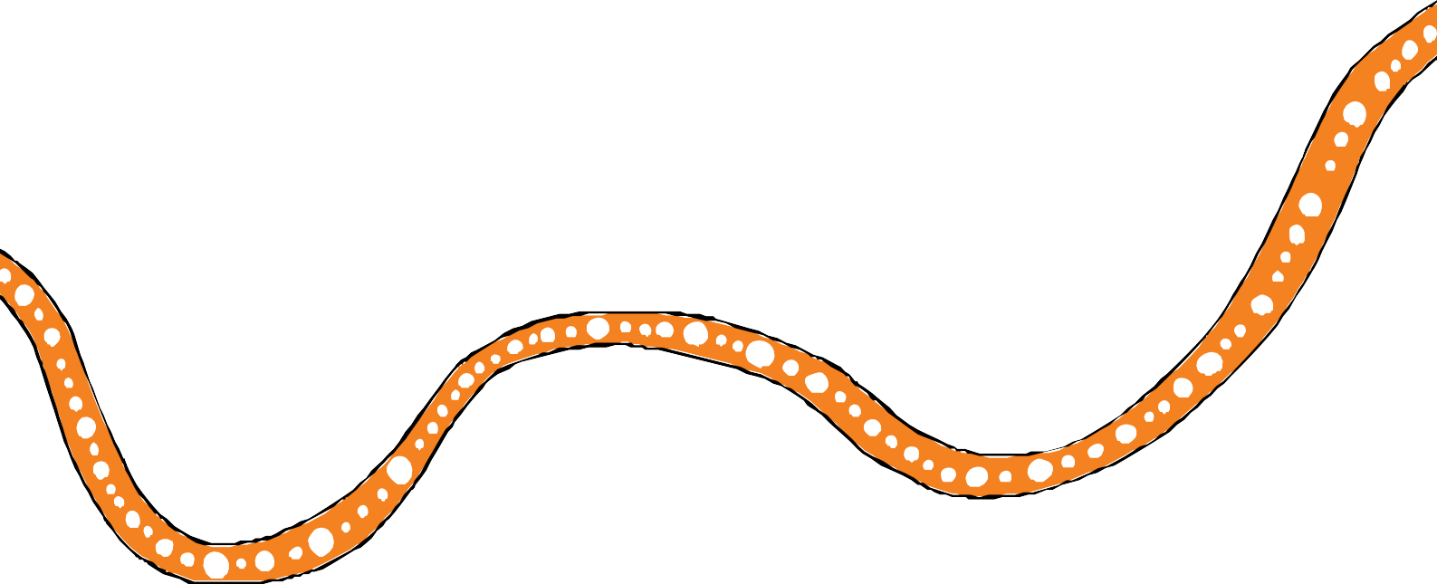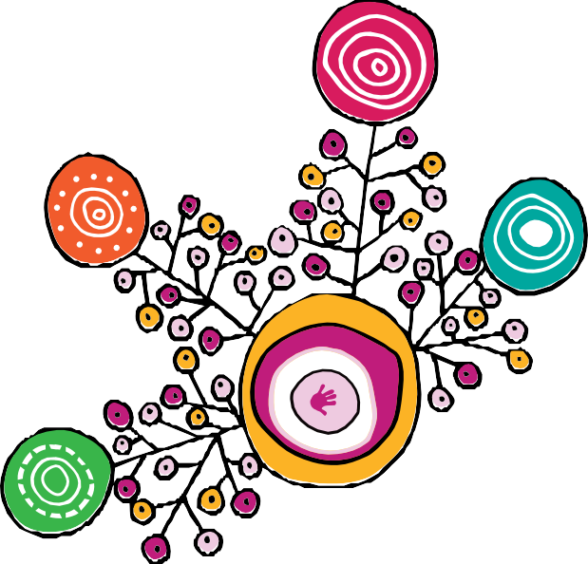

**We respectfully acknowledge the First Nations people in the State of Queensland; we acknowledge the cultural and spiritual connection that Aboriginal and Torres Strait Islander peoples have with the land and sea.**

**We respectfully acknowledge Aboriginal people and Torres Strait Islander people as two unique and diverse peoples with their own rich and distinct cultures.**

**We pay our respects to Elders past and present as well as the existing and emerging leaders who walk together in partnership on this journey.**

**We acknowledge the contributions of Rachael Sarra for the original design of artworks and the creative leadership of Gilimbaa in this report.**

# Contents



Message from the Queensland First Children and Families Board 3

Introduction 4

Progress 2019–20 5

Highlights 2019–20 6

Acronyms 14

Appendices 15

Appendix A – *Family Matters Report 2020* findings 15

Appendix B – Key achievements from *Changing Tracks action plan 2017-2019* 17

Appendix C – Our Way evaluation 21

References 24

Prepared by: Deloitte Access Economics, in partnership with Murawin and the Social Research Centre

1

# Message from the Queensland First Children and Families Board



With the launch of *Our Way: a generational strategy for Aboriginal and Torres Strait Islander children and families 2017–2037* (Our Way) in 2017, the Queensland Government, in partnership with Family Matters Queensland, committed to set the foundations for change across the child protection system in Queensland to support Aboriginal and Torres Strait Islander children to grow up safe, loved and cared for in family, community and culture.

The Queensland First Children and Families Board guides and oversees the implementation of Our Way. This is the third progress report and focuses on the progress of implementing the Changing Tracks action plans between July 2019 and June 2020. It builds on achievements and learnings reported in the *Changing Tracks Progress Report May 2017 – December 2018* and *Changing Tracks Report Card January 2019 – June 2019*.

Despite the enormous challenges that 2019–20 has presented for our partners, our families and our communities, we have continued to work together to implement key actions under the

Changing Tracks action plans. All actions under the first *Changing Tracks action plan* (2017–2019) are now complete and being embedded. *Changing Tracks: an action plan for Aboriginal and Torres Strait Islander children and families 2020–2022*, launched in early 2020, continues to establish

a new track to ensure all Aboriginal and Torres Strait Islander children and young people in Queensland grow up safe, loved and cared for in family, community and culture.

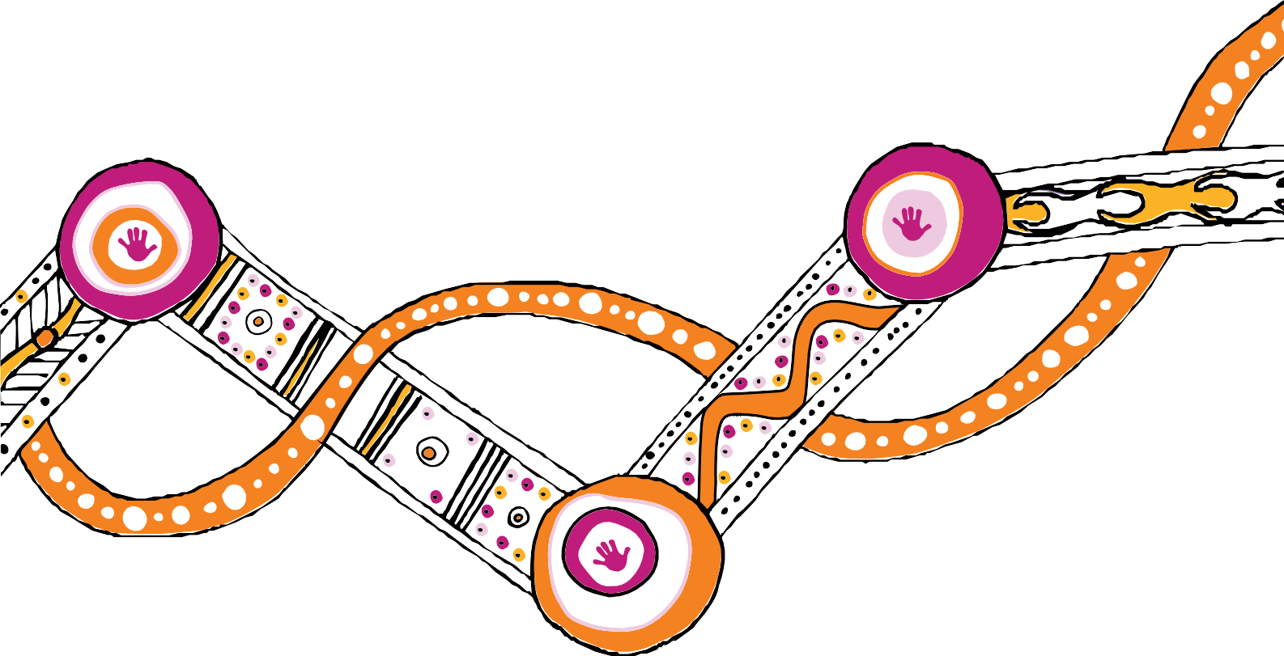While there is much to be celebrated, we cannot take our foot off the pedal. We know there is much more to be done to eliminate the disproportionate representation of Aboriginal and Torres Strait Islander children in the child protection system within a generation.

**Professor Boni Robertson**

Co-chair

**Mr Mick Gooda**

Co-chair

3

# Introduction



The Queensland Government and Family Matters Queensland are continuing to work in partnership with communities and key stakeholders to implement Our Way and *Changing Tracks: an action plan for Aboriginal and Torres Strait Islander children and families 2017–2022*.

The delivery of Our Way through a series of seven rolling action plans allows flexibility to determine future directions based on the outcomes, challenges and priorities identified in the implementation of each phase. The action plans span three phases:

* Changing Tracks (2017–2022)
* Breaking Cycles (2023–2031)
* Hitting Targets (2032–2037).

Actions and priorities in the plans are intended to move the child protection system to operating in a way that reflects the Family Matters building blocks and principles. The Queensland First Children and Families Board (the Board) oversees the development and implementation of action plans under the Our Way strategy on behalf of the Queensland Government and Family Matters Queensland.

From the summer bushfires of late 2019 to the ongoing impacts of the COVID-19 pandemic, the past 12 months has posed many challenges to the child protection system and Queenslanders in general. Aboriginal and Torres Strait Islander children and families have felt the impact of the pandemic:

##### *“The Australian Government has recognised that Aboriginal and Torres Strait* Islander people are at greater risk from COVID-19 than non-Indigenous people. These risks extend well beyond the health threat posed by the virus itself, to higher vulnerability to social and economic impacts due to pre-existing levels of disadvantage. This has had significant flow on effects for many Aboriginal and Torres Strait Islander children and families.” (Family Matters, 2020)1

There has been increasing demand for child and family support services with the impact of the pandemic on families, communities and service providers requiring new and different ways of working. Travel restrictions due to COVID-19 have impacted both the ways in which services are delivered, as well communities’ ability to participate in cultural activities.

Against this backdrop, Queensland has continued to progress its long-term commitment to eliminating the disproportionate representation of Aboriginal and Torres Strait Islander children in the child protection system by 2037, and to closing the gap in life outcomes for Aboriginal and Torres Strait Islander children and families.

4

# Progress 2019–2020



The actions prioritised for implementation over the last year focussed fundamentally on setting the foundations for change and creating a system that can achieve the longer-term Our Way vision. The outputs and initiatives highlighted throughout this report demonstrate examples of system changes beginning to emerge as a result of actions under the Changing Tracks action plans.

The *Family Matters Report 20202* found that Queensland has established stronger practice in relation to participation, control and self-determination for Aboriginal and Torres Strait Islander peoples (Building Block 2). There is also evidence emerging that systems are being established for true participation, with Aboriginal and Torres Strait Islander peak agencies, their member organisations and local communities playing critical roles in strategy, policy and program co- design and sector development.

There are some early indications of positive change in the 2019–20 Queensland child protection data, which shows:

* community-controlled early intervention services – family wellbeing services – are successfully de-escalating risks in Aboriginal and Torres Strait Islander families
* while the numbers and rates of Aboriginal and/or Torres Strait Islander children in care continue to increase, more children are being placed with kin
* the proportion of children in care who are Aboriginal and/or Torres Strait Islander has remained relatively stable, which is a reversal of pre-reform trend of growing disproportionate representation in the child protection system.

This is the third year of the 20-year strategy, and it is too soon to assess whether Our Way is directly contributing to these changes in the disproportionate representation of Aboriginal and Torres Strait Islander children in the child protection system.

It is clear that the majority of the Changing Tracks actions are being implemented on time and as intended, and that emerging changes to the system will enable Our Way to achieve its targets and longer-term outcomes.

Further work to fully examine the impact of the two Changing Tracks action plans on the child protection system and outcomes for Aboriginal and Torres Strait Islander children and families will be undertaken through the Our Way evaluation, due for completion in June 2022.

5

# Highlights 2019–20



#### After an extensive co-design process with key partners, the second Changing Tracks action plan was released in April 2020. It comprises 24 actions to consolidate and embed the achievements of the first action plan and continue setting foundations for transformational change. By the end of June 2020, all actions under Changing Tracks 2020–2022 were in progress.

**Key achievements under Changing Tracks for the June 2019 – June 2020 period:**

* + Trial models commenced under the Child and Family Service Reform initiatives in Cherbourg, Woorabinda and the Torres Strait focused on delivery of the community-based intake and referral model in remote communities. Doomadgee and Mornington Island have been approved as the next trial sites. The projects aim to provide greater community control over the services delivered to residents and ensure accountability to the community.
  + The Doomadgee Strong Women’s Group, an advocacy group with emerging leaders, was established to address domestic and family violence (DFV) and drive change in the community.
  + The Queensland Government released *Queensland’s framework for action: Reshaping our approach to Aboriginal and Torres Strait Islander domestic and family violence*, which sets out a new way of working and key actions, including community led-action plans, specialist DFV positions within five Aboriginal and Torres Strait Islander family wellbeing services

and strengthening procurement processes to include Aboriginal and Torres Strait Islander perspectives and prioritise cultural capability.

* + An expression of interest process with existing foster and kinship care agencies was undertaken to trial incentivised one-off payments for the identification and successful placement of children and young people with suitable kin.
  + The Department of Seniors, Disability Services, Aboriginal and Torres Strait Islanders Partnerships (DSDSATSIP) provided, and continues to provide, family and kinship mapping for Aboriginal and Torres Strait Islander children and young people in care who are not already connected to family and kin, in instances where parental consent is obtained.
  + Targeted consultation was undertaken by Winangali Pty Ltd across Queensland to test and validate Aboriginal and Torres Strait Islander peoples’ definition of holistic wellbeing and gain an understanding of outcomes and priorities for Aboriginal and Torres Strait Islander peoples. The *Wellbeing Outcomes Framework for Aboriginal and Torres Strait Islander children and young people in Queensland* was published in early 2020 to guide targeted investment across government and strengthen the accountability of government and service providers for the safety and wellbeing of Aboriginal and Torres Strait Islander children and young people.

6



* The Queensland Family and Child Commission drafted a report bringing together Queensland Government investment data in the child and family support sector, a narrative of the scope of sector capacity and work capability, and insights from engagement with community-controlled organisations. The report can be used as a resource to assist government and the community in building a stronger child and family sector.
* The *Queensland Healing Strategy* was co-designed and drafted in partnership with Aboriginal and Torres Strait Islander Queenslanders, the Healing Foundation and the Queensland Mental Health Commission. The development process involved hearing the voices of more than 400 people through yarning circles, interviews, forums and online surveys in Cairns, Gold Coast, Inala, Rockhampton, St George and Yarrabah with Elders, young people, families, community organisations, healers and Stolen Generations survivors. The Healing Strategy and implementation plan are now being considered by the Queensland Government and the Board to identify and work with key partners across government and the community to maximise opportunities for implementation.
* Queensland Aboriginal and Torres Strait Islander Child Protection Peak (QATSICPP), in consultation with member organisations and the Department of Children, Youth Justice and Multicultural Affairs (DCYJMA), finalised the Family Participation Program guidelines. This is the first time government-funded service guidelines have been written by a peak body. These guidelines inform the statewide delivery of Aboriginal and Torres Strait Islander family-led decision-making and have improved referral processes and engagement of families. To date, the Family Participation Program has been delivered exclusively by Aboriginal and Torres Strait Islander community-controlled organisations (ACCOs) in 15 catchments across the state. Procurement is currently underway for an ACCO to deliver the program in the Torres Strait Islands.
* Family Matters Queensland, QATSICPP and DCYJMA have signed a statewide collaborative agreement to formalise the co-design and implementation partnership to transition child protection powers and functions to ACCOs (delegated authority). This work will now move to the development of a blueprint to expand delegated authority across other Queensland sites.
* Local level collaborative agreements have been signed between DCYJMA and Central Queensland Indigenous Development (Rockhampton) and Refocus (Sunshine Coast) to support continued co-design and collaboration during the implementation of delegated authority. These service providers, together with QATSICPP, are being funded for two years (2020–22) to assist with implementation. DCYJMA expects requests for the delegation of decision making for Aboriginal and Torres Strait Islander children in the early adopter sites to commence in early 2021.
* Queensland was the first jurisdiction in Australia to participate in a trial of the Family Matters Practice Reflection Tool, which was designed to assist services reflect on their operations and ensure both Aboriginal and Torres Strait Islander and non-Indigenous services are working towards delivery of the Family Matters building blocks.

7



* + An independent review of the Queensland First Children and Families Board conducted by the Australian Indigenous Governance Institute identified the commitment and cultural knowledge of members and their commitment to the vision of Our Way as a key strength. The review also identified a number of opportunities for improvement that are being considered by the Board.
  + The Department of Education’s *Every Aboriginal and Torres Strait Islander student succeeding strategy*, in line with the Advancing Aboriginal and Torres Strait Islander education action plan, was released in December 2019.2
  + DCYJMA continued its active efforts to embed all five elements (prevention, partnership, participation, placement and connection) of the ATSICPP across the five system elements of the family support system (legislation, policy, programs, processes and practice).
  + Following approval of several cultural capability products, including the *Respectful language guide, The valuing of Aboriginal and Torres Strait Islander people’s knowledge lens* and the self-assessment tool *Our Journey, My Story*, an implementation and engagement plan was developed to support the embedding of these products across government.
  + Several investment activities have taken place to address sexual violence, including:

– service enhancements in Rockhampton, Gladstone, Toowoomba, South Burnett and Caboolture

— Queensland Government release of *Prevent. Support. Believe. Queensland’s framework to address sexual violence.*

* + Community-led action plans were announced to prevent youth sexual violence in Toowoomba, Yarrabah and on the Fraser Coast, subject to the agreement of those communities.
  + An Aboriginal Commissioner was appointed at the Queensland Family and Child Commission with a mandate to focus on systemic issues for Aboriginal children.
  + The first Queensland Chief Aboriginal and Torres Strait Islander Health Officer was appointed to lead the newly created Aboriginal and Torres Strait Islander Health Division, to drive efforts to improve health equity and outcomes for First Nations Queenslanders.
  + QATSICPP and member organisations are leading the development of a new Family Caring for Family model of kinship care.
  + New processes for community-led decision-making in youth justice have been established.
  + An evaluation of *Our Way: Changing Tracks* commenced in 2020 will assess the impact of this first phase of the Our Way strategy and use the *Wellbeing Outcomes Framework for Aboriginal and Torres Strait Islander children* as one tool to measure success.

8

**Snapshot:** *Leading healing our way*

#### Since January 2020 the Healing Foundation has worked with Aboriginal and Torres Strait Islander Queenslanders and key partners, including the Queensland Mental Health Commission, to co-design and develop the first ever Queensland Aboriginal and Torres Strait Islander Healing Strategy (*Leading healing our way*).

The Healing Strategy is underpinned by research and knowledge about Aboriginal and Torres Strait Islander wellbeing, trauma and healing documented in the *Keeping spirit strong* research report. The development process involved hearing the voices of more than 400 people through yarning circles, interviews, forums and an online survey in Cairns, Gold Coast, Inala, Rockhampton, St George and Yarrabah with Elders, young people, families, community organisations, healers and Stolen Generations survivors. Together, the evidence from *Keeping spirit strong* and *Dreaming big* provides the rationale for the Healing Strategy.

The strategy brings together the wisdom, experiences, hopes and solutions for healing of Aboriginal and Torres Strait Islander peoples, communities and organisations from across Queensland. It sets out five clear priorities that reflect these voices:

* tell the truth
* stop the trauma
* heal through culture
* communities decide
* walk alongside.



The Healing strategy indicates that all Queenslanders have a role to play in strengthening wellbeing and preventing new trauma: in respecting Aboriginal and Torres Strait Islander cultural authority, in acknowledging the state’s shared history and in stamping out racism. It also outlines how government, partners and the community can support, enable and resource Aboriginal and Torres Strait Islander peoples to be the custodians of healing.

It is a roadmap for healing in Queensland that:

* + recognises the importance of Aboriginal and Torres Strait Islander cultural authority and leadership in healing
  + commits to the systemic changes needed for healing that will bring about generational change and restore wellbeing to Aboriginal and Torres Strait Islander peoples across Queensland
  + establishes pathways and priorities for changes needed to heal the collective and intergenerational trauma experienced by Aboriginal and Torres Strait Islander Queenslanders.

The **Healing Strategy and implementation plan** are now being considered by the Queensland Government and the Board to identify and work with key partners across government and the community to maximise opportunities for implementation. Led by DSDSATSIP, Path to Treaty is a whole-of-government commitment to prioritising Truth Telling as part of a healing plan for

all Queenslanders. Path to Treaty will be the key driver to progress healing in Queensland, and DCYJMA is exploring with DSDSATSIP ways to bring the two pieces of work together.

9

## Snapshot:



### *Progress on implementing delegated authority*

#### Delegated authority allows for Aboriginal and Torres Strait Islander children and young people, families, communities and the organisations that support them to have greater control over how authority is exercised and how an entity works with families.

DCYJMA, along with key partners QATSICPP and the Aboriginal Child and Family services sector, have made significant progress in the design and implementation of delegated authority in 2020. The Board has endorsed Rockhampton, Maroochydore and Caloundra as early adopter sites for delegated authority. The next focus will be the co-design of the blueprint to support state-wide roll-out and identify additional sites for implementation.

#### Legislation

The *Child Protection Act 1999* has been amended to enable the Chief Executive for DCYJMA to delegate functions and powers to the chief executive officer of an Aboriginal and Torres Strait Islander entity for an Aboriginal or Torres Strait Islander child in need of protection, or likely to become in need of protection.

#### Implementation setup at the state level

* + - Agreements have been signed between DCYJMA and Central Queensland Indigenous Development and Refocus to support continued co-design and collaboration during the implementation of delegated authority. These service providers, together with QATSICPP, are being funded for two years (2020–22) to assist with implementation.
    - An agreement has been signed with QATSICPP to lead the co-design and implementation of an action research project that will support continuous improvement and build an evidence base to inform the future expansion of delegated authority across the state. QATSICPP will continue to provide support to entities to enable their participation in delegated authority.
    - Family Matters Queensland, QATSICPP and DCYJMA have signed a statewide collaborative agreement to formalise the co-design and implementation partnership and are now working together to develop a blueprint to expand delegated authority across other Queensland sites.
    - Key policies, operational procedures, tools and templates have been developed to support DCYJMA and the sector to implement delegated authority.

10

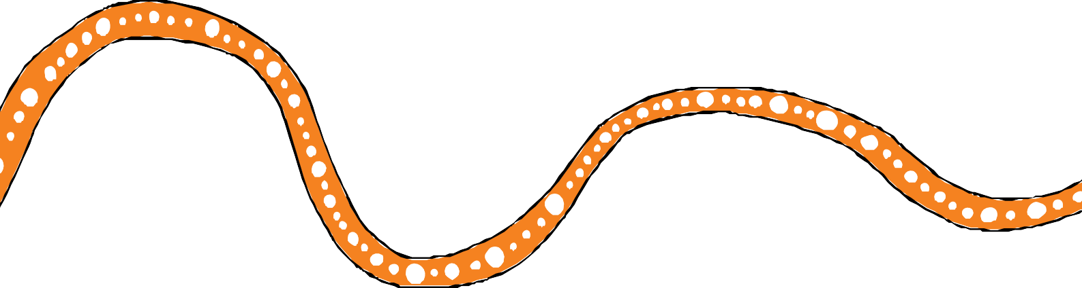

#### Implementation setup at the site level

* DCYJMA expects requests for the delegation of decision making for Aboriginal and Torres Strait Islander children in the early adopter sites in early 2021.
* Local governance groups have been established in each of the early adopter sites with regular communication to discuss local needs and issues.
* Opportunities have been created for local service providers and partners to be heard and have influence on the process and design of new approaches.
* Partners are making efforts to understand issues facing the sector in the delegated authority implementation phase.
* Regular communication channels have assisted in building relationships and a shared understanding and resolving issues.
* Criteria for assessing the suitability of Aboriginal and Torres Strait Islander community controlled organisations to participate in the delegated authority process have been identified by the Board:
  + extensive experience in service delivery and in-depth knowledge and understanding of Queensland child protection system
  + an extensive track record of working effectively with Aboriginal and Torres Strait Islander children, families and communities
  + the trust of the Aboriginal and Torres Strait Islander community as a culturally safe and competent service
  + the decision-making experience, capability and systems to be declared a delegated authority
  + the highest standards of corporate and administrative governance.

11

## Snapshot:

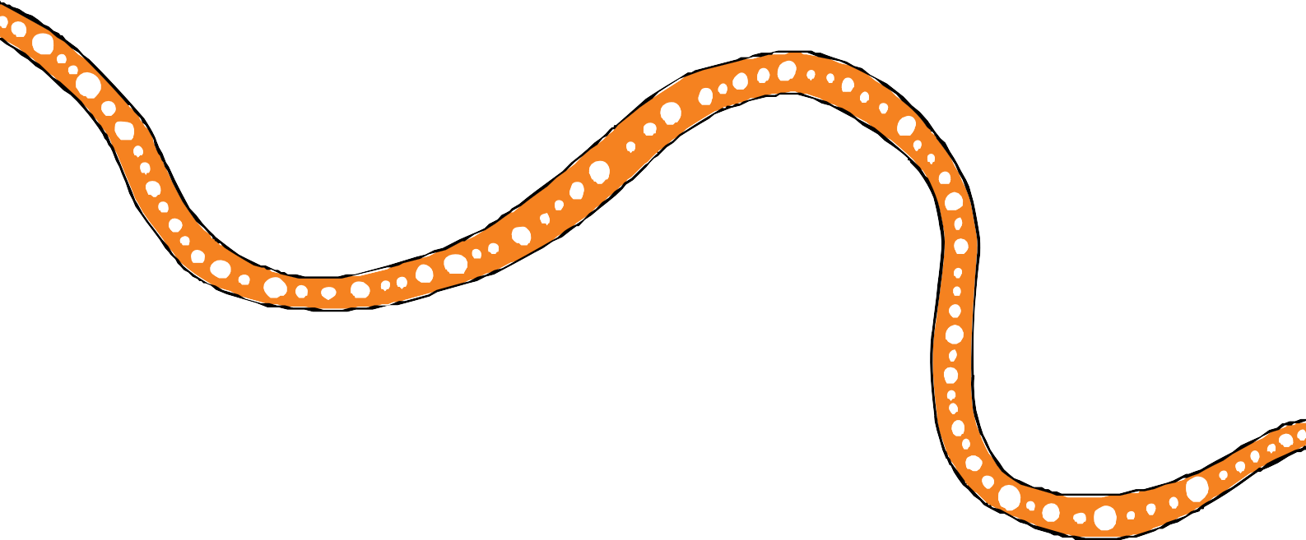

### *Evaluation of Our Way, Changing Tracks (2017–2022)*

#### DCYJMA has engaged Deloitte Access Economics, Murawin and the Social Research Centre to evaluate the Changing Tracks action plans 2017–2019 and 2020–2022 in this first phase of Our Way, using the Changing Tracks Evaluation Plan and the Our Way Monitoring and Evaluation Framework to guide the evaluation activities.6

* + - **Stage 1 2020:** Project planning and establishment of the methodology
    - **Stage 2 2021:** Baseline study – reviewing the Our Way Monitoring and Evaluation Framework, evaluation questions, indicators, and data sources to identify any gaps in available data and applying the wellbeing outcomes framework to design data collection tools. This stage also involves data collection activities (i.e. from document review, surveys and consultations) in order to develop a point in time assessment on progress
    - **Stage 3 2022:** Impact and outcome evaluation – undertaking further data collection to more fully assess system changes, conduct analysis against the agreed indicators, and report on the impact and outcomes of Our Way*,* Changing Tracks according to the key evaluation questions.

12

## Snapshot:

### *Continuous Quality Improvement (CQI) program (DCYJMA)*

#### DCYJMA’s CQI program commenced to review and assess child protection service delivery against nine service delivery standards including:

* culture
* assessment
* planning
* process
* engagement
* leadership
* workforce
* partnership
* systems.



By June 2020, the CQI team had assessed 48 child safety service centres against the service delivery standards and are currently considering the findings and developing improvement plans where required.

The CQI program aims to:

* ensure child protection services are of a consistently high standard and are sustainable
* support continuous improvement and strengthening practice, business systems and processes
* model the *Strengthening families, protecting children framework for practice*
* ensure a strong focus on improving practice and support for Aboriginal and Torres Strait Islander children, young people, parents and families
* influence changes to policies and procedures to support staff to deliver effective services
* make assessments about performance against standards, focusing on outcomes for children, young people, parents and families.

The service delivery standard of ‘Culture’ aims to inform culturally responsive practice with Aboriginal and Torres Strait Islander peoples by assessing DCYJMA’s service delivery to ensure:

* cultural values, protocols and ways of doing business are respected and embraced
* children, young people, parents and families participate in decisions affecting their storyline
* the Aboriginal and Torres Strait Islander Child Placement Principle (ATSICPP) is consistently applied
* children and young people are supported to maintain connection with their parents, family, community culture and country.

13

# Acronyms



ACCO Aboriginal and Torres Strait Islander community-controlled organisations ATSICPP Aboriginal and Torres Strait Islander Child Placement Principle

CQI continuous quality improvement

DCYJMA Department of Children, Youth Justice and Multicultural Affairs DFV domestic and family violence

OOHC out-of-home care

QATSICPP Queensland Aboriginal and Torres Strait Islander Child Protection Peak SNAICC Secretariat of National Aboriginal and Islander Child Care

14

**This appendix outlines the key findings from the *Family Matters Report 2020*.**

**Appendices**

**Appendix A**

*Family Matters Report 2020* findings

The report card provides a subjective assessment by Family Matters of highlights and lowlights and a corresponding traffic light designation in relation to state and territory progress.

This progress can be made on aligning legislation, policy and practice with each of the four building blocks of the Family Matters campaign. Assessments were led by the Aboriginal and Torres Strait Islander community sector and were developed with review and input of state Family Matters jurisdictional representatives and peak Aboriginal and Torres Strait Islander agencies.

In line with the campaign’s commitment to self-determination for Aboriginal and Torres Strait Islander peoples, the views provided in the community voices section of this report have been given significant weight in making assessments.

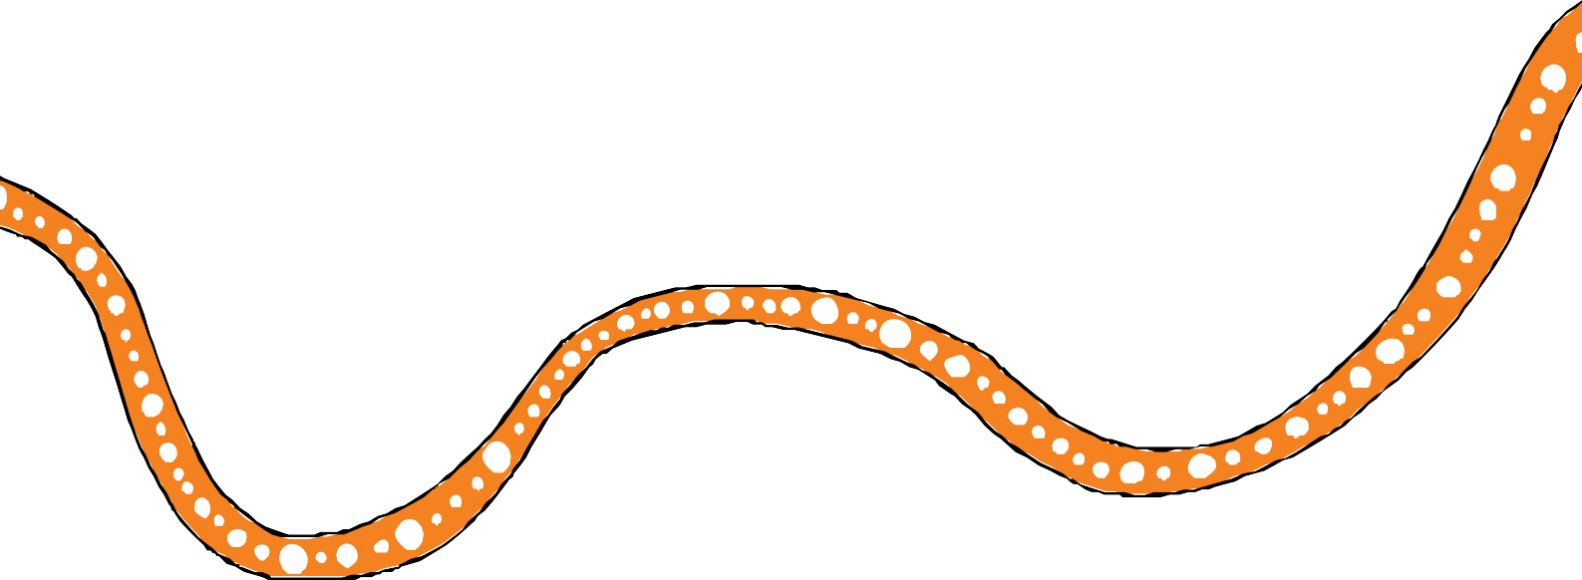Of note, a number of data points in the Family Matters report card are not provided by jurisdiction and, as a result, these are excluded from the assessment. A full list of specific data points considered in identifying highlights and lowlights and making assessments are documented in the *Family Matters Report 2020*.

15

**Table 4.1** Family Matters’ assessment of Queensland’s progress against the four building blocks

**Appendix A**

**Headline indicator Overrepresentation in out-of-home care (OOHC) (rate)\***

**Building block 1: Universal and targeted services**

**Building block 2: Participation, control and self-determination**

**Building block 3: Culturally safe and responsive systems**

**Building block 4:**

*Family Matters Report 2020* findings

**Accountability**

16

|  |  |  |  |  |
| --- | --- | --- | --- | --- |
| 8.8 (Second lowest across all Australian states and territories) | Highest expenditure on ACCOs for family support (14.7 per cent) and intensive family support (24.7 per cent)  Second lowest rate of OOHC over- representation  Lack of and need for data on prevention and early intervention service access**  Appointment of Chief Aboriginal and Torres Strait Islander Health Officer | Establishing systems for true participation, including planning for delegated authority and re-write to improve Family Participation Program guidelines  Aboriginal and Torres Strait Islander peak roles in strategy, policy co-design and sector development  New process for Aboriginal and Torres Strait Islander family-led decision-making in youth justice | Second lowest placement with Aboriginal and Torres Strait Islander carers (34.2 per cent)  Family Caring for Family kinship model under development, led by QATSICPP  No reunification data available  Culturally unsafe Adoption Bill tabled despite significant opposition from community | The Board guides and oversees the Our Way strategy and action plans  External evaluation of the *Our Way* strategy commenced and will validate wellbeing outcomes  Data improvements underway aligned to the ATSICPP  Aboriginal Commissioner appointed with mandate to focus on systemic issues for Aboriginal children |

##### Key *Very poor* *Poor* *Promising/improving* *Stronger practice/outcomes*

*Source: Family Matters (2020).*

*\* Lower rate is better. In terms of counting rules, it is noted that Family Matters re-includes children on third party parental responsibility orders in the count for over-representation in OOHC.*

*\*\* This finding by Family Matters relates to data on access to Aboriginal and Torres Strait Islander services only. This is not necessarily applicable in the case of non-indigenous services, where data on access by Aboriginal and Torres Strait Islander peoples is available, based on information provided by DCYJMA.*

#### This appendix summarises key outcomes of actions delivered under the first Changing

**Appendix B**

Key achievements from *Changing Tracks action plan 2017–2019*

**Tracks action plan (2017–2019) between July 2019 and June 2020.**

|  |  |
| --- | --- |
| **Action** | **Key outcomes** |
| **Action 3.2**  **Partner with three Aboriginal and Torres Strait Islander remote communities to build a coordinated, place-based**  **universal and secondary service system** | * Trial models were conducted under the Child and Family Service Reform initiatives in Cherbourg, Woorabinda and the Torres Strait and focused on delivery of the community-based intake and referral model in remote communities. The Premier approved Doomadgee and Mornington Island as the next three trial sites. The projects aim to provide greater community control over the services delivered to residents and ensure accountability to the community. |
| **Action 3.3**  **Develop future service delivery models for Aboriginal and Torres Strait Islander peoples based**  **on the findings from trials of domestic and family violence prevention and family support systems** | * The Doomadgee Strong Women’s Group, an advocacy group with emerging leaders, was established to address domestic and family violence (DFV) and drive change in the community. * The Queensland Government released *Queensland’s Framework for Action: Reshaping our approach to Aboriginal and Torres Strait Islander domestic and family violence,* which sets out a new way of working and key actions including community led action plans, specialist DFV positions within five Aboriginal and   Torres Strait Islander Family Wellbeing Services and strengthening procurement processes to include Aboriginal and Torres Strait Islander perspectives and prioritise cultural capability.   * Established four DFV targeted services for Aboriginal and Torres Strait Islander peoples to support victim safety and highlight perpetrator accountability. |
| **Action 4.1**  **Strengthen kinship care investment, supports and resources to maximise the use of kinship care placements** | * An expression of interest process with five existing foster and kinship care agencies was undertaken to trial incentivised one- off payments for the identification and successful placement of children and young people with suitable kin. * Consultants reviewed carer training and assessment. |

17

**Appendix B** Key achievements from *Changing Tracks action plan 2017-2019*

|  |  |
| --- | --- |
| **Action** | **Key outcomes** |
| **Action 4.5**  **Undertake family and kin mapping for Aboriginal and Torres Strait Islander**  **young people in out-of-home care who are not already connected to family and kin** | * The Department of Seniors, Disability Services, Aboriginal and Torres Strait Islanders Partnerships (formerly known as   Department of Aboriginal and Torres Strait Islander Partnerships) has provided, and continues to provide, family and kinship mapping for Aboriginal and Torres Strait Islander children and young people in care who are not already connected to family and kin, in instances where parental consent is obtained. Between 2017 and 2019, outcomes achieved included:   * + in 2017–18, 15 child safety related requests were received and 14 completed   + in 2018–19, 30 child safety related requests were received, of which 10 were completed, 6 lapsed and 14 were outstanding at the time   + from July-November 2019, 4 child safety related requests were received and completed. |
| **Action 6.4**  **Design a holistic Aboriginal and Torres Strait Islander child and family wellbeing outcomes framework and investment plan** | * Winangali Pty Ltd was commissioned to develop the framework, including a detailed mapping analysis of relevant existing Queensland Government strategies, action plans and frameworks and their alignment with the Our Way strategy. * Targeted consultation was undertaken across Queensland to test and validate Aboriginal and Torres Strait Islander peoples’ definition of holistic wellbeing and gain an understanding of the outcomes and priorities for Aboriginal and Torres Strait Islander peoples. A final report and wellbeing outcomes framework was completed end 2019. |
| **Action 6.5**  **Negotiate a Queensland First Children and Families partnership agreement between Family Matters Queensland and the Queensland Government to assist in implementing Our Way and Changing Tracks** | * A partnership agreement, between Family Matters Queensland, Department of Seniors, Disability Services and Aboriginal and Torres Strait Islander Partnership and DCYJMA was drafted, as a commitment by partners to work collaboratively to deliver the Our Way strategy and associated action plans. * A publicly available signed copy of the official partnership agreement will be made available to other Queensland Government agencies and family and child sector organisations and peaks to become signatories and make their commitment to the agreement. |
| **Action 6.6**  **Analyse current investment in sector capacity and workforce capability to help inform future investment to build the child and family sector** | * The Queensland Family and Child Commission drafted a report bringing together Queensland Government investment data in the child and family support sector, narrative of the scope of sector capacity and work capability, and insights from engagement with community-controlled organisations. The report can be used as   a resource to assist government and the community in building a stronger child and family sector. |

18

**Appendix B** Key achievements from *Changing Tracks action plan 2017-2019*

|  |  |
| --- | --- |
| **Action** | **Key outcomes** |
| **Action 6.7**  **Develop capability strategy with mainstream child and family service organisations** | * Following approval of several cultural capability products including the *Respectful language guide, The valuing of Aboriginal and Torres Strait Islander people’s knowledge lens* and the self-assessment tool *Our Journey, My Story*, an   implementation and engagement plan was developed to support the embedding of these products. |
| **Action 6.9**  **Implement solutions to integrate e-records across Aboriginal and Torres Strait Islander family wellbeing services** | * An options analysis for integration of e-records report was developed. The final recommendation was the ‘do nothing’ option, as the varied electronic medical records systems used by service providers increased the complexity of integration, with the cost to providers in time and resources likely to result in limited uptake in commitment. * Alternative ways to improve service access and responsiveness across Aboriginal and Torres Strait Islander family wellbeing services will continue to be explored and implemented where practical. |
| **Action 6.10**  **Review child protection practices** | * The structured decision-making tools were reviewed and revised, to recognise cultural knowledge and strengths. Several key stakeholders were consulted as part of the review. Further embedding of the Aboriginal and Torres Strait Islander Child Placement Principle is included in *Changing Tracks action plan 2020-2022*. |
| **Action 6.13**  **Develop an investment strategy for culturally safe prevention, early intervention and perpetrator services to address youth sexual violence and recovery services for young Aboriginal and Torres Strait Islander women** | * Several investment activities have taken place to address sexual violence including:   + range of service enhancements in Rockhampton, Gladstone, Toowoomba, South Burnett and Caboolture   + government released *Prevent. Support. Believe. Queensland’s framework to address sexual violence*   + government announced that community-led action plans to prevent youth sexual violence would be developed in   Toowoomba, Yarrabah and on the Fraser Coast, subject to the agreement of those communities.   * DCYJMA is also providing funding to initiatives in West Cairns and Aurukun to respond to the impacts of sexual violence on Aboriginal and Torres Strait Islander children and young people. |

19

**Appendix B** Key achievements from *Changing Tracks action plan 2017-2019*

|  |  |
| --- | --- |
| **Action** | **Key outcomes** |
| **Action 6.11**  **Design a Queensland Aboriginal and Torres Strait Islander healing strategy** | * The Healing Foundation has been working with Aboriginal and Torres Strait Islander Queenslanders since January 2020 to   co-design and develop the first ever Queensland Healing Strategy (*Leading healing our way*). This document has arisen from the Our Way strategy, which acknowledges that the Queensland Government and society have to work differently to realise the potential and promise of Aboriginal and Torres Strait Islander children and families.   * The healing strategy was underpinned by research and knowledge about Aboriginal and Torres Strait Islander wellbeing, trauma and healing documented in the *Keeping spirit strong* research report. Together, the *Keeping spirit strong* and *Dreaming big* consultation evidence provides the rationale for the Queensland Aboriginal and Torres Strait Islander Healing Strategy. *Leading healing our way* was delivered to DCYJMA in July 2020. |

20

#### This appendix provides an overview of the evaluation approach, community engagement strategy and cultural considerations in the evaluation of Our Way and the Changing Tracks action plans.

**Appendix C** Our Way evaluation

**Data sources for the 2019–20 annual progress report**

This progress report was informed by document analysis of:

* information provided by DCYJMA and Changing Tracks action leaders
* publications by key organisations, such as:
  + the governance review of the Board by the Australian Indigenous Governance Institute (AIGI)
  + Healing Foundation’s Healing Strategy, Voices we Heard and Research and Co-design Report
  + the review of the implementation of the Aboriginal and Torres Strait Islander Child Placement Principle (ATSICPP) by the Secretariat of National Aboriginal and Islander Child Care (SNAICC)
  + *Family Matters Report 2020*
  + DYJMA performance data.

#### Overview of evaluation approach

The evaluation of Our Way, Changing Tracks, commissioned by DCYJMA, spans June 2020 to the end of 2022. This evaluation will canvass changes at a system level, focusing on assessing whether legislation, policy and practice is starting to shift to enable long-term changes. An evaluation team, comprising researchers and evaluators from Deloitte Access Economics, the Social Research Centre, and Aboriginal and Torres Strait Islander team members from Murawin, are currently delivering this project.

The evaluation approach is based on evaluation questions as set out in the Changing Tracks evaluation plan and indicators as outlined in the Our Way monitoring and evaluation framework.

#### Community engagement

The engagement strategy with Aboriginal and Torres Strait Islander peoples involved in the evaluation is flexible in respect of diverse needs and preferences of the local communities.

As endorsed by the Board, eight community sites across Queensland have been selected for the evaluation, including Thursday Island, Cairns, Yarrabah, Mount Isa, Woorabinda, Rockhampton, Caboolture and Logan.

21

The evaluation team has begun engaging with service providers, including ACCOs that are providing child and family support programs, in the eight case study community sites to obtain support for participation in the evaluation. For each community participating in the evaluation, the evaluation team has identified a key point of contact (or small group of lead contacts) from these organisations to discuss opportunities to promote participation in the evaluation to the wider community, evaluation timings, cultural protocols, scheduling of consultations and other logistical considerations.

**Appendix C** Our Way evaluation

The evaluation team has also contacted DCYJMA’s regional staff to support engagement with the local service providers in the eight community sites. Advice is being sought from these officers for suitable contacts in the local ACCOs.

The evaluation team is mindful of the complexities within stakeholder groups, including Aboriginal and Torres Strait Islander communities, service providers and government, particularly in the context of statutory care responsibilities and arrangements. The evaluation team will facilitate engagements with key stakeholders in a sensitive and culturally respectful way. This is to ensure that they understand the objectives of the project, have considered the potential risks and benefits to the community and have the capacity to support the project. No primary data collection of participant engagements will commence until ethics approval is provided and the local level protocols and approaches are agreed to with community representatives and service providers.

The evaluation team recognises that pre-fieldwork recruitment and engagement process takes time and should not be done in haste. This commitment of time and effort is paramount to ensure genuine and positive working relationships with communities which are established on trust

and mutual respect. Furthermore, the evaluation team is cognisant that multiple communication styles and channels, which require time to develop, are necessary to facilitate the communities’ understanding of the evaluation activities, particularly when there are other evaluations on similar topics being rolled out in the field in parallel. To date, support to participate in the evaluation has been provided by all the selected community sites via formal letters and ongoing conversations with Murawin.

#### Cultural considerations

Cultural considerations are central to the evaluation approach. The evaluation approach to collecting qualitative data will ensure cultural safety, data sovereignty, and enable principles of self-determination. Personnel from the evaluation team who conduct fieldwork will also receive training on cultural competence and sensitivity. Focus group and interviewing techniques will favour a process that encompasses a question and answer approach coupled with a storytelling narrative approach to assist with ease of interviewee engagement, data collection and validation of experiences.

22

To ensure cultural appropriateness and safety in the discussion, each community consultation will be led by an Aboriginal or Torres Strait Islander interviewer and supported by a non-Aboriginal or Torres Strait Islander specialist evaluator. The evaluation team can provide participants with

**Appendix C** Our Way evaluation

a choice of interviewers where feasible, as well as seeking to recruit single sex groups or gender match interviewers with the participants. The engagement approach reflects the principles of consultation, free, prior and informed consent, mutual understanding, and respecting Aboriginal and Torres Strait Islander knowledge systems.

The semi-structured interviews and focus groups that will be conducted to collect qualitative information will utilise the Indigenous research method of ‘yarning’. The yarning approach will be inclusive of three identifiable processes for culturally appropriate discussions:

* social yarning — this will enable the researcher and interviewee to establish trust
* research topic yarning — this is a relaxed but purposeful conversation with the view of gathering information that is specifically related to the research topic
* collaborative yarning — this involves sharing information, exploring ideas with the aim of explaining new topics and leading to new insights and understandings.

Further, Aboriginal and Torres Strait Islander cultures in many settings highlight the importance of collective responsibility and approaches to problem solving. To accommodate this position, participants in consultations will be encouraged to invite a support person as needed.

Finally, the evaluation team understands that participants in the evaluation activities should stand to benefit from and not be disadvantaged by the project. The evaluation team will seek to engage with community Elders and leaders to understand a preferred method of reimbursement. If appropriate, a financial reimbursement can be offered to Aboriginal and Torres Strait islander community participants to cover their time.

#### Reporting arrangements

The upcoming reports in the evaluation of Our Way, Changing Tracks, as well as progress report of the Our Way strategy, are outlined in the following table:

|  |  |
| --- | --- |
| **Report** | **Planned schedule** |
| Baseline study report for the evaluation of Our Way, Changing Tracks | Mid 2021 |
| Changing Tracks Annual Progress Report 2020-21 | Late 2021 |
| Report for the evaluation of Our Way, Changing Tracks | Mid 2022 |
| Revised monitoring and evaluation framework and plan for Our Way and its associated action plans and recommendations for next phase of monitoring and evaluation | Mid 2022 |

*Source: Information provided by DCYJMA (2021).*

23

# References

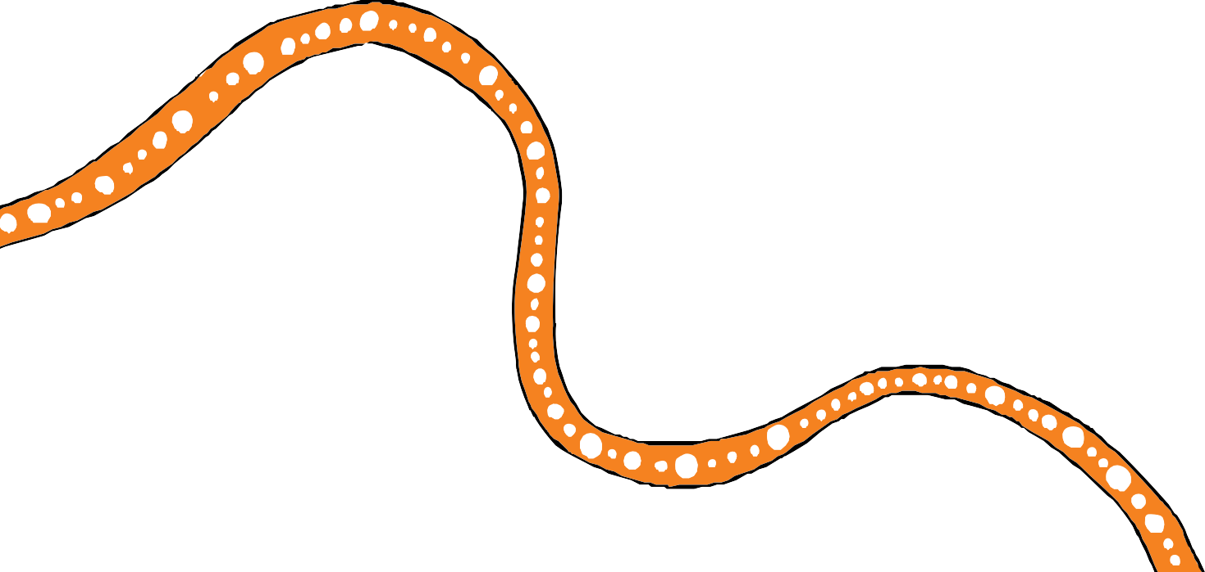

24



1. https:/[/www.family](http://www.familymatters.org.au/wp-content/uploads/2020/11/FamilyMattersReport2020_)m[atters.org.au/wp-content/uploads/2020/11/FamilyMattersReport2020_](http://www.familymatters.org.au/wp-content/uploads/2020/11/FamilyMattersReport2020_) LR.pdf
2. https://qed.qld.gov.au/publications/reports/annual-report/our-service-performance/every- student-succeeding#:~:text=In%20December%202019%2C%20we%20built,Strait%20 Islander%20student%20succeeding%20strategy
3. https:/[/www.csyw.qld.go](http://www.csyw.qld.gov.au/resources/campaign/supporting-families/changing-tracks-)v[.au/resources/campaign/supporting-families/changing-tracks-](http://www.csyw.qld.gov.au/resources/campaign/supporting-families/changing-tracks-) evaluation-plan.pdf

**Story of the motif**

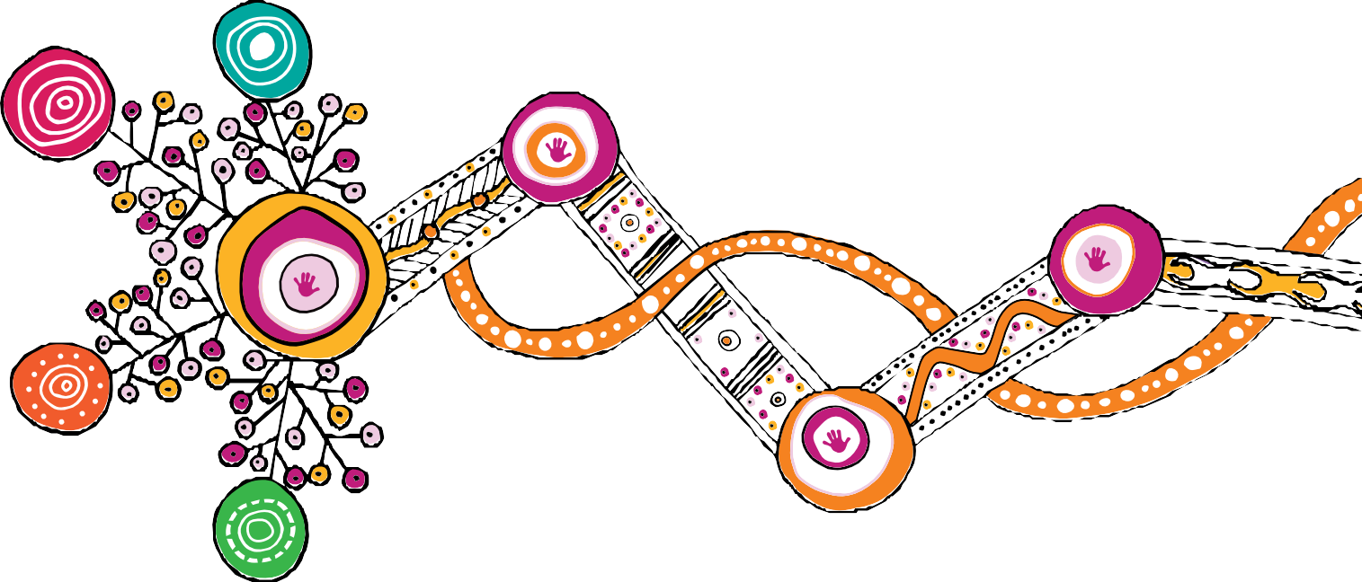

**The motif artwork was created by Rachael Sarra, an Indigenous artist and designer from creative agency Gilimbaa. Rachael originates from the Bunda People in Goreng Goreng country.**

**The motif design is a reflection of equal partners joining together in conversation and positive action. It represents a clear and focused pathway that began as the dispersed energy of many that has now fused to channel clarity, momentum, and strength. It shows the power of unity and simplicity that evolves from complexity. The artwork shows the journey of the child, depicted as the hands, connected to and supported by structures that nurture and guide.**

**Through the woven orange line it acknowledges culture, kin and the strength of learning from the past to act in the present and grow for the future.**

The text in this publication is licensed under a Creative Commons Attribution-NonCommercial-ShareAlike

4.0 International

The artwork in this publication is the property of the Queensland Government (Department of Child Safety, Youth and Women) and is licensed under a Creative Commons Attribution-NonCommercial-NoDerivatives

4.0 International

Visit <http://creativecommons.org.au/>for more information about Creative Commons licences.

© The State of Queensland (Department of Children, Youth Justice and Multicultural Affairs) 2021

Copyright protects this publication. Excerpts may be reproduced with acknowledgement of the State of Queensland (Department of Children, Youth Justice and Multicultural Affairs).

Department of Children, Youth Justice and Multicultural Affairs Locked Bag 3405, Brisbane QLD 4001

[www.cyjma.qld.gov.au](http://www.cyjma.qld.gov.au/)

0890_JUNE2021

