Health and social wellbeing — older Queenslanders

To progress towards an age-friendly Queensland where seniors are supported to make an active contribution to their community and lead a full and healthy life, we need to understand how seniors currently participate in, and connect with, their communities and social networks, and can be supported to make healthy lifestyle choices.

This fact sheet examines the civic and social participation of older Queenslanders, through provision of informal care, unpaid child care and volunteering, and how seniors remain connected to others. It also looks at the current health, physical activity and education levels of seniors.

**Who do we mean by older Queenslanders?**

For this fact sheet, older Queenslanders (or seniors) refers to persons aged 65 years and over, unless specified otherwise in the text and charts.

Longevity and good health

Queenslanders are living longer. A female baby born in 2020–2022, could expect to live to 85.0 years, on average — an increase of 2.6 years compared with a baby born in 2000–2002. Similarly, a male baby born in 2020–2022 could expect to live, on average, to 80.7 years — an increase of 3.5 years since 2000–2002.

**Figure 1: Life expectancy, Queensland, 2020–2022**



For many Queenslanders, these additional years of life are enjoyed in good health, while for others these years are impacted by disability and illness.

Health-adjusted life expectancy (HALE) is used as a measure of the time an individual at a specific age can, on average, expect to live in full health, without the health consequences of disease and injury.

The latest HALE data by age group indicated that for Queenslanders aged 65 years in 2018, males had a further 14.7 years in good health (74.8% of remaining life in full health), and females had a further 16.4 years (72.7% of remaining life in good health).

***Spotlight on COVID-19 pandemic***

The most recent life expectancy estimates are the first to include all three years of the COVID-19 pandemic. Nationally, life expectancy decreased in 2020–2022 for the first time since the mid 1990's, in part, due to the pandemic. Of the 190,939 deaths registered in 2022, 9,856 were due to COVID-19 (underlying cause of death). These included 1,580 deaths registered in Queensland, of which 1,466 were among people 65 years and older.

Leading causes of death typically vary with age and sex. COVID-19 was the third highest leading cause of death among men aged 85 years and older, and the fourth highest among their female peers. For both men and women aged 95 years and older, Dementia (including Alzheimer's disease) was the leading cause of death.

**Figure 2: COVID-19 as a leading cause of death, Queensland, 2022**



Health behaviours and lifestyle choices

The *Health of Queenslanders 2016* report noted that almost half (46%) of the deaths of those aged 65–74 years in 2012 were due to lifestyle-related chronic conditions. The good news was that death rates were decreasing for major conditions, with risk of premature death from a lifestyle-related chronic condition decreasing by 23% over a decade.

This was mainly attributed to:

* a steady decrease in tobacco use
* improved levels of physical activity
* improved monitoring of blood pressure and lipids
* earlier diagnosis and treatment of cardiovascular disease.

For older Queenslanders, measures of key modifiable risk factors from the Queensland Preventative Health Survey show that being overweight/obese remained the top risk factor for both older men and women in Queensland in 2022, with 61.6% of older women falling into this category, along with 68.6% of older men. A key protective factor for both sexes was sufficient daily fruit intake (Figure 3).

**Figure 3: Prevalence of health risk factors among older Queenslanders by sex, 2021–2022**



Australia’s physical activity and sedentary behaviour guidelines recommend that older people engage in strength activities two or three times a week to help maintain bone strength.

In 2021, slightly fewer than 1 in 2 older Queenslanders were reported as having sufficient physical activity. In 2022, this group were reported to have had an average of 6.9 physically unhealthy days in the 30 days prior to being surveyed.

The importance of physical activity to the health and wellbeing of older people is well researched. Sufficient physical activity has long been recognised as a protective factor against cardiovascular disease, associated with improved mental health, delaying the onset of dementia, and reducing falls risks.

**Spotlight on Dementia**

In 2021, there were an estimated 74,710 Queenslanders living with dementia. It is projected that dementia will affect 147,410 older Queenslanders (11.3%) by 2036.

Dementia is the leading cause of disease burden in women and the second leading cause of burden of disease in men among people aged 65 years and over in Australia. It is also a significant cause of disability in Australians aged 65 years or older, with 1 in 12 affected by the disease in this age group.

Hospitalisation rates for fall in older Queenslanders have increased significantly over time, from 2,174 per 100,000 persons in 2002–03, to 4,962 per 100,000 persons. Rates increase with increasing age, and are higher among older females than older males. Falls present a significant risk to the ongoing health and wellbeing of older people and can result in fractures, most commonly to the hip.

**Figure 4: Hospitalisations for falls among older Queenslanders by age and sex, 2020–21**

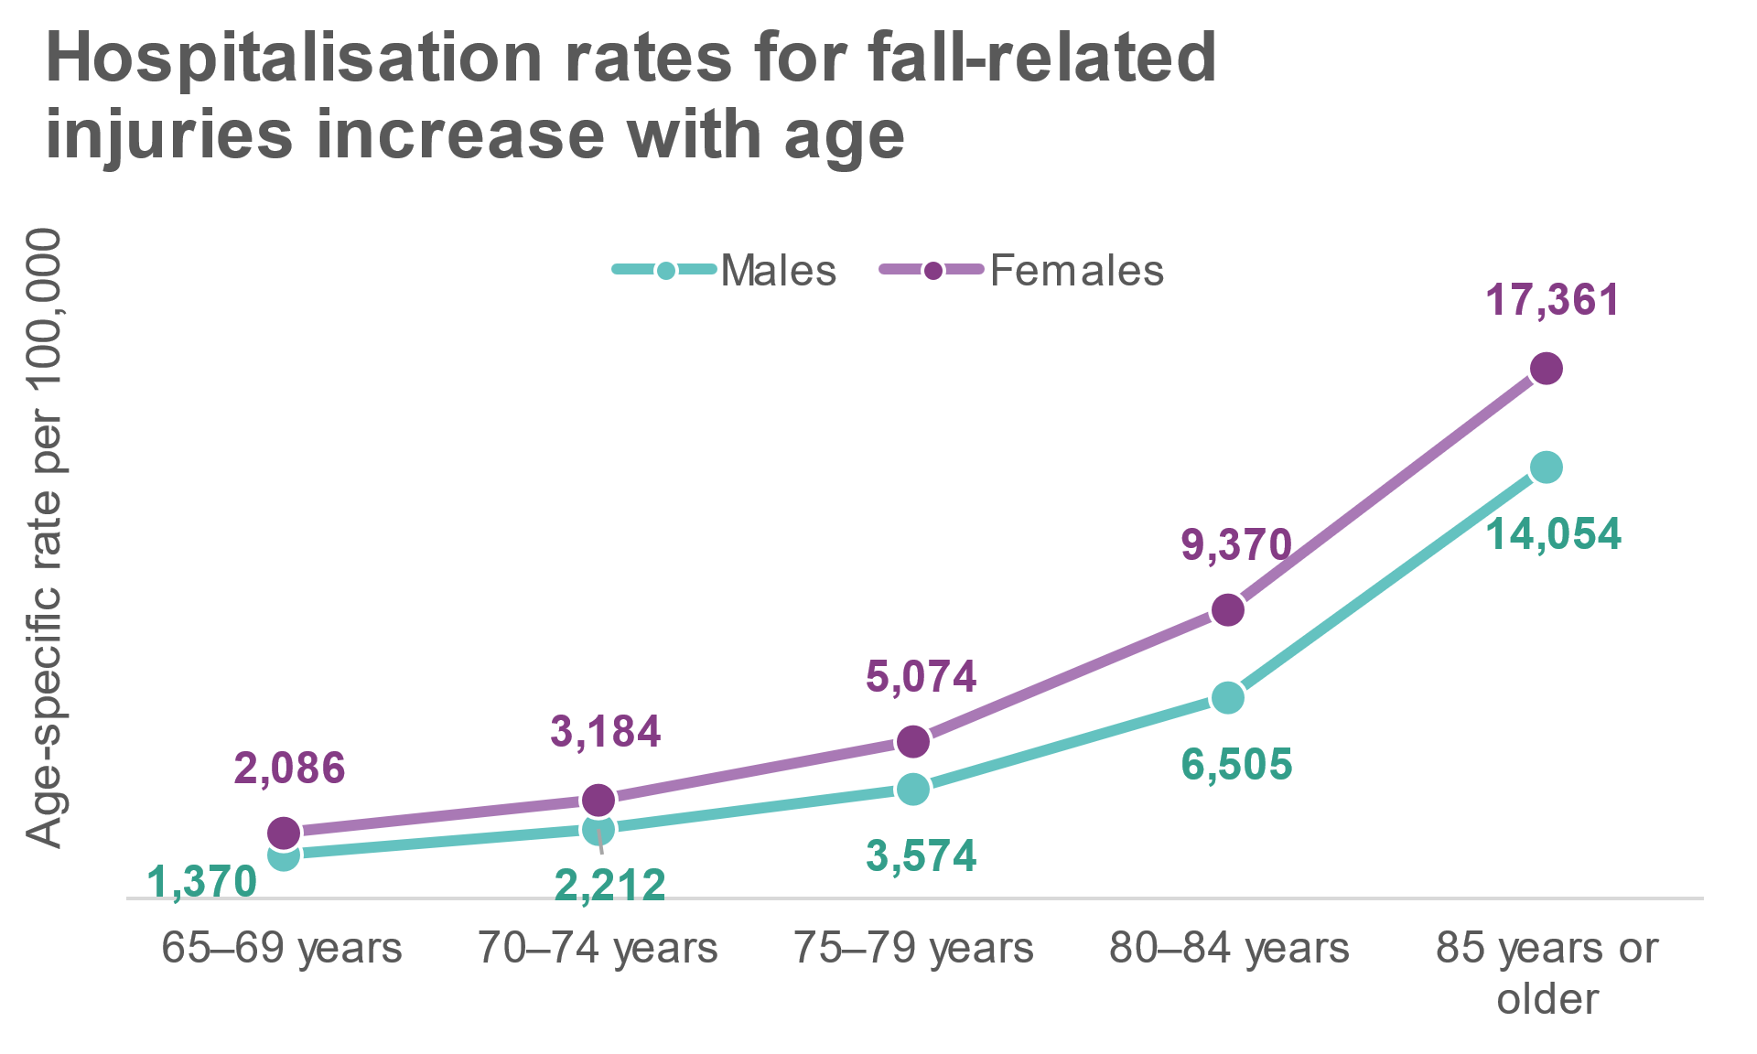

Figure 5 shows hospitalisation rates among older Queenslanders for selected chronic conditions that cause high levels of mortality and morbidity. These conditions are also considered to be preventable. For example: the significant risk factor for chronic obstructive pulmonary disease is smoking and exposure to tobacco smoke; excess body weight and lack of physical activity are risk factors for type II diabetes; and stroke and coronary heart disease are largely preventable, with risk factors including high blood pressure, being overweight, smoking, high cholesterol, high alcohol intake and diabetes.

**Figure 5: Hospitalisations for selected chronic conditions among older Queenslanders by age and sex, 2020–21**



Older people are using the internet to connect

The 2023 Australian Digital Inclusion Indexfound that digital ability decreases with age. Scores decreased steadily from 82.9 among 18–34 year olds to 42.3 among 65–74 year olds, before falling sharply to 23.3 among people 75 years and older. Never-the-less, among those older Australians using the internet, almost all use it to access government services. Keeping touch with family or friends was the next main use, followed by managing money, comparing prices, and online buying and selling. Other top 10 uses were accessing health services, entertainment services and learning or study (Figure 6).

**Figure 6: Selected reasons for accessing the internet in the last year, older Australians, 2022**



At the Queensland level, results from the Australian Digital Inclusion Index (ADII) 2018 showed that older Queenslanders were the least ‘digitally included’ demographic, and the second most digitally excluded group after people in low-income households. However, improvements in older Queenslanders’ digital inclusion outpaced the overall statewide increase over the reporting period (2014 to 2018).

As the importance of the internet grows as a medium for information exchange and access to essential services, ensuring older Queenslanders can access the internet becomes critical. With a growing older population and the most decentralised population in Australia, improving digital connectivity among older Queenslanders could be especially helpful in harnessing economic and social capital in rural and remote areas of Queensland.

Education attainment

The highest level of educational attainment for older Queenslanders varied considerably by age group according to results from the 2021 Census (Figure 7). Older Queenslanders aged 65 to 74 years had higher levels of educational attainment compared with those aged 75 years and older.

Not all older Queenslanders would have had the opportunity to attend secondary school. The highest compulsory attendance age of Queensland school students was 14 years of age up until 1963, and many students did not continue school beyond that. Not only were there few state secondary schools prior to the 1960’s, the progression of young Queenslanders into secondary education was determined by their results from the state scholarship exam.

Each new generation has benefited from improved access to, and standards of, higher education in Queensland.

**Figure 7: Highest education attainment, older Queenslanders by age group, 2021**

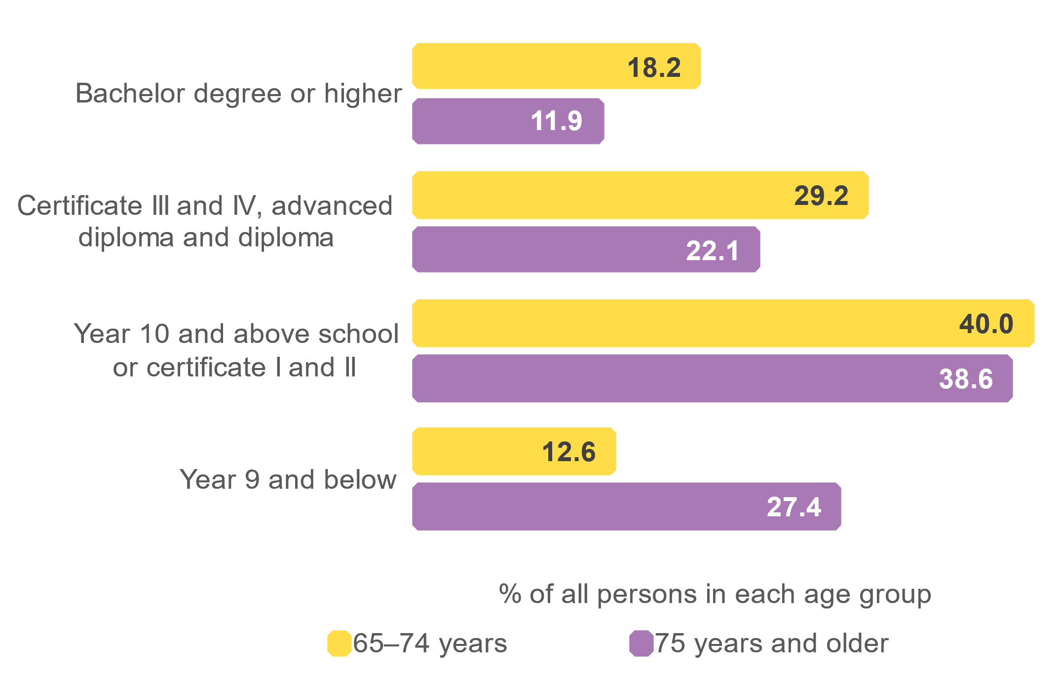

Looking forward, the proportion of older Queenslanders educated to higher levels is expected to increase, with younger age groups expected to complete higher education courses to gain employment positions that in decades past, would have been offered as on-the-job training or via cadetships etc. For example, prior to the 1990s, registered nursing training was undertaken in hospitals, however, by 1994, it had fully transitioned to the university sector.

Education attainment also varies by sex for older Queenslanders, with females less likely to be educated to a higher level than males. There were also clear differences between the sexes in the field of study of an older person’s highest completed non-school qualification (Figure 8).

**Figure 8: Field of study of the highest completed non-school qualification, older Queenslanders(a) by sex, 2021**

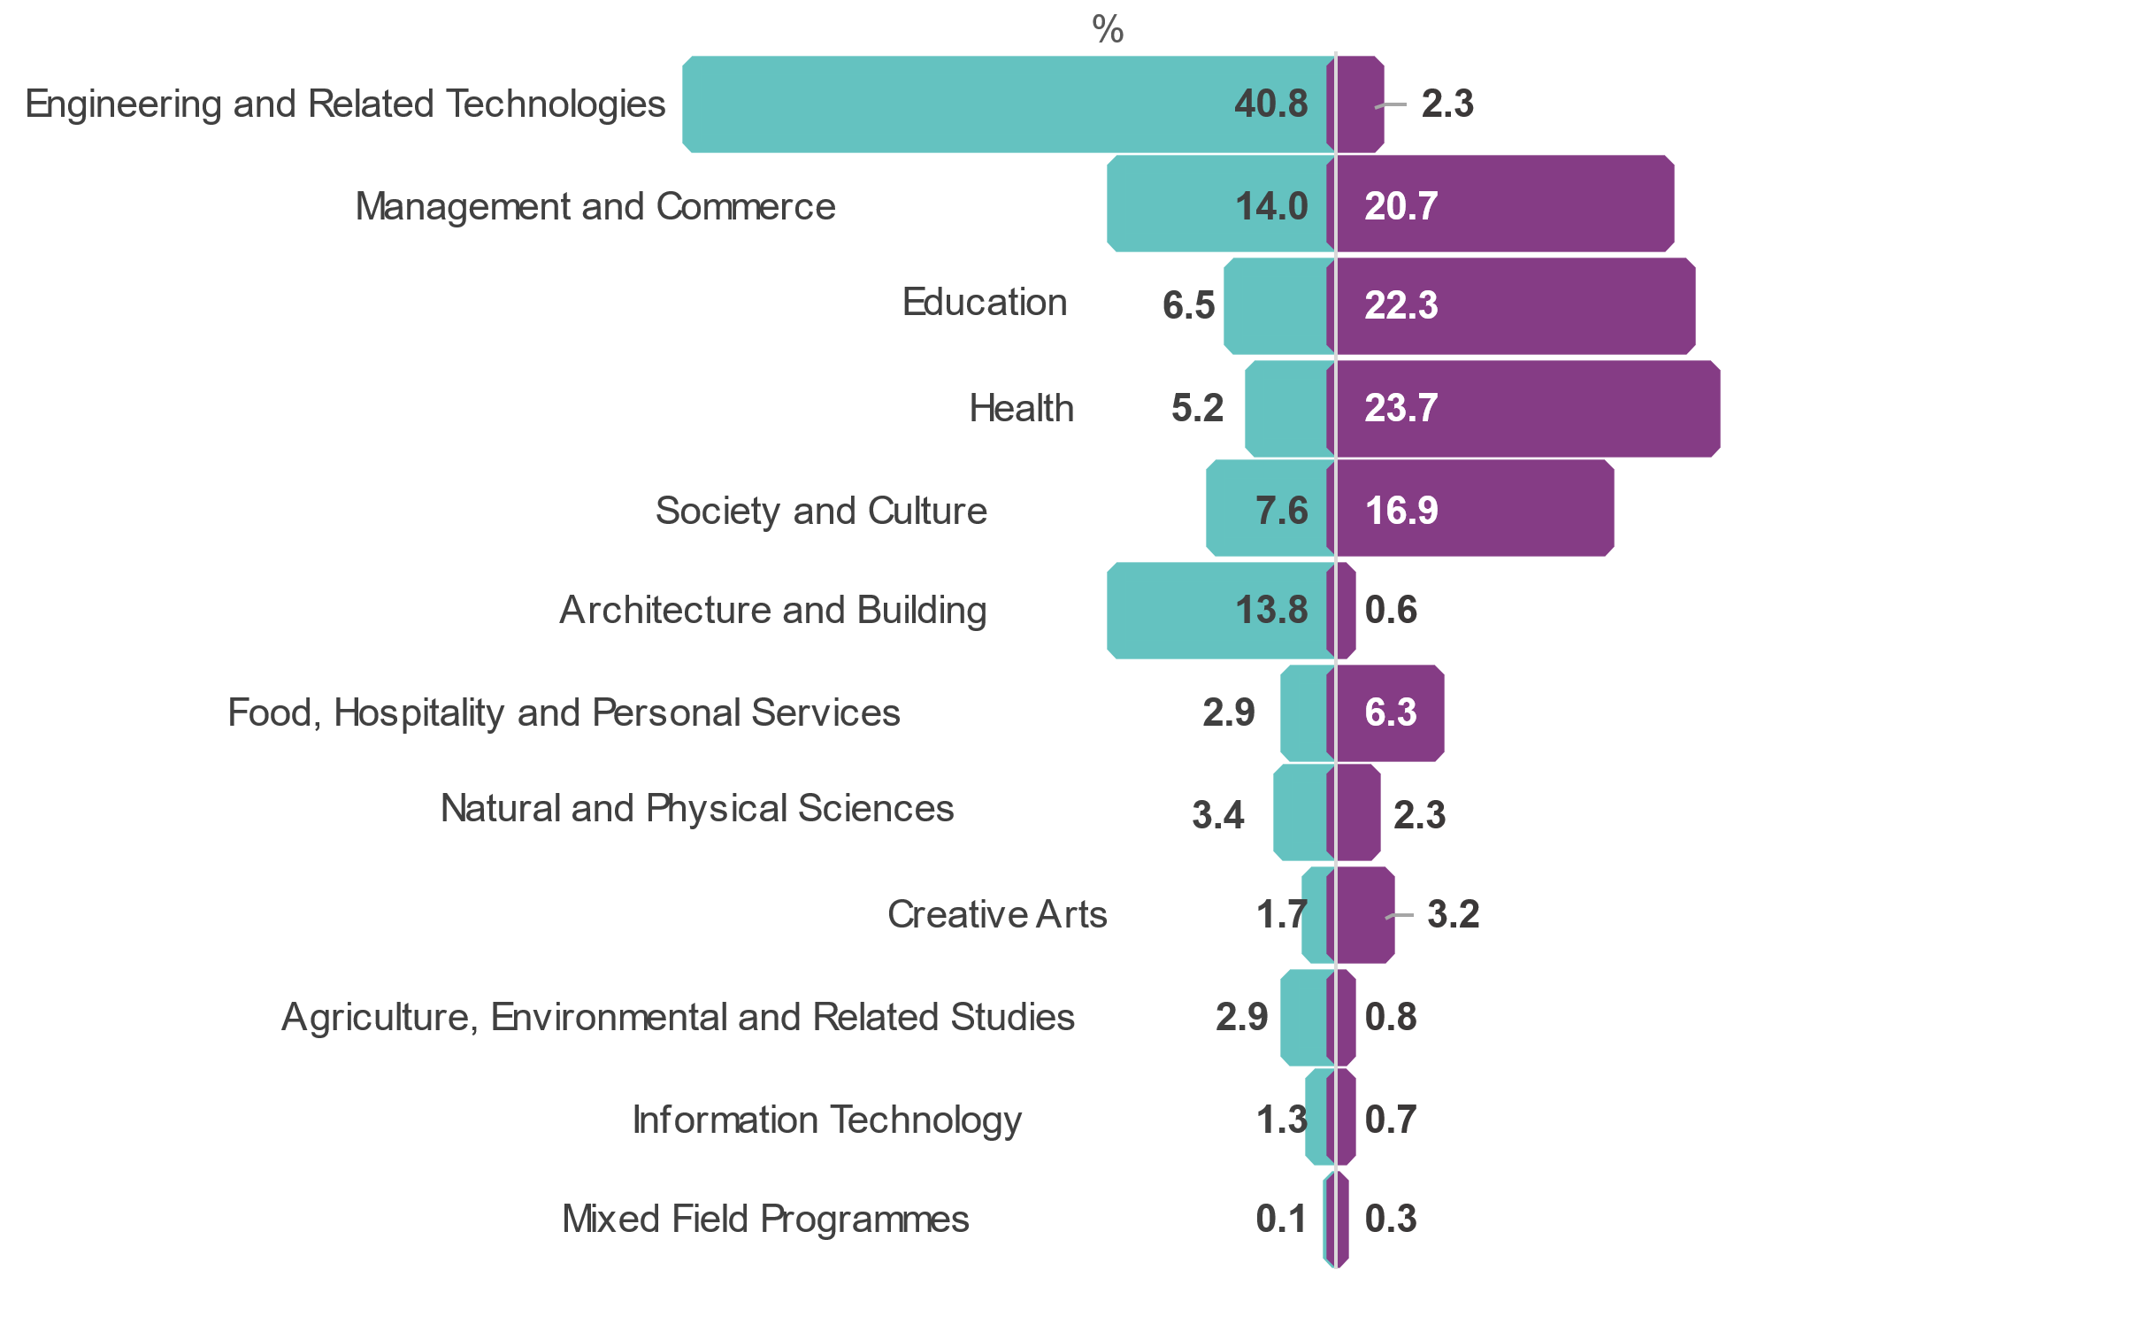

% qualified males

% qualified females

Driver licence possession declines with age

More than 4 in 5 (86.0%) older Queenslanders had a current driver licence in June 2023 with the proportion possessing a licence declining with age (Figure 9).

Among older Queenslanders, loss of licence is likely to be associated with medical conditions that impact on driving ability. These conditions commonly include impairments to cognition, vision or physical movement. In Queensland, everyone 75 years or older must obtain (at least every 13 months) a medical certificate to assess their ability to drive safely.

**Figure 9: Proportion of older Queenslanders with a driver licence by age group, June 2023**



The loss of a driver licence as people age can have a significant impact on their ability to play an active role within their community and to connect with family and friends, particularly if public transport options are limited or if ill-health or disability impacts their everyday mobility.

Need for assistance

Statistics about the disability status, and need for assistance of older Queenslanders was collected in the Survey of Disability, Ageing and Carers, last undertaken in 2018, and also results from the 2021 Census of Population and Housing. Questions from these two products are not directly comparable, never-the-less they both offer insights into older Queenslanders needs for support and assistance.

Around one third (38.3% or 293,400 people) of older Queenslanders were estimated to have needed assistance with at least one activity in 2018, slightly higher than the proportion in 2015 (36.3%). In 2018, 1 in 4 (26.2%) needed assistance with personal activities, including health care (24.6%), mobility (17.9%) and self-care(11.7%). Other tasks commonly reported needing assistance with included property maintenance (19.5%), household chores (17.0%) and transport (15.6%).

Need for assistance increased with age, ranging from 1 in 4 aged 65–69 years in need, to nearly 9 in 10 aged 90 years and over. In almost all age groups, a higher proportion of males were in need of care for at least one activity, than females (Figure 10).

**Figure 10: Proportion of older Queenslanders needing assistance with at least one activity by age group, 2018**



The 2021 Census counted those who had a need for assistance with core activities due to a long-term health condition, disability or old age (profound or severe disability). Overall, almost 1 in 5 older Queenslanders reported that they had a need for assistance with core activities, with this need increasing with age (Figure 11).

**Figure 11: Proportion of older Queenslanders needing assistance with core activities by age group, 2021**



**Figure 12: Proportion of older Queenslanders needing assistance with core activities by selected LGAs, 2021**

There were variations between regions in the proportions requiring assistance. When looking at Local Government Areas (LGAs) with 100 or more older Queenslanders, in 15 LGAs at least 20% of older people had a core activity need for assistance.

The highest proportion was in Torres Strait Islands, where 1 in 3 older people needed support, followed by Yarrabah and Palm Island.

Older Queenslanders play an important role in providing informal care

Older carers make an important contribution to the lives of others by providing informal care to another person, most commonly their partner, but also to adult children with disability or illness, elderly parents or other family members.

Almost 1 in 5 (17.5%) older Queenslanders, living in households, were carers of someone else in 2018. Nearly 2 in 5 (38.6%) of these were primary carers, with older females much more likely to be primary carers than older males (48.6% compared with 30.0% respectively).

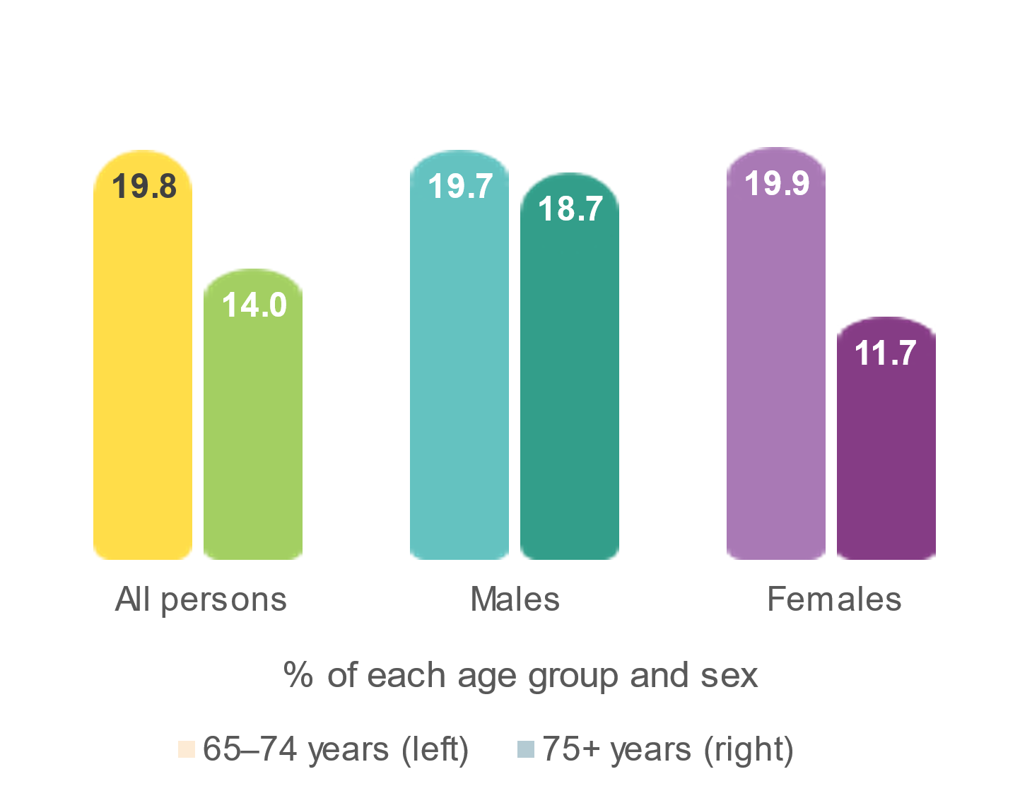Although the proportion of older Queenslanders providing care for someone else declined after the age of 75, males were more likely than females to be a carer in their older age (Figure 8).

Figure 8: Proportion of older Queenslanders who were carers, by sex and selected age group, 2018

Most primary carers aged 65 years and over were caring for their partner (85.0%). A small proportion were caring for their child (5.3%), while 8.5% were caring for someone who was not their partner of child.

Being a carer can bring many rewards as well as many challenges, with the amount of time taken to care for someone potentially impacting the ability for some carers to engage in social and community activities. In 2018, more than 1 in 3 primary older carers in Queensland spent an average of 40 or more hours on caring activities (Figure 14).

**Figure 14: Average weekly hours spent caring, primary carers in Queensland aged 65 years and over, 2018**



Older Queenslanders provide unpaid child care

In addition to providing informal care, older Queenslanders also play an important role in providing unpaid child care. Around 1 in 10 (10.6%) older Queenslanders reported they had provided care to at least one child under 15 years of age in the two weeks prior to Census night in 2021 — the majority of this care for another person’s child/children.

While the proportion of older Queenslanders who had provided unpaid child care declined with age, older females aged between 65 and 74 years were more likely than older males in this age group to have taken on a carer role (Figure 15).

**Figure 15:** **Proportion of older Queenslanders who provided unpaid child care by sex and selected age group, 2021**

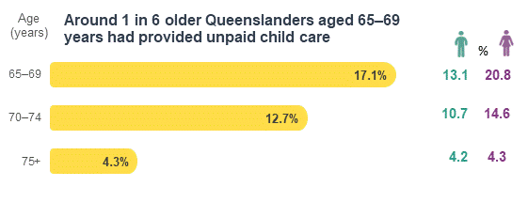

Recent analysis of care attended by children aged 0–12 years found that, nation-wide, grandparents were the most common care arrangement for children who attended school and the second most common arrangement for children not attending school[1].

Social engagement changes according to disability status

In 2018 more than 9 in 10 (93.1%) older Queenslanders participated in social and community activities away from home in the previous three months, with the most common activities involving visiting, or going out with, relatives and friends.

However, the level of social engagement by older Queenslanders within their communities differs when looking at disability status. Older Queenslanders with a disability were less likely to have participated in social and community activities away from home, or have had recent face-to-face contact with family or friends not living in the same household, compared with those without a disability (Figure 16).

The largest difference between the two groups was the extent to which older Queenslanders left their home as often as they would like. Only 77.8% of older Queenslanders with a disability indicated they did so, compared with 96.4% without a disability. The main reason older Queenslanders provided for not leaving home as often as they liked was due to their own disability or health condition.

**Figure 16: Social engagement measures for older Queenslanders by disability status, 2018**



Older Queenslanders with a profound or severe disability were less likely than those with other disability types to participate in social and community activities, and leaving home as often as they would like.

Volunteering by older Queenslanders is important for maintaining social connections

Many older Queenslanders contribute their time, service or skills to an organisation or group within their community, with 1 in 6 (16.5%) having spent time doing unpaid voluntary work through an organisation or group in the twelve months prior to Census night in 2021.

Participation by older Queenslanders in voluntary work declines with age, which may be related to a decline in health and mobility that can occur in older ages (Figure 17). While older females aged between 65 and 79 years had higher participation in voluntary work compared with older males in the same age group, participation by sex was relatively similar within the older age groups.

**Figure 17: Proportion of older Queenslanders who undertook voluntary work for an organisation or group by sex and age group, 2021**

**Participation in volunteering declines with age.**

Maintaining social connections is particularly important for older Queenslanders with a disability, however this group of older Queenslanders were less likely than those without a disability to have volunteered in the twelve months prior to Census night (Figure 18).

**Figure 18: Proportion of older Queenslanders who undertook voluntary work for an organisation by disability status, 2021**



Glossary

**Australian Digital Inclusion Index** – based on the Australian Internet Usage Survey (AIUS) designed by the ADII research team and administered by the Social Research Centre at the Australian National University. The survey sample is stratified and weighted to reflect the Australian population. The Australian Internet Usage Survey (AIUS) investigates who uses the internet, what benefits Australians get from the internet, and what barriers exist to its connection and use. The AIUS uses a sequential mixed-mode data collection design, which allows participants to complete the survey either online or in hardcopy. Further information can be found: [Collecting the data - Australian Digital Inclusion Index](https://www.digitalinclusionindex.org.au/collecting-the-data/)

**Health-adjusted life expectancy (HALE)** – the average number of years that a person at a specific age can expect to live in full health; that is, taking into account years lived in less than full health due to the health consequences of disease and/or injury. Definition sourced from: [Australian Burden of Disease Study 2023, Glossary - Australian Institute of Health and Welfare (aihw.gov.au)](https://www.aihw.gov.au/reports/burden-of-disease/australian-burden-of-disease-study-2023/contents/technical-notes/glossary)

**Burden of disease** – quantifies the impact of a disease and disability on a population by measuring the gap between a population’s actual health and an ideal level of health in a given year. The measure also allows the health impacts of different diseases and disabilities to be compared.

**Core activity need for assistance** – people with a profound or severe disability, defined as those people needing help or assistance in one or more of the three core activity areas of self-care, mobility and communication, because of disability, long-term health condition (lasting six months or more) or old age.

**Dementia** –dementia is not a specific disease; rather, it is a group of conditions characterised by the gradual impairment of brain function. It commonly affects people’s ability to think, remember and reason, as well as affecting their personality and impairing other core brain functions such as language and movement. The condition is degenerative and irreversible. Definition sourced from: <https://www.aihw.gov.au/reports-statistics/health-conditions-disability-deaths/dementia/overview>

**Disability** – defined by the *ABS Survey of Disability, Ageing and Carers* 2018 as any limitation, restriction or impairment, which restricts everyday activities and has lasted, or is likely to last, for at least six months.

**Non-school qualification** – educational attainments other than those of pre-primary, primary or secondary education. They include qualifications at the Postgraduate Degree level, Master Degree level, Graduate Diploma and Graduate Certificate level, Bachelor Degree level, Advanced Diploma and Diploma level, and Certificates I, II, III and IV levels. Non-school qualifications may be attained concurrently with school qualifications.

**Primary carer** – the main provider of care and provides the most assistance of all informal providers of care.

Data notes

1. All data in this fact sheet were the most recent at the time of preparation and represent Queensland-specific data unless otherwise specified. Data in this fact sheet may differ from data in other publications due to revisions and different calculation methods.
2. All charts have been produced by the Queensland Government Statistician’s Office. Figures in charts may not add to 100% due to rounding.
3. All Census analysis is based on usual resident counts.
4. Driver licence data includes learners, open, provisional/probational, P1 and P2 licence types. Proportion of population with a driver licence is a QGSO estimate using preliminary estimated resident population at 30 June 2022 (*ABS National, state and territory population*, Jun 2023, published 14 Dec 2023).
5. Average weekly hours spent on caring calculations exclude ‘not known’ responses.
6. The social and community activities participated in away from home in the last 3 months are: visited relatives or friends, went out with friends or relatives, religious or spiritual group activities, voluntary or community service activities, performing arts group activity, art or craft, or practical hobby group activities, went on holidays or camping with others, sport or physical recreation with others, other recreational or special interest group activities, support groups and other activities not specified elsewhere.
7. Volunteering and need for assistance calculations exclude ‘not stated’ responses.

## Data sources

Australian Bureau of Statistics (ABS) *Census of Population and Housing: TableBuilder Pro, Australia,* 2021.

ABS, *Causes of death*, *2022*, published 27 September 2023

ABS, *Disability, Ageing and Carers, Australia: Queensland,* 2018, published 5 February 2020.

ABS, *Life expectancy, 2020–2022*, published 8 November 2023

ABS, *National, state and territory population, Jun 2023*, June 2023, published 14 June 2023.

Australian Government Department of Health and Aged Care, *Physical activity and exercise guidelines for all Australians.* <https://www.health.gov.au/topics/physical-activity-and-exercise/physical-activity-and-exercise-guidelines-for-all-australians>, last updated 7 May 2021.

Australian Institute of Health and Welfare, *Dementia in Australia*. AIHW, published 21 September 2023.

Australian Institute of Health and Welfare, *Dementia in Australia* *Summary report 2022*. AIHW, published 23 February 2023.

Australian Institute of Health and Welfare, *Australian Burden of Disease Database,* <https://www.aihw.gov.au/reports/burden-of-disease/australian-burden-of-disease-study-2023/contents/interactive-data-on-disease-burden/leading-causes-of-disease-burden>

Australian Institute of Health and Welfare, *Australian Burden of Disease Study: Impact and causes of illness and death in Australia 2018,* published 24 November 2021.

Brown L, Hansnata E, La, H A, *Economic cost of dementia in Australia 2016–2056*, National Centre for Social and Economic Modelling, published 15 February 2017

Productivity Commission, *Report on Government Services,* Part F, Chapter 14 (Aged care services – attachment tables), 2024, published 22 January 2024.

Queensland Department of Transport and Main Roads, *Drivers Licences on Queensland Register over 65 Years by Gender* as at 30 June 2023, customised request.

Queensland Government, *History of education in Queensland*, extracted 07.03.24

Queensland Government. *Queensland survey analytic system (QSAS)*. <https://www.health.qld.gov.au/phsurvey.> Accessed: 2 February 2024.

Queensland Government, *Safe driving – Drivers 75 and over*, last updated 1 August 2022, <https://www.qld.gov.au/seniors/transport/safe-driving>

Queensland Government, *State education in Queensland, a brief history: Development of technical education 1902–1964; Technical education 1964–1982; Tertiary education*, last updated 16 February 2023.

Queensland Health, *The Health of Queenslanders*, 2023

Thomas, J., McCosker, A., Parkinson, S., Hegarty, K., Featherstone, D., Kennedy, J., Holcombe-James, I., Ormond-Parker, L., & Ganley, L. (2023). *Measuring Australia’s Digital Divide: Australian Digital Inclusion Index: 2023*. Melbourne: ARC Centre of Excellence for Automated Decision-Making and Society, RMIT University, Swinburne University of Technology, and Telstra.

1.