**Newsletter copy and image**

**Celebrate Grandparents Day on Sunday 27 October**

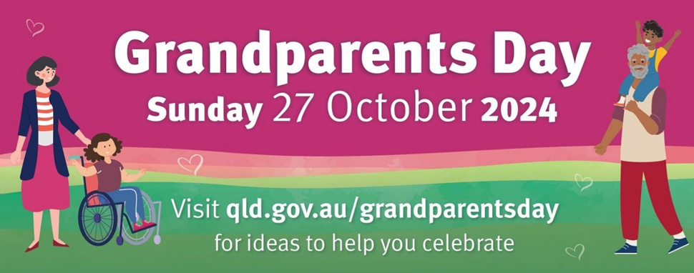

Grandparents Day is an opportunity for Queenslanders to say ‘thank you’ to grandparents for their care and support and for sharing their knowledge, experience and traditions with younger generations.

A child’s interactions with their grandparent are often their first interactions with an older person. High-quality relationships between grandparents and young people help to create and foster positive attitudes toward ageing and older people and combat ageism.

The bond between grandparents and their grandchildren is unique. The intergenerational love, care, wisdom and teachings shared can last a lifetime and beyond.

This Grandparents Day, celebrate and thank the grandparents in your life, in person or virtually by:

* downloading and sending a free e-card
* downloading and sending a free activity sheet and listing the top 10 reasons why you love your grandparents
* asking your grandparents about their experiences, memories and the joys of being a grandparent
* reading a book, playing a game or enjoying a craft project together
* cooking or sharing a favourite meal
* having a yarn together
* talking about your family history.

For more ideas about ways to celebrate the grandparents in your life, including free downloadable resources, visit [qld.gov.au/grandparentsday](https://www.dcssds.qld.gov.au/our-work/seniors/grandparents-day)

Grandparents can also be primary full-time carers for their grandchildren — safeguarding family connections. More information about support available for grandparent carers can be found at [qld.gov.au/seniors/grandparenting](https://www.qld.gov.au/seniors/grandparenting)

Grandparents Day is celebrated during Queensland Seniors Month. For more information about Queensland Seniors Month, and to find events near you, visit the [Queensland Seniors Month page](https://www.qld.gov.au/seniors/recreation-staying-connected/events-awards/seniors-month) at [qldseniorsmonth.org.au](https://qldseniorsmonth.org.au/)