## Acknowledgement of Traditional Owners

We pay our respects to the Aboriginal and Torres Strait Islander peoples of this land, their spirits and their legacy. The foundations laid by these ancestors—the First Australians—give strength, inspiration and courage to current and future generations towards creating a better Queensland.

We respectfully acknowledge the Aboriginal and Torres Strait Islander Traditional Owners and Elders of the lands and seas on which we meet, live, learn and work. We acknowledge those of the past, the ancestors whose strength has nurtured this land and its people, and who have passed on their wisdom. We acknowledge those of the present for their leadership and ongoing effort to protect and promote Aboriginal and Torres Strait Islander peoples and cultures. We acknowledge those of the future, the Elders not yet born, who will inherit the legacy of these efforts. We recognise it is our collective efforts, and responsibility as individuals, communities and governments, to ensure equality, recognition and advancement of Aboriginal and Torres Strait Islander Queenslanders across all aspects of society and everyday life.

#### Disclaimer on the use of ‘elder abuse’

The National Plan to Respond to the Abuse of Older Australians (the National Plan) acknowledges that the term ‘elder abuse’ remains commonly used, for referring to the abuse of an older person, and is used in the title of many specialist services and organisations. To ensure consistency with the National Plan, the Queensland Seniors Strategy primarily refers to the abuse and mistreatment of older people, rather than ‘elder abuse’. The term ‘elder abuse’ may be used within this document where it is referring to funded services.

#### Translating and interpreting



The Department of Child Safety, Seniors and Disability Services is committed to providing accessible information and services to Queenslanders from all cultural and linguistic backgrounds. To talk to someone about the *Queensland Seniors Strategy 2024-2029* in your preferred language call 1800 512 451 and ask to speak with the Seniors and Carers, Strategy and Reform team.

#### Copyright

This publication is protected by the *Copyright Act 1968*. © State of Queensland 2024

#### Creative Commons licence

The material in this work is licensed by the Department of Child Safety, Seniors and Disability Services under Creative Commons attribution 4.0 International licence (CC BY 4.0), with the exception of:

• the Queensland Coat of Arms

• any third party material

• any material protected by a trademark, and

• any images and/or photographs.

More information on the CC BY licence is set out as follows:

• Creative Commons website – [www.creativecommons.org](https://aus01.safelinks.protection.outlook.com/?url=http%3A%2F%2Fwww.creativecommons.org%2F&data=05%7C02%7CAngela.Bellew%40dsdsatsip.qld.gov.au%7Cb764c1abc87d40411ff108dca09f8056%7C95b907c2752b485088ad86939ce522f0%7C0%7C0%7C638561854140485678%7CUnknown%7CTWFpbGZsb3d8eyJWIjoiMC4wLjAwMDAiLCJQIjoiV2luMzIiLCJBTiI6Ik1haWwiLCJXVCI6Mn0%3D%7C0%7C%7C%7C&sdata=uAiMbN7nN22mioOBMNQ5oHLvKyddPRtKEPMxC9sbYzo%3D&reserved=0)

• Attribution 4.0 international (CC BY 4.0).

#### Attribution

The CC BY licence is a standard form licence agreement that allows you to copy and redistribute the material in any medium or format, as well as remix, transform, and build upon the material, on the condition that you provide a link to the licence, you indicate if changes were made, and you attribute the material as follows: © State of Queensland (Department of Child Safety, Seniors and Disability Services), *Queensland Seniors Strategy 2024-2029*.

Enquiries about the use of any material in this publication can be sent to the department at: [communication@cyjma.qld.gov.au](mailto:communication@cyjma.qld.gov.au)

#### Disclaimer

While every care has been taken in preparing this publication, to the extent permitted by law, the State of Queensland accepts no responsibility and disclaims all liability (including without limitation, liability in negligence) for all expenses, losses (including direct and indirect loss), damages and costs incurred as a result of decisions or actions taken as a result of any data, information, statement or advice, expressed or implied, contained within.

Contents

Acknowledgement of Traditional Owners 2

Minister’s Message 4

An Age-friendly Queensland: The Queensland Seniors Strategy 2024-2029 6

Introduction 6

Vision 7

Age-friendly Communities Framework 7

Principles for Action 8

Why Queensland needs an Age-friendly Strategy 10

The profile of Queensland’s seniors is changing 10

A global movement 10

United Nations Decade of Healthy Ageing 11

The voice of older Queenslanders 12

Where we travelled 12

Who we spoke with 12

Strategic Priorities 13

Outcome 1: Connected 13

Outcome 2: Cared For 16

Outcome 3: Celebrated 19

Actions and accountability 22

# Minister’s Message

Queensland’s population is ageing, making it more important than ever to deliver the right services and supports needed by seniors.

The Queensland Government aims to create an age-friendly state – one that embraces older people and recognises the enormous value they play in our families, neighbourhoods and wider communities. A state where older people live active, healthy and productive lives.

*An Age-friendly Queensland: The Queensland Seniors Strategy 2024–29* is the blueprint for achieving this vision, which will be driven by actions across Queensland Government totalling over $10 billion.

Importantly, the Strategy reflects the views of more than 16,000 older Queenslanders – from the south-east corner through to western Queensland and the Torres Strait – who told us what they want, and what they value.

During our consultations, three consistent themes emerged.

Older Queenslanders want to be connected to their communities and the people and services that matter to them.

They also want to be cared for and supported by world class frontline services when needed.

And they want to be recognised and celebrated for the significant contribution they make to our economy and our society.

Responding to the evolving needs of older Queenslanders is becoming an increasingly important task as the state undergoes a significant demographic shift.

The number of residents aged 65 and over has grown to 17 per cent of the population, and this age group is projected to more than double to 1.7 million by 2053.

To meet the future infrastructure, services and social support system required, it is imperative that we have a strong and unifying Strategy in place over the next five years.

Actions contained in this plan will be directed at creating Australia’s most age-friendly state. A state where older Queenslanders are connected, cared for and celebrated.

That begins by recognising that helping older Queenslanders with cost-of-living pressures must be addressed immediately.

That’s why in the first year of the Strategy, we are providing a record investment in concessions for Seniors Card holders and other eligible Queenslanders, including an electricity rebate which will mean most seniors will not pay for electricity at all.

Cheaper and improved public transport will help seniors get out and about, a new community safety plan will help them feel safe and financial support is available for eligible seniors to secure their homes.

Under this strategy there is an extra $10 million in social isolation prevention services over the next four years to help seniors stay connected within communities. There is also   
$34 million over four years for awareness and prevention services to combat the abuse of older people.

All these initiatives and much more are in the Age-friendly Queensland Action Plan 2024–25 to 2025–26, which will be delivered by a whole-of-government effort to improve the lives of older Queenslanders.

**Charis Mullen**

**Minister for Child Safety,**

**Minister for Seniors and Disability Services, and**

**Minister for Multicultural Affairs**

# An Age-friendly Queensland: The Queensland Seniors Strategy 2024-2029

## Introduction

Age-friendly communities support the needs and aspirations of all people to age well in a place that is right for them, to be included and contribute to their communities, to enjoy their independence and to be respected and feel valued. They are great places to live, work, play and age. Age-friendly communities are more liveable for everyone.

Queensland should be recognised as the nation’s most age-friendly community, where older people can lead active, healthy productive lives, where they are:

* connected to their communities and the services and people that matter to them,
* cared for and supported by world class frontline services, and
* celebrated for the contribution they make to the great Queensland lifestyles we all enjoy through their roles as carers, workers, volunteers and community leaders.

Achieving this vision will involve all Queensland Government agencies working together, and in collaboration with local governments and non-government partners, to deliver on the commitments of *An Age-friendly Queensland: The Queensland Seniors Strategy 2024-2029*.

The Strategy’s inaugural Action Plan includes whole-of-government delivery and investment that will benefit seniors valued at over $10 billion, including:

* significant cost-of-living support through concessions, rebates and discounts on a range of goods and services,
* strengthening community safety as well as safety in the home,
* investing in services to prevent and respond to abuse of older people and social isolation,
* improved transport affordability to help seniors stay connected with their family, friends and communities,
* stronger consumer protections for residents of retirement villages and residential parks, and
* challenging ageism and negative stereotypes about getting older, including through Seniors Month and a supporting community grants program.

This new Strategy responds directly to the voices of older Queenslanders.

The Strategy is built on the understanding that communities need to be inclusive of older people – it drives community cohesion and can positively influence the health, wellbeing and happiness of older people. Inclusion also creates a vibrant community that promotes productivity and economic growth.

The Strategy will drive a shift in how we think about and respond to ageing in Queensland, and what is needed to ensure that older Queenslanders have the opportunity to lead active, healthy, productive, safe and meaningful lives.

An age-friendly Queensland benefits us all, and our aim is to create the nation’s most age-friendly state.

## Vision

Queensland is an age-friendly state where older people live active, healthy and productive lives, where they are:

|  |  |  |  |  |
| --- | --- | --- | --- | --- |
|  |  |  |  |  |
| **connected**  to their communities and the services and people that matter to them.  Through the cultivation of meaningful connections, we strengthen intergenerational bonds and promote the value of inclusion, mutual respect, understanding and empathy. |  | **cared for**  and supported by world class frontline services, when support is needed.  By addressing barriers faced by older adults in accessing essential services, wherever they live, we ensure seniors can continue to actively participate in society for as long as possible. |  | **celebrated**  for the contribution they make to the great Queensland lifestyle we all enjoy through their roles as carers, workers, volunteers and community leaders.  We value the richness of cultures, experience and wisdom that seniors bring to society. |

This vision forms the foundation upon which we can build an age-friendly Queensland. To get there we will commit to actions under the Age-friendly Communities Framework.

## A flower with yellow petals. The centre circle is blue and text reads: Age-friendly city or community. Each petal contains a concept and a graphic representing that concept as follows: Bus: transportation Building: housing Two people talking: social participation Three people talking: respect and social inclusion Briefcase: civic participation and employment Two people talking: communication and information Heart with a cross: community support and health services Person climbing a hill: outdoor spaces and buildings. Age-friendly Communities Framework

Queensland is an affiliate member of the World Health Organisation’s Age-friendly Communities program. This provides a clear framework for how to structure investment and action to accelerate the creation of age-friendly cities and communities, which are better places to grow, live, work, play and age.

Age-friendly cities and communities improve access to key services and enable people of all ages to be and do what they value through action across eight domains.

## Principles for Action

**Rights-based**

We embed a human rights perspective, in line with the *Human Rights Act 2019* (Qld) to ensure the rights of all older people are protected and promoted through this Strategy. For older First Nations peoples, the Strategy recognises the distinct cultural rights as Australia’s first people and that acknowledges and celebrates them in their role as cultural knowledge holders.

**Person-centred**

We recognise the needs, preferences and capabilities of all older Queenslanders. This approach emphasises tailored support and services that respect autonomy and dignity, and requires whole-of-government leadership and commitment, as well as integration across services.

**Strengths-based**

The Strategy focuses on the experiences and contributions older people bring to their communities. By emphasising strengths rather than deficits, the Strategy promotes resilience, empowerment, and active engagement among older populations.

**Reframing the relationship**

The Queensland Government is committed to reframing the relationship with First Nations peoples and achieving the National Agreement on Closing the Gap targets. Life expectancy for First Nations people is lower than non-Indigenous people. The Strategy contributes to the National Agreement on Closing the Gap outcomes that Aboriginal and Torres Strait Islander people enjoy long and healthy lives. Our actions are underpinned by our commitment to reframing the relationship with Aboriginal and Torres Strait Islander people, recognising that when they have a genuine say in policy and the design and delivery of programs and services that affect them, better life outcomes are achieved.

**Recognising diversity**

The Strategy acknowledges that every older person is unique and has different needs based on their life experiences, personal characteristics, and identities. An age-friendly community must recognise the diversity amongst older people and enable inclusion as well as participation in community life.

Infographics in greens and purples depict the following statistics:

17 per cent of the Queensland population (926,752 people) was 65 years or older (Estimated Resident Population, June 2023)

By 2053 there will be 1.7 million Queenslanders 65 years and older including 340,000 85 years and older (ABS estimated population projections)

Local government areas with the highest proportion of people aged 65 years and older. Fraser Coast 30.1 per cent, Hinchinbrook 29.1 per cent, Noosa 27.7 per cent, North Burnett 27 per cent, Blackall Tambo 26.5 per cent (ABS Regional Population by Age and Sex, 2021)

Life expectancy at age 65 years for Women is 87.7 years, for men is 85.0 years (ABS Life Expectancy, 2020–2022)

17.1 per cent Aboriginal and Torres Strait Islander Queenslanders are 50 years or older. This compares to 35.8 per cent of the non-Indigenous population. (ABS Estimates of Aboriginal and Torres Strait Islander Australians, 2021)

1 in 3 older Queenslanders are born overseas from across 191 countries compared to 21.1 per cent of Queenslanders (Census 2021)

An estimated 22.3 per cent of all Queenslanders reported having a disability, but half of all seniors (50.3 per cent) reported having a disability (ABS, Disability, Ageing and Carers, 2022)

23.4 per cent of carers in Queensland are aged 65 years or older (ABS Disability, Ageing and Carers, 2022)

1 i n 6 older people (16.5 per cent) spend time doing unpaid voluntary work through an organisation or group (Census 2021)

95 per cent of older Queenslanders were living in private dewellings. 2 in 3 have 2 spare bedrooms. 15 per cent were renting (Census 2021)

18 per cent of older women are staying in the labour force longer compared with 11.5% of men (Queensland Government population projections, 2023)

In 2023–24, 2674 Queenslanders reported that they had experienced or were at risk of elder abuse (Elder Abuse Prevention Unit, 2024).


# Why Queensland needs an Age-friendly Strategy

## The profile of Queensland’s seniors is changing

Queensland, like many regions around the world, is experiencing a significant demographic shift towards an ageing population. The Australian Bureau of Statistics projects that by 2053, more than one in five Queenslanders will be 65 years or older (21.7 per cent or 1.7 million people).

We need to respond to the changes that are occurring in how we are ageing. Older Queenslanders are more likely, on average, to be healthier than any preceding generation. Many older Queenslanders are working well past traditional retirement age. They are more active, continue to drive and are digitally and socially connected. Older people are likely to be providing care for another person, including grandchildren, or someone with a disability or frailty due to age.

How we respond now to all of these factors matters. Being proactive now will help ensure that Queensland is well prepared and makes the best possible progress against the eight age-friendly domains, including by making sure that infrastructure, services and social support systems are equipped to meet the evolving needs of our older population. This includes working closely with local governments, which play an important role in creating age-friendly communities, through providing services and community awareness of programs and services available.

Doing so requires a whole-of-government effort. It involves engaging with seniors in all locations, and with the organisations that represent their interests, to understand their needs and priorities, as well as committing to making mainstream services available and fully accessible to seniors, and developing tailored responses to address any particular needs.

This Age-friendly Strategy will drive and focus the Queensland Government to meet the needs of seniors and do so in a transparent way. It has important linkages to [Communities 2032](https://www.dsdsatsip.qld.gov.au/resources/dsdsatsip/work/communities-2032/strategy-report.pdf), a long-term plan to build Queensland communities that support and empower every person to connect, participate, contribute and thrive, which also involves a whole-of-government endeavour.

## A global movement

The [World Health Organisation (WHO)](https://extranet.who.int/agefriendlyworld/age-friendly-cities-framework/) has developed guidance for implementing an age-friendly approach across eight domains that directly influence the quality of life and wellbeing of older people.

The age-friendly approach is designed to address the unique needs and abilities of older people, challenge perceptions of ageing and promote a world where people age with dignity and respect.

Queensland is proud to be an Affiliate Member of the [WHO’s Global Network of Age-friendly Cities and Communities](https://extranet.who.int/agefriendlyworld/age-friendly-cities-framework/). This membership reflects our commitment to listen to the needs of our ageing population, assess and monitor the age-friendliness of our communities, and to work collaboratively with older people directly and across sectors to create age-friendly physical and social environments.

Queensland’s role as an Affiliate Member puts us in a position to lead and learn about strategies that work to promote healthy ageing and meet the needs of an age-friendly community.

## United Nations Decade of Healthy Ageing

The United Nations declared 2021-2030 as the Decade of Healthy Ageing. The aim of this is to ensure that the needs of older people are planned for through practical approaches that optimise the health and wellbeing of people as they age.

This is a global collaboration with the WHO to lead international action that seeks to:

* combat ageism, by changing how we think, feel and act towards age and ageing
* develop age-friendly communities that foster the abilities of older people
* deliver person-centred, integrated care and health services that are responsive to the needs of older people
* provide older people access to long-term care when they need it.

Actions developed and delivered in the decade will be led by the voice, engagement and full participation of older people.

This Strategy’s age-friendly approach aligns with these principles, and the Queensland Government is committed to continuing and expanding the work it is doing in relation to age-friendly communities, supporting older people to connect to their communities, be cared for and supported, and be celebrated for their contribution to their communities.

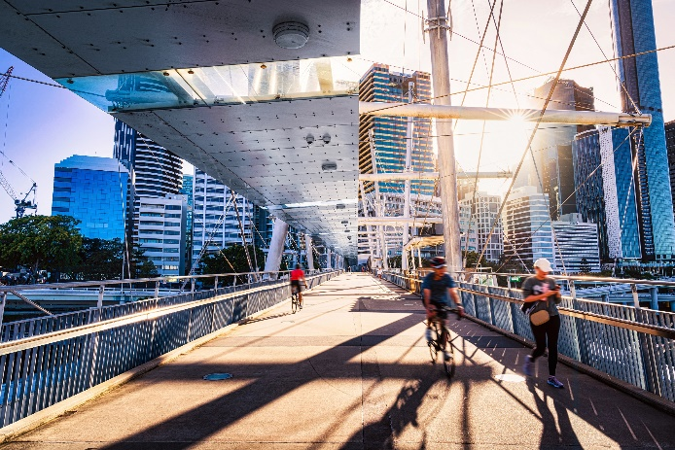

## The voice of older Queenslanders

The views and opinions of older Queenslanders were sought from across the State in developing the Strategy.

### Where we travelled

Since 2021, the Queensland Government has engaged with more than 16,000 older Queenslanders through over 76 Seniors Expos and Seniors Savings Pop-up events.

Expos provide seniors with information about supports and services available, and an opportunity to discuss what matters to them. Expos have been held statewide, from Bribie Island, Beaudesert and Cairns, to Hervey Bay, Longreach, Thursday Island, and Yeppoon.

The Seniors Savings Pop-ups provide seniors with specialist information about the cost-of-living savings available to them. They have travelled as far as Atherton, Bundaberg, Coomera, Dalby, Gladstone, Gympie, Port Douglas, Roma, and Sunshine Coast.

The Queensland Government is committed to engaging with older people through these events, including those for targeted cohorts, particularly older First Nations peoples and Queenslanders in regional, rural and remote areas.

### Who we spoke with

Infographics in greens and purples depict the following statistics:

3745 older Queenslanders completed our online survey.

3090 people attended our Seniors Expos and shared their thoughts. 

13,175 visited a Seniors Savings Pop-up event in their local community.

232 people provided feedback through Queensland Seniors Month activities.

148 Aboriginal and Torres Strait Islander people contributed through a variety of online and face-to-face engagement activities. 

188 people who identify as having a disability contributed through an online forum with Queenslanders with Disability Network, at Seniors Expos and through our online survey.

389 people engaged face-to-face through a listening post facilitated by the Council on the Ageing Queensland.

A diverse mix of people including from culturally and linguistically diverse backgrounds participated in one-on-one interviews and specialised ageing forums. 

160 older people who identify as LGBTIQA+ engaged through forums and workshops.


# Strategic Priorities

The Queensland Government will work together to achieve the vision of Queensland being the nation’s most age-friendly state, where older people live active, healthy and productive lives, and are connected, cared for and celebrated. This will be achieved through delivery of key initiatives under each of the WHO Age-friendly domains.

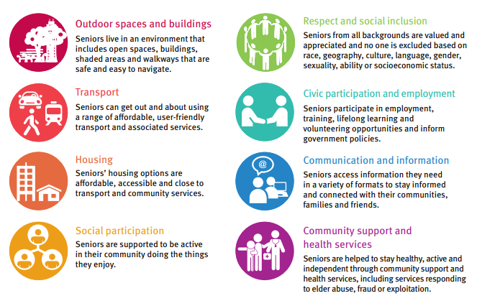

## Outcome 1: Connected

|  |  |  |  |
| --- | --- | --- | --- |
| You told us…   * Connections with family and friends are really important * I am not as mobile as I used to be * I want to see better pathways and accessible parking * I need to be able to find the right information quickly and easily * I want to keep working even though I’m at an age where I could retire * Volunteering keeps me connected to my community. |  | Supported by the WHO’s Age-friendly domains of: | |
|  | Outdoor spaces & buildings |
|  | Transport |
|  | Housing |
|  | Social participation |
|  | Respect and social isolation |
|  | Civic participation & employment |
|  | Communication & information |
|  |  | Community support & health services |

Social connectedness is essential for health and wellbeing at any age, but older adults are at increased risk of social isolation because they are more likely to live alone due to the loss of family and friends over time.

Social isolation and loneliness are complex issues that are gaining increasing awareness both in Australia and across the world. In older adults, social isolation poses serious risks to physical and mental health. It also increases the risk of abuse of older people.

People who remain connected with others and have strong relationships, are more likely to report better quality of life and satisfaction as they age, delayed progression of dementia and mental decline, less need for domestic support, and greater independence.

**Strategic priority**

Addressing social isolation and preventing loneliness, by keeping seniors connected, is one of the Queensland Government’s key priorities.

**Investment**

The Queensland Government funds social isolation services across the state that provide opportunities for older Queenslanders to connect with each other. They are community-led and delivered to meet the needs of older people, whether through a morning tea and a chat, craft groups, table tennis, tai chi, dancing or a wide range of other activities.

Funding for social isolation services has increased in 2024-25, with a $33 million investment over the life of the Strategy.

**Case studies**

*Social participation - TOMNET*

The Toowoomba Older Men’s Network Inc (TOMNET) is a community based, not-for-profit organisation that supports and promotes wellbeing of older men.

With over 300 members, its goal is to help older men remain connected to their community, including through coordinating volunteering programs like aged care visits, providing telephone support, mentoring disadvantaged youth and running community barbeques.

*Transport - Getting out and about*

To support older Queenslanders getting out and about the Queensland Government provides a range of concessions on transport. Whether it be by bus, rail, car or boat there is a discount or concession that you may be eligible to receive.

Over 900,000 Queensland Seniors Card and Seniors +Go card holders are eligible to receive reduced fees on their motor vehicle and boat registrations, as well as concessional fares on buses, ferries and trains.

For those wishing to travel further, Queensland Rail travel offers seniors discounts of up to 50% off full adult fares on long distance services.

The Queensland Government is committed to ensuring older people are connected to their communities and the people and services that matter to them. As part of our Age-friendly Queensland actions to ensure older people are connected, we will:

**Work to improve community infrastructure and accessibility to the transport network** to enable seniors to age actively and remain engaged and connected in their community, including by maintaining transport concessions and trialling ways to provide cheaper travel.

**Establish a sector lead for social isolation prevention services** and increase our partnerships with agencies to reduce loneliness and social isolation in older people. We will identify service responses to prevent social isolation for our most vulnerable cohorts, including First Nations peoples, seniors from culturally and linguistically diverse backgrounds and LGBTQIA+ seniors, seniors living with disability and those in rural and remote locations.

**Empower seniors by continuing to connect them with information, advice and referrals to services** through the Seniors Enquiry Line where they can speak to a real person and easily find the information they need about available services, supports and events.

**Promote the development of age-friendly initiatives, plans and programs** by working to ensure a continued partnership with local governments and community organisations.

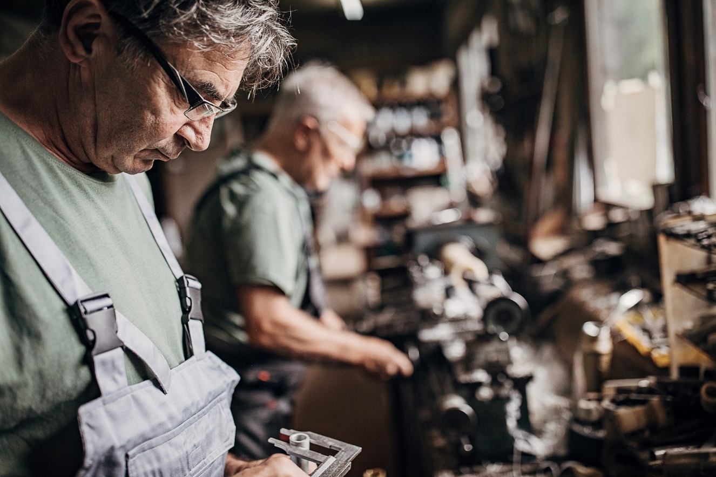

## Outcome 2: Cared For

|  |  |  |  |
| --- | --- | --- | --- |
| You said…   * I feel safe at home and want to stay living here for as long as possible * I need community services close to home * I need access to affordable health care now and in the future * Cost-of-living increases have a big impact on my fixed income * I need access to information about health care planning. |  | Supported by the WHO’s Age-friendly domains of: | |
|  | Outdoor spaces & buildings |
|  | Housing |
|  | Respect & social isolation |
|  |  | Civic participation & employment |
|  |  | Communication & information |
|  |  | Community support and health services |

The Queensland Government is committed to ensuring that older Queenslanders are supported to be active and stay healthy, and have access to world class services that provide support when it is needed.

**Strategic priority**

Every older person in Queensland has the right to feel safe, be respected and live with dignity and trust in their relationships. However, this is not the case for the estimated 14.8 per cent of older Queenslanders who experience or are at risk of abuse. Abuse of older people is any act within a relationship of trust that results in harm to an older person. It can be emotional, psychological, financial, physical or sexual abuse, or neglect. Preventing and addressing abuse of older people is a priority for the Queensland Government.

**Investment**

Over the five years of the Strategy the Queensland Government will invest over $40 million in a range of services and supports to raise awareness of and prevent abuse of older people, and to provide information, advice or referrals to support services offering social and family support and legal support for older people experiencing or at risk of abuse.

**Case studies**

*Community support – Prevention and intervention in the abuse of older people*

The Elder Abuse Prevention Unit and Helpline provide statewide information, advice and referral. The Helpline works in partnership with Seniors Legal and Support Services (SLASS) that provide free legal and social work support to older people who are experiencing abuse, mistreatment or financial exploitation. In 2023-24 support was provided to over 18,319 seniors through the combined efforts of these services.

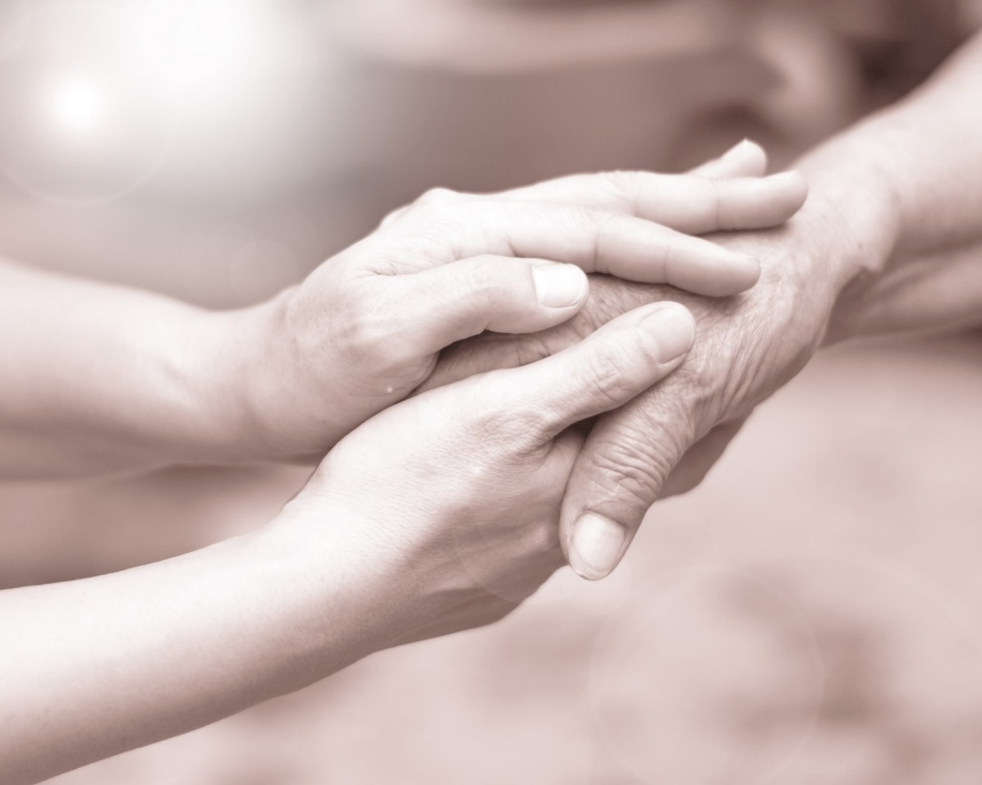

Older Queenslanders have also told us about the financial hardships they are experiencing as the cost‑of‑living increases - with those on low and fixed incomes most impacted.

**Strategic priority**

Queensland Seniors Card holders and pensioners may be eligible for a wide range of concessions and rebates across everyday expenses including household expenses like electricity, rates and water, as well as transport and health.

**Investment**

Successive Queensland Budgets have provided billions of dollars in cost-of-living relief by providing through concessions and rebates to Queensland seniors, families and businesses.

**Case study**

*Housing – Electricity rebate*

In year one of the Strategy, eligible seniors will receive increased support towards their household electricity bill through the cost-of-living rebate, meaning many seniors will not pay for electricity at all in 2024-25.

**Strategic priority**

Every Queenslander deserves to be safe and feel safe. The *Community Safety Plan for Queensland* will tackle crime, address the complex root causes of crime and hold offenders to account.

**Investment**

A total $1.28 billion investment has been allocated (across multiple years) to implement the *Community Safety Plan for Queensland*. The Plan will impact five key areas:Supporting victims; Support for the frontline; Detaining offenders; Intervening when people offend; and Preventing crime before it occurs.

**Case study**

*Outdoor spaces and buildings – Policing capacity*

Under the Community Safety Plan an extra 900 new police personnel, including 500 new sworn police officers, will be employed to keep Queenslanders safe.

*Outdoor spaces and buildings – Keeping seniors safe at home*

Since 2023 the Queensland Government has invested in a trial to help Seniors secure their homes in Townsville, Mount Isa, Cairns, Toowoomba, Tablelands and Mareeba. The initiative, delivered through partnerships with non-government organisations, provides grant funding to eligible seniors for installation of practical security related measures in their homes.

As part of our Age-friendly Queensland actions to ensure older people are cared for, we will:

**Build a stronger and more coordinated response to the abuse of older people** and better identify those at risk to improve prevention and intervention responses.

**Continue to support cost-of-living relief for seniors** and other Queenslanders on low or fixed incomes through concessions and rebates schemes targeted at reducing the cost of everyday household expenses.

**Continue to enable seniors and consumers to learn more about advance care planning** and their current, future and end of life health care options such as Enduring Power of Attorney, Advance Health Directives and Statements of Choice.

**Continue to deliver age-friendly hospital and health services** that provide high quality care of older people and promote improvements in physical health and mental wellbeing.

**Improve housing options and support for older Queenslanders to age in-place** including targeted services for those experiencing or at risk of homelessness, as well as responses for older women and support to improve home security.

**Promote the housing principles for inclusive communities of rights, choice, control and inclusions,** which are based on the lived experience of older people and people with disability and bring a person-centred focus to housing design and service delivery.

## Outcome 3: Celebrated

|  |  |  |  |
| --- | --- | --- | --- |
| You said…   * I hear negative remarks about my age when I am out and about * I want to be heard and respected but sometimes I feel invisible * I want to volunteer to share what I can do with the community * There needs to be more education for younger people about valuing older people. |  | Supported by the WHO’s Age-friendly domains of: | |
|  | Social participation |
|  | Respect and social inclusion |
|  | Civic participation and employment |
|  |  | Communication & information |

Older people make a significant contribution to Queensland’s economy, society and communities as workers, volunteers, carers, parents, grandparents, community leaders and advocates. They deserve to be recognised, valued and celebrated for the significant contributions they have made, and continue to make, to the great Queensland lifestyle that we all enjoy.

We demonstrate our recognition of older Queenslanders by listening to what matters most to them through our ongoing engagement programs and our continued focus on celebrating Seniors Month each year.

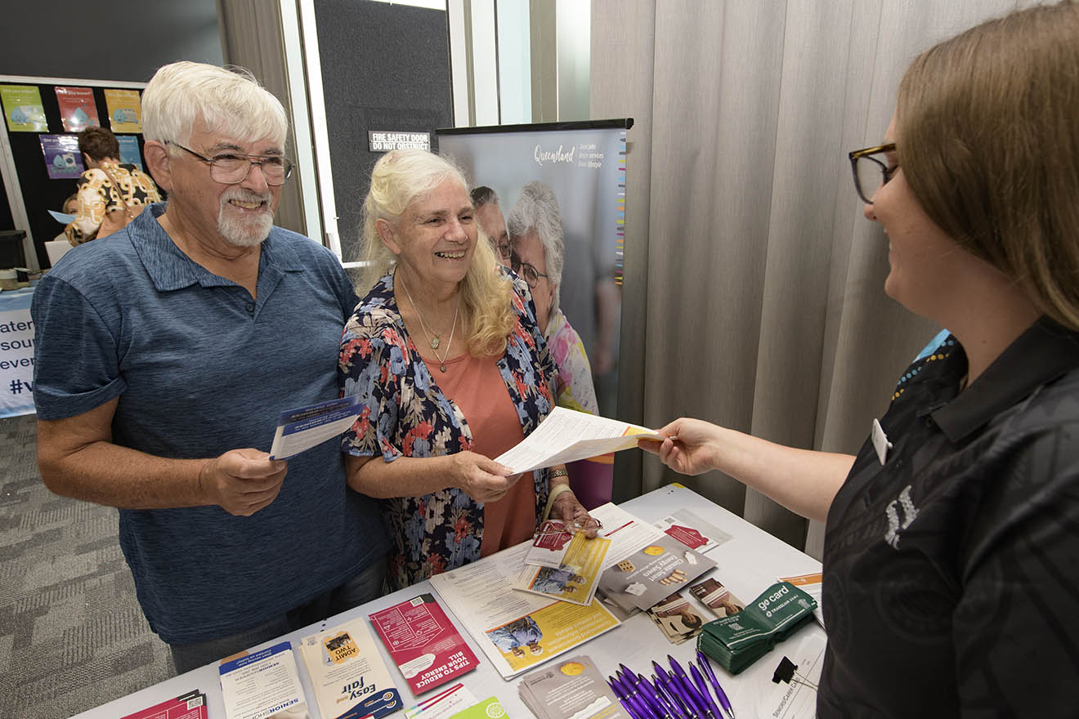

**Strategic priority**

The Queensland Government recognises the value of older people and seeks to amplify their voice in the development of policy and programs that affect them.

With people aged 65 and over becoming Queensland’s fastest growing cohort, it is critical that we create mechanisms to hear and understand the needs of older Queenslanders.

**Investment**

The Queensland Government will invest over $4 million in seniors peak and representative body services across the life of the Strategy. This will ensure that the voices of older people are heard, their rights protected, and their wellbeing promoted, and that genuine partnering and collaborating with government on policy and service development for seniors occurs.

**Case study**

*Respect and social inclusion – Seniors Month*

To celebrate the contribution of older people, October each year is recognised as Seniors Month in Queensland. Queensland Government partners with the Council on the Ageing Queensland to deliver on this long-standing commitment, which enables community-based organisations to share in grants of up to $2,000 to host events right across the state. The Seniors Month events promote positive community attitudes towards ageing and encourages local communities and organisations to get involved by celebrating seniors.

*Civic participation and employment – Seniors engagement*

The Council on the Ageing Queensland has played a critical role in enabling the participation of over 16,000 Queensland seniors in the development of this Strategy, including through partnering in the delivery of statewide engagement and collaboration on priority areas for action.

**Strategic priority**

It is critical that Seniors are able to access the information they need about the services that are important to them.

**Investment**

The Queensland Government will fund the Seniors Enquiry Line, $2.9 million over the life of the Strategy, to provide seniors with information, advice and referrals to a broad range of services for older people, their families and carers. By calling the Seniors Enquiry Line, older people, their families and carers will find the right support service or information they need.

**Case study**

*Communication and information – Seniors Enquiry Line*

In 2023-24 the Seniors Enquiry Line assisted over 15,246 people with information, advice and referral services and 3,889 people with community support. Callers sought information on a wide range of topics, including support services, concessions, social activities, household assistance, retirement accommodation, financial and legal matters, health, education and transport. The Seniors Enquiry Line also provides support for Queensland seniors in relation to scams and fraud and aims to educate them on avoiding and protecting themselves from scams.

As part of our Age-friendly Queensland actions to ensure older people are celebrated, we will:

**Invest in Seniors Month initiatives** **and celebrate seniors** including a focus on events that strengthen intergenerational community connections and aim to end ageism.

**Ensure the voices of Queensland’s seniors are heard** by increasing funding to a seniors peak body to better represent the views and perspectives of seniors in policy and service development, undertake system level advocacy to governments, as well as promote positive ageing.

**Continue to respect, recognise and invest in First Nations cultures** and identify culture as a key factor in improving social and emotional wellbeing for First Nations older peoples.

**Increase awareness and opportunities for seniors** **to volunteer** in their local communities.

**Continue to recognise the contribution of grandparents** and their invaluable role in families, communities and the economy.

**Continue to value the contribution mature age workers make** to the Queensland Public Service and support them in their continued career progression and transition into retirement.

# Actions and accountability

This Strategy will be delivered by a series of supporting action plans. This will ensure the Strategy continues to respond to the evolving needs of older people across Queensland and address their unique concerns and aspirations.

The Queensland Government is committed to listening to and amplifying the voices of older Queenslanders and engaging with the organisations that represent them, and the service providers that work with them.

We will work with older people and service providers from government and non-government sectors to co-design policy, programs and services that aim to address the issues of importance to older Queenslanders.

We will continue to work in partnership to build age-friendly communities across Queensland. We are committed to practices that put older people at the forefront of what we do, by using place based, collaborative approaches that harness the vision, resources, experiences, and opportunities present in each community.

There will be challenges in this. Queensland is geographically large, and each community is unique. We acknowledge the rich diversity of older Queenslanders and the communities in which they live. We can meet these challenges with innovative service delivery solutions and support mechanisms that are sustainable and reach people wherever they are across the state.

We will respect the needs and preferences of older people and empower them to live in the way they choose whilst ensuring they feel valued, independent, and included.

“Longer lives are one of humanity’s greatest achievements. However, we don’t just want to add years to our lives. We also want to enjoy good health and wellbeing in later life. This is healthy ageing.” (WHO Decade of Healthy Ageing)

We want Queensland to be the most age-friendly state, where older people can lead active, healthy and productive lives, where they are:

* connected to their communities and the services and people that matter to them
* cared for and supported by world class frontline services, and
* celebrated for the contribution they make to the great Queensland lifestyles we all enjoy through their roles as carers, workers, volunteers and community leaders.

This Strategy is one more step on that journey. The Queensland Government is committed to delivering on the Strategy and action plans over the next five years.