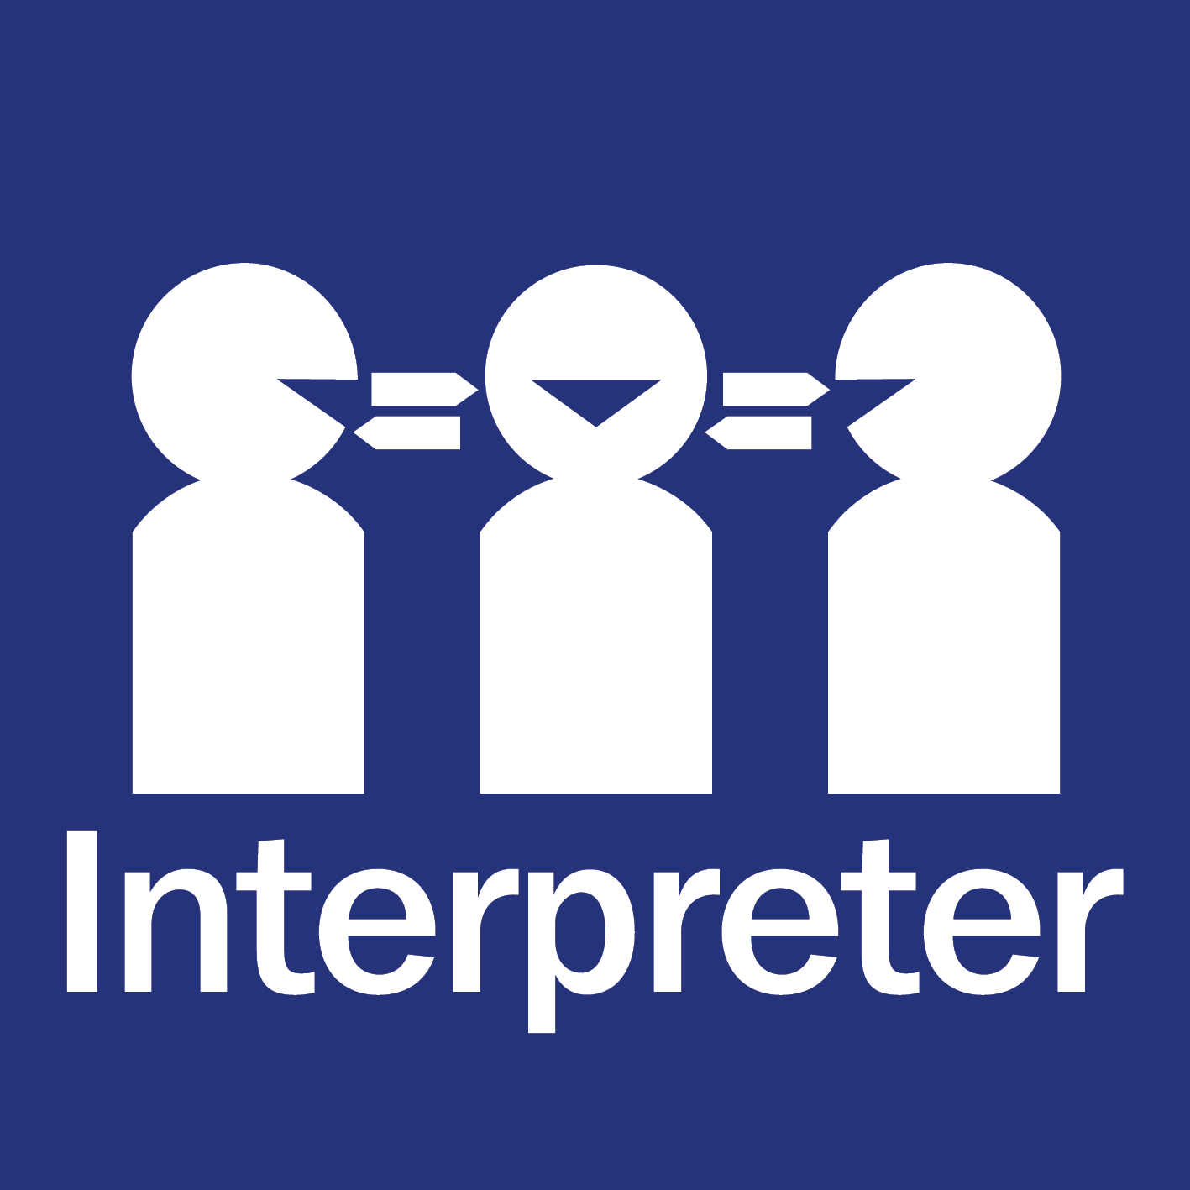

The Queensland Government is committed to providing accessible services to Queenslanders from all cultural and linguistic backgrounds. To talk to someone about the Queensland Multicultural Action Plan 2024–25 to 2026–27 in your preferred language call 1800 512 451 and ask to speak with the Department of Child Safety, Seniors and Disability Services.

*© The State of Queensland, August 2024. Published by the Department of Child Safety, Seniors and Disability Services, 111 George Street, Brisbane Qld 4000, Australia.*

*This work is licensed under the Creative Commons CC BY 4.0 Australia Licence. In essence, you are free to copy and distribute this material in any format, as long as you attribute the work to the State of Queensland (Department of Child Safety, Seniors and Disability Services) and indicate if any changes have been made.*

# Contents

Contents 3

Acknowledgement 4

Minister’s foreword 5

Our commitment to multiculturalism 6

Queensland’s growing cultural and linguistic diversity 7

Our journey so far 9

Multicultural Action Plan 2024-25 to 2026-27 11

FOCUS AREA 1: DELIVER CULTURALLY RESPONSIVE SERVICES 12

FOCUS AREA 2: DRIVE DIVERSITY AND INCLUSION ACROSS THE PUBLIC SECTOR 22

FOCUS AREA 3: STRENGTHEN OUR ECONOMY 28

FOCUS AREA 4: PROMOTE SOCIAL COHESION 34

Governance and reporting 42

List of government entities 43

# Acknowledgement

We respectfully acknowledge the Aboriginal peoples and Torres Strait Islander peoples in the State of Queensland. We acknowledge the cultural and spiritual connection that Aboriginal peoples and Torres Strait Islander peoples have with the land, seas and waters.

We respectfully acknowledge Aboriginal peoples and Torres Strait Islander peoples as two unique and diverse peoples made up of many distinct communities and groups, each with their own unique laws, traditions, languages, cultural and traditional knowledge.

We pay our respects to Elders of the past, the ancestors whose strength has nurtured the land and its people, and who have passed on their wisdom. We acknowledge those of the present for their leadership and ongoing efforts to protect and promote Aboriginal peoples and Torres Strait Islander peoples and cultures.

We recognise it is our collective efforts, and responsibility as individuals, communities, and government to ensure equality, recognition, and advancement of Aboriginal peoples and Torres Strait Islander peoples across all aspects of society and everyday life.

We will move forward together with a commitment to mutual respect, recognition and a willingness to speak the truth about our shared history. We will welcome all people in the State of Queensland from all cultural backgrounds on this journey.

# Minister’s foreword

The Multicultural Recognition Act 2016 details the Queensland Government’s vision for a unified, harmonious and inclusive community. It provides for a Multicultural Policy and Action Plan to set the path for us to realise this vision. I am pleased to present this fourth Multicultural Action Plan as an opportunity for all Queensland Government agencies to publicly commit to actions to promote the economic and social participation of all people who have made Queensland their home.

Our state benefits enormously from our diversity. However, global events over recent years, including the Coronavirus pandemic, war and geopolitical unrest in several countries, have had significant impacts on our communities. In some instances, these events have highlighted our strength and resilience as a community. In other instances, we have unfortunately seen crisis events present significant challenges to our social cohesion. Through these challenges, we have harnessed the benefits of our diversity and embedded partnerships to enhance our capacity to respond in the future. I acknowledge the valuable contributions of time, expertise and leadership provided by members of Queensland’s culturally and linguistically diverse communities.

There are still many areas where Queensland Government agencies need to improve if we are to achieve our vision of being a world leader in cultural diversity and inclusion by 2032. As our state becomes more diverse, government services need to adapt to remain inclusive and responsive to the needs of our ever-changing population. A key commitment under this Action Plan is for agencies delivering frontline services to develop culturally responsive approaches to ensure everyone has equitable access to government services.

The Public Sector is committed to ensuring our workforce is representative of the community we serve. We will improve the cultural and linguistic diversity of people on Queensland Government boards, and report on our progress. We will also work in partnership with industries across the state to strengthen our economy by streamlining pathways to employment for people from culturally and linguistically diverse backgrounds and maximising economic opportunities for all.

Importantly, this Action Plan continues to affirm our strong stance against racism and discrimination, with all agencies making a public commitment to addressing racism and making Queensland a place of welcome and inclusion for all.

We are committed to listening to the voices of all Queenslanders and working closely with communities to achieve meaningful outcomes. I look forward to working with my Ministerial colleagues and their agencies, my Multicultural Queensland Advisory Council, multicultural communities, non-government and private sector organisations, to realise the benefits of this Action Plan. I invite all Queenslanders to work with us and hold us to account on our commitments. Together, we can ensure the Queensland Government is a leader in supporting cultural diversity and inclusion by 2032.

The Honourable Charis Mullen MP

Minister for Child Safety,

Minister for Seniors and Disability Services,

and Minister for Multicultural Affairs

# Our commitment to multiculturalism

Under the *Multicultural Recognition Act 2016*, the Queensland Government has made a commitment to recognise and promote the valuable contribution of diverse groups of people to the Queensland community and to ensure policies, programs and services provided by government entities are responsive to our diversity. As part of our commitment to multiculturalism, we welcome all communities on our journey to a united, harmonious and inclusive Queensland.

The Queensland Government’s commitment to multiculturalism is embodied by our Multicultural Queensland Charter. The Charter honours Aboriginal peoples and Torres Strait Islander peoples and recognises our history of migration and cultural diversity as one of our greatest strengths.

Through this Multicultural Action Plan, the Queensland Government will bring these Multicultural Queensland Charter principles to life and contribute towards multiculturalism.

**Multicultural Queensland Charter**

The Charter’s eight guiding principles can be summarised as:

|  |
| --- |
| 1. A shared commitment to a free and democratic society, governed by the rule of law. |
| 1. The people of Queensland come from many diverse backgrounds and have worked, and continue to work, together to build a prosperous, fair and harmonious state. |
| 1. The people of Queensland should be able to express and celebrate, in a lawful way, our cultural, linguistic and religious diversity. |
| 1. Equal rights and responsibilities under the law, and equitable access to the services provided or funded by the Government for all people of Queensland. |
| 1. A shared commitment to mutual respect, fair treatment and valuing the diversity of people to foster a caring, safe and inclusive community. |
| 1. The creation of opportunities that encourage the full participation of people from diverse backgrounds in the cultural, economic, political and social life of Queensland. |
| 1. Sustained, respectful and inclusive engagements are a basis for mutual understanding. |
| 1. A unified and harmonious community promotes a sense of belonging and builds community confidence and resilience. |

# Queensland’s growing cultural and linguistic diversity

Our commitment to multiculturalism is more important than ever, as Queensland’s cultural diversity continues to flourish.

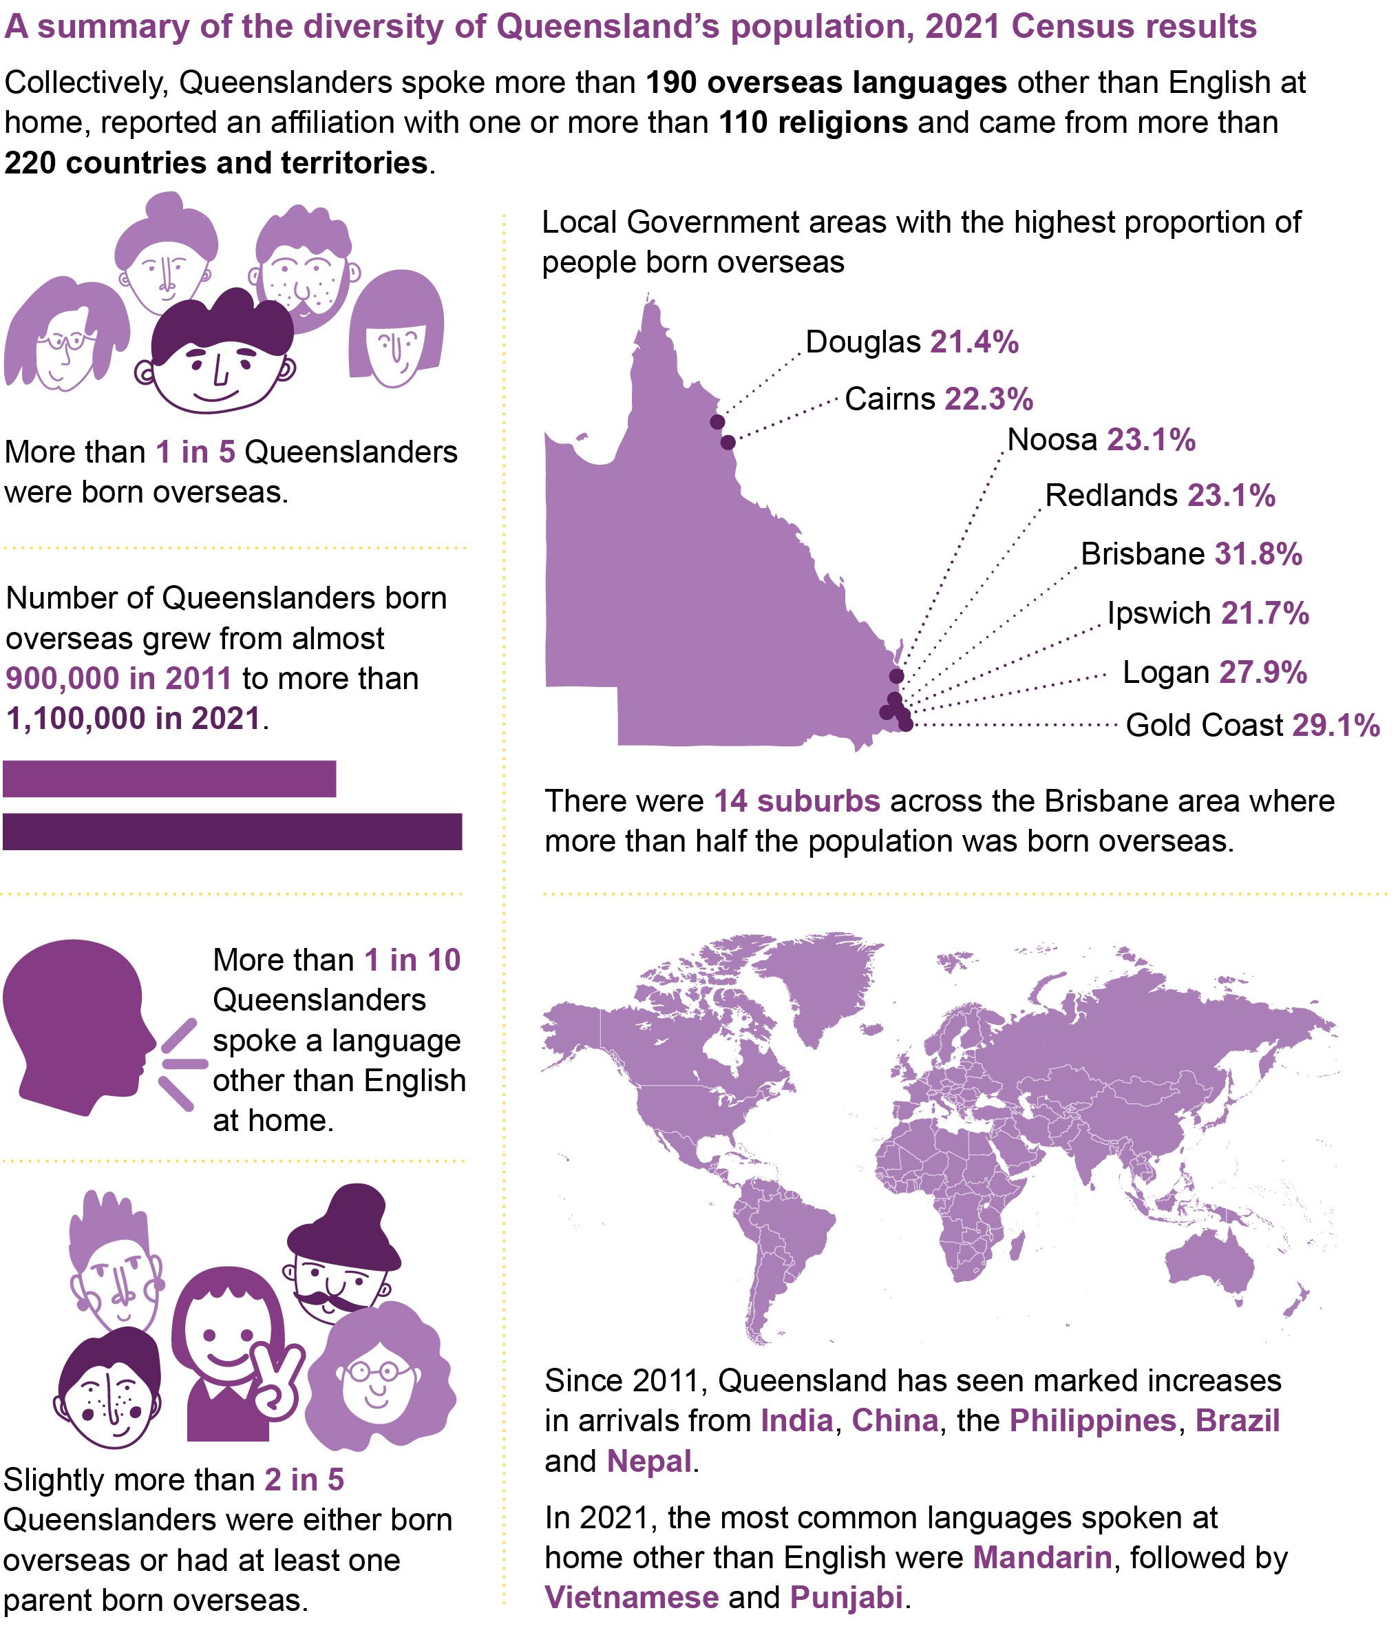

**A note on terminology**

This Action Plan includes references to people from ‘culturally and linguistically diverse’ backgrounds. While there is no formal agreed definition of this term, in this context it is used to refer to people from a migrant or refugee background (which can include second or third generation migrants), people seeking asylum, and Australian South Sea Islander peoples.

The scope of this Action Plan does not include a focus on Aboriginal Peoples or Torres Strait Islander Peoples, as they have a unique position and priority focus as First Nations people.

We recognise that using the term ‘culturally and linguistically diverse’ does not adequately capture the richness of Queensland’s diversity across cultural/ethnic backgrounds, language, country of birth, national origin, heritage/ancestry, race, and religion. Referring to a diverse group of people as a homogenous cohort risks masking the unique strengths and specific challenges that may be experienced by particular groups of people and the identities and experiences many culturally and linguistically diverse Queenslanders have, including living with a disability or identifying as LGBTQIA+.

To reflect this understanding, this term has been used with an understanding that actions will be delivered with a commitment to exploring the different aspects of cultural and linguistic diversity within our communities, including intersectionality, and to identify the unique opportunities and challenges experienced by individuals within this broad cohort.

|  |  |
| --- | --- |
| AUSTRALIAN SOUTH SEA ISLANDERS | |
|  | |
|  | |
| Australian South Sea Islanders are a distinct cultural group with a unique history and position in Australian society. Australian South Sea Islanders are the Australian-born direct descendants of people who were brought to Australia between 1863 and 1904 to work as indentured labourers in the primary industries. Over 50,000 people came from the Pacific Islands, primarily Vanuatu and the Solomon Islands. The majority were kidnapped, 'Blackbirded' or deceived into coming and were subjected to discrimination and harsh treatment.  Despite the hardships they faced, Australian South Sea Islanders have a strong legacy of contributing to Queensland’s social, cultural and economic development. Australian South Sea Islanders helped build many of our local economies and key industries.  Because of this unique history, today's Australian South Sea Islanders are recognised as a unique cultural group and are distinct from more recent migrants. The Queensland Government has formally recognised Australian South Sea Islanders and is committed to ensuring that present and future generations of Australian South Sea Islanders have equality of opportunity to participate in economic, social, political and cultural life.  The Queensland Government committed $1.1 million over four years from 2022-23 to 2025-26, and $170,000 per annum ongoing to strengthen recognition of, and services to, Australian South Sea Islander peoples in Queensland.  The Queensland Government Statistician’s Office (QGSO) has analysed data from the 2021 Census of Population and Housing to provide insights into Queensland’s Australian South Sea Islander communities. The report, *Australian South Sea Islanders in Queensland, Census 2021,* is available here: <https://www.qgso.qld.gov.au/issues/12031/aust-south-sea-islanders-qld-census-2021.pdf> |

# Our journey so far

Released in 2016, the [*Queensland Multicultural Policy: Our Story, Our Future*](https://www.des.qld.gov.au/__data/assets/pdf_file/0021/313923/multicultural-policy.pdf) sets out the priorities and outcomes that all Queensland Government entities are working towards as part of our commitment to the full economic and social participation of all people who have made Queensland their home.

The fourth Action Plan under the Queensland Multicultural Policy is an opportunity to accelerate our efforts to ensure people from culturally and linguistically diverse backgrounds can access services, feel welcome, and participate and contribute fully, both socially and economically.

The next three years represent a critical time in the Queensland Government’s journey to become an Australian and world leader in providing equitable services to all who may make up our diverse state.

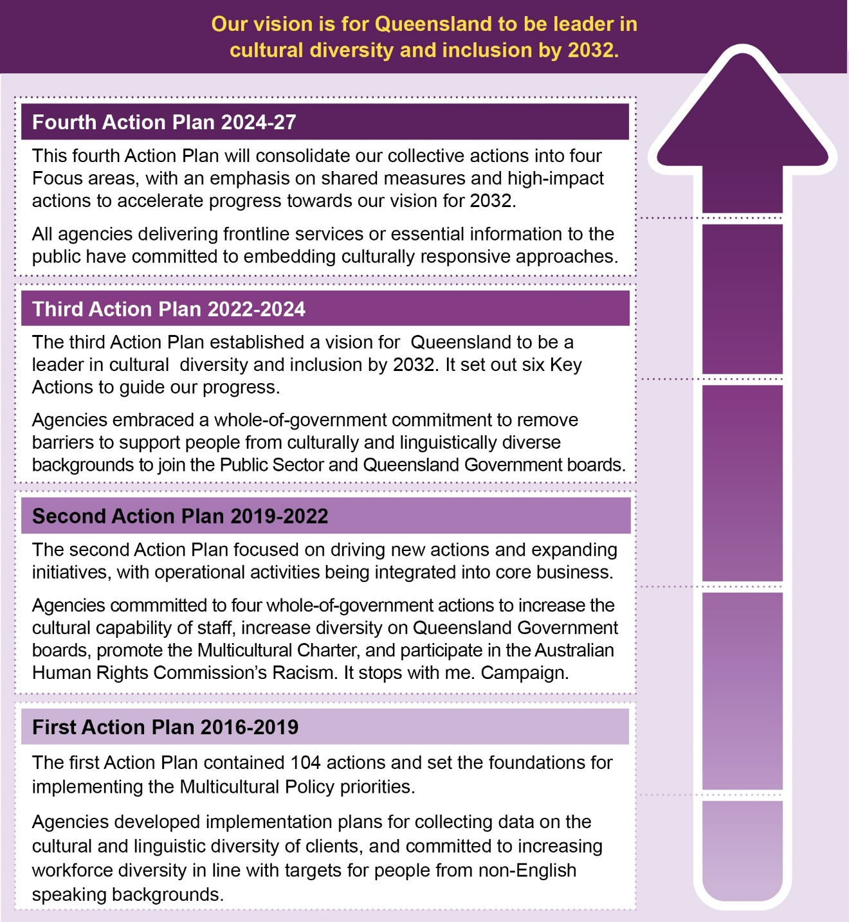

**Snapshot of key achievements**

|  |  |
| --- | --- |
| 2016 | * *Multicultural Recognition Act 2016 commenced.* * Inaugural Multicultural Queensland Advisory Council appointed. * *Queensland Multicultural Policy* and first *Queensland Multicultural Action Plan 2026-27 to 2018-19* released*.* |
| 2017 | * Multicultural Queensland Charter jointly signed by the then Premier Annastacia Palaszczuk MP and former Speaker Peter Wellington MP for display in Parliament House. * First *Refugee Health and Wellbeing Policy and Action Plan for Queensland* released. |
| 2018 | * Partnered with Welcoming Australia to strengthen welcome and inclusion in local communities across the state. * Released the Seizing the opportunity: Making the most of the skills and experience of migrants and refugees report. |
| 2019 | * Established the Asylum Seeker and Refugee Assistance (ASRA) Program. * Second *Multicultural Action Plan 2019-20 to 2021-22* released. * All Queensland Government agencies committed to Racism It Stops with Me. campaign. |
| 2020 | * *Human Rights Act 2019* commenced. * Committed $3.5 million towards establishing a Holocaust Museum and Education Centre in Brisbane. * Expanded the Celebrating Multicultural Queensland (CMQ) program to include funding for Youth and Community Connection projects. |
| 2021 | * Implemented the Safe and Diverse Communities grant program to build the capacity of multicultural communities to recognise, respond and prevent sexual, domestic and family violence. * Funded the CALD COVID Health Engagement Project to improve access to health services and information during the COVID-19 pandemic. * Launched Diverse Queensland Workforce program to support migrants, refugees and international students into employment. |
| 2022 | * Launched the Interpreter Training Boost program with investment of $738,588 over four years. * Launched the *Good People, Good Jobs: Queensland Workforce Strategy 2022-2032*. * Commenced the Workers' Rights Education and Support Services program with investment of $1 million over four years. * Committed $1.1 million over four years and $170,000 per annum ongoing to strengthen recognition of, and services to, Australian South Sea Islander peoples in Queensland. * Community Action for a Multicultural Society program expanded to cover 21 programs areas across Queensland. * Third *Multicultural Action Plan 2022-21 to 2023-24* released. |
| 2023 | * Established the Skilled Workforce Attraction Office. * Celebrating Multicultural Queensland project budget boosted to $3 million per annum. |
| 2024 | * Launched *Good Jobs, Good Training: Queensland Skills Strategy 2024-2028*. * Expanded investment into the ASRA program, committing an extra $4.8 million over two years. * *Criminal Code (Serious Vilification and Hate Crimes) and Other Legislation Amendment Act 2023* commenced. * Fourth *Multicultural Action Plan 2024-25 to 2026-27* released. |

# Multicultural Action Plan 2024-25 to 2026-27

|  |
| --- |
| FOCUS AREA 1: DELIVER CULTURALLY RESPONSIVE SERVICES |
|  |
|  |

The Queensland Government remains committed to ensuring all government initiatives and services, including funded services, are culturally responsive, accessible and inclusive of all people across Queensland.

As Queensland’s cultural diversity increases and changes over time, a one-size-fits-all approach cannot meet everyone’s needs. Many people from culturally and linguistically diverse backgrounds face structural barriers in accessing housing, employment and other services.[1] To address these barriers, government agencies need to continually reflect on how well our services, programs and information are meeting the needs of our communities and how we can improve where disparities are identified. To ensure government services are achieving equitable outcomes for all, it is important to understand the characteristics, circumstances, needs, preferences and cultural contexts of various groups and individuals to develop and deliver appropriate services.[2] This is especially important in the context of new and emerging communities, including people seeking asylum and those from refugee backgrounds, who may have unique and additional needs.

Under this focus area, agencies will review the cultural responsiveness of programs and services to identify barriers to equitable access or disparities in outcomes and implement strategies to address those gaps. Agencies that have undertaken a review under the previous *Multicultural Action Plan 2022-3 to 2023-24* will focus on implementing and embedding their findings.

|  |  |
| --- | --- |
| WHAT IS CULTURALLY RESPONSIVE SERVICE DELIVERY? | |
|  | |
|  | |
| In this Action Plan, *cultural responsiveness* refers to the capacity of our service system to understand and accommodate the diverse and intersecting needs of culturally and linguistically diverse clients and communities. At a system level, cultural responsiveness requires programs, policies and practices to be designed and delivered with a deep understanding of the varied experiences and expectations of culturally diverse clients and communities, and the capacity to accommodate those needs as they emerge. Culturally responsive service delivery requires a commitment to continuous reflection and ongoing collaboration with communities. Activities to improve the cultural responsiveness of information and services may include:   * analysing data to ensure services are reaching and achieving positive outcomes for culturally and linguistically diverse communities; * undertaking research to inform evidence-based interventions tailored to the needs of culturally and linguistically diverse communities; * engaging with people with lived experience, including partnering with community leaders, establishing advisory groups with diverse representation, and empowering communities to participate in co-design; * creating tailored information that is accessible by using plain English, translating messages, and using diverse communication channels and multi-modal formats; and * ensuring services are fully inclusive and accessible by engaging bilingual staff and qualified interpreters to support participation by people who have difficulty communicating in English. |

|  |
| --- |
| *“We know that people from multicultural backgrounds experience significant disparities accessing health services, and subsequently have poorer health outcomes. Challenges include language and cultural barriers, low health literacy, difficulties in navigating the health system, socio-economic barriers and discrimination. I am proud that this year Queensland Health will launch the Multicultural Health Policy and Action Plan, which sets out the priorities for Queensland Health and Queensland public health services to improve health outcomes for Queensland’s culturally and linguistically diverse communities. This is a significant milestone, and I look forward to continuing to work with community, sector and health professionals to improve health equity for Queensland’s culturally and linguistically diverse communities as we deliver initiatives under this plan.*  *Over the next four years, the Queensland government will invest about $11 million in improving health access and outcomes for our multicultural communities. This includes $4 million to attract, recruit, and appoint seven new recurrently funded Multicultural Health Liaison Officers in Hospital and Health Services with significant multicultural and refugee populations; $3.1 million to expand our Refugee Health Service capacity by appointing an additional five refugee health nurses across the state; and $0.9 million over four years to establish a centralised booking system for language services to support frontline services to deliver safe and effective services to people who communicate in languages other than English*”  Michael Walsh, Director-General, Queensland Health |

|  |
| --- |
| EXAMPLES OF WHAT QUEENSLAND GOVERNMENT HAS ACHIEVED SO FAR |

**Exploring the health of culturally and linguistically diverse populations in Queensland**

In 2022-23, Queensland Health contracted the University of Queensland to undertake a review of Queensland’s refugee health services. The review examined the way refugee health services are structured and delivered in Queensland and provided recommendations for how this could be improved to better meet the health needs of people from refugee backgrounds.

In 2022-23, Queensland Health analysedhospitalisation data, mortality data, population data and mental health data to identify disparities in health outcomes for culturally and linguistically diverse populations. The report, *Exploring the health of culturally and linguistically diverse populations in Queensland: 2016-17 to 2019-20,* identified that some country-level overseas-born communities experience higher rates of potentially preventable hospitalisations than the Australian-born population.

Based on the report’s findings, Queensland Health is collaborating with stakeholders to explore initiatives that address the health disparities experienced by communities, and to inform policy and service responses. Queensland Health will also explore opportunities to improve quality data collection and analysis of health outcomes for culturally and linguistically diverse populations, including Australian South Sea Islanders. For more information, visit: <https://www.health.qld.gov.au/public-health/groups/multicultural/multicultural-health-research-and-data/reports>

**Culturally responsive gambling help counselling and support services**

Previous research has found people from culturally diverse backgrounds are less likely to gamble than the general population, however those who do are more vulnerable to gambling harm. In 2022–23, the Department of Justice and Attorney-General (DJAG) commissioned a needs analysis of the Queensland Government-funded Gambling Help counselling and support services for people from culturally and linguistically diverse backgrounds. Over 40 culturally and linguistically diverse community stakeholder groups across Queensland were consulted.

The analysis identified several determinants that increased risk across most multicultural communities, namely: social isolation, financial vulnerability, varying levels of familiarity with commercial gambling products, cultural traditions and beliefs about luck and chance, and the impact of acculturation stresses on broader mental health and wellbeing. Key barriers to engaging with gambling help services and supports included: limited awareness of their availability and issues relating to stigma and shame.

In response to these research findings, DJAG is developing a targeted strategy and action plan in line with a public health approach to addressing gambling harm. This will include developing targeted, culturally appropriate resources and approaches as a priority activity.

**So’ofa’atasiga Aiga Pasifika foster and kinship care model**

|  |  |
| --- | --- |
| Village Connect LTD is a Pasifika community owned and led organisation based in Logan. In 2021, Village Connect coordinated six community talanoa (conversations) with the Department of Child Safety, Seniors and Disability Services (DCSSDS) to identify ways to support improved outcomes for Pasifika and Māori children and families. The process identified the need for a culturally responsive Foster and Kinship care service within the Pasifika and Māori community in Logan.  Village Connect developed the So’ofa’atasiga Aiga Pasifika foster and kinship care model which DCSSDS has funded over three years from 1 July 2023. As part of the program, Village Connect delivers culturally responsive foster care training to Pasifika and Māori clients, which includes adjusting training to recognise different learnings styles, using culturally appropriate multimedia videos to support learning, empowering participants to hold deep and culturally safe talanoa (conversations) about taboo subjects, acknowledging the importance of gender roles during facilitation and being flexible to deliver training within the home environment to meet the needs of a working household.  Community feedback has been positive with community members expressing support for the “mahi” (work) and showing their appreciation that the program knows how to “awhi” (embrace) them in cultural ways. | Front cover of So'ofa'atasiga 'Engaging with families' brochure |

**Emergency and disaster preparedness**

Throughout 2022-23, the former Queensland Fire and Emergency Services (QFES) worked with University of Southern Queensland (USQ) to better understand the emergency and disaster preparedness information needs of local culturally and linguistically diverse communities. QFES and USQ conducted three focus groups with 16 community leaders across Logan, Gold Coast and Ipswich, with participants from a broad range of backgrounds including Kenyan, Tongan, Burmese, Qatari, Sudanese, Samoan, Nigerian, South Sudanese, Chinese and Indian. The focus groups explored community attitudes toward emergency and disaster preparedness, communication channels and formats, language and cultural considerations, information sources, engagement opportunities and resources, with the intent to identify better ways of delivering inclusive preparedness initiatives through tailored engagement approaches. Key themes were identified and shared with internal and external stakeholders.

Through engaging with communities, the former QFES has developed inclusive community engagement resources to build the resilience of vulnerable community members. Public safety and preparation messages for smoke alarms, home fire escapes, bushfire safety and fire danger ratings have been translated and published in multiple languages including Easy English ([www.qfes.qld.gov.au/safetyeducation/resources](http://www.qfes.qld.gov.au/safetyeducation/resources)).

The former QFES is also a founding member of the Ipswich CALD Disaster Management Collaboration Network established in January 2023. The network includes representatives from Multicultural Australia, Queensland Program of Assistance to Survivors of Torture and Trauma (QPASTT), City of Ipswich, Australian Red Cross, Queensland Police Service (QPS) and the Polynesian African Cross-Cultural Advisory Group. The purpose of the network is for disaster management agencies and culturally and linguistically diverse communities in Ipswich to work together in a collaborative and coordinated way to support and deliver emergency and disaster resilience initiatives.

**Electoral Commission Queensland**

The Electoral Commission of Queensland (ECQ) continues to expand its engagement activities, resources and promotion of services to ensure elections are accessible to all Queenslanders. Activities undertaken for the March 2024 local government elections and in the lead up to the October 2024 State general election include:

* expanding translation of the *Multilingual Guide to Voting* and posters into 25 languages, with resources made available in polling places and on the ECQ website ([www.ecq.qld.gov.au](http://www.ecq.qld.gov.au));
* targeted advertising to raise awareness and encourage culturally and linguistically diverse communities to participate in elections, through radio (including in-language radio), television, print and digital channels;
* distributing election information to culturally and linguistically diverse community organisations;
* developing directional posters translated into Vietnamese for the March 2024 Inala State by-election; and
* promoting availability of translation and interpreting services to support participation, through partner agency Language Loop as well as Translation and Interpreting Services.

**Police Multicultural Advisory Group**

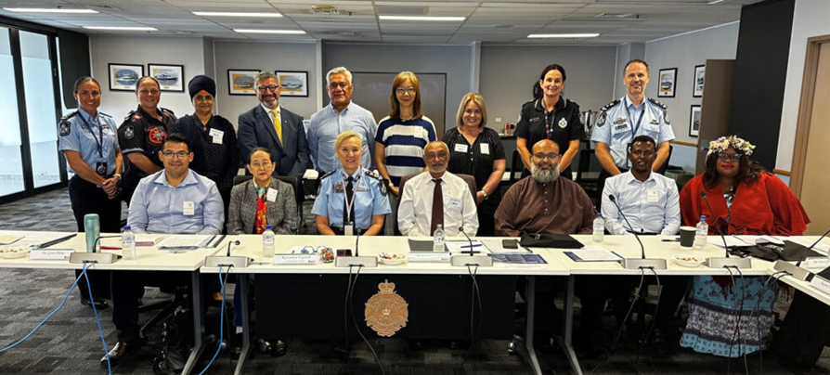In 2023 the Queensland Police Service (QPS) launched the Police Multicultural Advisory Group. This is an advisory body to the QPS, designed to make recommendations intended to improve key policing activities, responses and practices which impact multicultural people and communities in Queensland. The group is integral to enhancing the cultural capability of the QPS as well as contribute to enhancing relationships with multicultural communities.

**TAFE Queensland Pathway Guidance Expo**

In March 2024, over 80 Adult Migrant English Program (AMEP) students from Mooloolaba, Gympie and Noosa campuses joined together for a Pathway Guidance Expo on the Mooloolaba campus. The purpose of the event was to help students make informed decisions about their career pathway, including providing information to support them to continue further education and training. TAFE Queensland consulted with students to develop a program tailored to their needs and interests. The program included interactive break-out sessions on volunteering, small business support, and various vocational pathways, including:

* giving students the opportunity to visit different faculty classrooms, see the facilities and engage with faculty staff, who provided presentations tailored to the needs of students with English as an additional language;
* providing information about job opportunities and the nature of working in professions such as individual support, hospitality, early childhood education and care, beauty, and hairdressing;
* coordinating presentations from volunteer-based organisations such as Meals on Wheels and the Queensland Association of School Tuckshops on how to get involved and the benefits of volunteering for students with low confidence in English-speaking environments; and
* connecting students interested in starting their own business with helpful information, individualised support, and referrals to support them on this pathway, with a session provided by the Sunshine Coast Regional Council.

The event was successful in providing tailored and culturally responsive information and support to encourage migrant and humanitarian students to continue with their education and training within a familiar learning environment. TAFE Queensland will continue to host these events periodically throughout the year.

**Department of Education**

In 2023, the Department of Education (DoE) engaged Central Queensland University to co-develop advice, resources and capability programs for Queensland state schools supporting students learning English as an additional language or dialect (EAL/D students). This work includes a synopsis of contemporary international, national and local research related to the education of EAL/D students and information gathered from 16 Queensland state schools about their supports for EAL/D students.

In 2022-23, DoE awarded an Education Horizon grant to the Queensland University of Technology to co-develop a multilingual glossary of school-based terminology in partnership with schools, community members and support agencies. The glossary provides key terms and plain language definitions of school-based terminology in Arabic, English, Kurdish Kurmanji (audio and written), Portuguese and Swahili ([www.research.qut.edu.au/multilingualschoolglossary/](http://www.research.qut.edu.au/multilingualschoolglossary/)).

**Boosts to Specialist Homelessness Services and temporary supported accommodation**

Queensland Specialist Homelessness Services assist people experiencing or at risk of homelessness through a range of support services and temporary supported (crisis) accommodation, including Domestic and Family Violence Shelters. In 2022-23, 9.7 per cent of people assisted by a Queensland Specialist Homelessness Service were born overseas and 10.9 per cent spoke languages other than English at home.

Through Homes for Queenslanders, the Queensland Government continues to work towards ending homelessness, including a 20 per cent funding boost for frontline Specialist Homelessness Services, expanded Critical Response Teams and delivering more temporary supported accommodation including 10 new or replacement Shelters for people experiencing Domestic and Family Violence.

**Focus Area 1: Actions for 2024-25 to 2026-27**

|  |  |
| --- | --- |
| ACTION | AGENCY |
| Review child and family services across 2-3 locations to test service system responsiveness to the needs of children and families from culturally and linguistically diverse backgrounds. The review process is an opportunity to take stock of how well services are meeting the needs of culturally and linguistically diverse communities and identify opportunities for enhancements as part of a continuous improvement approach. | **DCSSDS** |
| Explore opportunities to engage with people with disability from culturally and linguistically diverse backgrounds on disability reforms in Queensland, including in relation to the *Independent Review of the National Disability Insurance Scheme (NDIS)* and *Royal Commission into Violence, Abuse and Neglect of People with Disability.* | **DCSSDS** |
| Engage with older people from culturally and linguistically diverse backgrounds to design culturally responsive elder abuse prevention initiatives and service responses. | **DCSSDS** |
| Work with the Queensland United Australian South Sea Islander Council (QUASSIC) and James Cook University to co-design research on the experiences of Queensland’s Australian South Sea Islander communities and promote the findings across government to inform future policy and program responses. | **DCSSDS** |
| Evaluate the accessibility and effectiveness of the *Enable Grants Program* in reaching and meeting the needs of culturally and linguistically diverse communities in accessing energy efficiency advice and activities and use findings to inform future energy program design and delivery. | **DEC** |
| Deliver actions in *Good Jobs, Great Training: Queensland Skills Strategy 2024-2028* to make information about training options and pathways easier to access and understand for students, apprentices and trainees, and employers and industry. | **DESBT** |
| Engage people from culturally and linguistically diverse backgrounds through science engagement initiatives such as Engaging Science Grants. | **DESI** |
| Ensure culturally and linguistically diverse stakeholders are consulted in improving the accessibility of housing products and services including efforts to modernise access to housing services online (Service Modernisation Program); and ensure communication and engagement with these stakeholders to promote housing products and services, and how to access them. | **DHLGPPW** |
| Develop a strategy and targeted resources to ensure Gambling Help services are accessible and responsive to the needs of culturally and linguistically diverse communities, including reviewing cultural capability across funded service providers to identify opportunities to enhance culturally responsive service delivery. | **DJAG** |
| Co-design accessible and culturally responsive resources on coercive control in partnership with culturally and linguistically diverse communities. | **DJAG** |
| Through the Office of the Victims Commissioner, improve access to the Charter of Victims’ Rights by translating the publication into seven languages other than English, and implementing a targeted communications campaign. | **DJAG** |
| Through the Office of the Public Advocate, advocate systemically for the rights of adults from culturally and linguistically diverse backgrounds with impaired decision-making ability when accessing mainstream services including health, justice and disability. | **DJAG** |
| Monitor and increase participation of children from non-English speaking communities in Early Childhood Education and Care services, including kindergarten. | **DoE** |
| Provide funding to services through the Kindy Uplift program to ensure all Queensland children have access to culturally safe, inclusive and responsive kindergarten programs. | **DoE** |
| Partner with a university supplier to co-develop culturally and linguistically responsive advice, resources and capability programs for Queensland state schools supporting students whose first language is a language or dialect other than English and who need additional support to develop proficiency in Standard Australian English. | **DoE** |
| Develop advice for staff about engaging with interpreters and translators, writing in plain English and Easy English and arranging translations of key information for people who use languages or dialects other than English and may not yet be literate in English. | **DoE** |
| Support international students and temporary residents to engage with culturally and linguistically diverse communities by providing targeted resourcing and services that support Queensland state schools to foster mutual understanding, and inclusivity of our schools and wider communities. | **DoE** |
| Drive participation and inclusion of students from culturally and linguistically diverse backgrounds in the Queensland Representative School Sport program at both state and regional levels. | **DoE** |
| Improve access to services for customers who have difficulty communicating in English by reviewing the provision of language services and working with the National Accreditation Authority for Translators and Interpreters to investigate multilingual staff becoming Community Language Aides. | **DTMR** |
| Assess delivery of elections for culturally and linguistically diverse Queensland electors, to inform improvements in the areas of service delivery, employment and training opportunities, and awareness and participation, informed by research and engagement with the sector. | **ECQ** |
| Develop a plan for building practical skills in community engagement, facilitation and public communication across the Public Sector, including consideration for accessible and appropriate engagement with culturally and linguistically diverse communities. | **PSC** |
| Improve the cultural responsiveness of services for people from culturally and linguistically diverse backgrounds in correctional facilities, including Queensland correctional facilities’ practice on removal of clothing searches as recommended by the Queensland Human Rights Commission. | **QCS** |
| Increase community awareness of warnings during incidents and disasters through community-led, grassroots engagement with culturally and linguistically diverse communities, including partnering with community leaders and non-government organisations. | **QFD**  **QPS** |
| Engage with the Police Multicultural Advisory Group to embed a focus on cultural responsiveness into the implementation of findings from recently completed reviews, including the Commission of Inquiry into Queensland Policy Service responses to domestic and family violence. | **QPS** |
| Undertake a review of the experiences of people from culturally and linguistically diverse backgrounds when reporting crime to police. | **QPS** |
| Support accessible service delivery across government by reviewing the provision of language services, including updating the Standing Offer Arrangement for Provision of Language Services (Interpreting and Translating), and the Queensland Language Services Policy and Guidelines. | **QH**  **DCSSDS** |
| Launch and implement a Multicultural Health Policy and Action Plan to outline comprehensive actions to improve the cultural responsiveness of health services. | **QH** |
| Review service delivery models and develop best practice guidelines to ensure equitable access to high-quality and culturally safe healthcare for culturally and linguistically diverse communities. | **QH** |
| Improve health responses for people from refugee backgrounds through implementation of the Refugee Health and Wellbeing Policy and Action Plan 2022-2027 in partnership with Refugee Health Network Queensland. | **QH** |
| Implement recommendations of the University of Queensland Review of Queensland Health Refugee Health Services, including increasing the refugee health nursing workforce. | **QH** |
| Review and implement recommendations of the Strengthening the State Funded Mental Health, Alcohol and Other Drugs (MHAOD) Service Response for People from Culturally and Linguistically Diverse Communities Report prepared by Nous Group for Queensland Health. | **QH** |
| Ensure timely and equitable access to public health services for people seeking asylum, including those fleeing emergent international conflicts. | **QH** |
| Work with relevant stakeholders to address barriers to health access for people in Queensland under the Pacific Australia Labour Mobility Scheme and the Seasonal Worker Programme. | **QH** |
| Implement a targeted program to improve access to health services for Australian South Sea Islander populations in the Mackay Hospital and Health Service region. | **QH** |
| Build the capacity of Queensland Health to engage and co-design policies, initiatives and resources with culturally and linguistically diverse communities. | **QH** |
| Improve access to in-language health services by implementing guidelines to build capability of staff to effectively engage with interpreters in a healthcare setting and implementing the language badge program across Queensland Health services. | **QH** |
| Develop a Strategy to improve the overarching mental health and wellbeing of Queenslanders, including a focus on the needs of culturally and linguistically diverse communities. | **HWQld**  **QMHC** |
| Promote integrated models of suicide prevention and support that use a whole-of-family and kin approach, including a focus on people from culturally and linguistically diverse backgrounds as part of implementing *Every life: The Queensland Suicide Prevention Plan 2019-2029*. | **QMHC** |
| Facilitate the delivery of resources and community-based programs to reduce alcohol and other drugs related harms in culturally and linguistically diverse communities as part of implementing *Achieving balance: The Queensland Alcohol and Other Drugs Plan 2022-2027*. | **QMHC** |
| Review and refine dispute resolution processes to make them more accessible and inclusive for people from culturally and linguistically diverse backgrounds. | **QHRC** |
| Develop tools, education, and support to help guide communication with culturally and linguistically diverse communities, including those in rural and remote areas to promote disaster preparedness, resilience and recovery. | **QRA** |
| Promote and support local councils to implement culturally and linguistically diverse community engagement programs and activities for disaster preparedness. | **QRA** |
| Work with PCYC Queensland to increase participation by people from culturally and linguistically diverse backgrounds in the Braking the Cycle program, funded by the Motor Accident Insurance Commission, which helps Queenslanders access the 100 hours of on-road driver training required to obtain their driver’s license. | **QT** |
| Develop a stakeholder engagement framework to enhance relationships with key multicultural organisations, government agencies and other stakeholders with relevant expertise and networks, with the aim of increasing engagement with customers from culturally and linguistically diverse communities. | **RTA** |
| Expand approaches to culturally responsive service delivery used in TAFE Queensland English Language and Literacy Services (TELLS) across the wider TAFE system to support students to successfully transition into vocational training. | **TAFE Qld** |

|  |
| --- |
| FOCUS AREA 2: DRIVE DIVERSITY AND INCLUSION ACROSS THE PUBLIC SECTOR |
|  |
|  |

A diverse and inclusive workforce that is representative of the community we serve is essential to ensuring we are a culturally responsive government. As the largest employer in Queensland, it is imperative the Queensland Government demonstrates leadership in improving workforce participation in the public sector for people from culturally and linguistically diverse backgrounds.

To support improved diversity, the Queensland public sector has set a workforce target of 12 per cent of employees who speak a language other than English at home (including Aboriginal languages and Torres Strait Islander languages) by 2026. Through this Action Plan, all agencies commit to delivering actions to improve the cultural diversity of our workforce to achieve this target by 2026.

|  |
| --- |
| Diversity targets – how are we tracking? As at March 2024, 8.24 per cent of Queensland’s public sector workforce had reported through the payroll system that they speak a language other than English at home (including First Nations languages). However, in the anonymous Working for Queensland survey, 12 per cent of respondents indicated they spoke a language other than English at home. Aside from issues anonymity, the reasons respondents gave for not sharing this information via their payroll include people not seeing any reason or benefit in sharing it, and/or not considering it relevant to their employment.  To assist agencies in overcoming these barriers, the Public Sector Commission (PSC) developed an internal communication toolkit for agencies to use to encourage employees to update their diversity information. The toolkit can be found here: <https://www.forgov.qld.gov.au/recruitment-performance-and-career/workforce-planning/workforce-statistics-and-tools/workforce-diversity-census> |

To harness the benefits of our increasingly diverse workforce, the Queensland Government is also committed to fostering inclusive workplace cultures that respect and value the contributions of people with different backgrounds, experiences and perspectives. According to the 2023 Working for Queensland survey results, 69 per cent of respondents who identified as speaking a language other than English at home (including First Nations languages) reported that cultural background is not a barrier to success in their organisation, which is an increase from 66 per cent in 2022. [3]

Since 2021, Public Sector workforce data and surveys have also included an indicator to enable Australian South Sea Islander identification. Based on the 2023 Working for Queensland Survey, 64 per cent of respondents who identified as Australian South Sea Islander reported that being an Australian South Sea Islander person was not a barrier to success in their organisation (up from 60 per cent in 2022) and 60 per cent of Australian South Sea Islander people felt culturally safe at work (up from 59 per cent in 2022). [4] All agencies will continue to focus on improving these results during the Action Plan period.

A key part of fostering inclusive workplaces will be addressing racism and discrimination across the Public Sector. Based on 2023 Working for Queensland survey results, 6 per cent of respondents from the Queensland Public Sector had experienced racism in the last 12 months.[5] Thirty-two per cent of those had not reported or told anyone about their experience, with the main barriers being: not thinking any action would be taken (43 per cent), not thinking it was worth the hassle of going through the reporting process (29 per cent) and concerns it could affect their career (25 per cent).[6] Addressing racism across the Public Sector is essential to improving diversity in recruitment and retention and ensuring safe workplaces. Our collective commitments to address racism are outlined under Focus Area 4.

|  |  |
| --- | --- |
| DIVERSITY ON QUEENSLAND GOVERNMENT BOARDS | |
|  | |
|  | |
| The Queensland Government is committed to increasing the cultural and linguistic diversity of representation on government boards and will adopt a whole-of-government approach to diversity and inclusion to achieve this goal. The Department of the Premier and Cabinet will monitor and report on the representation of people from culturally and linguistically diverse backgrounds on Queensland Government boards, noting data will only be collected on a voluntary basis from government body members. Agencies will deliver on this with guidance from the Diversity and Inclusion on Boards: A Toolkit which outlines practical strategies to ensure well-targeted and inclusive recruitment practices for government boards. The toolkit is available here: <https://www.des.qld.gov.au/__data/assets/pdf_file/0022/316912/diversity-inclusion-toolkit.pdf> |

|  |
| --- |
| *“Queensland welcomed my family and I more than 20 years ago. Australia provided us with safe haven and opportunity – as it does for thousands of migrants every year. My experience moving to Queensland and learning English is a reminder to me about the steadfast commitment to multiculturalism the public service needs, if we are to be truly reflective of the community we serve. In DJAG we believe that our diversity is our strength”.*  Jasmina Joldić PSM, Director-General, Department of Justice and Attorney-General |

|  |
| --- |
| EXAMPLES OF WHAT QUEENSLAND GOVERNMENT HAS ACHIEVED SO FAR |

**Electoral Commission Queensland**

The ECQ expanded its recruitment strategies to seek greater diversity in its temporary election workforce for the March 2024 local government elections and will continue this work in the lead up to the October 2024 State general election. This includes:

* targeted recruitment through advertising and promotion to identified communities for culturally and linguistically diverse temporary election staff;
* distribution of temporary election staff recruitment stakeholder kits to culturally and linguistically diverse community organisations;
* providing Returning Officers (election field managers) with recruitment training to consider cultural diversity and equity in hiring temporary election staff, including use of cultural diversity demographics and statistics of individual Queensland electorates or local government areas; and
* simplifying recruitment information on the ECQ website, in position descriptions and employment forms to cater to different levels of literacy.

**‘Get Prepared’ program**

In 2024, QPS, Queensland Corrective Services (QCS), Australian Federal Police (AFP) and Multicultural Australia partnered to deliver the ‘Get Prepared’ program. Targeting interested applicants from diverse cultural backgrounds, the program prepares participants for a potential career in public safety within one of the partner agencies. Specific barriers to employment are addressed during the program which includes First Aid training, interview practice, communication skills, swimming lessons and industry exposure.

The pre-employment program is intended to bridge the gap for interested and talented applicants in the employment application process for QPS, QCS and AFP and assist applicants in becoming employment ready. Employment guarantees are not provided, however participants completing the program can develop a solid understanding of each agency, employment opportunities and requirements for entry level roles within each agency. They can also develop strong networks and support within each partner agency and be competitive to meet recruitment standards.

**Public Sector Commission**

The PSC has supported implementation of the *Public Sector Act 2022* which commenced in March 2023. The Act provides a stronger focus on the importance of a culture of respect and inclusion in the public sector and introduces responsibilities for agencies to prepare annual equity and diversity audits and plans. The new legislation supports improved employment outcomes for culturally and linguistically diverse groups by clarifying recruitment and selection processes reflect the agency's *Public Sector Act 2022* obligations relating to equity, diversity, respect and inclusion.

Implementation of these new provisions is primarily through the PSC’s new Recruitment and Selection Directive which came into effect on 26 June 2023. In deciding the eligible applicant best suited to a position, the hiring manager can consider the extent to which a candidate would contribute to the organisation's equity, diversity, respect and inclusion objectives.

In 2023, the PSC, with support from the Special Commissioner for Equity and Diversity, delivered a webinar to human resource professionals from across the public sector and developed supporting resources for human resource teams and hiring managers on ways to attract and recruit for diversity and foster inclusion. Further practical supporting resources and tools will be developed as part of the Even Better Public Sector for Queensland strategy’s action for inclusive recruitment and selection. For more information, visit: <https://www.qld.gov.au/about/how-government-works/government-structure/public-sector-commission/office-of-the-special-commissioner-equity-and-diversity>

**Queensland Corrective Services**

QCS is working proactively to be culturally responsive to the needs of people from diverse backgrounds. A recent example is QCS’s engagement with the Queensland African Community Council (QACC), which has resulted in an open and direct line of communication with many African communities. To improve the cultural capability of QCS staff, the QACC has delivered African cultural awareness training to select teams at the Wolston Correctional Centre (WCC) and Borallon Training and Correctional Centre (BTCC), and to the Custodial Operations General Managers at a Regional Forum in 2023.

**Queensland Police Service**

The QPS continues to offer the Multicultural Recruit Preparation Pathway for police recruit applicants from culturally and linguistically diverse backgrounds. This includes delivering a program which supports multicultural police recruit applicants through the recruitment process. Recruits from culturally and linguistically diverse backgrounds commencing within the Recruit Training Program are offered targeted mentorship and support from the QPS Multicultural Inclusion Network.

The QPS also continues to employ Police Liaison Officers (PLO) from multicultural backgrounds state-wide. Recognising that applying for a job within a government recruitment application framework can be challenging for applicants from non-English speaking backgrounds, several police districts including Logan, South Brisbane and Darling Downs Districts delivered career forums for targeted PLO applicants. These forums provided advice and information surrounding the PLO role as well as dedicated support surrounding the application process. The forums provided the opportunity for potential applicants to receive specific advice around their application and the recruitment process prior to making application for the role. The forums resulted in talented individuals from a range of cultural backgrounds being employed as PLOs across these districts.

In 2023, the QPS also launched an international recruiting strategy aimed at enhancing diversity of international recruit applicants with policing experience.

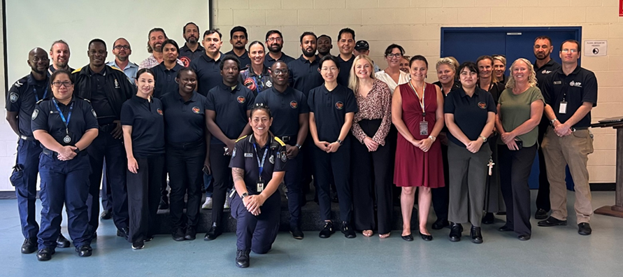

**Focus Area 2: Actions for 2024-25 to 2026-27**

|  |  |
| --- | --- |
| ACTION | AGENCY |
| Monitor data related to culturally and linguistically diverse employee representation and deliver strategies to achieve the whole-of-government target of 12 per cent for employees who speak a language other than English at home. | **All agencies** |
| Monitor Working for Queensland survey results relevant to cultural diversity and inclusion and deliver strategies to improve inclusion for culturally and linguistically diverse employees, including Australian South Sea Islander peoples. | **All agencies** |
| Using the *Diversity and Inclusion on Boards Toolkit*, implement targeted actions to increase the cultural and linguistic diversity of representation on Queensland Government boards. | **All agencies** |
| Agencies will provide DPC with data on the cultural and linguistic diversity of Queensland Government boards to enable Government to monitor and report on the diversity of Queensland Government bodies. | **DPC**  **All agencies** |
| Report annually on the experiences of culturally and linguistically diverse employees across the Public Sector, including monitoring representation, inclusion and engagement.in the State of the Sector report. | **PSC** |
| Review Working for Queensland survey questions to ensure they capture the experience of culturally and linguistically diverse employees, that definitions align with contemporary recommendations and that the survey provides actionable insights. | **PSC** |
| Deliver a public campaign to promote the diverse employment opportunities that exist across the public sector and clearly explain why the sector is a great place to build a career, including targeted communications for culturally and linguistically diverse groups. | **PSC** |
| Implement a new sector-wide program for non-frontline graduate recruitment aimed at launching and supporting meaningful public sector careers, including a target for graduates from culturally and linguistically diverse backgrounds. | **PSC** |
| Implement strategies to attract, recruit and train a culturally and linguistically diverse election workforce. | **ECQ** |
| Expand workforce data collection to capture the languages spoken by employees and ensure key documents and resources in the employee lifecycle are available in the languages with the greatest need (by demand and largest written-English literacy gaps). | **DoE** |
| Undertake a comprehensive review of diversity and inclusion within the QPS, including consulting with current and past officers from culturally and linguistically diverse backgrounds, and developing recommendations to improve recruitment and retention of culturally and linguistically diverse employees. | **QHRC**  **QPS** |
| Continue to deliver the Multicultural Recruit Preparation Pathway as an opportunity to support applicants from culturally and linguistically diverse backgrounds join the QPS. | **QPS** |
| Undertake an evaluation of the Get Prepared program to determine opportunities to improve and/or expand the program. | **QPS** |
| Partner with Multicultural Australia to attract culturally and linguistically diverse applicants to the QCS and QPS (in partnership with the Australian Federal Police). | **QCS**  **QPS** |
| Develop and deliver the Health Workforce Strategy for Queensland to 2032, with implementation supported through the Queensland Health Workforce Action Plan 2024 to 2028, including a focus on expanding employment opportunities for culturally and linguistically diverse-identified positions. | **QH** |
| Enhance the specialist multicultural health workforce across various Queensland Health services, including establishing dedicated multicultural health liaison officer roles in areas with significant multicultural and refugee populations. | **QH** |
| Partner with culturally diverse organisations to attract more diverse candidate pools during the recruitment process. | **RTA** |
| Deliver training to improve the cross-cultural capability of staff to better understand and meet the needs of culturally and linguistically diverse communities. | **RTA, DTMR, TIQ, QH** |

|  |
| --- |
| FOCUS AREA 3: STRENGTHEN OUR ECONOMY |
|  |
|  |

Queensland’s economy and community will thrive when there is equitable access to opportunity, and we better utilise the skills and talents of our population.

Improving diversity and inclusion across our economy is important from an equity perspective and is essential to our ongoing innovation and economic growth. With many industries facing workforce shortages, and a new mix of skills needed in critical areas like healthcare, the net zero transition and the digital economy, ensuring the full inclusion and participation of people from culturally and linguistically diverse backgrounds is critical to Queensland’s future social and economic success.

Diversity across our industry workforces brings many benefits. It is critical that we ensure Queensland’s key industries have high-performing and inclusive workforce participation, particularly in the lead up to 2032 where we will showcase Queensland’s cultural inclusion and diversity to the world during the Brisbane 2032 Olympic and Paralympic Games. We will have greater impact by working collaboratively with local industries and communities to deliver innovative and mutually beneficial solutions.

Under this Focus Area, Queensland Government agencies will take specific actions to identify and address the barriers that people from culturally and linguistically diverse backgrounds face to participate in economic opportunities in line with their skills and ambitions. This includes international students, people from migrant and refugee backgrounds, and Australian South Sea Islander peoples.

|  |
| --- |
| *“My department is committed to ensuring all Queenslanders can seize the enormous job opportunities available now and into the next decade. Through the Good people. Good jobs: Queensland Workforce Strategy 2022-2032, we are supporting employers across the state to tap into workers they might not have traditionally accessed, including migrants, refugees and international students. This not only enables employers to draw on a larger talent pool but ensures all Queenslanders have access to employment opportunities, particularly people who have been previously under-represented. By increasing participation and leveraging the existing skills, experience and qualifications of Queenslanders, including migrant communities, the state can build a stronger, more resilient and capable workforce”*  Peter McKay, Director-General, Department of Employment, Small Business and Training |

|  |
| --- |
| EXAMPLES OF WHAT QUEENSLAND GOVERNMENT HAS ACHIEVED SO FAR |

**Queensland Workforce Strategy**

*Good people. Good jobs: Queensland Workforce Strategy 2022-2032* (QWS) is Queensland’s comprehensive whole-of-government workforce strategy to harness the potential of our people, drive economic growth, and strengthen our communities. The strategy is connecting Queenslanders with work, in particular people from diverse backgrounds, including migrants and refugees.

Under the first QWS Action Plan (2022-25), a range of initiatives and programs are being delivered across the Queensland Government to support workforce participation for Queenslanders from culturally and linguistically diverse backgrounds, including:

* Establishing a Multicultural Affairs Queensland Settlement team to advocate and improve workforce outcomes for migrants and refugees in Queensland.
* Expanding the Diverse Queensland Workforce (DQW) program to ensure work-ready migrants, refugees and international students have the support and guidance needed to find a fulfilling job and build rewarding careers. In 2022-23, an additional $5.5 million was committed to DQW, increasing reach of the program to assist an additional 1,500 people, including three new delivery locations and extending the life of the program until 30 June 2025. Approved providers are delivering one-stop-shops or hubs to provide a range of client-centred employment and training services in Cairns, Logan, Gold Coast, Brisbane, Ipswich, Toowoomba, Rockhampton, Sunshine Coast and Townsville. As at 31 May 2024, providers had assisted 1,966 people with 1,240 (80 per cent) of the exited participants gaining employment. Based on annual performance review, funded projects will be extended for a further 12 months in 2024-25. For more information, visit: <https://desbt.qld.gov.au/training/future-skills-fund/diverse-qld-workforce>.
* Established the Workforce Connect Fund to increase investment in industry and community-led projects that address attraction, retention, and participation issues with the workforce. This includes Motor Trades Association of Queensland who have been funded to deliver the Opening Doors to the Automotive Industry project. Partnering with Multicultural Australia and CoAct, the project aims to create sustainable pathways to jobs and grow a diverse and inclusive workforce.
* Delivering the Social Enterprise Jobs Fund to support the development of a sustainable and thriving social enterprise sector and increase the participation of Queenslanders currently underrepresented in the workforce. The social enterprise sector also supports vulnerable job seekers from culturally and linguistically diverse backgrounds. In 2022-23, the initiative provided grant funding of $1.89 million for 89 projects under the Social Enterprise Growth Grants program.
* Creating a Skilled Workforce Attraction Office (SWAO) to attract a skilled and a talented workforce to meet Queensland’s labour market needs.The SWAO will strengthen the Queensland Government’s skilled migration policy, advocacy and attraction activities, including helping attract a skilled and a talented workforce to meet Queensland’s labour market needs across the state.
* Partnering with industry to harness onshore migrant skills to maximise employment opportunities for migrants who are already in Australia (see below for more detail).
* Delivering the *Queensland Public Sector Inclusion and Diversity Strategy 2021–2025* to build a diverse Queensland workforce representing the community it serves. Delivering a range of other actions to support people from diverse backgrounds into employment, including the School to Work Transitions Program and activities supported through the Queensland Care Consortium supporting health and community services sector-led workforce development, attraction, and retention strategies.

**Skilling Queenslanders for Work**

With an ongoing annual investment of $80 million, the Skilling Queenslanders for Work initiative assists disadvantaged Queenslanders to gain skills, qualifications, and experience to enter and stay in the workforce. The initiative funds community organisations to deliver training and support programs to up to 15,000 unemployed or underemployed Queenslanders, including a focus on people from culturally and linguistically diverse backgrounds. Outcomes include:

* **Step Up To Work Toowoomba:** CatholicCare Social Services was awarded $257,600 to deliver a Work Skills Traineeships project to employ 10 people from culturally and linguistically diverse backgrounds in Toowoomba. Trainees undertook paid work placement over 26 weeks while completing the Certificate I in Workplace Skills. Work activities at various local host employer organisations included: data entry; filing and record keeping; reception duties; ordering supplies; banking; invoicing; recording travel; collating newsletter information; generating templates; printing; promotional work; event planning; and liaising with stakeholders. Trainees were assisted with wrap around support including language, numeracy and literacy assistance; counselling; team building; job readiness; job search and post participation support. At project completion in April 2023, 10 culturally and linguistically trainees had completed the program with five (50 per cent) gaining employment.
* **Migrant and Refugee Youth Support Program (MaRYS):** Downs Industry Schools Co-Op (DISCO) was awarded $148,200 to assist 34 disadvantaged youth from a culturally and linguistically diverse background to be confident and work ready. Participants completed either Certificate II in Skills for Work and Vocational Pathways or Certificate I in Access to Vocational Pathways to gain valuable practical skills for employment and/or further education and training. To increase their employability, additional training included First Aid, General Construction Induction Training Card, Responsible Service of Alcohol, and Responsible Gambling Services. Participants undertook career development activities to determine areas of capability and interest. This was followed up with work experience and job preparation activities to match, preparing them to meet the expectations of employers. Wrap around support included intensive case management; language, literacy, numeracy and digital support; transport assistance; provision of personal protective equipment; work and interview clothing; specialists support referrals; life skills and post participation support for up to three months to aid with the transition into the workplace. The project ended in December 2023, having assisted 34 people with 33 (97 per cent) completing accredited training, 22 (65 per cent) gaining employment, and one returning to school.

**Boosting opportunities for culturally and linguistically diverse suppliers**

In 2023, the Queensland Government launched Buy Queensland 2023, which comprises the *Queensland Procurement Strategy 2023 – Jobs, Economy, Legacy, Confidence* and the *Queensland Procurement Policy 2023*. It sets the strategic direction of Queensland Government procurement, including harnessing our procurement power to deliver more quality, local jobs. Buy Queensland commits the Queensland Government to boost access for suppliers including culturally and linguistically diverse suppliers.

**Attracting and retaining engineers from migrant backgrounds**

Through the QWS, the Queensland Government has committed to partnering with industry to harness the existing skills of the onshore migrant workforce, particularly to address skills shortages in high demand sectors. A partnership between Engineers Australia, Consult Australia and the Queensland Government developed the *Attracting and Retaining Engineers from Migrant Backgrounds: Guide for Employers*. The guide provides practical advice and information to tap into the pool of international skills and knowledge of people from migrant backgrounds with engineering qualifications. It also provides information to employers regarding approaches in attracting and retaining skilled migrant and refugee engineers, supporting businesses to access the workforce they need and support the growth of industries. The report is available here: <https://www.dcssds.qld.gov.au/our-work/multicultural-affairs/programs-initiatives/attracting-retaining-engineers-migrant-backgrounds>

**Focus Area 3: Actions for 2024-25 to 2026-27**

|  |  |
| --- | --- |
| ACTION | AGENCY |
| Continue to deliver the QWS to improve workforce outcomes for people from culturally and linguistically backgrounds. | **DESBT** |
| Expand the Back to Work suite of programs to support employment pathways for jobseekers from culturally and linguistically diverse backgrounds, as well as offer employers a suite of financial and non-financial supports to be inclusive workplaces and improve their ability to attract and retain a diverse workforce. | **DESBT** |
| Deliver the *Good Jobs, Great Training: Queensland Skills Strategy 2024-2028* to provide access and the support needed to gain skills for well-paid and secure jobs for all Queenslanders including people from culturally and linguistically diverse communities. | **DESBT** |
| Deliver targeted skills and training programs supporting disadvantaged Queenslanders, including migrants and refugees and people from culturally diverse backgrounds to gain the skills, qualifications and experience needed to enter and stay in the workforce under the Skilling Queenslanders for Work initiative. | **DESBT** |
| Conduct a review of the DQW program to inform continuation of the hubs that support people from culturally diverse backgrounds to participate in the economy. | **DESBT** |
| Deliver initiatives to support culturally and linguistically diverse workforce participation in the residential construction workforce through the Construction Workforce Fund. | **DESBT** |
| Identify opportunities to assist culturally and linguistically diverse small business intenders and operators. | **DESBT** |
| Continue to offer small business grant and mentoring programs to culturally and linguistically diverse small business owners. | **DESBT** |
| Develop and deliver a free micro-credential on Cultural Diversity in the Workforce to build capacity of small businesses and other employers. | **DESBT**  **TAFE Qld** |
| Strengthen the energy workforce by establishing priority processing for the State Nominated Skilled Migration program for relevant energy workers under the Clean Energy Workforce Roadmap. | **TIQ**  **DESBT** |
| Through the SWAO, develop and deliver strategies to attract a skilled and talented workforce to meet Queensland labour market needs. | **TIQ** |
| Undertake Export and Investment roadshows for Migration Queensland business visa holders and migration agents/immigration lawyers to facilitate investment in a Queensland regional area in conjunction with Mayors, local councils, and businesses | **TIQ** |
| Continue to deliver the *Queensland International Education and Training Strategy 2022-2027* to support the international student experience and enable employability opportunities. | **TIQ** |
| Promote the Women in Manufacturing Diversity, Equity and Inclusion Toolkit and deliver Toolbox Talks across the Queensland manufacturing industry to increase economic opportunities for culturally and linguistically diverse workforce participation. | **DRDMW** |
| Support participation by young people from culturally and linguistically backgrounds in the Young Tourism Leaders program, which focuses on inspiring young people to consider a career in tourism. | **DTS** |
| Develop and deliver the Health Workforce Strategy for Queensland to 2032, with implementation supported through the Queensland Health Workforce Action Plan 2024 to 2028, including addressing barriers to skills recognition for migrants and refugees. | **QH** |
| Monitor and increase participation of people from culturally and linguistically backgrounds in the early childhood workforce through initiatives under the Queensland Early Childhood Workforce Strategy. | **DoE** |
| Support the provision of enrolment into Queensland state schools for dependants of international university students and skilled migrants who will enter the workforce, supporting skills shortages post study. | **DoE** |
| Attract a diverse cohort of international students to engage in learning in Queensland state schools to provide economic benefits to local communities. | **DoE** |

|  |
| --- |
| FOCUS AREA 4: PROMOTE SOCIAL COHESION |
|  |
|  |

All Queenslanders have a responsibility to foster social cohesion in our communities. While social cohesion has various definitions, it essentially means the willingness of members of society to cooperate with each other in order to survive and prosper.[7] A strong focus on fostering united, harmonious and inclusive communities is of vital importance to our 2032 vision; and reflects our commitment to diversity in hosting the *Brisbane 2032 Olympic and Paralympic Games*.[8]

Being a multicultural state means we are connected to every part of the world. Global events such as war and geopolitical unrest can have a profound effect on individuals and communities in Queensland, with flow on effects for community wellbeing and social cohesion. Social cohesion is also influenced by cost of living pressures and events like natural disasters and local community crises.[9] To promote social cohesion, the Queensland Government is committed to encouraging every Queenslander to stand together and to support one another.

Under this Focus Area, Queensland Government agencies will take action to respect and celebrate the contributions of Queenslanders from diverse backgrounds. Agencies will focus on building cross-cultural connections so people from all backgrounds can come together to honour and embrace all aspects of Queensland’s diversity, including celebrating our rich and ancient First Nations history.

The majority of Australians support multiculturalism and recognise the benefits that cultural diversity brings to our way of life. In 2023, 89 per cent of Australians agreed that that multiculturalism has been good for Australia, and 86 per cent agree that immigrants are generally good for Australia’s economy.[10] However, this positive attitude exists alongside negative sentiment towards some minorities. For example, while more than 90 per cent of Australians have positive feelings towards immigrants from Italy, Germany, and the United Kingdom, this drops to 70 per cent for immigrants from India, and to little more than 60 per cent or below for immigrants from Ethiopia, Lebanon, China, Iraq, and Sudan. [11] In 2023, 18 per cent of Australians said they had been discriminated against in the last 12 months based on their skin colour, ethnic origin or religion; rising to 28 per cent for people born overseas and 39 per cent for people from non-English speaking backgrounds.[12]

The Queensland Government has a strong position against racism and discrimination. The Queensland Multicultural Policy Our Story, Our Future makes clear the Queensland Government’s position against racism and discrimination. This complements the intent of the *Anti-Discrimination Act 1991 (Qld)*, the *Human Rights Act 2019 (Qld)* and the *Criminal Code (Serious Vilification and Hate Crimes) and Other Legislation Amendment Act 2023 (Qld).* Racism undermines the Queensland Government’s vision for inclusive, harmonious and united communities. It damages individuals and the wider community, leading to poorer social, economic and health outcomes. Evidence shows that addressing racism requires a proactive anti-racism stance and a commitment to taking preventative and remedial action.[13] This Action Plan continues to prioritise a strong stand against racism as an important step to fostering social cohesion.

|  |  |  |
| --- | --- | --- |
| WHAT IS RACISM? | | |
|  | | |
|  | | |
| According to the Diversity Council of Australia, “*racism is when an individual or organisation with race-based societal power discriminates, excludes, or disadvantages a racially marginalised person because of their race, colour, descent, nationality, ethnicity, religion and/or immigrant status. Racism can be unconscious or conscious, active or passive, obvious or subtle.*  *Specifically, there is interpersonal racism, which is individuals’ beliefs, attitudes, and actions that discriminate, exclude, or disadvantage people from racially marginalised groups.*  *There is also systemic racism, which is organisations’ policies, procedures, and practices that directly or indirectly discriminate, exclude, or disadvantage people from racially marginalised groups”.* | |

|  |
| --- |
| **Commissioners’ Statement**  *The Queensland Human Rights Commission, the Queensland Public Sector Commission and the Queensland Mental Health Commission acknowledge the work outlined in this Action Plan and commit to working together to achieve the elimination of all forms of racism and discrimination in Queensland.*  *Our vision is a Queensland where all people experience equity of opportunity and support systems, regardless of their cultural background, ethnicity, religion, race, sexual orientation, gender, age, disability or other attributes.*  *We welcome new legislation that introduces a ‘positive duty’ or legal obligation on public and private entities to do all they reasonably can to prevent discrimination and sexual harassment before it happens. We will work together to embed understanding of these duties across Queensland Government.*  *Exclusion based on discrimination corrodes our social cohesion and sense of belong as a community. For individuals, the stigma, hurt and harm caused by discrimination can have severe consequences, particularly for people with multiple protected attributes who experience intersectional discrimination. There is a well-established link between experiences of racism and discrimination and increased risk of poor mental and physical health outcomes, problematic alcohol and other drugs use and suicide, as well as decreased help-seeking attitudes and willingness to participate in economic and community activities.*  *A collective effort is essential to bring about better outcomes for all Queenslanders and public sector entities have a vital role to play. We acknowledge there is good work happening across the Queensland Government to address the impacts of conscious and unconscious bias, racism and discrimination, and develop inclusive practices in service design and delivery. We look forward to continuing our collaborative progress with agencies over the coming years across a broad range of portfolio areas to create a culturally inclusive Queensland.*  Signature of Scott McDougall, Queensland Human Rights Commissioner  Scott McDougall, Queensland Human Rights Commissioner  Signature of Ivan Frkovic, Queensland Mental Health Commissioner  Ivan Frkovic, Queensland Mental Health Commissioner  Signature of David Mackie, Public Sector Commissioner  David Mackie, Public Sector Commissioner |
| EXAMPLES OF WHAT QUEENSLAND GOVERNMENT HAS ACHIEVED SO FAR | |

**Serious vilification and hate crimes**

*The Criminal Code (Serious Vilification and Hate Crimes) and Other Legislation Amendment Act 2023* commenced on 29 April 2024. This Act was developed following multiple consultation processes and advocacy from across Queensland’s diverse communities. The legislation bans the public display, distribution, or publication of prescribed symbols that are representative of an ideology of extreme prejudice against particular groups, without reasonable excuse. The Nazi Hakenkreuz has been prescribed. The Act also amends existing offences to provide for a new circumstance of aggravation for certain offences. People who commit these offences while motivated by hatred or serious contempt based on race, religion, sexuality, sex characteristics or gender identity will face increased penalties including longer custodial sentences.

**Courageous Conversations about Race workshops**

Mental health workers at Metro South Hospital and Health Service have been working in partnership with the Addiction and Mental Health Services’ Way Forward team, Inala Indigenous Health Centre of Excellence and the Queensland Transcultural Mental Health Centre to introduce Courageous Conversations about Race (CCAR) workshops across the Australian healthcare sector since 2018. The CCAR program is an innovative training and cultural immersion program designed to transform understanding of how race impacts everyone’s lives, work and communities. The team have trained more than 400 Metro South Health workers in practical approaches to dealing with issues relating to race and racism in the workplace. Their work has received widespread attention from other health districts, partner organisations and non-government organisations, and the team were awarded a prestigious *2022 International Racial Equity Leadership Award* in 2023. For more information about the program, see this video from the Gold Coast Hospital and Health Service: <https://youtu.be/EaZ5TAiEERc?si=hbpZOrMvQF07fLfe>

**Social cohesion in times of crisis**

In 2023-24, the DCSSDS funded *Queensland Program of Assistance to Survivors of Torture and Trauma (QPASTT)* and their subsidiary organisation HEAL (Home of Expressive Arts and Learning) to deliver a *Social Cohesion in Times of Crisis* project, with a focus on young people and their families. The project uses a co-design and co-delivery approach to explore opportunities for evidence-based school-based programs with students and cultural communities through expressive arts therapies. The program promotes connection, belonging and social cohesion, and is focused on human rights education, non-discrimination and peaceful conflict resolution. Expected outcomes include increasing the confidence of young people in expressing self, managing trauma and addressing conflict; increased connections between schools, parents and cultural community supports; and reduced youth disengagement.

**Showcasing and celebrating our cultural diversity**

In 2022-23, the Department of Treaty, Aboriginal and Torres Strait Islander Partnerships, Communities and the Arts delivered several cultural events to promote cultural diversity. 2023 saw a return of a Queensland Performing Arts Centre produced concert *Song of Hope*, featuring artists from culturally and linguistically diverse backgrounds. The concert brought audiences and artists together to share diverse stories of modern Australia and raise funds for HEAL. In 2023, the concert raised funds for people of migrant backgrounds and employed artists of diverse refugee and migrant backgrounds. Exhibitions at the Queensland Art Gallery included *‘Kin’*, which explored how contemporary artists in Papua New Guinea draw on traditional kinship structures to create families of support and inspiration for their work; and ‘*Lies, Magicians and Blind Faith’* which drew on the Queensland Art Gallery | Gallery of Modern Art Collection to reflect the dynamic exchange between Australian and Filipino artists throughout the 1990s and 2000s.

**Building connections through sport**

In 2022-23, the Department of Tourism and Sport (DTS) engaged Football Queensland, the Queensland African Communities Council and the Braza Football Club (Brazil) to identify and offer opportunities for individuals to participate in events associated with the FIFA Women’s World Cup 2023 (FWWC23) which is the largest women’s sporting event in the world. These opportunities included inviting individuals to participate in FWWC23 team welcome events and invitations to open training sessions held by Brisbane-based teams.

DTS also provided $150,000 to the Australian National Sikh Sports and Cultural Council Queensland to support the 35th Australian Sikh Games (the Games) held on the Gold Coast from 7-9 April 2023. This event promotes the values of the Sikh faith and culture by embodying community values and incorporating the fundamentals of multiculturalism in Australia. 3500 athletes competed in the Games across 14 different sports over the three days of competition and festivities.

Also in 2022-23, under Round 2 of its ActiveKIT program, DTS provided funding to Access Community Services/Settlement Services International aimed at engaging inactive young people aged 12-17 from multicultural backgrounds in physical activities. Through a range of activities, the project equipped young people to become active and health literate while empowering them to become leaders for change in their local community's health outcomes.

From 2018 to 2021, DTS successfully secured a hosting role for Queensland for FIFAWWC23, and subsequently coordinated and leveraged Queensland’s hosting role for the tournament. FIFAWWC23 featured 32 nations and played a powerful role in strengthening social cohesion. Over 365,000 fans from a diverse range of backgrounds attended eight matches featuring 10 nations at Suncorp Stadium in Brisbane, with almost 100,000 fans attending Brisbane’s FIFA Fan Festival throughout the tournament. Four teams based themselves in Brisbane throughout the tournament. Queensland has previously hosted many other international events including the International Cricket Council Women’s and Men’s Twenty20 World Cups in 2020 and 2022.

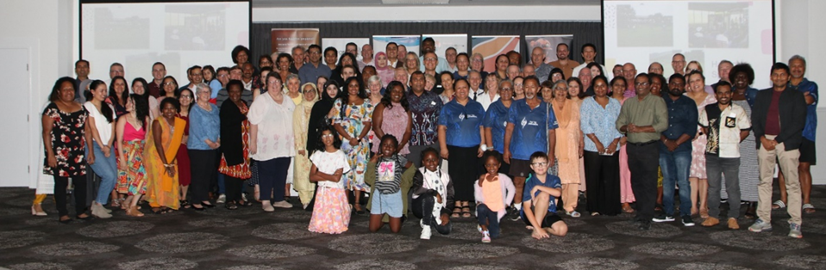**Annual Multifaith Dinner**

|  |  |
| --- | --- |
| In June 2023, the former QFES, QPS, Multicultural Australia, the Queensland Human Rights Commission and the Rockhampton Regional Council partnered to host the sixth annual Multi-faith Dinner. The dinner enables government and other agency representatives to join together and promote the shared values of all faiths. There were 125 guests representing 21 cultures and 11 religions. The event included a feature by Tu-Te Awaroa Māori Culture Group and the theme for the informative panel was ‘Families’. | **Performance of the Tu-Te Awaroa Cultural Group** |

**Holocaust Museum and Education Centre**

Across the globe, Holocaust Museums and Education Centres play an important role in educating and reminding us of how we can individually contribute to stopping racism, hatred and genocides. Queensland is home to many survivors and their descendants of the devastating Holocaust. The museum is providing accessible educational programs so Queensland students can participate either in person or online. In 2023, the Queensland Government delivered on its 2020 election commitment to fund the establishment of a Queensland Holocaust Museum and Education Centre. The Queensland Holocaust Museum and Education Centre will help individuals to stand up against hatred and prejudice, to prevent human rights atrocities from reoccurring. Since opening, more than 2000 people have visited the museum in Brisbane. In March 2024, the Queensland Travelling Holocaust Museum was launched on the Gold Coast, which will enable information and resources to be shared across Queensland.

**Focus Area 4: Actions for 2024-25 to 2026-27**

|  |  |
| --- | --- |
| ACTION | AGENCY |
| Take a strong stance against racism, and actively promote anti-racism messages to staff, clients and communities in line with each agency’s unique context. | **All agencies** |
| Improve social cohesion by delivering programs and initiatives targeted at promoting social inclusion and intergenerational connection for older people from culturally and linguistically diverse backgrounds. | **DCSSDS** |
| Work with the African Youth Support Council to expand early intervention services, community building and mentoring programs to support young Queenslanders from African backgrounds across southeast Queensland. | **DCSSDS** |
| Continue to promote cultural diversity and inclusion via the Customer Calendar and the My Home Awards, which recognises that public housing tenants are culturally and linguistically diverse. | **DHLGPPW** |
| Modernise and strengthen Queensland’s anti-discrimination legislation by a phased response to implementing the Queensland Human Rights Commission’s Building Belonging report recommendations. | **DJAG** |
| Coordinate locally-led and culturally appropriate community responses following serious crimes that result in significant human and social community impacts. | **DJAG**  **DTASTIPCA** |
| Fund participatory research in selected Queensland State Schools on strengthening social inclusion for students and families from culturally and linguistically diverse backgrounds. | **DoE**  **DCSSDS** |
| Deliver targeted grants to address social isolation and loneliness experienced by people from culturally and linguistically diverse backgrounds. | **DTATSIPCA** |
| Foster cross-cultural inclusion and understanding by delivering major Queensland Art Gallery | Gallery of Modern Art exhibitions that showcase our social and cultural diversity, including presenting the 11th Asia Pacific Triennial of Contemporary Art. | **DTATSIPCA** |
| Engage with Queensland’s Australian South Sea Islander communities to deliver a Queensland Museum exhibition to mark the 30th anniversary of the Commonwealth’s Government’s recognition of Australian South Sea Islanders. | **DTATSIPCA** |
| Embed and strengthen knowledge, understanding and respect for Aboriginal and Torres Strait Islander cultures and histories by engaging culturally and linguistically diverse communities in activities associated with dates of cultural significance | **DTATSIPCA** |
| Raise awareness and understanding of Aboriginal languages and Torres Strait Islander languages within culturally and linguistically diverse communities through implementation of the Many Voices: Queensland Aboriginal and Torres Strait Islander Languages policy and programs | **DTATSIPCA** |
| Explore opportunities to engage with and promote visibility and inclusion of LGBTQIA+ people from culturally and linguistically diverse backgrounds within all the communities to which they belong in Queensland, recognising and celebrating intersectional identities. | **DTATSIPCA**  **DCSSDS** |
| Develop and implement a new Respectful Relationships training program, including a focus on increasing staff awareness of what constitutes racism and discrimination, and building skills on how to prevent and respond to it. | **DTMR** |
| Drive inclusion and community connections for people from culturally and linguistically diverse backgrounds through initiatives to support grassroots participation in sport and recreation. | **DTS** |
| Support a pipeline of mega and strategic events to provide a unique opportunity to celebrate Queensland’s cultural diversity and promote inclusivity and understanding. | **DTS** |
| Expand place-based partnerships with culturally and linguistically diverse non-government organisations to deliver community connection and support social cohesion for people from culturally and linguistically diverse backgrounds exiting correctional facilities. | **QCS** |
| Explore opportunities to partner with research institutes and key stakeholders to understand barriers and opportunities to improve communications for culturally and linguistically diverse communities in disaster management. | **QFD** |
| Develop and deliver the Health Workforce Strategy for Queensland to 2032, with implementation supported through the Queensland Health Workforce Action Plan 2024 to 2028, including implementing anti-racism and cultural safety actions across the health workforce. | **QH** |
| Engage with educators and young people to inform the development and delivery of resources for school principals and teachers to prevent and manage racism in schools, and to support students, parents and caregivers to understand and address racism, including information about discrimination laws, preventative measures and practical tools to help address racism in schools. | **QHRC** |
| Develop targeted products and actions to enhance community awareness and confidence of people from culturally and linguistically diverse backgrounds to report hate crime incidents to police. | **QPS** |
| Work in partnership with industry stakeholders to deliver strategies to address and respond to racism. | **QPS** |
| Provide education and awareness for the residential rental sector to help prevent unlawful discrimination and racism, and direct customers to relevant agencies for support, such as the QHRC, given the RTA can only commence regulatory action in relation to non-compliance with the *Residential Tenancies and Rooming Accommodation Act 2008*. | **RTA** |

# Governance and reporting

This Multicultural Action Plan sets out the actions the Queensland Government will progress to advance outcomes under each of the Multicultural Policy priorities.

The Action Plan presents new and significant initiatives that will be implemented across the Queensland Government over the next three years. It is not intended to capture the full range of business-as-usual activities the Queensland Government undertakes to improve outcomes for people from culturally and linguistically diverse backgrounds.

The Multicultural Policy and Action Plan intersect and complement a range of strategic efforts by the Queensland Government to achieve its objectives for the community, including:

* Queensland Public Sector Inclusion and Diversity Strategy 2021-25
* Even Better Public Sector for Queensland Strategy 2024 - 2028
* Queensland Procurement Strategy 2023 – Jobs, Economy, Legacy, Confidence
* Good People, Good Jobs: Queensland Workforce Strategy: 2022-32
* Queensland Government Reconciliation Action Plan July 2023 – June 2025
* National Agreement on Closing the Gap
* Communities 2032: A plan to strengthen the fabric of Queensland’s communities
* Communities 2032 Action Plan 2022-2025
* Queensland's Disability Plan 2022-2027: Together, a better Queensland
* Good Jobs, Great Training: Queensland Skills Strategy 2024 – 2028

Some agencies have also developed their own Multicultural Action Plans to guide their efforts, which will have their own reporting and governance structures.

The DCSSDS, through Multicultural Affairs Queensland, has a leadership role in supporting Queensland Government to ensure policies, programs and services are responsive to our culturally diverse communities.

To support implementation of the policy and action plan in line with the requirements of the *Multicultural Recognition Act 2016*, the following monitoring and reporting will be undertaken:

* Queensland Government agencies with actions in the action plan will report publicly on their actions and provide a summary of their progress every year.
* The Minister for Multicultural Affairs will table a report to Parliament on progress towards multicultural policy outcomes as soon as practicable after 30 June 2027.

# List of government entities

These Queensland Government entities will deliver actions under this Multicultural Action Plan.

|  |  |
| --- | --- |
| GOVERNMENT ENTITY | ACRONYM |
| Department of Agriculture and Fisheries | DAF |
| Department of Child Safety, Seniors and Disability Services | DCSSDS |
| Department of Education | DoE |
| Department of Employment, Small Business and Training | DESBT |
| Department of Energy and Climate | DEC |
| Department of Environment, Science and Innovation | DESI |
| Department of Housing, Local Government, Planning and Public Works | DHLGPPW |
| Department of Justice and Attorney-General | DJAG |
| Department of Regional Development, Manufacturing and Water | DRDMW |
| Department of Resources | DoR |
| Department of State Development and Infrastructure | DSDI |
| Department of the Premier and Cabinet | DPC |
| Department of Tourism and Sport | DTS |
| Department of Transport and Main Roads | DTMR |
| Department of Treaty, Aboriginal and Torres Strait Islander Partnerships, Communities and the Arts | DTATSIPCA |
| Department of Youth Justice | DYJ |
| Electoral Commission of Queensland | ECQ |
| Health and Wellbeing Queensland | HWQld |
| Legal Aid Queensland | LAQ |
| Public Sector Commission | PSC |
| Queensland Corrective Services | QCS |
| Queensland Fire Department | QFD |
| Queensland Health | QH |
| Queensland Human Rights Commission | QHRC |
| Queensland Mental Health Commission | QMHC |
| Queensland Police Service | QPS |
| Queensland Reconstruction Authority | QRA |
| Queensland Treasury | QT |
| Residential Tenancies Authority | RTA |
| TAFE Queensland | TAFE |
| Trade and Investment Queensland | TIQ |

# ENDNOTES

1. Scanlon Foundation Research Institute (O’Donnell, J) *Mapping Social Cohesion 2023.* <https://scanloninstitute.org.au/mapping-social-cohesion-2023>
2. Government of Western Australia, Department of Local Government, Sport and Cultural Industries, Office of Multicultural Interests, 2019. *New and emerging communities in Western Australia*. <https://www.omi.wa.gov.au/resources-and-statistics/publications/publication/new-and-emerging-communities-in-western-australia>
3. Public Sector Commission, 2024
4. Public Sector Commission, 2024
5. Queensland Government, 2023.*Working for Queensland survey: Highlights report.* <https://www.forgov.qld.gov.au/__data/assets/pdf_file/0031/462982/queensland-public-sector-2023-working-for-queensland-survey-report.pdf>
6. Queensland Government, 2023.*Working for Queensland survey: Highlights report.* <https://www.forgov.qld.gov.au/__data/assets/pdf_file/0031/462982/queensland-public-sector-2023-working-for-queensland-survey-report.pdf>
7. Scanlon Foundation Research Institute, 2023. *What is social cohesion?* [https://scanloninstitute.org.au/research/mapping-social-cohesion/what-social-cohesion#:~:text=The%20Scanlon%20Foundation%E2%80%99s%20Mapping%20Social%20Cohesion%20has%20become,examining%20trends%20in%20public%20attitudes%20to%20social%20cohesion.](https://scanloninstitute.org.au/research/mapping-social-cohesion/what-social-cohesion%23:~:text=The%20Scanlon%20Foundation%E2%80%99s%20Mapping%20Social%20Cohesion%20has%20become,examining%20trends%20in%20public%20attitudes%20to%20social%20cohesion.)
8. International Olympic Committee, 2021. *Olympic Host Contract Principles: Games of the XXXV Olympaid 2032.* <https://stillmed.olympics.com/media/Documents/Olympic-Games/Brisbane-2032/Host-Contract/Host-City-Contract-2032-Principles.pdf>
9. Scanlon Foundation Research Institute (O’Donnell, J) *Mapping Social Cohesion 2023.* <https://scanloninstitute.org.au/mapping-social-cohesion-2023>
10. Scanlon Foundation Research Institute (O’Donnell, J) *Mapping Social Cohesion 2023.* <https://scanloninstitute.org.au/mapping-social-cohesion-2023>
11. Scanlon Foundation Research Institute (O’Donnell, J) *Mapping Social Cohesion 2023.* <https://scanloninstitute.org.au/mapping-social-cohesion-2023>
12. Scanlon Foundation Research Institute (O’Donnell, J) *Mapping Social Cohesion 2023.* <https://scanloninstitute.org.au/mapping-social-cohesion-2023>
13. Diversity Council Australia (P. Anderson, V. Mapedzahama, A. Kaabel, and J. O’Leary) *Racism at Work: How organisations can stand up to and end workplace racism*, Diversity Council Australia, 2022.